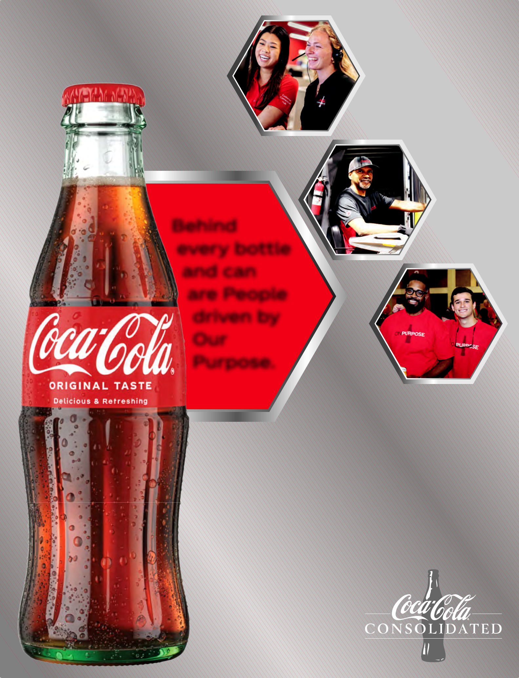
20

25

Annual
Report

Behind

every bottle

and can

are People

driven by

Our

Purpose.

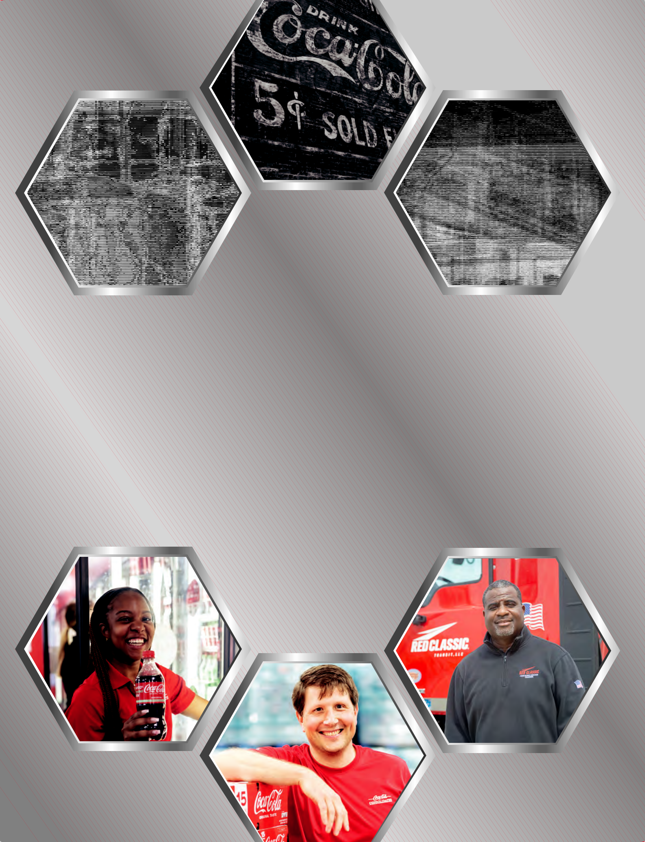

“At Coca-Cola Consolidated,

our legacy is grounded in values that endure. Our Purpose shapes the decisions we make, and our future is driven by people who are committed to serving others and pursuing excellence.”
- Morgan H. Everett

VICE CHAIR OF THE BOARD OF DIRECTORS

2 | Coca-Cola Consolidated, Inc.


To Our Stockholders,

Behind every bottle, every mini can, every sparkling new |  | We also expanded our Regional Operations Center in
flavor and timeless classic that we produce is something |  | Monroe, North Carolina, with a $15 million investment
much greater - Our Purpose. |  | that added a 42,000-square-foot warehouse and
Coca-Cola Consolidated is guided by a simple but powerful |  | upgraded infrastructure to support future growth.
truth. Our Purpose drives everything we do. It shapes how |  | In Twinsburg, Ohio, we invested $35 million in a new
we serve our customers, how we support our teammates, |  | can line, increasing production capacity by more than
and how we show up for the communities where we live and |  | six million cases each year. Across our network, we
work. It connects every bottle we make to the people and |  | strengthened our fleets, upgraded technology, and
places that make our work meaningful. |  | expanded capabilities to ensure Coca-Cola Consolidated
Each day, more than 17,000 teammates across our Company |  | continues to lead our industry for generations to come.
embody this Purpose. Their dedication has made us |  | Empowering Our People
the largest Coca-Cola bottler in the United States and a
 |  | At Coca-Cola Consolidated, we believe our greatest
Company deeply rooted in the communities we serve.
 |  | investment is in our people. Their energy, pride, and
Together, we distribute more than 300 brands and flavors
 |  | commitment fuel everything we achieve. In 2025, we
of The Coca-Cola Company and our partner brands, serving
 |  | expanded our paid parental leave program for eligible
millions of consumers from small towns to big cities. Beyond
 |  | teammates, as part of our continued effort to support
the products we deliver, what defines us most
the products we deliver, what defines us most |  |  | families and help teammates thrive both
is the impact we create, the families we |  |  | families and help teammates thrive both
is the impact we create, the families we |  |  | personally and professionally. We also
support, the careers we grow, and the |  |  | personally and professionally. We also
support, the careers we grow, and the |  |  | strengthened base pay, performance
neighborhoods we strengthen. |  |  | strengthened base pay, performance
neighborhoods we strengthen. | “Looking ahead, |  | incentives, and career development
In 2025, our teams continued to build on |  |  | incentives, and career development
In 2025, our teams continued to build on |  |  | opportunities across our Company.
that legacy with focus and discipline. | we remain |  | opportunities across our Company.
that legacy with focus and discipline. | steadfast in our |  | This culture of care and opportunity has
Despite challenges in our external |  |  | This culture of care and opportunity has
Despite challenges in our external | Purpose: To honor |  | earned national recognition.
environment, we stayed true to our |  |  | earned national recognition.
environment, we stayed true to our | God in all we do; |  | Coca-Cola Consolidated was
values and focused on what we could |  |  | Coca-Cola Consolidated was
values and focused on what we could | To serve others; To |  | named one of Newsweek’s 2025
control. We executed with excellence, | pursue excellence; |  | named one of Newsweek’s 2025
control. We executed with excellence, |  |  | “America’s Greatest Workplaces for
invested in our people, and prepared | To grow profitably.” |  | “America’s Greatest Workplaces for
for the future. The result was another |  |  | Parents & Families.” This honor reflects
for the future. The result was another |  |  | our dedication to creating a workplace
strong year of performance and progress, |  |  | our dedication to creating a workplace
strong year of performance and progress, |  |  | where teammates feel valued, supported,
defined not only by financial results |  |  | where teammates feel valued, supported,
defined not only by financial results |  |  | and inspired to grow.
but by the meaningful ways we lived out our |  |  | and inspired to grow.
Purpose to serve others. |  | Rooted in Purpose, Proudly Bottled in America

Strong Financial Performance

Our full-year results reflect a 4.8% increase in net sales to $7.2 billion, driven by strong volume, pricing, and brand performance. Our products remain a preferred choice among consumers, and our disciplined execution supported continued growth across our territories. We also delivered consistent operating cash flow of $932 million, enabling us to reinvest in our business and strengthen our supply chain through $312 million in capital expenditures. These results reflect the strength of our brands, the dedication of our teammates, and the confidence of our customers.

Investing in What Matters Most

Throughout the year, we made strategic investments that reflect our long-term commitment to innovation, sustainability, and operational excellence. Our $90 million investment in a new, state-of-the-art 60-acre campus in Columbus, Ohio, stands as a symbol of that commitment. Designed to handle more than 16 million cases annually, the 400,000 square foot facility integrates advanced automation and logistics systems that enhance productivity, teammate safety, and customer service.

As we approach our nation’s 250th anniversary, we take pride in being part of an enduring American story built on faith, hard work, and community. Every bottle we produce represents more than a beverage. It represents the strength of American enterprise, the dignity of honest work, and the joy of serving others.

Looking ahead, we remain steadfast in our Purpose: To honor God in all we do; To serve others; To pursue excellence; To grow profitably. Our focus on people, innovation, and community will continue to guide our growth and create lasting value for our stockholders, teammates, and the families who trust us every day.

Thank you for your continued support and partnership.

- gratitude,

J. Frank Harrison, III | David M. Katz
CHAIRMAN OF THE BOARD OF | PRESIDENT & CHIEF
DIRECTORS & | OPERATING OFFICER
CHIEF EXECUTIVE OFFICER

2025 Annual Report | 3

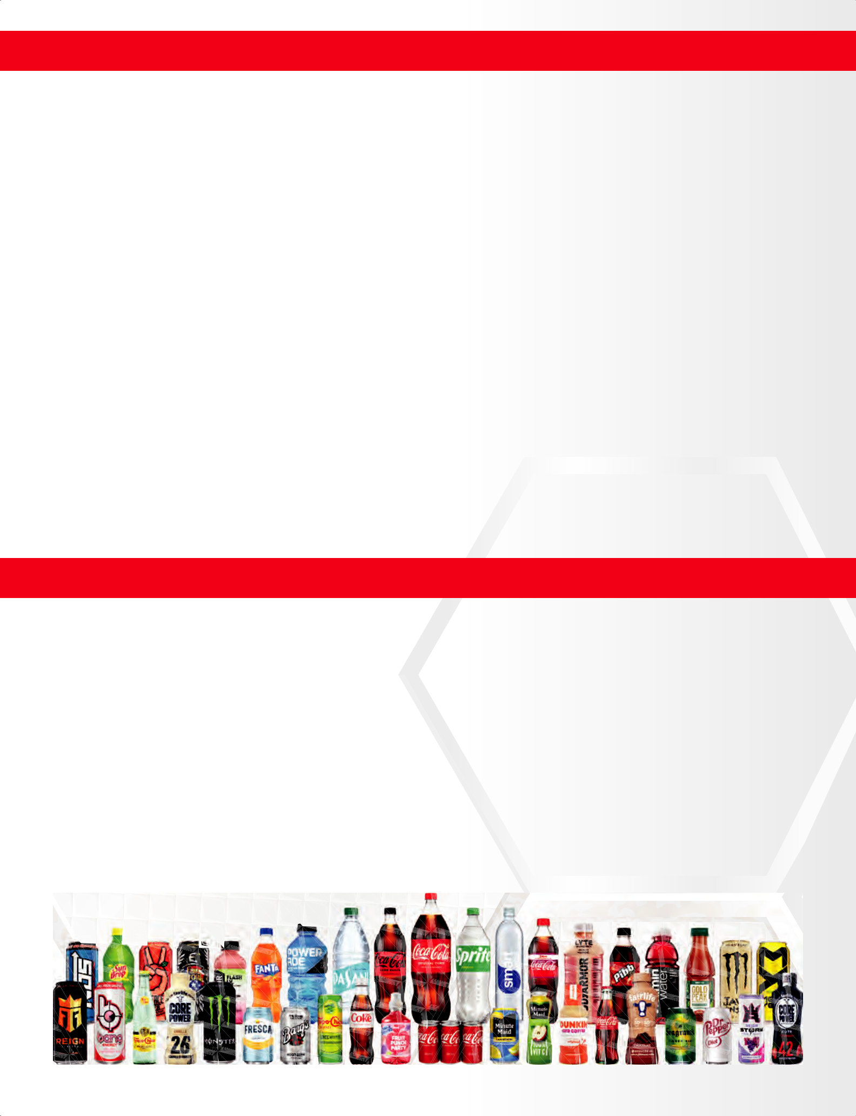
Our Purpose 

At Coca-Cola Consolidated, we are guided by our Purpose. We believe that honoring God, serving

others, pursuing excellence, and growing profitably creates lasting value for our customers, teammates, communities, and stockholders.

Our commitment begins with people. We believe business should be a force for good , supporting families and strengthening the communities we serve through care, partnership, and business investment.

From investing in our teammates through our Employee Value Promise, to helping communities affected by natural disasters, we are inspired to be on Purpose. This Purpose is not a slogan; it is a beacon that guides and motivates our actions. 

Our Portfolio

With a vast and growing portfolio of more than 300 brands and flavors, Coca-Cola Consolidated helps meet the needs of 60 million consumers. Sparkling soft drinks remain

the core of our business, representing about two-thirds of portfolio revenue, while continued innovation expands choice across categories and occasions. 

Demand continues to grow for minis and value packs, including mini cans, 1.25 liter bottles, and six-pack sparkling flavors. As more consumers choose zero sugar and functional options,

our zero sugar portfolio continues to lead the industryand our protein drinks are accelerating. Investments in our network, including warehouse improvements, help us serve customers

with greater efficiency, accuracy, and reliability.

4|| CCococaa--CoCollaaConsolidatConsolidated,ed,InIncc..


Our People

At Coca-Cola Consolidated, our people are at the heart of our business. Investing in our teammates strengthens our Company and the communities we serve, creating impact that extends well beyond the workplace.

We continue to invest in competitive compensation, meaningful benefits, and family support. In 2025, we expanded Paid Parental Leave, reinforcing our commitment to supporting families.

Career development remains a key focus. Through training, leadership development, and advancement opportunities, we encourage long-term careers and promote from within.

By investing in our people, we strengthen our business and build a future grounded in care, opportunity, and shared success. 

Coca-Cola Consolidated was named one of Newsweek’s 2025 America’s Greatest Workplaces for Parents & Families, reflecting our commitment to supporting teammates both at work and

at home. Based on independent research and feedback from working parents across the United States, the recognition highlights organizations that prioritize flexibility, family support, and inclusive workplace culture. For Coca-Cola Consolidated, this honor reinforces our focus on creating an environment where teammates feel valued, supported, and able to succeed while caring for their families.

2025 Annual Report | 5


Our Reach

Coca-Cola Consolidated serves customers and communities across 14 states and Washington, D.C. Within this footprint, we do more than deliver beverages. We create jobs, support families, and invest in local economies. Our presence reflects a commitment to long-term community partnership and meaningful opportunities for the people who live and work in the regions we serve.

We Are Coca-Cola Consolidated, Your Local Bottler.

 |  |  |  | PA
 | IL |  | OH
 | IL |  |  | MDMD
 |  | IN |  | MDMD
 |  |  | WV | DC | DE
MO |  |  | WV | DC
MO |  |  | WV | VA
 |  | KY
 |  | TN
 |  | TN | NCNC
AR |  |  | SCSC *
MS AL GA

LA

FL | Headquarters
FL | Charlotte, NC

14 | Operations | 17K
14 | in 14 states & | 17K
 | Washington, D.C.
11 | Centers* | 60
 | Production

Teammates

Distribution Centers

60M

300

Consumers

Brands & Flavors

6 | Coca-Cola Consolidated, Inc. * Includes South Atlantic Canners (Not Owned)

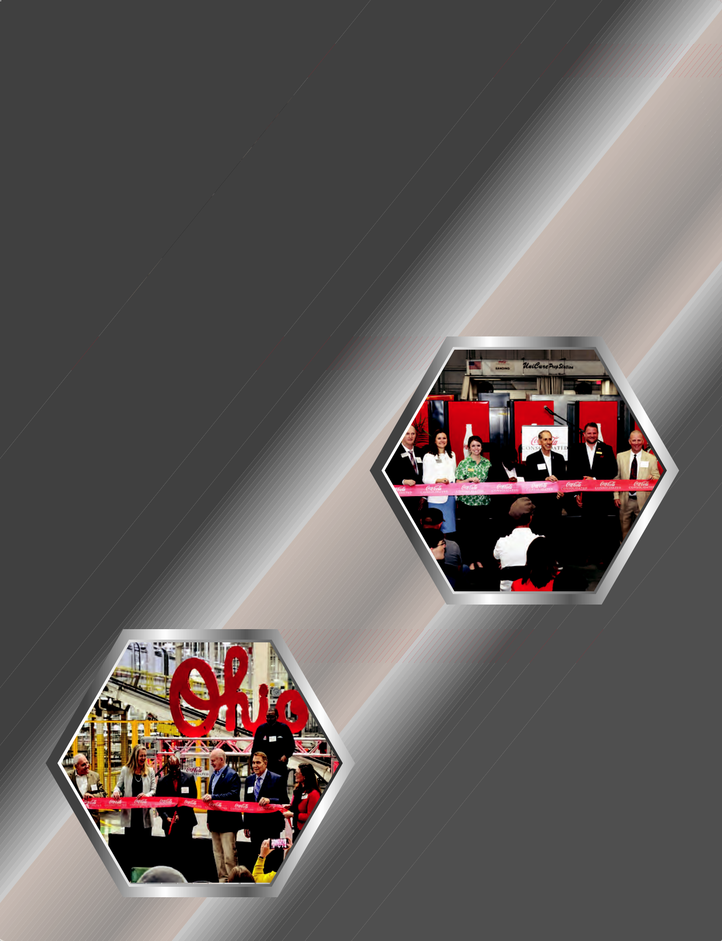
$90M Columbus, OH Campus Investment

Coca-Cola Consolidated announced a $90 million investment in a new 60-acre campus in Columbus, Ohio designed to support sustained growth and operational excellence. The campus includes a 400,000 square foot distribution and warehouse facility along with two 15,000 square foot buildings dedicated to equipment repair and fleet maintenance. The Columbus campus strengthens the Company’s supply chain and reflects its continued commitment to innovation and reliable service.

$15M Monroe, NC Expansion

Coca-Cola Consolidated completed a $15 million expansion of its Regional Operations Center in Monroe, North Carolina. The expansion added a 42,000 square-foot warehouse to enhance efficiency and provide training space for the new Coca-Cola Consolidated Technical Academy. This investment enhances service capabilities while supporting teammates through improved training resources and modernized infrastructure.

$35M Twinsburg, OH Can Line

Coca-Cola Consolidated invested $35 million in a new can line at its manufacturing facility in Twinsburg, Ohio to expand production capacity and support growing demand. The addition is expected to increase output by more than six million cases annually while improving effi ciency. This investment reflects the Company’s focus on modernization while delivering consistent quality for our customers.

2025 Annual Report | 7

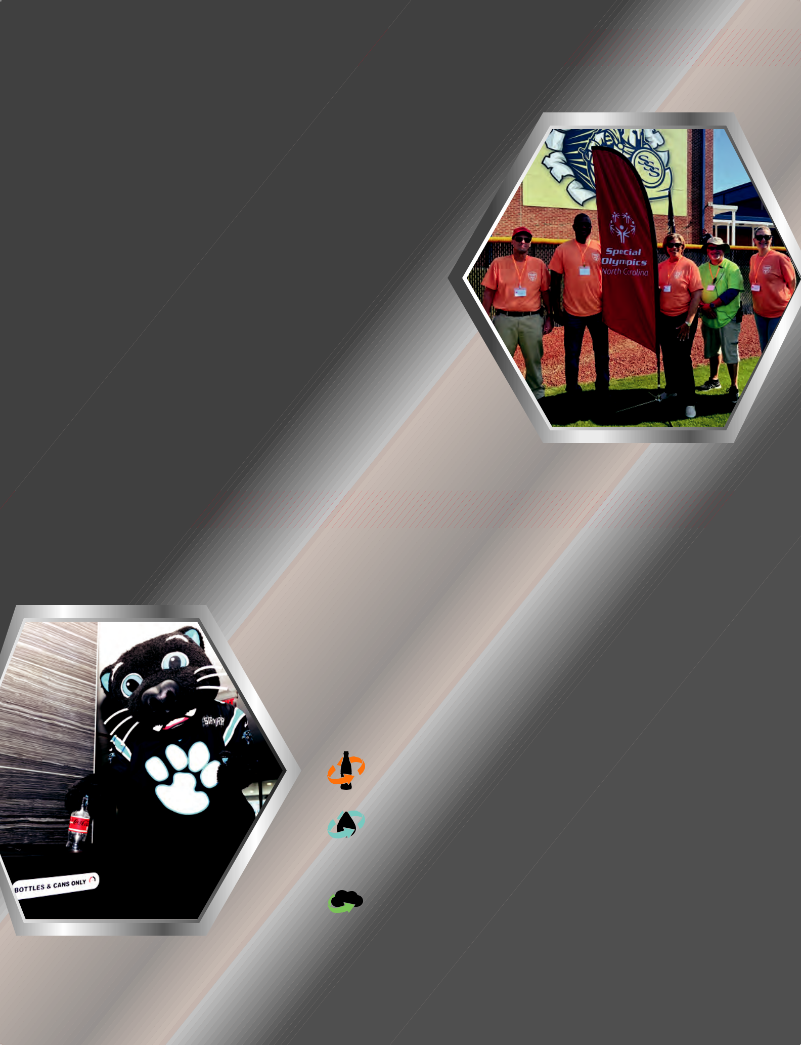
Purpose in Action, Serving Our Community

At Coca-Cola Consolidated, Purpose in Action means showing up for the people and communities we serve in practical, measurable ways. Our teammates partner with local nonprofits, schools, and community leaders to support families and strengthen communities. In 2025, these efforts supported education, youth development, crisis assistance, health and wellness, veterans and first responders, and sustainability initiatives throughout our territory. Together, this work reflects a continued commitment to serving others through consistent action and meaningful community partnership.

Sustainability

At Coca-Cola Consolidated, sustainability is about protecting what matters most while building a business that can serve communities for generations. Our approach balances environmental stewardship, operational responsibility and long-term resilience, ensuring we grow in ways that support our teammates, our customers, and the communities we serve.

We focus our sustainability efforts in the areas where we can make the greatest impact.

Package Recycling

Our bottles and cans are made to be remade.

Water Leadership

Water is essential to what we do. We strive to improve water efficiency across our operations.

 Emissions Reduction

We continue to reduce emissions and energy use by modernizing facilities, optimizing transportation, and investing in technology.

8 | Coca-Cola Consolidated, Inc.

UNITED STATES

SECURITIES AND EXCHANGE COMMISSION

Washington, D.C. 20549

FORM 10-K

- ANNUAL REPORT PURSUANT TO SECTION 13 OR 15(d) OF THE SECURITIES EXCHANGE ACT OF 1934

For the fiscal year ended December 31, 2025

or
- TRANSITION REPORT PURSUANT TO SECTION 13 OR 15(d) OF THE SECURITIES EXCHANGE ACT OF 1934

For the transition period from to

Commission File Number: 0-9286
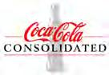

COCA-COLA CONSOLIDATED, INC.

(Exact name of registrant as specified in its charter)

Delaware | 56-0950585
(State or other jurisdiction of | (I.R.S. Employer
incorporation or organization) | Identification No.)
4100 Coca-Cola Plaza | 28211
Charlotte, NC | 28211
(Address of principal executive offices) | (Zip Code)

Registrant’s telephone number, including area code: (980) 392-8298

Securities registered pursuant to Section 12(b) of the Act:
 | Title of each class |  |  | Trading Symbol(s) |  | Name of each exchange on which registered
Common Stock, par value $1.00 per share |  |  |  | Trading Symbol(s) |  | The Nasdaq Global Select Market
 |  |  |  | COKE
Securities registered pursuant to Section 12(g) of the Act: None

Indicate by check mark if the registrant is a well-known seasoned issuer, as defined in Rule 405 of the Securities Act. Yes ☒ No ☐ Indicate by check mark if the registrant is not required to file reports pursuant to Section 13 or Section 15(d) of the Act. Yes ☐ No ☒

Indicate by check mark whether the registrant (1) has filed all reports required to be filed by Section 13 or 15(d) of the Securities Exchange Act of 1934 during the preceding 12 months (or for such shorter period that the registrant was required to file such reports), and (2) has been subject to such filing requirements for the past

90 days. Yes ☒ No ☐

Indicate by check mark whether the registrant has submitted electronically every Interactive Data File required to be submitted pursuant to Rule 405 of Regulation S-T (§232.405 of this chapter) during the preceding 12 months (or for such shorter period that the registrant was required to submit such files). Yes ☒ No ☐
Indicate by check mark whether the registrant is a large accelerated filer, an accelerated filer, a non-accelerated filer, a smaller reporting company, or an emerging growth company. See the definitions of “large accelerated filer,” “accelerated filer,” “smaller reporting company,” and “emerging growth company” in Rule 12b-2 of the Exchange Act.

Large accelerated filer | ☒ | Accelerated filer | ☐
Non-accelerated filer | ☐ | Smaller reporting company | ☐
 |  | Emerging growth company | ☐

If an emerging growth company, indicate by check mark if the registrant has elected not to use the extended transition period for complying with any new or revised financial accounting standards provided pursuant to Section 13(a) of the Exchange Act. ☐

Indicate by check mark whether the registrant has filed a report on and attestation to its management’s assessment of the effectiveness of its internal control over financial reporting under Section 404(b) of the Sarbanes-Oxley Act (15 U.S.C. 7262(b)) by the registered public accounting firm that prepared or issued its audit report. ☒
If securities are registered pursuant to Section 12(b) of the Act, indicate by check mark whether the financial statements of the registrant included in the filing reflect the correction of an error to previously issued financial statements. ☐
Indicate by check mark whether any of those error corrections are restatements that required a recovery analysis of incentive-based compensation received by any of the registrant’s executive officers during the relevant recovery period pursuant to §240.10D-1(b). ☐

Indicate by check mark whether the registrant is a shell company (as defined in Rule 12b-2 of the Act). Yes ☐ No ☒

State the aggregate market value of the voting and non-voting common equity held by non-affiliates computed by reference to the price at which the common equity was last sold, or the average bid and asked price of such common equity, as of the last business day of the registrant’s most recently completed second fiscal quarter.
 | Class |  | Market Value as of June 27, 2025
Common Stock, par value $l.00 per share |  |  | $6,464,713,553
Class B Common Stock, par value $l.00 per share |  |  | *

*No market exists for the Class B Common Stock, which is neither registered under Section 12 of the Act nor subject to Section 15(d) of the Act. The Class B Common Stock is convertible into Common Stock on a share-for-share basis at any time at the option of the holder.

Indicate the number of shares outstanding of each of the registrant’s classes of common stock, as of the latest practicable date.

 | Class |  |  | Outstanding as of January 30, 2026
Common Stock, par value $1.00 per share |  |  | 56,517,334
Class B Common Stock, par value $1.00 per share |  |  | 10,046,960

DOCUMENTS INCORPORATED BY REFERENCE

Portions of the registrant’s definitive proxy statement to be filed with the United States Securities and Exchange Commission in connection with the registrant’s 2026 Annual Meeting of Stockholders are incorporated by reference into Part III of this report to the extent described herein.

COCA-COLA CONSOLIDATED, INC.

ANNUAL REPORT ON FORM 10-K

FOR THE FISCAL YEAR ENDED DECEMBER 31, 2025

TABLE OF CONTENTS

Page

PART I

Item 1. Business 1

Item 1A. Risk Factors 9

Item 1B. Unresolved Staff Comments 17

Item 1C. Cybersecurity 17

Item 2. Properties 18

Item 3. Legal Proceedings 19

Item 4. Mine Safety Disclosures 19

Information About Our Executive Officers 20

PART II

Item 5. Market for Registrant’s Common Equity, Related Stockholder Matters and Issuer Purchases of Equity Securities . 22

Item 6. [Reserved] 23

Item 7. Management’s Discussion and Analysis of Financial Condition and Results of Operations 24

Item 7A. Quantitative and Qualitative Disclosures About Market Risk 40

Item 8. Financial Statements and Supplementary Data 41

Item 9. Changes in and Disagreements With Accountants on Accounting and Financial Disclosure 85

Item 9A. Controls and Procedures 85

Item 9B. Other Information 85

Item 9C. Disclosure Regarding Foreign Jurisdictions that Prevent Inspections 85

PART III

Item 10. Directors, Executive Officers and Corporate Governance 86

Item 11. Executive Compensation 86

Item 12. Security Ownership of Certain Beneficial Owners and Management and Related Stockholder Matters 86

Item 13. Certain Relationships and Related Transactions, and Director Independence 86

Item 14. Principal Accountant Fees and Services 86

PART IV

Item 15. Exhibits and Financial Statement Schedules 87

Item 16. Form 10-K Summary 92

Signatures 94

i

PART I

Item 1. Business.

Introduction

Coca-Cola Consolidated, Inc., a Delaware corporation (together with its majority-owned subsidiaries, “Coca-Cola Consolidated,” the “Company,” “we,” “us” or “our”), distributes, markets and manufactures nonalcoholic beverages in territories spanning 14 states and the District of Columbia. The Company was incorporated in 1980 and, together with its predecessors, has been in the nonalcoholic beverage manufacturing and distribution business since 1902. We are the largest Coca-Cola bottler in the United States. Approximately 85% of our total bottle/can sales volume to retail customers consists of products of The Coca-Cola Company, which include some of the most recognized and popular beverage brands in the world. We also distribute products for several other beverage companies, including Monster Energy Company (“Monster Energy”) and Keurig Dr Pepper Inc. (“Dr Pepper”). Our Purpose is to honor God in all we do, to serve others, to pursue excellence and to grow profitably.

Ownership

As of December 31, 2025, J. Frank Harrison, III, Chairman of the Board of Directors and Chief Executive Officer of the Company, controlled 10,043,940 shares of the Company’s Class B Common Stock, par value $1.00 per share (“Class B Common Stock”), which represented approximately 78% of the total voting power of the Company’s outstanding Common Stock, par value $1.00 per share (“Common Stock”), and Class B Common Stock on a consolidated basis.

Beverage Products

We offer a range of nonalcoholic beverage products and flavors, including both sparkling and still beverages, designed to meet the demands of our consumers. Sparkling beverages are carbonated beverages and the Company’s principal sparkling beverage is Coca-Cola. Still beverages include energy products and noncarbonated beverages such as bottled water, ready-to-drink tea, ready-to-drink coffee, enhanced water, juices and sports drinks.

Our sales are divided into two main categories: (i) bottle/can sales and (ii) other sales. Bottle/can sales primarily include products packaged in plastic bottles and aluminum cans. Other sales include sales to other Coca-Cola bottlers, post-mix sales, transportation revenue and equipment maintenance revenue. Post-mix products are dispensed through equipment that mixes fountain syrups with carbonated or still water, enabling fountain retailers to sell finished products to consumers in cups or glasses.

The following table sets forth some of our principal products, including products of The Coca-Cola Company and products licensed to us by other beverage companies:

 | Sparkling Beverages |  |  | Still Beverages
The Coca-Cola Company Products:
Barqs Root Beer | Fresca |  | BODYARMOR | Minute Maid
Barqs Zero Sugar | Mello Yello |  | Core Power | POWERade
Coca-Cola | Mr. Pibb |  | Dasani | POWERade Powerwater
Coca-Cola Cherry | Mr. Pibb Zero Sugar |  | Dunkin’ Coffee | Topo Chico
Coca-Cola Zero Sugar | Seagrams Ginger Ale |  | fairlife | Topo Chico Sabores
Diet Coke | Seagrams Ginger Ale Zero Sugar |  | glacéau smartwater | Tum-E Yummies
Fanta | Sprite |  | glacéau vitaminwater
Fanta Zero Sugar | Sprite Zero Sugar |  | Gold Peak
Products Licensed to Us by Other Beverage Companies:
Ale 8 | Dr Pepper |  | Bang Energy | Monster Energy
Diet Dr Pepper | Dr Pepper Zero Sugar |  | FLRT | NOS®
Diet Sundrop | Sundrop |  | Full Throttle | Reign/Reign Storm
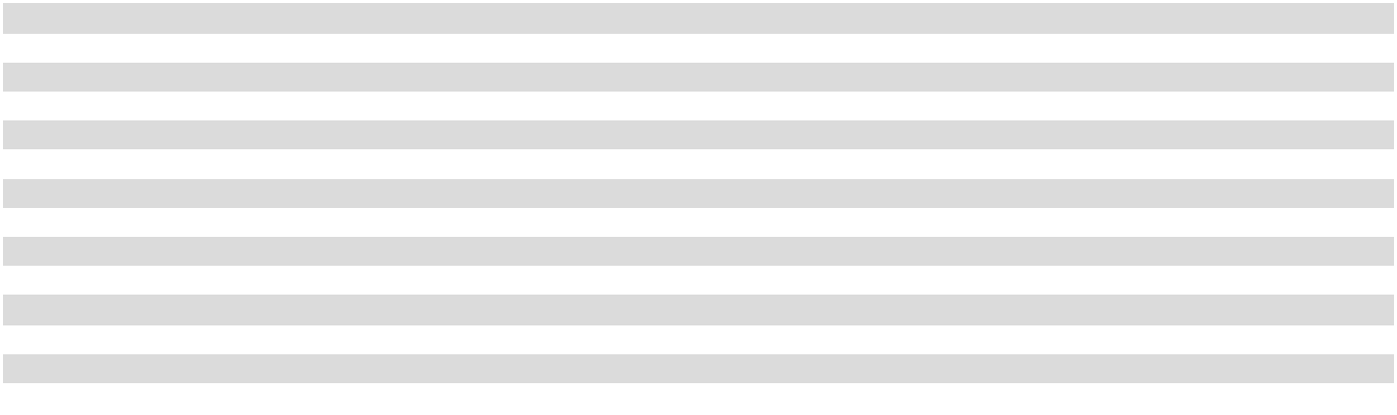

Beverage Distribution and Manufacturing Agreements

We have rights to distribute, promote, market and sell certain nonalcoholic beverages of The Coca-Cola Company pursuant to comprehensive beverage agreements (as amended, collectively, the “CBA”) with The Coca-Cola Company and Coca-Cola Refreshments USA, LLC (“CCR”), a wholly owned subsidiary of The Coca-Cola Company. The CBA relates to a multi-year series of transactions, which were completed in October 2017, through which the Company acquired and exchanged distribution territories and manufacturing plants. The CBA requires the Company to make quarterly acquisition related sub-bottling payments to CCR on a

1

continuing basis in exchange for the grant of exclusive rights to distribute, promote, market and sell the authorized brands of The Coca-Cola Company and related products in certain distribution territories the Company acquired from CCR. In addition to certain termination and default rights, the CBA requires us to make minimum, ongoing capital expenditures in our distribution business and to meet certain minimum volume requirements, gives The Coca-Cola Company certain approval and other rights in connection with a sale of the Company or the distribution business of the Company and prohibits us from producing, manufacturing, preparing, packaging, distributing, selling, dealing in or otherwise using or handling any beverages, beverage components or other beverage products other than the beverages and beverage products of The Coca-Cola Company and certain expressly permitted cross-licensed brands without the consent of The Coca-Cola Company.

We also have rights to manufacture, produce and package certain beverages bearing trademarks of The Coca-Cola Company at our manufacturing plants pursuant to a regional manufacturing agreement (as amended, the “RMA”) with The Coca-Cola Company entered into on March 31, 2017. We may distribute these beverages for our own account in accordance with the CBA or may sell them to certain other U.S. Coca-Cola bottlers or to The Coca-Cola Company in accordance with the RMA. For prices determined pursuant to the RMA, The Coca-Cola Company unilaterally establishes from time to time the prices, or certain elements of the formulas used to determine the prices, that the Company charges for these sales to certain other U.S. Coca-Cola bottlers or to The Coca-Cola Company. The RMA contains provisions similar to those contained in the CBA restricting the sale of the Company or the manufacturing business of the Company, requiring minimum, ongoing capital expenditures in our manufacturing business, prohibiting us from manufacturing any beverages, beverage components or other beverage products other than the beverages and beverage products of

The Coca-Cola Company and certain expressly permitted cross-licensed brands without the consent of The Coca-Cola Company and allowing for the termination of the RMA.

In addition to our agreements with The Coca-Cola Company and CCR, we also have rights to manufacture and/or distribute certain beverage brands owned by other beverage companies, including Monster Energy and Dr Pepper, pursuant to agreements with such other beverage companies. Our distribution agreements with Dr Pepper permit us to distribute Dr Pepper beverage brands, as well as certain post-mix products of Dr Pepper. Certain of our agreements with Dr Pepper also authorize us to manufacture certain Dr Pepper beverage brands. Our distribution agreements with Monster Energy grant us the rights to distribute certain products offered, packaged and/or marketed by Monster Energy. Similar to the CBA, these beverage agreements contain restrictions on the use of trademarks and approved bottles, cans and labels and the sale of imitations or substitutes, as well as provisions for their termination for cause or upon the occurrence of other events defined in these agreements. Sales of beverages under these agreements with other beverage companies represented approximately 15% of our total bottle/can sales volume to retail customers in 2025, 2024 and 2023.

Finished Goods Supply Arrangements

We have finished goods supply arrangements with other U.S. Coca-Cola bottlers to sell and buy finished goods bearing trademarks owned by The Coca-Cola Company and produced by us in accordance with the RMA or produced by a selling U.S. Coca-Cola bottler in accordance with a similar regional manufacturing authorization held by such bottler. Pursuant to the RMA,

The Coca-Cola Company unilaterally establishes from time to time the prices, or certain elements of the formulas used to determine the prices, for such finished goods. In most instances, the Company’s ability to negotiate the prices at which it sells finished goods bearing trademarks owned by The Coca-Cola Company to, and the prices at which it purchases such finished goods from, other U.S. Coca-Cola bottlers is limited pursuant to these pricing provisions.

Other Agreements Related to the Coca-Cola System

We have other agreements with The Coca-Cola Company, CCR and other Coca-Cola bottlers regarding product supply, information technology services and other aspects of the North American Coca-Cola system, as described below. Many of these agreements involve system governance structures that require the Company’s management to closely collaborate and align with other participating bottlers in order to successfully implement Coca-Cola system plans and strategies.

Incidence-Based Pricing Agreement with The Coca-Cola Company

The Company has an incidence-based pricing agreement with The Coca-Cola Company, which establishes the prices charged by The Coca-Cola Company to the Company for (i) concentrates of sparkling and certain still beverages produced by the Company and

- certain purchased still beverages. Under the incidence-based pricing agreement, the prices charged by The Coca-Cola Company are impacted by a number of factors, including the incidence rate in effect, our pricing and sales of finished products, the channels in which the finished products are sold, the package mix and, in the case of products sold by The Coca-Cola Company to us in finished form, the cost of goods for certain elements used in such products. The Coca-Cola Company has no rights under the incidence-based pricing agreement to establish the prices, or the elements of the formulas used to determine the prices, at which we sell products, but does have the right to establish certain pricing under other agreements, including the RMA.

2

National Product Supply Governance Agreement

We are a member of a national product supply group (the “NPSG”), which is composed of The Coca-Cola Company, the Company and certain other Coca-Cola bottlers who are regional producing bottlers in The Coca-Cola Company’s national product supply system (collectively with the Company, the “NPSG Members”), pursuant to a national product supply governance agreement (as amended, the “NPSG Agreement”) executed in 2015 with The Coca-Cola Company and certain other Coca-Cola bottlers. The stated objectives of the NPSG include, among others, (i) Coca-Cola system strategic infrastructure investment and divestment planning; (ii) network optimization of plant to distribution center sourcing; and (iii) new product or packaging infrastructure planning.

Under the NPSG Agreement, the NPSG Members established certain governance mechanisms, including a governing board (the “NPSG Board”) composed of representatives of certain NPSG Members. The NPSG Board makes and/or oversees and directs certain key decisions regarding the NPSG. Subject to the terms and conditions of the NPSG Agreement, each NPSG Member is required to comply with certain key decisions made by the NPSG Board, which include decisions regarding strategic infrastructure investment and divestment planning, optimal national product supply sourcing and new product or packaging infrastructure planning. We are also obligated to pay a certain portion of the costs of operating the NPSG.

CONA Services LLC

Along with certain other Coca-Cola bottlers, we are a member of CONA Services LLC (“CONA”), an entity formed to provide business process and information technology services to its members. We are party to an amended and restated master services agreement with CONA, pursuant to which CONA agreed to make available, and we became authorized to use, the Coke One North America system (the “CONA System”), a uniform information technology system developed to promote operational efficiency and uniformity among North American Coca-Cola bottlers. As part of making the CONA System available to us, CONA provides us with certain business process and information technology services, including the planning, development, management and operation of the CONA System in connection with our direct store delivery (“DSD”) and manufacture of products. In exchange for our rights to use the CONA System and receive CONA-related services, we are charged service fees by CONA, which we are obligated to pay even if we are not using the CONA System for all or any portion of our distribution and manufacturing operations.

Amended and Restated Ancillary Business Letter

On March 31, 2017, we entered into an amended and restated ancillary business letter (the “Ancillary Business Letter”) with The Coca-Cola Company, pursuant to which we were granted advance waivers to acquire or develop certain lines of business involving the preparation, distribution, sale, dealing in or otherwise using or handling of certain beverage products that would otherwise be prohibited under the CBA.

Under the Ancillary Business Letter, the consent of The Coca-Cola Company, which consent may not be unreasonably withheld, would be required for us to acquire or develop (i) any grocery, quick service restaurant, or convenience and petroleum store business engaged in the sale of beverages, beverage components or other beverage products not otherwise authorized or permitted by the CBA or (ii) any other line of business for which beverage activities otherwise prohibited under the CBA represent more than a certain threshold of net sales (subject to certain limited exceptions).

3

Regions Served and Facilities

We serve approximately 60 million consumers within our territories, which are comprised of four principal regions. Previously, these four principal regions were organized into five market units. Certain information regarding each of the regions follows:

 |  |  |  | Manufacturing |  | Number of
Region |  | Description |  | Manufacturing |  | Distribution
Region |  | Description |  | Plants |  | Centers
Carolinas |  | The majority of North Carolina and South Carolina and portions of |  | Charlotte, NC |  | 17
 |  | southern Virginia, including Boone, Hickory, Mount Airy, Charlotte,
 |  | Raleigh, Winston-Salem, Greensboro, Fayetteville, Greenville and New
 |  | Bern, North Carolina, Conway, Marion, Charleston, Columbia, Greenville
 |  | and Ridgeland, South Carolina and surrounding areas.
Mid-Atlantic |  | The entire state of Maryland, the majority of Virginia, West Virginia and |  | Baltimore, MD | 20
 |  | Delaware, the District of Columbia, a portion of south-central |  | Silver Spring, MD
 |  | Pennsylvania, a portion of northeastern Kentucky and a portion of |  | Roanoke, VA
 |  | southern Ohio, including Easton, Salisbury, Capitol Heights, Baltimore, |  | Sandston, VA
 |  | Hagerstown and Cumberland, Maryland, Norfolk, Staunton, Alexandria,
 |  | Roanoke, Richmond, Yorktown and Fredericksburg, Virginia, Beckley,
 |  | Bluefield, Clarksburg, Elkins, Parkersburg, Craigsville and Charleston,
 |  | West Virginia, Pikeville, Kentucky, Portsmouth, Ohio and surrounding
 |  | areas.
Mid-South |  | A significant portion of central and southern Arkansas and Tennessee and |  | West Memphis, AR | 10
 |  | portions of western Kentucky and northwestern Mississippi, including |  | Nashville, TN
 |  | Little Rock and West Memphis, Arkansas, Cleveland, Cookeville, Johnson
 |  | City, Knoxville, Memphis and Morristown, Tennessee, Paducah,
 |  | Kentucky and surrounding areas.
Mid-West |  | A significant portion of Indiana and Ohio, a portion of northeastern |  | Indianapolis, IN | 13
 |  | Kentucky and a portion of southeastern Illinois, including Anderson, |  | Cincinnati, OH
 |  | Whitestown, Evansville, Fort Wayne, Indianapolis and South Bend, |  | Twinsburg, OH
 |  | Indiana, Lexington and Louisville, Kentucky, Akron, Cincinnati,
 |  | Columbus, Dayton, Elyria, Lima, Mansfield, Toledo, Willoughby and
 |  | Youngstown, Ohio and surrounding areas.
Total |  |  |  | 10 |  | 60
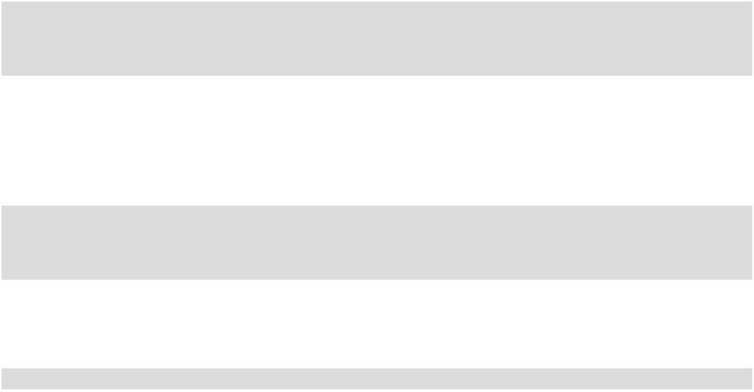

The Company is also a shareholder of South Atlantic Canners, Inc. (“SAC”), a manufacturing cooperative managed by the Company. SAC is located in Bishopville, South Carolina, and the Company utilizes a portion of the production capacity from the Bishopville manufacturing plant.

Raw Materials

In addition to concentrates purchased from The Coca-Cola Company and other beverage companies for use in our beverage manufacturing, we also purchase sweetener, carbon dioxide, plastic bottles, aluminum cans, closures and other packaging materials, as well as equipment for the distribution, marketing and production of nonalcoholic beverages.

We purchase all of the plastic bottles used in our manufacturing plants from Southeastern Container and Western Container, two manufacturing cooperatives we co-own with several other Coca-Cola bottlers, and all of our aluminum cans from two domestic suppliers.

Along with all other Coca-Cola bottlers in the United States and Canada, we are a member of Coca-Cola Bottlers’ Sales & Services Company LLC (“CCBSS”), which was formed to provide certain procurement and other services with the intention of enhancing the efficiency and competitiveness of the Coca-Cola bottling system. CCBSS negotiates the procurement for the majority of our raw materials, excluding concentrate, and we receive a rebate from CCBSS for the purchase of these raw materials.

We are exposed to price risk on commodities such as aluminum, corn and PET resin (a petroleum- or plant-based product), which affects the cost of raw materials used in the production of our finished products. We both produce and procure these finished products. Examples of the raw materials affected are aluminum cans and plastic bottles used for packaging and high-fructose corn syrup used as a product ingredient. Further, we are exposed to commodity price risk on crude oil, which impacts our cost of fuel used in the movement and delivery of our products. We participate in commodity hedging and risk mitigation programs, including programs administered by CCBSS and programs we administer. In addition, other than as discussed above, there are no limits on the prices The Coca-Cola Company and other beverage companies can charge for concentrate.

4

Customers and Marketing

The Company’s products are sold and distributed in the United States through various channels, which include selling directly to customers, including grocery stores, mass merchandise stores, club stores, convenience stores and drug stores, selling to on-premise locations, where products are typically consumed immediately, such as restaurants, schools, amusement parks and recreational facilities, and selling through other channels such as vending machine outlets. The Company also distributes its products using alternative routes to market (“ARTM”), which include distribution by third-party distributors, the manufacturer of the product or the customer’s supply chain infrastructure. We receive a fee in connection with the sale of products distributed via ARTM within our territories; however, the sale of such products is not included in the reported product volume sold by the Company.

The following table summarizes the percentage of the Company’s total bottle/can sales volume to its largest customers, as well as the percentage of the Company’s total net sales that such volume represents:

Fiscal Year

 |  | 2025 |  |  |  | 2024
Approximate percent of the Company’s total bottle/can sales volume: |  |  | 21 | % | 21 |  | %
Walmart Inc.⁽¹⁾
The Kroger Co.⁽²⁾ |  |  | 15 | % | 15 |  | %
Total approximate percent of the Company’s total bottle/can sales volume |  |  | 36 % |  |  | 36 %
Approximate percent of the Company’s total net sales: |  |  | 17 | % | 17 |  | %
Walmart Inc.⁽¹⁾
The Kroger Co.⁽²⁾ |  |  | 12 | % | 12 |  | %
Total approximate percent of the Company’s total net sales |  |  | 29 % |  |  | 29 %
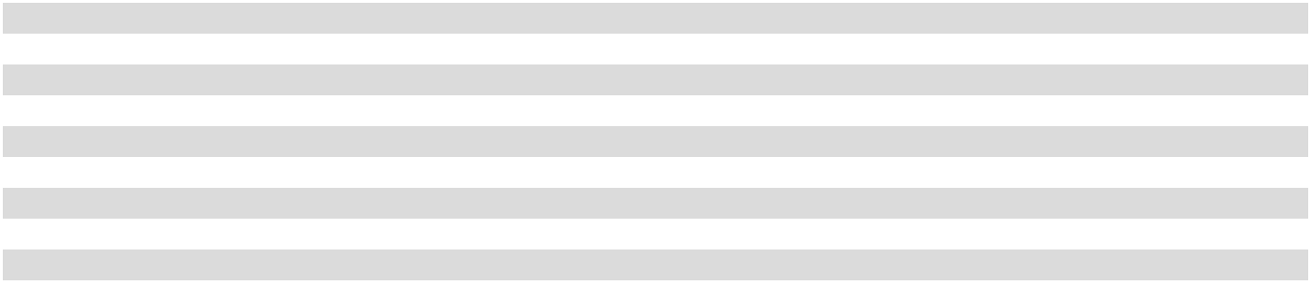

- Includes bottle/can sales volume related to the Walmart, Sam’s Club and Walmart Neighborhood Market chains.

- Includes bottle/can sales volume related to the Kroger and Harris Teeter chains.

The loss of Walmart Inc. or The Kroger Co. as a customer could have a material adverse effect on the operating and financial results of the Company. No other customer represented greater than 10% of the Company’s total net sales or would impose a material adverse effect on the operating or financial results of the Company should they cease to be a customer of the Company.

New brand and product introductions, packaging changes and sales promotions are the primary sales and marketing practices in the nonalcoholic beverage industry and have required, and are expected to continue to require, substantial expenditures. Recent and upcoming introductions include Sprite + Tea, POWERade Powerwater, new flavors and packages of BODYARMOR, POWERade, Monster and Topo Chico and the relaunch of Mr. Pibb and Mr. Pibb Zero Sugar. Additionally, during 2026, the Company will launch Coca-Cola Cherry Float, FLRT Energy Drink and enhanced glass offerings of our Coca-Cola Original Taste and other brands.

We sell our products primarily in single-use, recyclable bottles and cans in varying package configurations from market to market. For example, there may be up to 23 different packages for Diet Coke within a single geographic area. Total bottle/can sales volume to retail customers during 2025 was approximately 46% bottles and 54% cans.

We rely extensively on advertising in various media outlets, primarily online, television and radio, for the marketing of our products. The Coca-Cola Company, Monster Energy and Dr Pepper make substantial expenditures on advertising programs in our territories from which we benefit. Although The Coca-Cola Company and other beverage companies have provided us with marketing funding support in the past, our beverage agreements generally do not obligate such funding.

We also expend substantial funds on our own behalf for extensive local sales promotions of our products. Historically, these expenses have been partially offset by marketing funding support provided to us by The Coca-Cola Company and other beverage companies in support of a variety of marketing programs, such as point-of-sale displays and merchandising programs. We consider the funds we expend for marketing and merchandising programs necessary to maintain or increase revenue.

In addition to our marketing and merchandising programs, we believe a sustained and planned charitable giving program to support the communities we serve is an essential component to the success of our brand and, by extension, our net sales. In light of the Company’s financial performance, distribution territory footprint and future business prospects, in 2025, the Company made cash donations of approximately $52 million to various charities and donor-advised funds. The Company focuses on charities impacting communities throughout our territories in the following areas: Education, Youth Development, Crisis Assistance, Health & Wellness, Veteran & First Responders and Sustainability. The Company intends to continue its charitable contributions in future years, subject to the Company’s financial performance and other business factors.

5

Seasonality

Business seasonality results primarily from higher unit sales of the Company’s products in the second and third quarters of the fiscal year, as sales of our products are typically correlated with warmer weather. We believe that we and other manufacturers from whom we purchase finished products have adequate production capacity to meet sales demand for sparkling and still beverages during these peak periods. See “Item 2. Properties” for information relating to utilization of our manufacturing plants. Sales volume can also be impacted by weather conditions. Fixed costs, such as depreciation expense, are not significantly impacted by business seasonality.

Competition

The nonalcoholic beverage industry is highly competitive for both sparkling and still beverages. Our competitors include bottlers and distributors of nationally and regionally advertised and marketed products, as well as bottlers and distributors of private label beverages. Our principal competitors include local bottlers of PepsiCo, Inc. products and, in some regions, local bottlers of Dr Pepper products.

The principal methods of competition in the nonalcoholic beverage industry are new brand and product introductions, point-of-sale merchandising, new vending and dispensing equipment, packaging changes, pricing, sales promotions, product quality, retail space management, customer service, frequency of distribution and advertising. We believe we are competitive in our territories with respect to these methods of competition.

Government Regulation

Our business is subject to various laws and regulations administered by federal, state and local government agencies of the United States, including laws and regulations governing the production, storage, distribution, sale, display, advertising, marketing, packaging, labeling, content, quality and safety of our products, our occupational health and safety practices and the transportation and use of many of our products.

We are required to comply with a variety of U.S. laws and regulations, including, but not limited to: the Federal Food, Drug and Cosmetic Act and various state laws governing food safety; the Food Safety Modernization Act; the Occupational Safety and Health Act; the Clean Air Act; the Clean Water Act; the Resource Conservation and Recovery Act; the Robinson-Patman Act; the Comprehensive Environmental Response, Compensation and Liability Act; the Federal Motor Carrier Safety Act; the Lanham Act; various federal and state laws and regulations governing competition and trade practices; various federal and state laws and regulations governing our employment practices, including those related to equal employment opportunity, such as the Equal Employment Opportunity Act and the National Labor Relations Act; and laws and regulations restricting the sale of certain of our products in schools.

As a manufacturer, distributor and seller of beverage products of The Coca-Cola Company and other beverage companies in exclusive geographic territories, we are subject to antitrust laws of general applicability. However, pursuant to the United States Soft Drink Interbrand Competition Act, soft drink bottlers, such as us, are permitted to have exclusive rights to manufacture, distribute and sell soft drink products in a defined geographic territory if that soft drink product is in substantial and effective competition with other products of the same general class in the market. We believe such competition exists in each of the exclusive geographic territories in the United States in which we operate.

In response to growing health, nutrition and wellness concerns for today’s youth, a number of state and local governments have regulations restricting the sale of soft drinks and other foods in schools, particularly elementary, middle and high schools. Many of these restrictions have existed for several years in connection with subsidized meal programs in schools. Additionally, legislation has been proposed by certain state and local governments to limit or restrict the sale of energy drinks to minors and/or persons below a specified age and/or to restrict the venues in which energy drinks can be sold. Restrictive legislation, if widely enacted, could have an adverse impact on the Company’s products, sales and reputation.

Most beverage products sold by the Company are classified as food or food products and are therefore generally eligible for purchase using supplemental nutrition assistance program (“SNAP”) benefits by consumers purchasing them for home consumption. Energy drinks with a nutrition facts label are also classified as food and may be eligible for purchase for home consumption using SNAP benefits, whereas energy drinks classified as a supplement by the United States Food and Drug Administration (the “FDA”) are not. Regulators may restrict the use of benefit programs, including SNAP, to purchase certain beverages and foods currently classified as food or food products. Certain states in our territories have implemented, or have announced that they will implement, restrictions on the use of SNAP benefits to purchase certain products of the Company, such as soft drinks or energy drinks.

6

Certain jurisdictions in which our products are sold have imposed, or are considering imposing, taxes, labeling requirements or other limitations on, or regulations pertaining to, the sale of certain of our products or ingredients contained in, or attributes of, our products or commodities used in the manufacture of our products, including certain of our products that contain added sugars or sodium, exceed a specified caloric count or include specified ingredients such as caffeine or high-fructose corn syrup. It has also been proposed that the federal government, through agencies such as the United States Department of Health and Human Services, or individual states enact policies that would discourage consumption of our products or ban or restrict the usage of certain ingredients used in the manufacture of the products that we sell. Restrictive policies, if widely enacted, could have an adverse impact on our products, input costs, sales and reputation. Further, state variability in such policies could result in supply chain and customer relationship complexities.

Legislation has been proposed in Congress and by certain state and local governments which would prohibit the sale of soft drink products in non-refillable bottles and cans or require a mandatory deposit as a means of encouraging the return of such containers, each in an attempt to reduce solid waste and litter. Similarly, we are aware of certain legislation that will impose fees or taxes on various types of containers that are used in our business, implement new recycling regulations and the reduction of single-use plastics and place the onus on plastic suppliers to identify or share the financial burden of recycling solutions. We are not currently impacted by the policies in such legislation, but it is possible that similar or more restrictive legal requirements may be proposed or enacted within our distribution territories in the future.

We are also subject to federal, state and local environmental laws, including laws related to water consumption and treatment, wastewater discharge and air emissions. Our facilities must comply with the Clean Air Act, the Clean Water Act, the Comprehensive Environmental Response, Compensation and Liability Act, the Resource Conservation and Recovery Act and other federal, state and local laws regarding handling, storage, release and disposal of wastes generated on-site and sent to third-party owned and operated off-site licensed facilities.

We do not currently have any material commitments for environmental compliance or environmental remediation for any of our properties. We do not believe compliance with enacted or adopted federal, state and local provisions pertaining to the discharge of materials into the environment or otherwise relating to the protection of the environment will have a material adverse impact on our consolidated financial statements or our competitive position.

Human Capital Resources

At Coca-Cola Consolidated, our teammates are the heart of our business and the key to our success. As of December 31, 2025, we employed approximately 17,000 employees which we refer to as “teammates,” of which approximately 15,000 were full-time and approximately 2,000 were part-time. Approximately 15% of our workforce is covered by collective bargaining agreements. While the number of collective bargaining agreements that will expire in any given year varies, we have been successful in the past in negotiating renewals to expiring agreements without any material disruption to our operations, and management considers teammate relations to be good.

Purpose and Culture

We believe a strong and clear purpose is the foundation to a strong culture and critical to the long-term success of the business. At Coca-Cola Consolidated, we strive to fulfill our Purpose – To honor God in all we do, to serve others, to pursue excellence and to grow profitably. As a waypoint to help guide us along this journey is our Operating Destination – One Coca-Cola Consolidated Team, consistently generating strong cash flow, while empowering the next generation of diverse servant leaders. At the core of our culture is a focus on service. We want teammates to recognize and embrace a passion for serving each other along with our consumers, our customers and our communities. Through our Coke Cares program, we provide opportunities for our teammates to be involved in stewardship, charitable and community activities as a way to serve our communities. We aim to fulfill our Employee Value Promise, ensuring that every day, our teammates feel Supported, Inspired, Rewarded, Developed, Empowered and Connected.

We recognize the personal challenges and difficulties facing our teammates each day, and how it may be difficult for them to discuss their struggles with other teammates. Through our corporate chaplaincy program and our employee assistance program, we provide resources for our teammates to engage with a third party in a personal and confidential manner to discuss their personal challenges. These programs are administered by third parties and are valuable resources to help enhance emotional wellness, reduce stress and increase productivity.

Talent Acquisition, Development and Retention

The success and growth of our business depend in a large part on our ability to execute on our talent strategy, which is to be a purpose driven organization that attracts, engages and grows a highly talented, diverse workforce of servant leaders enabling our growth and performance. To meet our talent objectives, we utilize key strategies and processes related to recruitment, onboarding and learning

7

development. Through our Total Rewards Program, we strive to offer competitive compensation, benefits and services to our full-time teammates, including incentive plans, recognition plans, defined contribution plans, healthcare benefits, tax-advantaged spending accounts, corporate chaplaincy, employee assistance programs and other programs. Management monitors market compensation and benefits to be able to attract, retain and promote teammates and to reduce turnover and its associated costs.

In recent years, the Company has faced periods of high teammate turnover, periodic labor shortages and wage inflation in our front-line workforce due to tight conditions in the labor market. The Company has responded to these challenges by making certain investments in our teammates to reward them for their contributions in achieving strong operating results and to remain competitive in the current labor environment, including an additional investment in the base wages of our front-line teammates that became effective during the third quarter of 2025. The Company continues to reward teammates for their contributions to the Company’s strong operating results.

We are a learning organization committed to the goal of continuous improvement and the development of our teams and teammates. To empower our teammates to unlock their potential, we offer a wide range of learning experiences and resources. Our teammate onboarding experiences involve online learning, job-specific training and on-the-job development to learn about our Company, our products and our industry. Job-specific training includes activity-based classes that focus on how teammates can safely and efficiently sell, merchandise and display our products. After onboarding, our teammates may participate in numerous learning experiences offered by the Company to help them develop and improve their skills and capabilities to advance in their careers, including at one of our six dedicated experiential learning centers where teammates can develop and grow their skills through a hands-on experience. We provide a leadership program designed to challenge and grow our future servant leaders through a series of learning experiences, including on-the-job training, mentorship, peer coaching and formal leadership courses. This program focuses on developing leadership skills, building cohesive teams and strengthening business acumen to prepare teammates for a leadership position at Coca-Cola Consolidated. The Company also sponsors a scholarship program intended to support eligible teammates and their immediate family members in pursuing additional educational opportunities, including a two- or four-year college degree, license or certification, and to promote personal development and growth.

An important part of attracting and retaining top talent is teammate satisfaction, and we conduct an annual engagement survey administered and analyzed by an independent third party to assess teammate satisfaction and engagement and the effectiveness of our teammate development and compensation programs. In 2025, 85% of our teammates participated in the survey. This survey provides valuable insight to our leaders about how our teammates experience the Company and how we can better serve them and improve job performance, satisfaction and retention. Our executive officers review the survey results and develop and implement specific action plans to address key areas of opportunity. Additionally, leaders across our Company discuss the results with local managers to develop additional action plans to best address teammate feedback in different market units and functional areas.

Health and Safety

One of our top priorities is protecting the health and safety of our teammates. We are committed to operating in a safe, secure and responsible manner for the benefit of our consumers, customers, teammates and communities. We sponsor a number of programs and initiatives designed to reduce the frequency and severity of workplace injuries, incidents, risks and hazards, including safety committees, Company policies and procedures, coaching and training, and awareness through leadership engagement and messaging. Additionally, the Company employs a Health & Wellness Director to further promote the overall physical, mental and emotional well-being of our teammates.

Diversity

As a part of Our Purpose, we strive to cultivate diversity in our workforce and believe teammates with different backgrounds, experiences and viewpoints bring value to our organization. We have a task force composed of teammates from across the organization and led by our President and Chief Operating Officer with a focus on cultivating diversity at Coca-Cola Consolidated. This task force developed a framework focused on four pillars – communication, accountability, empowerment and partnerships. The task force and resource groups across our organization strive to enhance Company-wide engagement and provide opportunities for teammates to discuss and develop initiatives to support our framework.

Exchange Act Reports

Our website is www.cokeconsolidated.com and we make available free of charge through the investor relations portion of our website our Annual Report on Form 10-K, Quarterly Reports on Form 10-Q, Current Reports on Form 8-K, and any amendments to these reports, as well as proxy statements and other information. These documents are available on our website as soon as reasonably practicable after such documents are electronically filed with, or furnished to, the United States Securities and Exchange Commission (the “SEC”). The information on our website or linked to or from our website is not incorporated by reference into, and does not constitute a part of, this report or any other documents we file with, or furnish to, the SEC.

8

We use our website to distribute information, including as a means of disclosing material, nonpublic information and for complying with our disclosure obligations under Regulation FD. We routinely post and make accessible financial and other information regarding the Company on our website. Accordingly, investors should monitor the investor relations portion of our website, in addition to our press releases, SEC filings and other public communications.

The SEC also maintains a website, www.sec.gov, that contains reports, proxy and information statements, and other information regarding issuers that file electronically with the SEC.

Item 1A. Risk Factors.

In addition to other information in this report, the following risk factors should be considered carefully in evaluating the Company’s business. The Company’s business, financial condition or results of operations could be materially and adversely affected by any of these risks.

Risks Related to Our Business

The Company’s business and results of operations may be adversely affected by increased costs or disruption, unavailability or shortages of raw materials, fuel and other supplies.

Raw material costs, including the costs for plastic bottles, aluminum cans, PET resin, carbon dioxide and high-fructose corn syrup, are subject to significant price volatility, which may be worsened by periods of increased demand, supply constraints, high inflation or uncertainty around tariffs. International or domestic geopolitical or other events, including pandemics, armed conflict or the imposition of tariffs and/or quotas by the U.S. government on any of these raw materials, have adversely impacted and could in the future adversely impact the supply and cost of these raw materials to the Company or render them unavailable at commercially favorable terms or at all. In addition, there are few limits on the prices The Coca-Cola Company and other beverage companies can charge for concentrate. If the Company cannot offset higher raw material costs with higher selling prices, effective commodity price hedging, increased sales volume or reductions in other costs, the Company’s results of operations and profitability could be adversely affected.

The Company uses significant amounts of fuel for its delivery fleet and other vehicles used in the distribution of its products. International or domestic geopolitical or other events could impact the supply and cost of fuel and the timely delivery of the Company’s products to its customers. Although the Company strives to reduce fuel consumption and uses commodity hedges to manage the Company’s fuel costs, there can be no assurance the Company will succeed in limiting the impact of fuel price increases or price volatility on the Company’s business or future cost increases, which could reduce the profitability of the Company’s operations.

The Company uses a combination of internal and external freight shipping and transportation services to transport and deliver products. The Company’s freight cost and the timely delivery of its products may be adversely impacted by a number of factors that could reduce the profitability of the Company’s operations, including driver shortages, reduced availability of independent contractor drivers, higher fuel costs, weather conditions, traffic congestion, increased government regulation and other matters.

The Company continues to make significant reinvestments in its business to evolve its operating model and to accommodate future growth and portfolio expansion, including supply chain optimization. The increased costs associated with these reinvestments, the potential for disruption in manufacturing and distribution and the risk the Company may not realize a satisfactory return on its investments could adversely affect the Company’s business, financial condition or results of operations.

The reliance on purchased finished products from external sources could have an adverse impact on the Company’s profitability.

The Company does not, and does not plan to, manufacture all of the products it distributes and, therefore, remains reliant on purchased finished products from external sources to meet customer demand. As a result, the Company is subject to incremental risk, including, but not limited to, product quality and availability, price variability and production capacity shortfalls for externally purchased finished products, which could have an impact on the Company’s profitability and customer relationships. Particularly, the Company is subject to the risk of unavailability of still products that it acquires from other manufacturers, leading to an inability to meet consumer demand for these products. In most instances, the Company’s ability to negotiate the prices at which it purchases finished products from other U.S. Coca-Cola bottlers is limited pursuant to The Coca-Cola Company’s right to unilaterally establish the prices, or certain elements of the formulas used to determine the prices, for such finished products under the RMA, which could have an adverse impact on the Company’s profitability.

9

Changes in public and consumer perception and preferences, including concerns related to product safety and sustainability, artificial ingredients, brand reputation and obesity, could reduce demand for the Company’s products and reduce profitability.

Concerns about perceived negative safety and quality consequences of certain ingredients in the Company’s products, such as non-nutritive sweeteners or ingredients in energy drinks, may erode consumers’ confidence in the safety and quality of the Company’s products, whether or not justified. The Company’s business is also impacted by changes in consumer concerns or perceptions surrounding the product manufacturing processes and packaging materials, including single-use and other plastic packaging, and the environmental and sustainability impact of such manufacturing processes and packaging materials. Any of these factors may reduce consumers’ willingness to purchase the Company’s products and any inability on the part of the Company to anticipate or react to such changes could result in reduced demand for the Company’s products or erode the Company’s competitive and financial position and could adversely affect the Company’s business, reputation, financial condition or results of operations.

The Company’s success depends on its ability to maintain consumer confidence in the safety and quality of its products. The Company has rigorous product safety and quality standards. However, if beverage products taken to market are or become contaminated or adulterated, the Company may be required to conduct costly product recalls and may become subject to product liability claims and negative publicity, which could cause its business and reputation to suffer.

The Company’s success also depends in large part on its ability and the ability of The Coca-Cola Company and other beverage companies it works with to maintain the brand image of existing products, build up brand image for new products and brand extensions and maintain its corporate reputation and social license to operate. Engagements of the Company or The Coca-Cola Company or their respective executives in social and public policy debates may occasionally be the subject of criticism from advocacy groups that have differing points of view and could result in adverse media and consumer reaction, including product boycotts. Similarly, the Company’s sponsorship relationships and charitable giving program could subject the Company to negative publicity as a result of actual or perceived views of organizations the Company sponsors or supports financially. Likewise, negative postings or comments on social media or networking websites about the Company, The Coca-Cola Company or one of the products the Company carries, even if inaccurate or malicious, could generate adverse publicity that could damage the reputation of the Company’s brands or the Company.

The Company’s business depends substantially on consumer tastes, preferences and shopping habits that change in often unpredictable ways. As a result of certain health and wellness trends, including concern over the public health consequences associated with obesity, consumer preferences over the past several years have shifted from sugar-sweetened sparkling beverages to diet sparkling beverages, tea, sports drinks, enhanced water and bottled water. As the Company distributes, markets and manufactures beverage brands owned by others, the success of the Company’s business depends in large measure on the ability of The Coca-Cola Company and other beverage companies to develop and introduce product innovations to meet the changing preferences of the broad consumer market, and failure to satisfy these consumer preferences could adversely affect the Company’s profitability.

Changes in government regulations related to nonalcoholic beverages, including regulations related to obesity, public health, artificial ingredients, recycling, sustainability, product safety and benefit programs, including SNAP, could reduce demand for the Company’s products and reduce profitability.

The Company’s business and properties are subject to various federal, state and local laws and regulations, including those governing the production, packaging, quality, labeling and distribution of beverage products. Compliance with or changes in existing laws or regulations could require material expenses and negatively affect our financial results through lower sales or higher costs.

The production and marketing of beverages are subject to the rules and regulations of the FDA and other federal, state and local health agencies, and extensive changes in these rules and regulations could increase the Company’s costs or adversely impact its sales. The Company cannot predict whether any such rules or regulations will be enacted or, if enacted, the impact that such rules or regulations could have on its business.

In response to growing health, nutrition and wellness concerns for today’s youth, a number of state and local governments have regulations restricting the sale of soft drinks and other foods in schools, particularly elementary, middle and high schools. Many of these restrictions have existed for several years in connection with subsidized meal programs in schools. Additionally, legislation has been proposed by certain state and local governments to limit or restrict the sale of energy drinks to minors and/or persons below a specified age and/or to restrict the venues in which energy drinks can be sold. Restrictive legislation, if widely enacted, could have an adverse impact on the Company’s products, sales and reputation.

Legislation has been proposed in Congress and by certain state and local governments which would prohibit the sale of soft drink products in non-refillable bottles and cans or require a mandatory deposit as a means of encouraging the return of such containers, each in an attempt to reduce solid waste and litter. Similarly, the Company is aware of proposed legislation, including in the Company’s territory, that would impose fees or taxes on various types of containers that are used in its business, implement new

10

recycling regulations and the reduction of single-use plastics and place the onus on plastic suppliers to identify recycling solutions. The Company is not currently impacted by the policies in such legislation, but it is possible that similar or more restrictive legal requirements may be proposed or enacted within its distribution territories in the future which could adversely impact bottle/can sales. Additionally, legislative priorities for increased recycled content in packaging could adversely impact our margins due to increased demand for such materials. It is also possible that the Company could be a named party in a lawsuit related to the environmental impact of plastics or littering. Any such lawsuit could subject us to liability or damage the reputation of the Company, which could adversely affect the Company’s profitability.

Concerns about perceived negative safety and quality consequences of certain ingredients in the Company’s products, such as non-nutritive sweeteners or ingredients in energy drinks, could result in additional governmental regulations concerning the production, marketing, labeling or availability of the Company’s products or the ingredients in such products, possible new taxes or negative publicity resulting from actual or threatened legal actions against the Company or other companies in the same industry. It has also been proposed that the federal government enact policies through agencies such as the United States Department of Health and Human Services that would ban or restrict the usage of certain ingredients used in the manufacture of the products that we sell. Any such government actions could damage the reputation of the Company or reduce demand for the Company’s products, which could adversely affect the Company’s profitability.

The FDA occasionally proposes major changes to the nutrition labels required on all packaged foods and beverages, including those for most of the Company’s products, which could require the Company and its competitors to revise nutrition labels to include updated serving sizes, information about total calories in a beverage product container and information about any added sugars or nutrients. Any pervasive nutrition label changes could increase the Company’s costs and could inhibit sales of one or more of the Company’s major products.

Most beverage products sold by the Company are classified as food or food products and are therefore eligible for purchase using SNAP benefits by consumers purchasing them for home consumption. Energy drinks with a nutrition facts label are also classified as food and are eligible for purchase for home consumption using SNAP benefits, whereas energy drinks classified as a supplement by the FDA are not. Regulators may restrict the use of benefit programs, including SNAP, to purchase certain beverages and foods currently classified as food or food products. Certain states in our territories have implemented, or have announced that they will implement, restrictions on the use of SNAP benefits to purchase of certain of the Company’s products, such as soft drinks or energy drinks.

The Company relies on The Coca-Cola Company and other beverage companies to invest in the Company through marketing funding and to promote their own company brand identity through external advertising, marketing spending and product innovation. Decreases from historic levels of investment could negatively impact the Company’s business, financial condition and results of operations.

The Coca-Cola Company and other beverage companies have historically provided financial support to the Company through marketing funding. While the Company does not believe there will be significant changes to the amount of marketing funding support provided by The Coca-Cola Company and other beverage companies, the Company’s beverage agreements generally do not obligate such funding and there can be no assurance the historic levels will continue. Decreases in the level of marketing funding provided, material changes in the marketing funding programs’ performance requirements or the Company’s inability to meet the performance requirements for marketing funding could adversely affect the Company’s business, financial condition and results of operations.

In addition, The Coca-Cola Company and other beverage companies have their own external advertising campaigns, marketing spending and product innovation programs, which directly impact the Company’s operations. Decreases in advertising, marketing and product innovation spending by The Coca-Cola Company and other beverage companies, or advertising campaigns that are negatively perceived by the public, could adversely impact the sales volume growth and profitability of the Company. While the Company does not believe there will be significant changes in the level of external advertising and marketing spending by The Coca-Cola Company and other beverage companies, there can be no assurance the historic levels will continue or that advertising campaigns will be positively perceived by the public. The Company’s sales volume growth is also dependent on product innovation by

The Coca-Cola Company and other beverage companies, and their ability to develop and introduce products that meet consumer preferences.

The Company is a participant in several Coca-Cola system governance entities, and decisions made by these governance entities may be different than decisions that would have been made by the Company individually. Any failure of these governance entities to function efficiently or in the best interest of the Company and any failure or delay of the Company to receive anticipated benefits from these governance entities could adversely affect the Company’s business, financial condition and results of operations.

The Company is a member of CONA and party to an amended and restated master services agreement with CONA, pursuant to which the Company is an authorized user of the CONA System, a uniform information technology system developed to promote operational

11

efficiency and uniformity among North American Coca-Cola bottlers. The Company relies on CONA to make necessary upgrades to and resolve ongoing or disaster-related technology issues with the CONA System, and it is limited in its authority and ability to timely resolve errors or to make changes to the CONA software. Any service interruptions of the CONA System could result in increased costs or adversely impact the Company’s results of operations. In addition, because other Coca-Cola bottlers are also users of the CONA System and would likely experience similar service interruptions, the Company may not be able to have another bottler process orders on its behalf during any such interruption.

The Company is also a member of the NPSG, which is composed of The Coca-Cola Company, the Company and certain other Coca-Cola bottlers who are regional producing bottlers in The Coca-Cola Company’s national product supply system. Subject to the terms and conditions of the NPSG Agreement, the Company is required to comply with certain key decisions made by the NPSG Board, which include decisions regarding strategic infrastructure investment and divestment planning, optimal national product supply sourcing and new product or packaging infrastructure planning. Although the Company has a representative on the NPSG Board, the Company cannot exercise sole decision-making authority relating to the decisions of the NPSG Board, and the interests of other members of the NPSG Board may diverge from those of the Company. Any such divergence could have a material adverse effect on the operating and financial results of the Company.

Provisions in certain of our material agreements, including the CBA and the RMA with The Coca-Cola Company, could delay or prevent a change in control of the Company or a sale of the Company’s Coca-Cola distribution or manufacturing businesses.

Provisions in certain of our material agreements, including the CBA and the RMA, could discourage potential acquirors of the Company. For instance, both the CBA and the RMA require the Company to obtain The Coca-Cola Company’s prior approval of a potential buyer of the Company’s Coca-Cola distribution or manufacturing businesses, which could delay or prevent a change in control of the Company or the Company’s ability to sell such businesses. The Company can obtain a list of pre-approved third-party buyers from The Coca-Cola Company annually. In addition, the Company can seek buyer-specific approval from

The Coca-Cola Company upon receipt of a third-party offer to purchase the Company or its Coca-Cola distribution or manufacturing businesses. Additionally, the instruments that govern our public bonds contain provisions that give the holders of those bonds a right to require us to purchase those bonds in the event of a change in control. Other of our commercial arrangements may also be terminated in the event of a change in control. If a change in control or sale of one of our businesses is delayed or prevented by the provisions of our material agreements, the market price of the Common Stock could be negatively affected.

The concentration of the Company’s capital stock ownership with our Chairman and Chief Executive Officer limits other stockholders’ ability to influence corporate matters.

As of December 31, 2025, J. Frank Harrison, III, Chairman of the Board of Directors and Chief Executive Officer of the Company, controlled 10,043,940 shares of Class B Common Stock, which represented approximately 78% of the total voting power of the outstanding Common Stock and Class B Common Stock on a consolidated basis. Mr. Harrison also has the right to acquire 2,923,860 shares of Class B Common Stock from the Company in exchange for an equivalent number of shares of Common Stock. In the event of such an exchange, Mr. Harrison would control 12,967,800 shares of Class B Common Stock, which would represent approximately 83% of the total voting power of the outstanding Common Stock and Class B Common Stock on a consolidated basis. Furthermore, Mr. Harrison and another member of the Harrison family serve on the Company’s Board of Directors. As a result, Mr. Harrison has the ability to exert substantial influence or actual control over the Company’s management and affairs and over substantially all matters requiring action by the Company’s stockholders, including the election of directors and the approval of significant corporate transactions, such as a merger or other sale of the Company or its assets. This concentration of ownership could have the effect of delaying or preventing a change in control otherwise favored by the Company’s other stockholders and could depress the stock price or limit other stockholders’ ability to influence corporate matters, which could result in the Company making decisions that stockholders outside the Harrison family may not view as beneficial.

The Company’s inability to meet requirements under its beverage agreements could result in the loss of distribution and manufacturing rights.

Under the CBA and the RMA, which authorize the Company to distribute and/or manufacture products of The Coca-Cola Company, and pursuant to the Company’s distribution agreements with other beverage companies, the Company must satisfy various requirements, such as making minimum capital expenditures or maintaining certain performance rates. Failure to satisfy these requirements could result in the loss of distribution and manufacturing rights for the respective products under one or more of these beverage agreements. The occurrence of other events defined in these agreements could also result in the termination of one or more beverage agreements.

The RMA also requires the Company to provide and sell covered beverages to other U.S. Coca-Cola bottlers at prices established pursuant to the RMA. As the timing and quantity of such requests by other U.S. Coca-Cola bottlers can be unpredictable, any failure by the Company to adequately plan for such demand could also constrain the Company’s supply chain network.

12

Changes in the inputs used to calculate the Company’s acquisition related contingent consideration liability could have a material adverse impact on the Company’s financial condition and results of operations.

The Company’s acquisition related contingent consideration liability, which totaled $717.9 million as of December 31, 2025, consists of the estimated amounts due to The Coca-Cola Company as acquisition related sub-bottling payments under the CBA with
The Coca-Cola Company and CCR over the useful life of the related distribution rights. Changes in business conditions or other events could materially change both the future cash flow projections and the estimated weighted average cost of capital (“WACC”) used in the calculation of the fair value of contingent consideration under the CBA. These changes could result in material changes to the fair value of the acquisition related contingent consideration liability and could materially impact the amount of non-cash expense (or income) recorded each reporting period.

General Risk Factors

Technology failures or cyberattacks on the Company’s information technology systems or the Company’s effective response to technology failures or cyberattacks on its third-party service providers’, business partners’, customers’, suppliers’ or other third parties’ information technology systems could disrupt the Company’s operations and negatively impact the Company’s reputation, business, financial condition or results of operations.

The Company increasingly relies on information technology systems to process, transmit and store electronic information. The Company’s information technology systems are vulnerable to interruption due to a variety of events beyond the Company’s control, including, but not limited to, power outages, computer and telecommunications failures, computer viruses, other malicious computer programs and cyberattacks, denial-of-service attacks, security breaches, catastrophic events such as fires, tornadoes, earthquakes and hurricanes, usage errors by employees and other security issues. In addition, third-party providers of data hosting or cloud services, as well as other vendors, customers and suppliers, are vulnerable to cybersecurity incidents involving data the Company shares with them or data systems the Company relies on. Such incidents could materially impact the Company in the future.

The Company depends heavily upon the efficient operation of technological resources and a failure in these information technology systems or controls could negatively impact the Company’s business, financial condition or results of operations. In addition, the Company continuously upgrades and updates current technology or installs new technology. In order to address risks to its information technology systems, the Company continues to monitor networks and systems, to upgrade security policies and to train its employees, and it requires third-party service providers and business partners, customers, suppliers and other third parties to do the same. The inability to implement upgrades, updates or installations in a timely manner, to train employees effectively in the use of new or updated technology or to obtain the anticipated benefits of the Company’s technology could adversely impact the Company’s business, financial condition or results of operations. Additionally, the failure of the Company to successfully migrate key data to new systems could lead to data integrity issues, service interruptions or delays and other increased costs that could adversely impact the Company’s business, financial condition or results of operations.

The Company has technology security initiatives and disaster recovery plans in place to mitigate its risk to these vulnerabilities. However, these measures may not be adequate or implemented properly to ensure that the Company’s operations are not disrupted. If the Company’s information technology systems, or those of its third-party service providers or business partners, are damaged, breached or cease to function properly, the Company may incur significant costs and require other resources to mitigate, upgrade, repair or replace them, and the Company may suffer interruptions in its business operations, resulting in lost revenues and potential delays in reporting its financial results.

Further, misuse, leakage or falsification of the Company’s information could result in violations of data privacy laws and regulations and damage the reputation and credibility of the Company. The Company may suffer financial and reputational damage because of lost or misappropriated confidential information belonging to the Company, current or former employees, bottling partners, other customers, suppliers or consumers and may become subject to legal action and increased regulatory oversight. The Company could also be required to spend significant financial and other resources to remedy the damage caused by a security breach or to repair or replace networks and information technology systems, including liability for stolen information, increased cybersecurity protection costs, litigation expense and increased insurance premiums.

The Company’s financial condition can be impacted by the performance of the general economy.

Unfavorable changes in general economic conditions or in the geographic markets in which the Company does business may have the effect of reducing the demand for certain of the Company’s products. For example, economic forces may cause consumers to shift away from purchasing higher-margin products and packages sold through immediate consumption and other highly profitable channels. Periods of sustained high inflation may have adverse impacts on demand for the Company’s products and on the Company’s ability to sustain margins due to higher input costs. Adverse economic conditions could also increase the likelihood of customer

13

delinquencies and bankruptcies, which would increase the risk of collectability of certain accounts. Each of these factors could adversely affect the Company’s overall business, financial condition and results of operations.

The Company’s capital structure, including its cash positions and borrowing capacity with banks or other financial institutions and financial markets, exposes it to the risk of default by or failure of counterparty financial institutions. The risk of counterparty default or failure may be heightened during economic downturns and periods of uncertainty in the financial markets. If one of the Company’s counterparties were to become insolvent or enter bankruptcy, the Company’s ability to recover losses incurred as a result of default or to retrieve assets that are deposited or held in accounts with such counterparty may be limited by the counterparty’s liquidity or the applicable laws governing the insolvency or bankruptcy proceedings. Consequently, the Company’s access to capital may be diminished. Any such event of default or failure could negatively impact the Company’s business, financial condition and results of operations.

Changes in trade policies, including the imposition of, or increase in, tariffs on imported goods, could negatively affect our business.

Our business operations are subject to the impact of trade policies, including the imposition of tariffs, trade restrictions and duties on imported goods used within our supply chain to produce our products. Certain trade restrictions or the imposition of, or increases in, tariffs on imported goods could increase the cost to produce our products and, to the extent these costs are passed along to consumers, could make our products less affordable, which may negatively impact our net sales and profitability. Further, the imposition of so-called “across-the-board” tariffs has the potential to substantially reduce overall levels of aggregate demand within the U.S. economy, which could reduce consumer demand for the products which we offer or the financial stability of our customers.

In 2025, the U.S. implemented a variety of additional tariffs on goods from multiple nations and trading blocks and has been subject to reciprocal tariffs and other retaliatory actions in response. These additional tariffs, and the uncertainty around additional tariffs due to current legal and administrative actions, have increased costs and volatility in commodity markets, in particular with respect to the price of aluminum. The Company may execute future price increases in an effort to offset these increased commodity costs, but there can be no assurance that such efforts will fully offset the increased commodity costs or that customer demand will not be adversely affected.

The concentration risks among the Company’s customers and suppliers could impact our sales and our ability to access necessary product inputs at commercially advantageous prices.

The Company faces concentration risks related to a few customers comprising a large portion of the Company’s annual sales volume and net sales. The Company’s business, financial condition and results of operations could be adversely affected if net sales from one or more of these significant customers is materially reduced or if the cost of complying with the customers’ demands is significant.
Additionally, if receivables from one or more of these significant customers become uncollectible, the Company’s financial condition and results of operations may be adversely impacted.

The Company’s largest customers, Walmart Inc. and The Kroger Co., accounted for approximately 36% of the Company’s 2025 total bottle/can sales volume to retail customers and approximately 29% of the Company’s 2025 total net sales. These customers typically make purchase decisions based on a combination of price, product quality, consumer demand and customer service performance and generally do not enter into long-term contracts. The Company faces risks related to maintaining the volume demanded on a short-term basis from these customers, which can also divert resources away from other customers. The loss of Walmart Inc. or The Kroger Co. as a customer could have a material adverse effect on the business, financial condition and results of operations of the Company.

Moreover, the Company’s net sales are affected by promotion of the Company’s products by significant customers, such as in-store displays created by customers or the promotion of the Company’s products in customers’ periodic advertising. If the Company’s significant customers change the manner in which they market or promote the Company’s products, or if the marketing efforts by significant customers become ineffective, the Company’s sales volume and net sales could be adversely impacted.

Further, the suppliers of certain inputs of the Company’s key products, particularly plastic bottles and aluminum cans, are highly concentrated. This concentration could have an adverse effect on the Company’s ability to negotiate the lowest costs and, in light of the Company’s relatively low in-plant raw material inventory levels, has the potential for causing interruptions in the Company’s supply of raw materials and in its manufacture of finished goods. Because some of the limited number of suppliers are located outside the United States, disruptions to the supply chain or tariffs levied on the inputs we purchase may increase input costs.

The Company purchases all of the plastic bottles used in its manufacturing plants from Southeastern Container and Western Container, two manufacturing cooperatives the Company co-owns with several other Coca-Cola bottlers, and all of its aluminum cans from two domestic suppliers. The inability of these suppliers to meet the Company’s requirements for containers could result in the Company not being able to fulfill customer orders and production demand until alternative sources of supply are located. The Company attempts

14

to mitigate these risks by working closely with key suppliers and by purchasing business interruption insurance where appropriate. Failure of the plastic bottle or aluminum can suppliers to meet the Company’s purchase requirements could negatively impact inventory levels, customer confidence and results of operations, including sales levels and profitability.

The Company may not be able to respond successfully to changes in the marketplace.

The Company operates in the highly competitive nonalcoholic beverage industry and faces strong competition from other general and specialty beverage companies. The Company’s response to continued and increased customer and competitor consolidations and marketplace competition may result in lower than expected net pricing of the Company’s products. The Company’s ability to gain or maintain the Company’s share of sales or gross margins may be limited by the actions of the Company’s competitors, which may have advantages in setting prices due to lower raw material costs.

Competitive pressures in the markets in which the Company operates may cause channel and product mix to shift away from more profitable channels and packages. If the Company is unable to maintain or increase volume in higher-margin products and in packages sold through higher-margin channels, such as immediate consumption, pricing and gross margins could be adversely affected. Any related efforts by the Company to improve pricing and/or gross margin may result in lower than expected sales volume.

In addition, the Company’s sales of finished goods to The Coca-Cola Company and other U.S. Coca-Cola bottlers are governed by the RMA, pursuant to which the prices, or certain elements of the formulas used to determine the prices, for such finished goods are unilaterally established by The Coca-Cola Company from time to time. This limits the Company’s ability to adjust pricing in response to changes in the marketplace, which could have an adverse impact on the Company’s business, financial condition and results of operations.

Changes in the Company’s level of debt, borrowing costs and credit ratings could impact the Company’s access to capital and credit markets, restrict the Company’s operating flexibility and limit the Company’s ability to obtain additional financing to fund future needs.

As of December 31, 2025, the Company had $2.79 billion of debt outstanding. The Company’s level of debt requires a substantial portion of future cash flows from operations to be dedicated to the payment of principal and interest, which reduces funds available for other purposes. The Company’s debt level can negatively impact its operations by limiting the Company’s ability to, and/or increasing its cost to, access credit markets for working capital, capital expenditures and other general corporate purposes; increasing the Company’s vulnerability to economic downturns and adverse industry conditions by limiting the Company’s ability to react to changing economic and business conditions; and exposing the Company to increased risk that the Company will not be able to refinance the principal amount of debt as it becomes due or that a significant decrease in cash flows from operations could make it difficult for the Company to meet its debt service requirements and to comply with financial covenants in its debt agreements.

The Company’s acquisition related contingent consideration, revolving credit facility and pension and postretirement medical benefits are subject to changes in interest rates. If interest rates increase in the future, the Company’s borrowing costs could increase, which could negatively impact the Company’s financial condition and results of operations and limit the Company’s ability to spend in other areas of the business. Further, a decline in the interest rates used to discount the Company’s pension and postretirement medical benefits could increase the cost of these benefits and the amount of the liabilities.

In assessing the Company’s credit strength, credit rating agencies consider the Company’s capital structure, financial policies, consolidated balance sheet and other financial information and may also consider financial information of other bottling and beverage companies. The Company’s credit ratings could be significantly impacted by the Company’s operating performance, changes in the methodologies used by rating agencies to assess the Company’s credit ratings, changes in The Coca-Cola Company’s credit ratings and the rating agencies’ perception of the impact of credit market conditions on the Company’s current or future financial performance. In November 2025, Standard & Poor’s affirmed the Company’s credit rating of ‘BBB+’ but revised the Company’s rating outlook to negative from stable. Lower credit ratings could significantly increase the Company’s borrowing costs or adversely affect the Company’s ability to obtain additional financing at acceptable interest rates or to refinance existing debt.

Failure to attract, train and retain qualified employees while controlling labor costs and other labor issues could have an adverse effect on the Company’s reputation, business, financial condition and results of operations.

The Company’s future growth and performance depend on its ability to attract, hire, train, develop, motivate and retain a highly skilled, diverse and properly credentialed workforce, including front-line employees. The Company’s ability to meet its labor needs while controlling labor costs is subject to many external factors, including competition for and availability of qualified personnel in a given market, unemployment levels within those markets, prevailing wage rates, minimum wage laws, health and other insurance costs and changes in employment and labor laws or other workplace regulations. The Company’s labor costs could be impacted by new or revised labor laws, rules or regulations or healthcare laws that are adopted or implemented. Any unplanned turnover or

15

unsuccessful implementation of the Company’s succession plans could deplete the Company’s institutional knowledge base and erode its competitive advantage or result in increased costs due to increased competition for employees, higher employee turnover or increased employee benefit costs. Any of the foregoing could adversely affect the Company’s reputation, business, financial condition or results of operations.

The Company uses various insurance structures to manage costs related to workers’ compensation, auto liability, medical and other insurable risks. These structures consist of retentions, deductibles, limits and a diverse group of insurers that serve to strategically finance, transfer and mitigate the financial impact of losses to the Company. Losses are accrued using assumptions and procedures followed in the insurance industry, then adjusted for company-specific history and expectations. Although the Company has actively sought to control increases in these costs, there can be no assurance the Company will succeed in limiting future cost increases, which could reduce the profitability of the Company’s operations.

In addition, the Company’s profitability is substantially affected by the cost of pension retirement benefits, postretirement medical benefits and current employees’ medical benefits. Macroeconomic factors beyond the Company’s control, including increases in healthcare costs, declines in investment returns on pension assets and changes in discount rates used to calculate pension and related liabilities, could result in significant increases in these costs for the Company. Although the Company has actively sought to control increases in these costs, there can be no assurance the Company will succeed in limiting future cost increases, which could reduce the profitability of the Company’s operations.

Failure to maintain productive relationships with our employees covered by collective bargaining agreements, including failing to renegotiate collective bargaining agreements, could have an adverse effect on the Company’s business, financial condition and results of operations.

Approximately 15% of the Company’s employees are covered by collective bargaining agreements. Any inability of the Company to renegotiate subsequent agreements with labor unions on satisfactory terms and conditions could result in work interruptions or stoppages, which could have a material adverse impact on the Company’s profitability. In addition, the terms and conditions of existing or renegotiated agreements could increase costs or otherwise affect the Company’s ability to fully implement operational changes to improve overall efficiency.

Certain employees of the Company whose employment is covered under collective bargaining agreements participate in a multiemployer pension plan, the Employers-Teamsters Local Union Nos. 175 and 505 Pension Fund (the “Teamsters Plan”). Participating in the Teamsters Plan involves certain risks in addition to the risks associated with single employer pension plans, as contributed assets are pooled and may be used to provide benefits to employees of other participating employers. If a participating employer stops contributing to the Teamsters Plan, the unfunded obligations of the Teamsters Plan may be borne by the remaining participating employers. If the Company chooses to stop participating in the Teamsters Plan, the Company could be required to pay the Teamsters Plan a withdrawal liability based on the underfunded status of the Teamsters Plan.

Changes in tax laws, disagreements with tax authorities or additional tax liabilities could have a material adverse impact on the Company’s financial condition and results of operations.

The Company is subject to income taxes within the United States. The Company’s annual income tax rate is based upon the Company’s income, federal tax laws and various state and local tax laws within the jurisdictions in which the Company operates. Changes in federal, state or local income tax rates and/or tax laws could have a material adverse impact on the Company’s financial results.

Excise or other taxes imposed on the sale of certain of the Company’s products by the federal government and certain state and local governments, particularly any taxes incorporated into shelf prices and passed along to consumers, could cause consumers to shift away from purchasing products of the Company, which could have a material adverse impact on the Company’s business and financial results.

In addition, an assessment of additional taxes resulting from audits of the Company’s tax filings could have an adverse impact on the Company’s profitability, cash flows and financial condition.

Litigation or legal proceedings could expose the Company to significant liabilities and damage the Company’s reputation.

The Company is from time to time a party to various lawsuits, claims and other legal proceedings that arise in the ordinary course of business, including, but not limited to, litigation claims and legal proceedings arising out of its advertising and marketing practices, product claims and labels, intellectual property and commercial disputes, and environmental and employment matters. With respect to all such lawsuits, claims and proceedings, the Company records reserves when it is probable a liability has been incurred and the amount of loss can be reasonably estimated. Although the Company does not believe a material amount of loss in excess of recorded

16

amounts is reasonably possible as a result of these claims, the Company faces risk of an adverse effect on its results of operations, financial position or cash flows, depending on the outcome of the legal proceedings.

Natural disasters, changing weather patterns and unfavorable weather, or the increased frequency of any such events due to climate change, and public expectations around combatting climate change or legislative or regulatory responses to such change could negatively impact the Company’s business, financial condition and future results of operations.

Natural disasters or unfavorable weather conditions in the geographic regions in which the Company or its suppliers operate could have an adverse impact on the Company’s revenue and profitability. For instance, unusually cold or rainy weather during the summer months may have a temporary effect on the demand for the Company’s products and contribute to lower sales, which could adversely affect the Company’s profitability for such periods. Prolonged drought conditions could lead to restrictions on water use, which could adversely affect the Company’s cost and ability to manufacture and distribute products. Hurricanes or similar storms may have a negative sourcing impact or cause shifts in product mix to lower-margin products and packages. There is also concern that climate change could cause significant changes in weather patterns and an increase in the frequency or duration of extreme weather and climate events. These changes could adversely impact some of the Company’s facilities, the availability and cost of key raw materials used by the Company in production or the demand for the Company’s products.

Furthermore, public expectations for reductions in greenhouse gas emissions to combat climate change could result in increased energy, transportation and raw material costs and may require the Company to make additional investments in facilities and equipment. In addition, federal, state or local governmental authorities may propose legislative and regulatory initiatives in response to concerns over climate change, which could directly or indirectly adversely affect the Company’s business, require additional investments or increase the cost of raw materials, fuel, ingredients and water. As a result, the effects of climate change could have a long-term adverse impact on the Company’s business and results of operations

Item 1B. Unresolved Staff Comments.

None.

Item 1C. Cybersecurity.

Risk Management and Strategy

The Company’s Cybersecurity team maintains a cybersecurity program designed to assess, identify and manage material risks from cybersecurity threats and to protect against, detect, respond to and recover from cybersecurity incidents. The Company’s cybersecurity processes are integrated into the overall risk management program. The Company reviews and updates a Cybersecurity Incident Response Plan at least annually, which documents the intended processes and the roles and responsibilities of teammates involved in managing cybersecurity threats and incidents. Third parties are engaged to assist with the assessment and ongoing development of the cybersecurity processes and program.

The cybersecurity program is grounded in the National Institute of Standards and Technology Cybersecurity Framework. Key elements of the risk management approach include risk assessments of systems and applications to identify risks, vulnerabilities and threats. Incident response exercises, including tabletop exercises, are conducted to evaluate and improve incident response processes. Cybersecurity awareness training and phishing exercises are conducted, and all teammates are required to complete such training. Continuous monitoring of the Operational Technology and Information Technology environment is conducted, including proactive threat hunting for indicators of potential cybersecurity events, through processes designed to capture application, system and network alerts for review and escalation, as appropriate.

In the event of a cybersecurity incident, the Company’s Cyber Incident Response Team (the “CIRT”), led by a designated Cyber Incident Coordinator (the “CIC”), is responsible for coordinating investigation and response activities, including collecting and analyzing relevant information about the incident and its potential business impact. Members of the CIRT, including the CIC, are selected based on knowledge of cybersecurity and/or the information systems or business functions implicated by the incident. The CIRT uses incident response strategies intended to help collect and preserve relevant forensic data, mitigate the impact of the incident and restore systems to normal operation. These strategies include practices recommended by the United States Department of Homeland Security’s Industrial Control Systems Cyber Emergency Response Team. For significant cybersecurity incidents, external experts in relevant fields, such as legal counsel, forensic specialists or other advisors may be engaged, as appropriate.

Cybersecurity risks can arise from third-party relationships, including vendors, service providers and other partners. Processes and technologies are utilized to help oversee and identify cybersecurity risks associated with third-party service providers. As part of those processes, the Vice President and Chief Technology Officer meets with and assesses third-party service providers to help ensure the

17

Company is made aware of potentially material cybersecurity threats or incidents in a timely manner. The Company’s largest external service provider is CONA, as further discussed in “Item 1A. Risk Factors” of this report.

During 2025, the Company did not identify cybersecurity incidents or risks from cybersecurity threats that had, or were reasonably likely to have, a material effect on our business strategy, results of operations or financial condition. While we maintain cybersecurity insurance, the costs related to cybersecurity incidents or disruptions may not be fully insured. See “Item 1A. Risk Factors” for a discussion of cybersecurity risks.

Governance

The Company’s cybersecurity program is led by the Senior Director, Information Technology Security, who reports to the Vice President and Chief Technology Officer. The Senior Director, Information Technology Security holds a Bachelor of Science in Information Systems and obtained a Graduate Certificate in Cybersecurity. The Senior Director, Information Technology Security and the Vice President and Chief Technology Officer have a combined 25 years of experience in information technology security and over 25 years with the Company. They are familiar with the Company’s cybersecurity landscape, risks and best practices for mitigation of those risks identified.

The Senior Director, Information Technology Security is responsible for establishing and maintaining core cybersecurity policies and procedures and for designating the CIC and selecting members of the CIRT to lead response efforts for cybersecurity incidents. The CIRT is responsible for executing incident response activities in accordance with established policies and procedures.

The internal assessment matrix is leveraged to evaluate the severity of cybersecurity incidents and to support escalation decisions. The Senior Director, Information Technology Security, with input from the CIRT, determines whether an incident should be escalated to executive management (including the Chief Operating Officer, the Chief Financial Officer, the Chief Legal and Administrative Officer and the Company’s Data Governance Committee) based on severity and potential business impact. Executive management determines the incident handling strategy, with input from the Senior Director, Information Technology Security, including whether notification to the Audit Committee of the Board of Directors is warranted. The CIC provides regular updates to executive management regarding response progress and the evolving risk profile until the incident is resolved.

The Board of Directors delegates oversight of information technology and cybersecurity matters to the Audit Committee. As part of this oversight, information technology leadership provides an annual detailed cybersecurity update to the Audit Committee. In addition, the Audit Committee receives quarterly cybersecurity updates, which may include summaries of program activities and key risk indicators, such as phishing testing results and the results of quarterly cybersecurity disclosure questionnaires. In the event of a material cybersecurity incident, the Audit Committee will report such incident to the full Board of Directors.

Item 2. Properties.

As of January 30, 2026, the principal properties of the Company included its corporate headquarters, subsidiary headquarters,

60 distribution centers and 10 manufacturing plants. The Company owns 47 distribution centers and all 10 manufacturing plants, and leases its corporate headquarters, subsidiary headquarters and 13 distribution centers.

Following is a summary of the Company’s manufacturing plants and certain other properties:

Facility Type |  | Location |  | Square |  | Leased / |  | Lease
Facility Type |  | Location |  | Feet |  | Owned |  | Expiration
Distribution Center/Manufacturing Plant Combination(1) |  | Charlotte, NC |  | 650,000 |  | Owned |  | —
Distribution Center⁽²⁾ |  | Columbus, OH | 430,000 |  |  | Owned |  | —
Distribution Center |  | Whitestown, IN | 415,000 |  |  | Owned |  | —
Manufacturing Plant |  | Indianapolis, IN | 400,000 |  |  | Owned |  | —
Warehouse |  | Charlotte, NC | 380,000 |  |  | Leased | 2028
Manufacturing Plant |  | Cincinnati, OH | 368,000 |  |  | Owned |  | —
Warehouse |  | Chester, VA | 353,000 |  |  | Leased | 2028
Manufacturing Plant |  | West Memphis, AR | 326,000 |  |  | Owned |  | —
Manufacturing Plant |  | Sandston, VA | 326,000 |  |  | Owned |  | —
Manufacturing Plant |  | Roanoke, VA | 310,000 |  |  | Owned |  | —
Distribution Center |  | Erlanger, KY | 301,000 |  |  | Leased | 2034
Distribution Center |  | Louisville, KY | 300,000 |  |  | Leased | 2030
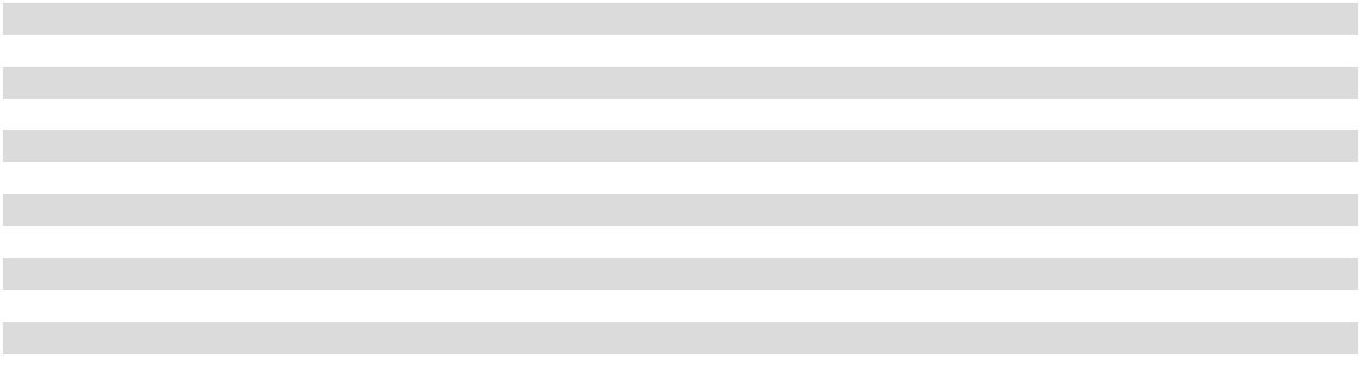

18

Facility Type |  | Location |  | Square |  | Leased / |  | Lease
Facility Type |  | Location |  | Feet |  | Owned |  | Expiration
Manufacturing Plant |  | Twinsburg, OH |  | 287,000 |  | Owned |  | —
Warehouse |  | Hanover, MD | 278,000 |  |  | Leased | 2027
Distribution Center |  | Hanover, MD | 276,000 |  |  | Leased | 2034
Distribution Center |  | Memphis, TN | 266,000 |  |  | Leased | 2030
Distribution Center |  | Clayton, NC | 233,000 |  |  | Leased | 2036
Manufacturing Plant |  | Nashville, TN | 220,000 |  |  | Owned |  | —
Distribution Center |  | La Vergne, TN | 220,000 |  |  | Leased | 2031
Distribution Center |  | Sandston, VA | 210,000 |  |  | Owned |  | —
Corporate Headquarters(3)(4) |  | Charlotte, NC | 172,000 |  |  | Leased | 2029
Manufacturing Plant |  | Baltimore, MD | 155,000 |  |  | Owned |  | —
Manufacturing Plant |  | Silver Spring, MD | 104,000 |  |  | Owned |  | —
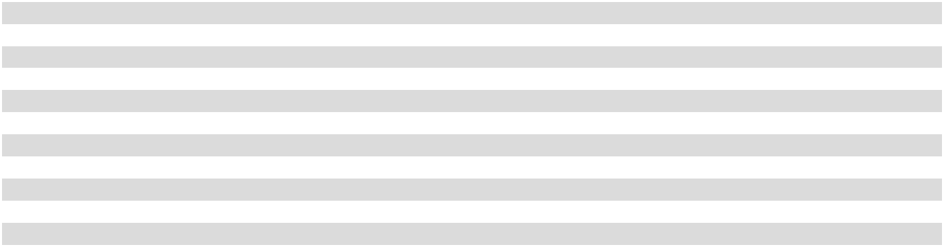

- Includes a 535,000-square foot manufacturing plant and an adjacent 115,000-square foot distribution center.

- In February 2025, this facility replaced the Company’s previous distribution center in Columbus, OH totaling approximately 124,000 square feet.

- Includes two adjacent buildings totaling approximately 172,000 square feet.

- The lease for this facility is with a related party.

The Company believes all of its facilities are in good condition and are adequate for the Company’s operations as presently conducted. The Company has production capacity to meet its current operational requirements. For the fiscal year ended December 31, 2025, the aggregate utilization rate of the Company’s manufacturing plants, which fluctuates with the seasonality of the business, was approximately 84%. The estimated utilization is based on actual production divided by capacity, based on an expected operation rate of six days per week and 20 hours per day.

In addition to the facilities noted above, the Company utilizes a portion of the production capacity from the 261,000-square foot manufacturing plant owned by SAC, a manufacturing cooperative located in Bishopville, South Carolina.

The Company’s products are generally transported to distribution centers for storage pending sale. There were no changes to the number of distribution centers by market area between December 31, 2025 and January 30, 2026.

As of January 30, 2026, the Company owned and operated approximately 4,600 vehicles in the sale and distribution of the Company’s beverage products, of which approximately 3,000 were route delivery trucks. In addition, the Company owned approximately 432,000 beverage dispensing and vending machines for the sale of beverage products in the Company’s territories as of January 30, 2026.

Item 3. Legal Proceedings.

The Company is involved in various claims and legal proceedings which have arisen in the ordinary course of its business. Although it is difficult to predict the ultimate outcome of these claims and legal proceedings, management believes the ultimate disposition of these matters will not have a material adverse effect on the financial condition, results of operations or cash flows of the Company. No material amount of loss in excess of recorded amounts is believed to be reasonably possible as a result of these claims and legal proceedings.

Item 4. Mine Safety Disclosures.

Not applicable.

19

Information About Our Executive Officers

The following is a description of the names and ages of the executive officers of the Company, indicating all positions and offices with the Company held by each such person and each such person’s principal occupation or employment during at least the past five years. Each executive officer of the Company is elected by the Board of Directors and holds office from the date of election until thereafter removed by the Board.

Name |  | Position and Office |  | Age
J. Frank Harrison, III |  | Chairman of the Board of Directors and Chief Executive Officer |  | 71
David M. Katz |  | President and Chief Operating Officer | 57
Matthew J. Blickley |  | Chief Financial Officer and Chief Accounting Officer | 44
Joshua L. Dorminy |  | Executive Vice President, Assistant to the Chairman and CEO | 48
Donell W. Etheridge |  | Chief Supply Chain Officer | 57
Morgan H. Everett |  | Vice Chair of the Board of Directors | 44
E. Beauregarde Fisher III |  | Chief Legal and Administrative Officer and Corporate Secretary | 57
Ellison C. Glenn |  | Chief Sales and Service Officer | 35
Christine A. Motherwell |  | Chief Customer Officer | 47
N. Brent Tollison |  | Chief People and Public Affairs Officer | 52
Clark A. Walker |  | Chief Commercial Officer | 56

Mr. J. Frank Harrison, III was elected Chairman of the Board of Directors of the Company in 1996 and Chief Executive Officer of the Company in 1994. Mr. Harrison served as Vice Chairman of the Board of Directors of the Company from 1987 to 1996. He was first employed by the Company in 1977 and also served as a Division Sales Manager and as a Vice President.

Mr. David M. Katz was elected President and Chief Operating Officer of the Company in December 2018. Prior to that, he served in various positions within the Company, including Executive Vice President and Chief Financial Officer from January 2018 to December 2018, Executive Vice President, Product Supply and Culture & Stewardship from April 2017 to January 2018, Executive Vice President, Human Resources from April 2016 to April 2017 and Senior Vice President from January 2013 to March 2016. He held the position of Senior Vice President, Midwest Region for CCR, a wholly owned subsidiary of The Coca-Cola Company, from November 2010 to December 2012. Previously, Mr. Katz was Vice President, Sales Operations for the East Business Unit of Coca-Cola Enterprises Inc. (“CCE”), a distributor, marketer and manufacturer of nonalcoholic beverages primarily for The Coca-Cola Company, from January 2010 to November 2010. From 2008 to 2010, he served as Chief Procurement Officer and as President and Chief Executive Officer of CCBSS, a company formed to provide certain procurement and other services with the intention of enhancing the efficiency and competitiveness of the Coca-Cola bottling system. He began his Coca-Cola career in 1993 with CCE as a Logistics Consultant.

Mr. Matthew J. Blickley was elected Chief Financial Officer and Chief Accounting Officer of the Company in January 2025, effective April 2025. Mr. Blickley was also an Executive Vice President of the Company from April 2025 to December 2025. Mr. Blickley served as Senior Vice President, Financial Planning and Chief Accounting Officer of the Company from August 2020 to March 2025, as Vice President, Financial Planning and Analysis of the Company from April 2018 to August 2020, as Senior Director, Financial Planning and Analysis of the Company from April 2016 to March 2018 and as Corporate Controller of the Company from November 2014 to March 2016. Before joining the Company, Mr. Blickley was with Family Dollar Stores, Inc., an operator of general merchandise retail discount stores, from January 2011 to November 2014, where he served in various senior financial roles, including Divisional Vice President, Financial Planning & Analysis and Director, Financial Reporting. Mr. Blickley began his career with PricewaterhouseCoopers LLP in 2004, where he advanced from Audit Associate to Audit Manager during his more than six years with that firm.

Mr. Joshua L. Dorminy was elected Executive Vice President, Assistant to the Chairman and CEO of the Company in March 2024. In this role, Mr. Dorminy is responsible for advising the Chairman and Chief Executive Officer of the Company regarding various aspects of the Company’s business, supporting the Company’s strategic objectives, and participating in the management of the Chairman’s office. Mr. Dorminy is also deeply involved in the strategic direction and planning of the Company’s culture and stewardship and charitable giving programs. Mr. Dorminy served as Senior Vice President, Assistant to the Chairman and CEO of the Company from October 2019 to March 2024 and as Vice President, Assistant to the Chairman and CEO of the Company from September 2016 to September 2019. Before joining the Company, he was the broker and managing member of 5D Ventures, LLC, a commercial real estate firm based in Woodstock, Georgia, from January 2009 to August 2016. Mr. Dorminy also served as Executive Director of Timothy + Barnabas, an organization dedicated to training and encouraging pastors and their spouses worldwide, from January 2011 to August 2016.

Mr. Donell W. Etheridge was elected Chief Supply Chain Officer of the Company in August 2025, effective January 2026. Prior to that, he served in various other positions within the Company, including Executive Vice President, Product Supply Operations from

20

March 2021 to December 2025, Senior Vice President, Product Supply Operations from September 2016 to February 2021, Vice President, Product Supply Operations from December 2013 to September 2016, Senior Director, Manufacturing from August 2011 to November 2013, Director, Operations from April 2009 to July 2011 and Plant Manager from January 2003 to March 2009. He also served the Company in several other positions prior to 2003 and was first employed by the Company in 1990.

Ms. Morgan H. Everett was elected Vice Chair of the Board of Directors of the Company in May 2020. Prior to that, she was Senior Vice President of the Company from April 2019 to May 2020, Vice President of the Company from January 2016 to March 2019, and Community Relations Director of the Company from January 2009 to December 2015. Ms. Everett has served as Chairman of Red Classic Services, LLC, an operating subsidiary of the Company, since December 2018, and she served as Chairman of Data Ventures, Inc., a former operating subsidiary of the Company, from December 2018 to December 2025. She has been an employee of the Company since October 2004.

Mr. E. Beauregarde Fisher III was elected Chief Legal and Administrative Officer and Corporate Secretary of the Company in August 2025, effective January 2026. Prior to that, he served as Executive Vice President, General Counsel of the Company from February 2017 to December 2025 and as Secretary of the Company beginning in May 2017. Before joining the Company, he was a partner with the law firm of Moore & Van Allen PLLC, where he served on the firm’s management committee and chaired its business law practice group. He was associated with the firm from 1998 to 2017 and concentrated his practice on mergers and acquisitions, corporate governance and general corporate matters. From 2011 to 2017, he served as the Company’s outside corporate counsel.

Mr. Ellison C. Glenn was elected Chief Sales and Service Officer of the Company in August 2025, effective January 2026. Prior to that, Mr. Glenn served in various other positions within the Company, including Senior Vice President, Product Supply Planning from October 2024 to December 2025, Senior Vice President, Product Supply Strategy & Operations from January 2024 to September 2024, Vice President, Market Unit General Manager for the Central Market Unit from July 2022 to December 2023, Vice President, Market Unit Sales & Service from January 2021 to June 2022, Director, Financial Planning and Analysis from January 2020 to December 2020 and Director, Revenue Growth Management from January 2019 to December 2019. He also served the Company in several other positions prior to 2019 and was first employed by the Company in 2014.

Ms. Christine A. Motherwell was elected Chief Customer Officer of the Company in August 2025, effective January 2026. Prior to that, she served in various other positions within the Company, including Senior Vice President, Human Resources from January 2022 to December 2025, Vice President, Human Resources Business Partner from October 2019 to December 2021, Vice President, Home Market Sales from April 2016 to September 2019, Vice President, Walmart/Club from April 2015 to March 2016 and Senior Director, Customer Development – Walmart from February 2013 to March 2015. Before joining the Company, Ms. Motherwell was National Account Executive, Publix of The Coca-Cola Company, the world’s largest nonalcoholic beverage company, from December 2011 to February 2013. Previously, Ms. Motherwell was with CCR, a wholly owned subsidiary of The Coca-Cola Company, where she served as Director, Sales from January 2011 to December 2011 and as Sales Center Manager from October 2009 to December 2010.

Mr. N. Brent Tollison was elected Chief People and Public Affairs Officer of the Company in August 2025, effective January 2026. Prior to that, he served as Senior Vice President, Public Affairs, Communications, Community, and Sustainability of the Company from May 2023 to December 2025, a role he had held in an interim capacity since November 2022. From June 2021 to August 2023, he served as Senior Vice President, Assistant to the President and Chief Operating Officer of the Company. Mr. Tollison was Vice President of Commercial Sales at W.W. Grainger, Inc., a broad line, business-to-business distributor of maintenance, repair and operating products and services with operations primarily in North America, Japan and the United Kingdom, from May 2014 to June 2021. Previously, he served in various roles of increasing responsibility within the Coca-Cola system for approximately 18 years, including Vice President of Sales and Operations – Northeast of The Coca-Cola Company, the world’s largest nonalcoholic beverage company, from June 2013 to April 2014, Vice President of Region Sales – New York Market Unit of CCR, a wholly owned subsidiary of The Coca-Cola Company, from October 2011 to June 2013, Market Unit Vice President – Virginia of CCR from January 2011 to October 2011, Vice President of Convenience Retail – East Business Unit of CCE, a distributor, marketer and manufacturer of nonalcoholic beverages primarily for The Coca-Cola Company, from November 2008 to January 2011 and Vice President of Convenience Retail – Southeast Business Unit of CCE from September 2007 to November 2008.

Mr. Clark A. Walker was elected Chief Commercial Officer of the Company in August 2025, effective January 2026. Prior to that, Mr. Walker served as Senior Vice President, Revenue Growth Management Planning of the Company from October 2018 to December 2025 and as Vice President, Revenue Growth Management Planning of the Company from October 2016 to September 2018. Before joining the Company in October 2016, Mr. Walker was with The Coca-Cola Company, the world’s largest nonalcoholic beverage company, from May 2010 to August 2016, where he held various positions, including Vice President, Revenue Growth Management. Mr. Walker has served within the Coca-Cola system since 1990, holding numerous positions in the areas of operations, sales and finance. He also served as Managing Director of Data Ventures, Inc., a former operating subsidiary of the Company, from February 2020 to December 2025.

21

PART II

Item 5. Market for Registrant’s Common Equity, Related Stockholder Matters and Issuer Purchases of Equity Securities.

The Company has two classes of common stock outstanding, Common Stock and Class B Common Stock. The Common Stock is traded on The Nasdaq Global Select Market under the symbol “COKE.” There is no established public trading market for the Class B Common Stock. Shares of Class B Common Stock are convertible on a share-for-share basis into shares of Common Stock at any time at the option of the holder.

The Company’s Board of Directors determines the amount and frequency of dividends declared and paid by the Company in light of the earnings and financial condition of the Company at such time. No assurance can be given that dividends will be declared or paid in the future.

As of January 30, 2026, the number of stockholders of record of the Common Stock and the Class B Common Stock was 1,088 and five, respectively.

The following table sets forth information about the shares of Common Stock the Company repurchased during the quarter ended

December 31, 2025:

 |  |  |  |  |  |  | Total Number of |  | Approximate Dollar
 |  | Total Number |  | Average Price |  |  | Shares Purchased as |  | Value of Shares that
 |  | Total Number |  |  |  |  | Part of Publicly |  |  | May Yet Be
Period |  | of Shares |  |  | Paid per |  | Announced Plans or |  | Purchased Under the
Period |  | Purchased⁽¹⁾⁽²⁾ |  |  | _{Share}(1)(2) |  | Programs⁽¹⁾ |  | Plans or Programs⁽¹⁾
September 27, 2025 - October 24, 2025 |  | 480,090 |  | $ | 121.11 |  | 480,090 |  | $ | 741,997,407
October 25, 2025 - November 21, 2025 | 18,880,142 |  |  |  | 127.00 | 44,682 |  |  |  | 136,336,724
November 22, 2025 - December 31, 2025 |  | — |  |  | — |  | — |  |  | 136,336,724
Total |  | 19,360,232 |  |  |  |  | 524,772
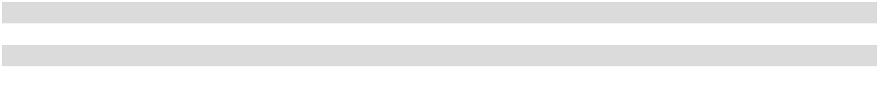

- On August 20, 2024, the Company announced that its Board of Directors had approved a share repurchase program (the “Share Repurchase Program”) under which the Company was initially authorized to repurchase up to $1.00 billion of Common Stock. On November 7, 2025, the Company’s Board of Directors reduced the total authorization under the Share Repurchase Program from $1.00 billion to $400.0 million. The share repurchase authorization is discretionary and has no expiration date. As of December 31, 2025, the total remaining share repurchase authorization was $136.3 million.

- On November 7, 2025, the Company entered into a purchase agreement (“the Repurchase Agreement”) with Carolina Coca-Cola Bottling Investments, Inc. (the “Seller”), an indirect wholly owned subsidiary of The Coca-Cola Company,
The Coca-Cola Company and J. Frank Harrison, III, Chairman of the Board of Directors and Chief Executive Officer of the Company, pursuant to which the Company agreed to purchase and the Seller agreed to sell all of the Seller’s shares of Common Stock for a cash payment in the aggregate amount of approximately $2.4 billion (the “Repurchase”).

Stock Performance Graph

Presented below is a line graph comparing the yearly percentage change in the cumulative total return on the Common Stock to the cumulative total return of the Standard & Poor’s 500 Index and a peer group for the period commencing December 31, 2020 and ending December 31, 2025. The peer group is composed of Keurig Dr Pepper Inc., National Beverage Corp.,

The Coca-Cola Company and PepsiCo, Inc.

22

The graph assumes $100 was invested in the Common Stock, the Standard & Poor’s 500 Index and each of the companies within the peer group at market close on the last trading day for the fiscal year ended December 31, 2020, and that all dividends were reinvested. Returns for the companies included in the peer group have been weighted on the basis of the total market capitalization for each company.

COMPARISON OF 5-YEAR CUMULATIVE TOTAL RETURN

Among Coca-Cola Consolidated, Inc., the S&P 500 Index and a Peer Group

$650.00 |  |  |  |  |  |  |  |  |  |  |  | $602.04
$600.00 |  |  |  |  |  |  |  |  |  |  |  | $602.04
$550.00
$500.00 |  |  |  |  |  |  |  |  |  | $490.97
$450.00
$400.00
$350.00 |  |  |  |  |  |  |  | $353.72
$300.00 |  |  |  | $233.24
$250.00 |  |  |  |  |  |  |  |  |  |  |  | $196.16
$250.00 |  |  |  |  |  | $193.39
 |  |  |  |  |  |  |  |  |  | $166.40
$200.00 |  |  |  | $128.71 |  | $124.79 |  | $133.10
$150.00
$100.00 |  |  |  | $115.80 |  | $105.40 |  | $119.97 |  | $120.86 |  | $128.37
12/31/2020 |  |  |  | 12/31/2021 |  | 12/31/2022 |  | 12/31/2023 |  | 12/31/2024 |  | 12/31/2025
 |  |  |  |  |  |  | Period Ending
 |  |  |  | Coca-Cola Consolidated, Inc. |  |  |  | S&P 500 Index |  | Peer Group
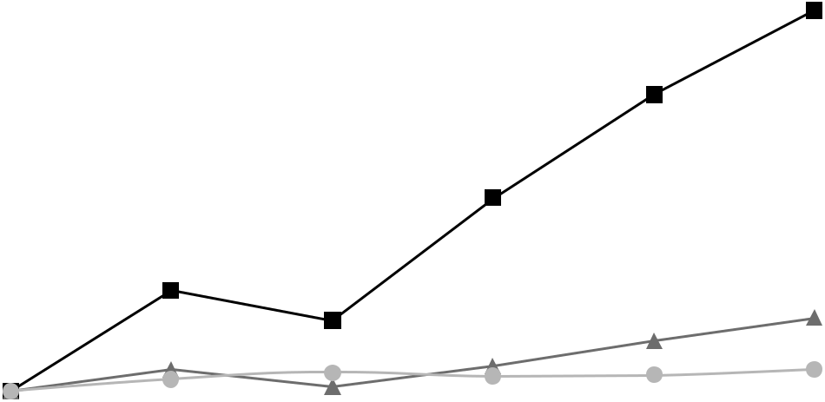

Item 6. [Reserved]

23

Item 7. Management’s Discussion and Analysis of Financial Condition and Results of Operations.

The following Management’s Discussion and Analysis of Financial Condition and Results of Operations of the Company is intended to help the reader understand our financial condition and results of operations and is provided as an addition to, and should be read in conjunction with, our consolidated financial statements and the accompanying notes to the consolidated financial statements. The consolidated financial statements include the accounts and the consolidated operations of the Company and its majority-owned subsidiaries. All comparisons are to the prior year unless specified otherwise.

The periods presented are the fiscal years ended December 31, 2025 (“2025”) and December 31, 2024 (“2024”). Information concerning the fiscal year ended December 31, 2023 (“2023”) and a comparison of 2024 and 2023 may be found under “Item 7. Management’s Discussion and Analysis of Financial Condition and Results of Operations” in the Company’s Annual Report on Form 10-K for 2024, filed with the SEC on February 20, 2025.

The Company manages its business on the basis of two operating segments. Nonalcoholic Beverages represents the vast majority of the Company’s consolidated net sales and income from operations. The additional operating segment, which includes the Red Classic subsidiaries, does not meet the quantitative threshold for separate reporting and, therefore, has been reported as “All Other.”

Executive Summary

Net sales increased 4.8% to $7.23 billion in 2025, with standard physical case volume up 0.3% when compared to the prior year. The growth in net sales was primarily the result of annual pricing actions executed during the first quarter of 2025. For 2025, Sparkling and Still net sales increased 3.5% and 6.1%, respectively. The increase in Sparkling category net sales was driven primarily by sales of multi-pack, take-home packages sold within our large store, club and value channels. The increase in Still category net sales was driven primarily by the solid performance across our Still portfolio sold within large retail and convenience stores.

Fiscal year 2025 had one fewer selling day compared to fiscal year 2024, which negatively impacted the annual volume comparison by approximately 0.3%, as further discussed in the “Comparable and Adjusted Results (Non-GAAP)” section. For fiscal year 2025, Sparkling volume was flat while Still volume increased 1.0%. The steady Sparkling volume performance was driven by growth within zero-sugar and flavor offerings, offset by slower sales of Coca-Cola Original Taste during 2025. Within the Still portfolio, Monster, Powerade, BODYARMOR, Topo Chico and Core Power all achieved volume growth during the year, reflecting strength across our entire portfolio of brands and driving growth in net sales in 2025.

Gross profit in 2025 increased $119.2 million, or 4.3%, while gross margin decreased 20 basis points to 39.7%. Aluminum costs, including the impact of elevated import tariffs, adversely affected our gross margin in 2025, particularly in the back half of the year. The reduction in gross margin also resulted from a shift in sales toward our Still portfolio, which generally have lower gross margins compared to Sparkling beverages.

Selling, delivery and administrative (“SD&A”) expenses in 2025 increased $88.9 million, or 4.8%. SD&A expenses as a percentage of net sales in 2025 remained stable as compared to 2024. The increase in SD&A expenses was primarily driven by the cost of labor, which includes annual wage adjustments made earlier this year and an additional investment in the base wages of our front-line teammates, which became effective at the beginning of the third quarter of 2025.

Income from operations in 2025 increased $30.3 million to $950.7 million and net income in 2025 declined $62.5 million to

$570.6 million, as compared to 2024. On an adjusted basis, as defined in the “Comparable and Adjusted Results (Non-GAAP)” section, net income in 2025 was $668.5 million, compared to $678.6 million in 2024, a decrease of $10.1 million, or 1.5%. As compared to 2024, net income for 2025 was more adversely impacted by routine, non-cash fair value adjustments to our acquisition related contingent consideration liability, primarily driven by changes in the discount rate and future cash flow projections used to compute the fair value of the liability, and by increased interest expense. Income tax expense for 2025 was $202.3 million, compared to $223.5 million for 2024, resulting in an effective income tax rate of approximately 26% for both periods.

Cash flows from operations for 2025 were $931.9 million, compared to $876.4 million for 2024. Cash flows from operations reflected our strong operating performance during 2025. In 2025, we invested $312.3 million in capital expenditures as we continue to optimize our supply chain and invest for future growth. In fiscal year 2026, we expect capital expenditures to be approximately $300 million. In the fourth quarter of 2025, we repurchased all of the remaining shares of our Common Stock previously owned by The Coca-Cola Company for approximately $2.4 billion. Throughout 2025, we have returned approximately $2.7 billion to stockholders through share repurchases and dividends.

24

Areas of Emphasis

Key priorities for the Company include executing our commercial strategy, executing our revenue management strategy, optimizing our supply chain, generating cash flow, determining the optimal route to market and creating and maintaining a digitally enabled selling platform.

Commercial Execution: Our success is dependent on our ability to execute our commercial strategy within our customers’ stores. Our ability to obtain shelf space within stores and remain in-stock across our portfolio of brands and packages in a profitable manner will have a significant impact on our results. We are focused on execution at every step in our supply chain, including raw material and finished product procurement, manufacturing conversion, transportation, warehousing and distribution, to ensure in-store execution can occur. We continue to invest in tools and technology to enable our teammates to operate more effectively and efficiently with our customers and to drive long-term value in our business. We also continue to focus on opportunities to enhance the customer experience by adapting to changes in our customer landscape, enabling operational flexibility and focusing on customer service.

Revenue Management: Our revenue management strategy focuses on pricing our brands and packages optimally within product categories and channels, creating effective working relationships with our customers and making disciplined, fact-based decisions. Pricing decisions are made considering a variety of factors, including brand strength, competitive environment, input costs, the roles certain brands play in our product portfolio and other market conditions.

Supply Chain Optimization: We are continually focused on optimizing our supply chain, which includes identifying nearby warehousing and distribution operations that can be consolidated into new facilities to increase capacity, expand production capabilities, reduce overall production costs and add automation to allow the Company to better serve its customers and consumers. The Company undertook significant capital expenditures to optimize our supply chain and to invest for future growth during 2025, and expects to continue to make significant investments during fiscal year 2026. During the first quarter of 2025, the Company began operations in a new 430,000-square foot automated distribution center in Columbus, Ohio.

Cash Flow Generation: We have several initiatives in place to optimize cash flow, improve profitability, prudently manage capital expenditures and enhance capital returns to our stockholders. We believe strengthening our balance sheet gives us the flexibility to make optimal capital allocation decisions for long-term value creation. We have and expect to continue to return value to our stockholders.

Optimal Route to Market: We are focused on implementing optimal methods of distribution of our products within our territories. DSD is our preferred and primary route to market. Our typical DSD method uses Company-owned vehicles and warehouses, but we increasingly shifted to alternative methods of distribution, or ARTM, during 2024 and continued to use ARTM during 2025. For example, in instances of post-mix delivery for use in fountain machines, we have shifted and continue to shift our delivery method towards alternative distributors in order to enhance profitability and customer service. We receive a fee from our brand partners on these post-mix gallons delivered to locally managed customers in our territories, which is recorded as a reduction to cost of sales. In instances of bottle/can delivery, we have shifted certain products for certain customers and channels of business to ARTM. These ARTM include third-party distributors, the manufacturer of the product or the customer’s supply chain infrastructure. These bottle/can arrangements generally come with favorable commercial terms for the Company, and, because we have the exclusive distribution rights for nonalcoholic beverages within our franchise territories, we receive fees from our brand partners for the delivery of qualified product in our territories. These fees are reported in net sales but not our reported volume metrics.

During 2025, approximately two-thirds of our post-mix gallons and less than 10% of our bottle/can volume were delivered through ARTM.

Digitally Enabled Selling Platform: Through our investment in CONA Services LLC, we, along with other Coca-Cola bottlers, have built a digitally enabled selling platform called MyCoke that we believe has enabled, and will continue to enable, us to better serve our customers. This platform creates a more seamless order and payment platform for certain customers and we expect this platform will continue to enable us to enhance customer service and create more selling opportunities for our teammates. This platform is currently targeted to certain on-premise and small store customers.

25

Results of Operations

The Company’s results of operations for 2025 and 2024 are highlighted in the table below and discussed in the following paragraphs.

 |  |  | Fiscal Year |  |  |  |  |  | Change
(in thousands) |  |  | 2025 |  |  | 2024 |  |  | Change
Net sales |  | $ | 7,228,055 |  | $ | 6,899,716 |  | $ | 328,339
Cost of sales |  |  | 4,355,693 |  |  | 4,146,537 |  |  | 209,156
Gross profit |  |  | 2,872,362 |  |  | 2,753,179 |  |  | 119,183
Selling, delivery and administrative expenses |  |  | 1,921,706 |  |  | 1,832,829 |  |  | 88,877
Income from operations |  |  | 950,656 |  |  | 920,350 |  |  | 30,306
Interest expense, net |  |  | 42,678 |  |  | 1,848 |  |  | 40,830
Mark-to-market on acquisition related contingent consideration |  |  | 131,901 |  |  | 59,166 |  |  | 72,735
Other expense, net |  |  | 3,159 |  |  | 2,682 |  |  | 477
Income before taxes |  |  | 772,918 |  |  | 856,654 |  |  | (83,736)
Income tax expense |  |  | 202,336 |  |  | 223,529 |  |  | (21,193)
Net income |  |  | 570,582 |  |  | 633,125 |  |  | (62,543)
Other comprehensive (loss) income, net of tax |  |  | (7,890) |  |  | 6,161 |  |  | (14,051)
Comprehensive income |  | $ | 562,692 |  | $ | 639,286 |  | $ | (76,594)
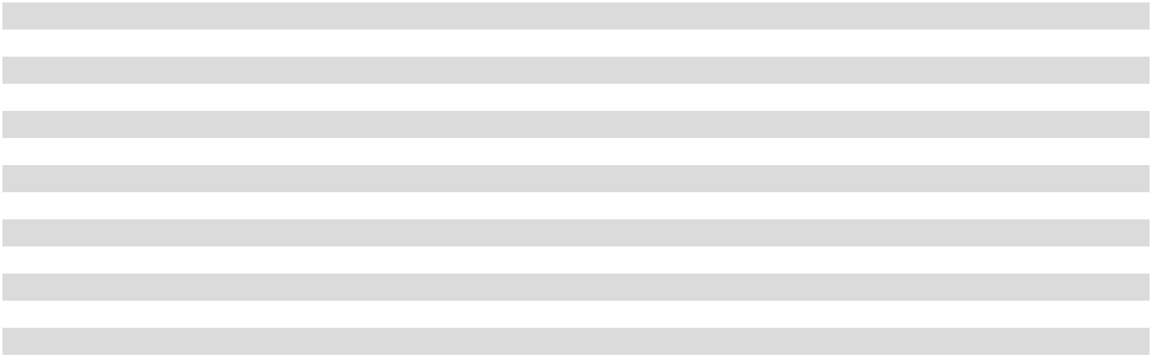

Net Sales

Net sales increased $328.3 million, or 4.8%, to $7.23 billion in 2025, as compared to $6.90 billion in 2024. The largest driver of the increase in net sales was higher average bottle/can sales price per unit charged to retail customers, which increased net sales by approximately $215 million. Net sales was also positively impacted by shifts in product mix in 2025, as certain of the Company’s higher-priced brands, including energy, enhanced water and protein products, had strong sales during the period.

Net sales by product category were as follows:

 |  |  | Fiscal Year |  |  |  |  | % Change
(in thousands) |  |  | 2025 |  |  | 2024 |  | % Change
Bottle/can sales:
Sparkling beverages |  | $ | 4,249,847 | $ |  | 4,106,073 | 3.5 |  | %
Still beverages |  |  | 2,362,873 |  |  | 2,227,243 | 6.1 |  | %
Total bottle/can sales |  |  | 6,612,720 |  |  | 6,333,316 |  | 4.4 %
Other sales:
Sales to other Coca-Cola bottlers |  |  | 383,658 |  |  | 345,586 | 11.0 |  | %
Post-mix sales and other |  |  | 231,677 |  |  | 220,814 | 4.9 |  | %
Total other sales |  |  | 615,335 |  |  | 566,400 |  | 8.6 %
Total net sales
 |  | $ | 7,228,055 |  | $ | 6,899,716 |  | 4.8 %
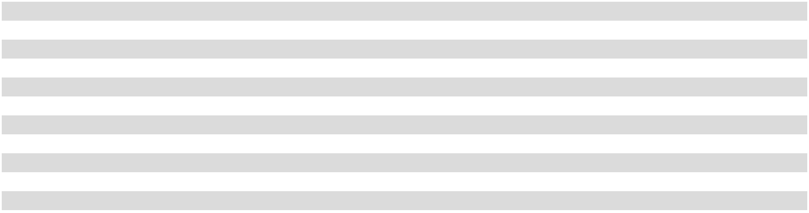

Product category sales volume of standard physical cases (as defined below) and the percentage change by product category were as follows:

 |  | Fiscal Year |  |  |  |  | % Change
(in thousands) |  | 2025 |  |  | 2024 |  | % Change
Bottle/can sales volume:
Sparkling beverages |  | 266,749 |  |  | 266,686 |  | — %
Still beverages |  | 87,299 |  |  | 86,417 | 1.0 %
Total bottle/can sales volume |  | 354,048 |  |  | 353,103 |  | 0.3 %

A standard physical case is a volume metric used to standardize differing package configurations in order to measure delivered cases on an equivalent basis. As the Company evaluates its volume metrics, it reassesses the way in which physical case volume is measured, which may lead to differences from previously presented results in order to conform with current period standard volume measurement techniques, as used by management. Additionally, as the Company introduces new products, it reassesses the category

26

assigned to its products at the SKU level, therefore categorization could differ from previously presented results in order to conform with current period categorization. Any differences are not material.

The bottle/can sales volume above represents volume that is delivered directly to our customer outlets using Company-owned vehicles and warehouses. In order to serve our customers in the most efficient way, respond to customer demands and increase profitability, the Company has, in certain circumstances, shifted the delivery of our products to third-party distributors, the manufacturer of the product or the customer’s supply chain infrastructure, rather than through Company-owned vehicles and warehouses. As a result, these cases are not included in our 2025 or 2024 reported case sales volume.

The following table summarizes the percentage of the Company’s total bottle/can sales volume to its largest customers, as well as the percentage of the Company’s total net sales that such volume represents:

Fiscal Year

 |  | 2025 |  |  | 2024
Approximate percent of the Company’s total bottle/can sales volume:
Walmart Inc.⁽¹⁾ |  |  | 21 | % | 21 |  | %
The Kroger Co.⁽²⁾ |  |  | 15 | % | 15 |  | %
Total approximate percent of the Company’s total bottle/can sales volume |  |  | 36 % |  |  | 36 %
Approximate percent of the Company’s total net sales:
Walmart Inc.⁽¹⁾ |  |  | 17 | % | 17 |  | %
The Kroger Co.⁽²⁾ |  |  | 12 | % | 12 |  | %
Total approximate percent of the Company’s total net sales |  |  | 29 % |  |  | 29 %
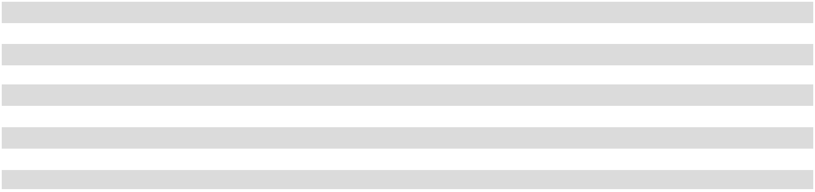

- Includes bottle/can sales volume related to the Walmart, Sam’s Club and Walmart Neighborhood Market chains.

- Includes bottle/can sales volume related to the Kroger and Harris Teeter chains.

Cost of Sales

Inputs representing a substantial portion of the Company’s cost of sales include: (i) purchases of finished products, (ii) raw material costs, including aluminum cans, plastic bottles, carbon dioxide and sweetener, (iii) concentrate costs and (iv) manufacturing costs, including labor, overhead and warehouse costs. In addition, cost of sales includes shipping, handling and fuel costs related to the movement of finished products from manufacturing plants to distribution centers, amortization expense of distribution rights, distribution fees of certain products and marketing credits and post-mix funding from brand companies. Input costs for products we produce, including underlying commodity costs for aluminum cans, plastic bottles, carbon dioxide and sweetener, as well as labels and other packaging materials, and excluding concentrate, represent approximately 20% of total cost of sales on an annual basis.

Cost of sales increased $209.2 million, or 5.0%, to $4.36 billion in 2025, as compared to $4.15 billion in 2024. The increase in cost of sales was primarily driven by higher input costs, which increased cost of sales by approximately $135 million. Higher input costs included an increase in aluminum costs, which were impacted by elevated import tariffs during 2025. Cost of sales also increased due to shifts in product mix to higher cost Still products as compared to 2024.

The Company relies extensively on advertising and sales promotions in the marketing of its products. The Coca-Cola Company and other beverage companies that supply concentrates, syrups and finished products to the Company make substantial marketing and advertising expenditures, including national advertising programs, to develop their brand identities and to promote sales in the Company’s territories. Our brand partners also provide funding related to the delivery of post-mix gallons to locally managed customers within the Company’s territories. Certain of these marketing, advertising and other funding expenditures are made pursuant to annual arrangements. Total funding support from The Coca-Cola Company and other beverage companies, which includes both direct payments to the Company and payments to customers for marketing programs, was $209.5 million in 2025, as compared to $186.5 million in 2024.

Selling, Delivery and Administrative Expenses

SD&A expenses include the following: sales management labor costs, distribution costs resulting from transporting finished products from distribution centers to customer locations, distribution center overhead including depreciation expense, distribution center warehousing costs, delivery vehicles and cold drink equipment, point-of-sale expenses, advertising expenses, cold drink equipment repair costs, amortization of intangible assets and administrative support labor and operating costs. Labor costs represent approximately two-thirds of total SD&A expenses on an annual basis.

27

SD&A expenses increased $88.9 million, or 4.8%, to $1.92 billion in 2025, as compared to $1.83 billion in 2024. The increase in SD&A expenses was primarily driven by an increase in labor and benefits costs related to annual wage adjustments, medical benefit trends and an additional investment in the base wages of our front-line teammates, which became effective beginning in the third quarter of 2025. SD&A expenses as a percentage of net sales was 26.6% in both 2025 and 2024.

Shipping and handling costs included in SD&A expenses were approximately $842 million in 2025 and approximately $806 million in 2024.

Interest Expense, Net

Interest expense, net increased $40.8 million to $42.7 million in 2025, as compared to $1.8 million in 2024. The increase in interest

expense, net was primarily driven by higher average debt balances during 2025 as compared to 2024. In 2025, the Company had

$102.9 million of interest expense and $60.2 million of interest income. In 2024, the Company had $62.0 million of interest expense

and $60.2 million of interest income.

Mark-to-Market on Acquisition Related Contingent Consideration

Each reporting period, the Company adjusts its acquisition related contingent consideration liability to fair value, which is determined by discounting future expected acquisition related sub-bottling payments using the Company’s estimated WACC and future cash flow projections, and records the fair value adjustment as mark-to-market on acquisition related contingent consideration in the consolidated statement of operations.

Mark-to-market on acquisition related contingent consideration was an increase of $131.9 million in 2025 and an increase of

$59.2 million in 2024. During 2025, the $131.9 million increase in the fair value of the acquisition related contingent consideration liability was primarily driven by decreases in the WACC used to calculate the fair value of the liability and higher projections of future cash flows in the distribution territories subject to acquisition related sub-bottling payments. During 2024, the $59.2 million increase in the fair value of the acquisition related contingent consideration liability was primarily driven by higher projections of future cash flows in the distribution territories subject to acquisition related sub-bottling payments, partially offset by increases in the WACC used to calculate the fair value of the liability.

Other Expense, Net

Other expense, net was $3.2 million in 2025 and $2.7 million in 2024.

Income Tax Expense

The Company’s effective income tax rate was 26.2% for 2025 and 26.1% for 2024. The Company’s income tax expense decreased

$21.2 million, or 9.5%, to $202.3 million in 2025, as compared to $223.5 million in 2024. The increase in the effective income tax rate was primarily attributable to lower income before taxes.

Other Comprehensive (Loss) Income, Net of Tax

Other comprehensive (loss) income, net of tax was a loss of $7.9 million in 2025 and income of $6.2 million in 2024. The change was primarily related to changes in the actuarial assumptions related to the Company’s pension and postretirement plan liabilities.

Segment Operating Results

The Company evaluates segment reporting in accordance with Financial Accounting Standards Board Accounting Standards Codification Topic 280, Segment Reporting, each reporting period, including evaluating the reporting package reviewed by the Chief Operating Decision Maker (the “CODM”). The Company has concluded the Chief Executive Officer, the Chief Operating Officer and the Chief Financial Officer, as a group, represent the CODM. Segment asset information is not provided to the CODM.

As of December 31, 2025, the Company has two operating segments, each identified by its products and services. Nonalcoholic Beverages represents the vast majority of the Company’s consolidated net sales and income from operations. The accounting policies of the Nonalcoholic Beverages operating segment are the same as those described in the summary of significant accounting policies presented in Note 1 to the consolidated financial statements. The additional operating segment, which includes the Red Classic subsidiaries, does not meet the quantitative threshold for separate reporting and, therefore, has been reported as “All Other.”

Previously, the Company had three operating segments, Nonalcoholic Beverages and two additional operating segments, which included Data Ventures, Inc. and the Red Classic subsidiaries. Since the two additional operating segments did not meet the

28

quantitative thresholds for separate reporting, either individually or in the aggregate, they were combined into “All Other.” As of December 31, 2025, the Data Ventures, Inc. operating segment was liquidated, dissolved and merged into the Nonalcoholic Beverages operating segment. For reporting purposes, all periods presented have been retroactively adjusted to reflect the liquidation and dissolution of the Data Ventures, Inc. operating segment within the “All Other” bucket and the merger of the Data Ventures, Inc. operating segment with the Nonalcoholic Beverages operating segment.

The CODM uses net sales, gross profit and income from operations in the annual budgeting and forecasting process. Monthly, the CODM considers budget-to-actual variances and current year to prior year variances for these profit measures when making strategic business decisions and allocating resources to Company operations.

The Company’s segment results are as follows:
 |  |  |  |  |  | Fiscal Year 2025
(in thousands) |  |  | Nonalcoholic |  |  | All Other |  | Eliminations(1) |  |  |  | Total
 |  |  | Beverages |  |  | All Other |  |  |  |  |  | Total
Net sales |  | $ | 7,183,782 |  | $ | 325,969 |  | $ | (281,696) |  | $ | 7,228,055
Cost of goods sold |  |  | 4,380,271 |  |  | 186,810 |  |  | (211,388) |  |  | 4,355,693
Gross profit |  |  | 2,803,511 |  |  | 139,159 |  |  | (70,308) |  |  | 2,872,362
Selling, delivery and administrative expenses:
Payroll costs⁽²⁾ |  | $ | 1,203,097 | $ |  | 50,542 | $ |  | — | $ |  | 1,253,639
Fleet costs⁽³⁾ |  |  | 99,135 |  |  | 31,216 |  |  | — |  |  | 130,351
Depreciation and amortization expense⁽⁴⁾ |  |  | 115,744 |  |  | 2,204 |  |  | — |  |  | 117,948
All other segment items⁽⁵⁾ |  |  | 460,370 |  |  | 29,706 |  |  | (70,308) |  |  | 419,768
Total selling, delivery and administrative expenses |  |  | 1,878,346 |  |  | 113,668 |  |  | (70,308) |  |  | 1,921,706
Income from operations |  | $ | 925,165 |  | $ | 25,491 |  | $ | — |  | $ | 950,656
Total depreciation and amortization expense⁽⁴⁾
 |  | $ | 197,602 |  | $ | 20,928 |  | $ | — |  | $ | 218,530
 |  |  |  |  |  | Fiscal Year 2024
(in thousands) |  |  | Nonalcoholic |  |  | All Other |  | Eliminations⁽¹⁾ |  |  |  | Total
 |  |  | Beverages |  |  | All Other |  |  |  |  |  | Total
Net sales |  | $ | 6,839,368 |  | $ | 342,892 |  | $ | (282,544) |  | $ | 6,899,716
Cost of goods sold |  |  | 4,138,869 |  |  | 219,204 |  |  | (211,536) |  |  | 4,146,537
Gross profit |  |  | 2,700,499 |  |  | 123,688 |  |  | (71,008) |  |  | 2,753,179
Selling, delivery and administrative expenses:
Payroll costs⁽²⁾ |  | $ | 1,149,363 | $ |  | 50,668 | $ |  | — | $ |  | 1,200,031
Fleet costs⁽³⁾ |  |  | 103,444 |  |  | 31,475 |  |  | — |  |  | 134,919
Depreciation and amortization expense⁽⁴⁾ |  |  | 103,451 |  |  | 1,993 |  |  | — |  |  | 105,444
All other segment items⁽⁵⁾ |  |  | 437,014 |  |  | 26,429 |  |  | (71,008) |  |  | 392,435
Total selling, delivery and administrative expenses |  |  | 1,793,272 |  |  | 110,565 |  |  | (71,008) |  |  | 1,832,829
Income from operations |  | $ | 907,227 |  | $ | 13,123 |  | $ | — |  | $ | 920,350
Total depreciation and amortization expense⁽⁴⁾
 |  | $ | 177,527 |  | $ | 16,264 |  | $ | — |  | $ | 193,791

- The entire net sales elimination represents net sales from the All Other segment to the Nonalcoholic Beverages segment. The entire cost of goods sold and SD&A eliminations represent costs incurred by the All Other segment in the generation of net sales to the Nonalcoholic Beverages segment.
- Payroll costs includes compensation, incentive plans, defined contribution plans, healthcare benefits and tax-advantaged spending accounts.

- Fleet costs includes fleet repairs, maintenance and fuel and oil costs.

- Total depreciation and amortization expense is included within both cost of goods sold and SD&A expenses. For segment reporting, the difference between total depreciation and amortization expense and the portion within SD&A expenses is the amount within cost of goods sold.

- All other segment items includes information technology costs, stewardship, insurance and other costs incurred in the selling and delivery of the Company’s products.

29

Comparable and Adjusted Results (Non-GAAP)

The Company reports its financial results in accordance with accounting principles generally accepted in the United States (“GAAP”). However, management believes that certain non-GAAP financial measures provide users of the financial statements with additional, meaningful financial information that should be considered, in addition to the measures reported in accordance with GAAP, when assessing the Company’s ongoing performance. Management also uses these non-GAAP financial measures in making financial, operating and planning decisions and in evaluating the Company’s performance. Non-GAAP financial measures should be viewed in addition to, and not as an alternative for, the Company’s reported results prepared in accordance with GAAP. The Company’s non-GAAP financial information does not represent a comprehensive basis of accounting.

The tables below reconcile reported results (GAAP) to comparable and adjusted results (non-GAAP). Results for 2025 include one fewer selling day compared to 2024. For comparison purposes, the estimated impact of the additional selling day in 2024 has been excluded from our comparable volume results. All share or per share amounts impacting the basic net income per share amounts have been retroactively adjusted to reflect the effects of the Stock Split (as defined below) executed by the Company during 2025. Refer to the discussion in “Liquidity and Capital Resources” below for further details related to the Stock Split.

(in thousands) |  |  |  |  |  |  |  |  |  |  |  |  |  | Fiscal Year |  |  |  |  |  |  |  |  | Change
 |  |  |  |  |  |  |  |  |  | 2025 |  |  |  |  |  |  | 2024 |  |  |  |  |  | Change
Standard physical case volume |  |  |  |  |  |  |  |  |  | 354,048 |  |  |  |  |  |  |  | 353,103 |  |  |  |  | 0.3 %
Volume related to extra day in fiscal period |  |  |  |  |  |  |  |  |  |  |  |  |  | — |  |  |  | (965)
Comparable standard physical case volume |  |  |  |  |  |  |  |  |  | 354,048 |  |  |  |  |  |  |  | 352,138 |  |  |  |  | 0.5 %
 |  |  |  |  |  |  |  |  |  | Fiscal Year 2025
(in thousands, except per share data) |  |  | Gross |  | SD&A |  | Income from |  |  |  |  |  | Income before |  |  |  |  |  | Net |  |  | Basic net income
 |  |  | profit |  | expenses |  |  | operations |  |  |  |  |  | taxes |  |  |  |  | income |  |  |  | per share
Reported results (GAAP) |  |  | $2,872,362 |  | $1,921,706 |  | $ | 950,656 |  |  |  |  | $ | 772,918 |  |  |  |  | $ 570,582 |  |  | $ | 6.82
Fair value adjustment of acquisition |  |  | — |  | — |  |  |  |  | — |  |  |  | 131,901 |  |  |  | 99,190 |  |  |  |  | 1.18
related contingent consideration⁽¹⁾ |  |  | — |  | — |  |  |  |  |  |  |  |  |  |  |  |  |  |  |  |  |  | 1.18
Fair value adjustments for commodity |  |  | (2,183) | (455) |  |  |  | (1,728) |  |  |  |  |  | (1,728) |  |  |  | (1,299) |  |  |  |  | (0.02)
derivative instruments⁽²⁾ |  |  | (2,183) |  |  |  |  |  |  |  |  |  |  |  |  |  |  |  |  |  |  |  | (0.02)
Total reconciling items |  |  | (2,183) |  | (455) |  |  | (1,728) |  |  |  |  |  | 130,173 |  |  |  |  | 97,891 |  |  |  | 1.16
Adjusted results (non-GAAP) |  |  | $2,870,179 |  | $1,921,251 |  | $ | 948,928 |  |  |  |  | $ | 903,091 |  |  |  |  | $ 668,473 |  |  | $ | 7.98
Adjusted percentage change versus 2024 |  |  | 4.2 % | 4.9 % |  |  |  | 3.0 %
 |  |  |  |  |  |  |  |  |  | Fiscal Year 2024
(in thousands, except per share data) |  |  | Gross |  | SD&A |  | Income from |  |  |  |  |  | Income before |  |  |  |  |  | Net |  |  | Basic net income
 |  |  | profit |  | expenses |  |  | operations |  |  |  |  |  | taxes |  |  |  |  | income |  |  |  | per share
Reported results (GAAP) |  |  | $2,753,179 |  | $1,832,829 |  | $ | 920,350 |  |  |  |  | $ | 856,654 |  |  |  |  | $ 633,125 |  |  | $ | 7.01
Fair value adjustment of acquisition |  |  | — |  | — |  |  |  |  | — |  |  |  | 59,166 |  |  |  | 44,493 |  |  |  |  | 0.49
related contingent consideration⁽¹⁾ |  |  | — |  | — |  |  |  |  |  |  |  |  |  |  |  |  |  |  |  |  |  | 0.49
Fair value adjustments for commodity |  |  | 728 | (547) |  |  |  | 1,275 |  |  |  |  |  | 1,275 |  |  |  | 959 |  |  |  |  | 0.01
derivative instruments⁽²⁾ |  |  | 728 |  |  |  |  |  |  |  |  |  |  |  |  |  |  |  |  |  |  |  | 0.01
Total reconciling items |  |  | 728 |  | (547) |  |  | 1,275 |  |  |  |  |  | 60,441 |  |  |  |  | 45,452 |  |  |  | 0.50
Adjusted results (non-GAAP) |  |  | $2,753,907 |  | $1,832,282 |  | $ | 921,625 |  |  |  |  | $ | 917,095 |  |  |  |  | $ 678,577 |  |  | $ | 7.51
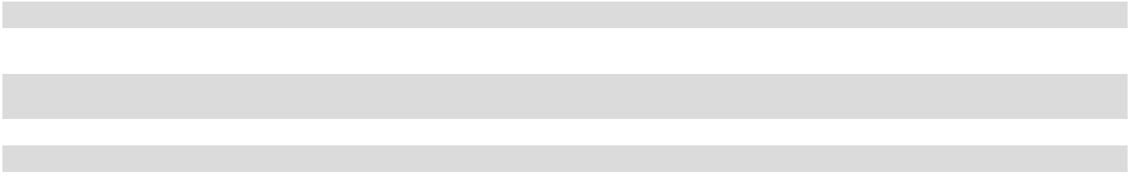

Following is an explanation of non-GAAP adjustments:

- This non-cash, fair value adjustment of acquisition related contingent consideration fluctuates based on factors such as long-term interest rates and future cash flow projections of the distribution territories subject to acquisition related sub-bottling payments.
- The Company enters into commodity derivative instruments from time to time to hedge some or all of its projected purchases of aluminum, PET resin, diesel fuel and unleaded gasoline in order to mitigate commodity price risk. The Company accounts for its commodity derivative instruments on a mark-to-market basis.

Financial Condition

Total assets decreased $1.01 billion to $4.30 billion on December 31, 2025, as compared to $5.31 billion on December 31, 2024. Net working capital, defined as current assets less current liabilities, was $298.0 million on December 31, 2025, which was a decrease of $936.1 million from December 31, 2024.

30

Significant changes in net working capital as of December 31, 2025 as compared to December 31, 2024 were as follows:

- A decrease in cash and cash equivalents of $853.9 million and a decrease in short-term investments of $301.2 million, primarily as a result of share repurchases and related fee payments totaling $2.61 billion, which were funded through cash on hand, liquidation of short-term investments and additional borrowings, as further discussed below. The Company also used cash to repay $350 million of senior bonds and to invest in capital expenditures totaling approximately $312 million. These decreases to cash were partially offset by the Company’s strong operating performance during 2025.
- A decrease in current portion of debt of $249.7 million due to the repayment of $350 million of senior bonds, net of issuance costs, which matured on November 25, 2025, offset by the reclassification to current portion of debt of $100 million of senior notes maturing on October 10, 2026.

- An increase in other accrued liabilities of $60.6 million, primarily as a result of accrued excise taxes on share repurchases of

$28.0 million, an increase in the current portion of the liability related to the acquisition related contingent consideration and an increase in accrued insurance costs.

Liquidity and Capital Resources

The Company’s sources of capital include cash flows from operations, available credit facilities and the issuance of debt and equity securities. As of December 31, 2025, the Company had $281.9 million in cash and cash equivalents. The Company’s cash equivalent balance at December 31, 2025 consisted predominantly of investments in money market funds. As of December 31, 2025, the Company did not have any short-term investments. Historically, short-term investments have consisted primarily of U.S. Treasury securities and investment-grade corporate bonds with maturities of one year or less. The Company has obtained its debt from public markets, private placements and bank facilities. Management believes the Company has sufficient sources of capital available to finance its business plan, to meet its working capital requirements and to maintain an appropriate level of capital spending for at least the next 12 months from the issuance of the consolidated financial statements.

On November 7, 2025, the Company entered into the Repurchase Agreement with the Seller, an indirect wholly owned subsidiary of The Coca-Cola Company, The Coca-Cola Company and J. Frank Harrison, III, Chairman of the Board of Directors and Chief Executive Officer of the Company, pursuant to which the Company agreed to purchase and the Seller agreed to sell all of the Seller’s shares of Common Stock for a cash payment in the aggregate amount of approximately $2.4 billion. The closing of the Repurchase also occurred on November 7, 2025. The Company funded the purchase price for the Repurchase with cash on hand and a term loan obtained under a certain bridge loan agreement (the “Bridge Facility”), as further discussed below.

Upon completion of the Repurchase, the 18,835,460 shares of Common Stock repurchased from the Seller were retired and recorded as a reduction to Common Stock at par value, with the excess of carrying value over par value recorded as a deduction from retained (deficit) earnings. As a result, the Company is in a deficit position as of December 31, 2025. This deficit position does not impact the Company’s ability to pay dividends.

In the third quarter of 2025, the Company retired 31,488,535 shares of Common Stock and 6,281,140 shares of Class B Common Stock included in treasury stock. The retired treasury stock had a carrying value of $162.6 million. The retirement of treasury stock was recorded as a reduction to Common Stock and Class B Common Stock at par value, with the excess of carrying value over par value recorded as a deduction from retained (deficit) earnings.

On March 4, 2025, the Company announced that its Board of Directors had approved a 10-for-1 forward stock split (the “Stock Split”) of Common Stock and Class B Common Stock. The Stock Split was effected through an amendment to the Company’s Restated Certificate of Incorporation (the “Amendment”). The Amendment also effected a proportionate increase in the number of authorized shares of Common Stock and Class B Common Stock. The Amendment obtained stockholder approval at the Company’s 2025 Annual Meeting of Stockholders, which took place on May 13, 2025. Each stockholder of record as of the close of business on May 16, 2025 received nine additional shares for each share of Common Stock or Class B Common Stock held as of such date reflected in the stockholder’s account on May 23, 2025. Trading began on a split-adjusted basis on May 27, 2025. The par value per share of Common Stock and Class B Common Stock remains unchanged.

On August 20, 2024, the Company announced that its Board of Directors had approved a Share Repurchase Program under which the Company was initially authorized to repurchase up to $1.00 billion of Common Stock. On November 7, 2025, the Company’s Board of Directors reduced the total authorization under the Share Repurchase Program from $1.00 billion to $400.0 million. The Company expects share repurchases to be made from time to time in the open market or through private transactions or block trades. The timing and amount of repurchases will depend on market conditions, the prevailing market price, applicable legal requirements and other factors. The share repurchase authorization is discretionary and has no expiration date. During 2025, the Company repurchased 1,778,081 shares of Common Stock under the Share Repurchase Program for an aggregate purchase price of $212.0 million, excluding fees and expenses related to the share repurchases. As of December 31, 2025, the total remaining share repurchase authorization was $136.3 million.

31

The Company’s debt as of December 31, 2025 and December 31, 2024 was as follows:

(in thousands) |  | Maturity Date |  | December 31, 2025 |  |  | December 31, 2024
Senior bonds (the “2025 Senior Bonds”)⁽¹⁾ | 11/25/2025 |  | $ |  | — | $ |  | 350,000
Senior notes⁽²⁾ | 10/10/2026 |  |  |  | 100,000 |  |  | 100,000
Term loan facility (the “Three-Year Term Loan Facility”)⁽³⁾ | 12/8/2028 |  |  |  | 900,000 |  |  | —
Senior bonds (the “2029 Senior Bonds”)⁽⁴⁾ | 6/1/2029 |  |  |  | 700,000 |  |  | 700,000
Revolving credit facility⁽⁵⁾ | 6/10/2029 |  |  |  | — |  |  | —
Senior notes | 3/21/2030 |  |  |  | 150,000 |  |  | 150,000
Term loan facility (the “Five-Year Term Loan Facility”)⁽³⁾ | 12/6/2030 |  |  |  | 450,000 |  |  | —
Senior bonds (the “2034 Senior Bonds”)⁽⁶⁾ | 6/1/2034 |  |  |  | 500,000 |  |  | 500,000
Unamortized discount on senior bonds⁽¹⁾⁽⁴⁾⁽⁶⁾ |  | Various |  |  | (1,201) |  |  | (1,482)
Debt issuance costs |  |  |  |  | (12,790) |  |  | (12,170)
Total debt |  |  |  |  | 2,786,009 |  |  | 1,786,348
Less: Current portion of debt⁽¹⁾⁽²⁾ |  |  |  |  | 100,000 |  |  | 349,699
Total long-term debt |  |  |  | $ | 2,686,009 |  | $ | 1,436,649
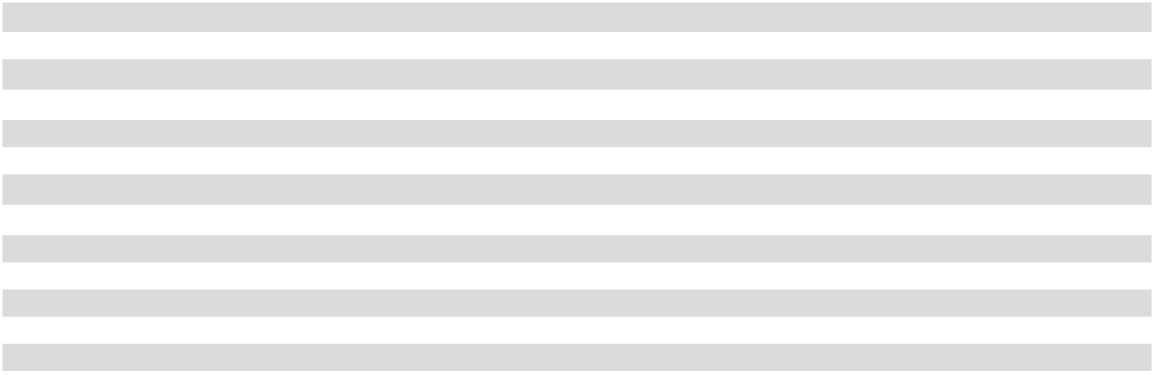

- The 2025 Senior Bonds were issued at 99.975% of par. The 2025 Senior Bonds were fully repaid during the fourth quarter of 2025.
- As of December 31, 2025, the senior notes maturing in 2026 were classified as current portion of debt in the consolidated balance sheets.

- The Term Loan Facilities (as defined below) were issued in connection with the financing of the Repurchase, as further discussed above.

- The 2029 Senior Bonds were issued at 99.843% of par.

- The Company’s revolving credit facility has an aggregate maximum borrowing capacity of $500 million. The Company currently believes all banks participating in the revolving credit facility have the ability to and will meet any funding requests from the Company.

- The 2034 Senior Bonds were issued at 99.893% of par.

The Company entered into the Bridge Facility, dated as of November 7, 2025, providing for a 364-day senior unsecured bridge term loan facility in an aggregate principal amount of $1.20 billion to fund the Repurchase. Also on November 7, 2025, the Company borrowed $1.20 billion under the Bridge Facility, the full amount available under the Bridge Facility.

On December 8, 2025, the Company entered into a term loan agreement, providing for (i) the Three-Year Term Loan Facility, a senior unsecured term loan facility in the aggregate principal amount of up to $900 million, maturing on December 8, 2028, and (ii) the Five-Year Term Loan Facility, a senior unsecured term loan facility in the aggregate principal amount of up to $450 million, maturing on December 6, 2030 (collectively, the “Term Loan Facilities”). Also on December 8, 2025, the Company borrowed $1.35 billion under the Term Loan Facilities, the full amount available under the Term Loan Facilities. In conjunction with the borrowings under the Term Loan Facilities, the Company modified and extinguished the Bridge Facility discussed above, fully repaying the $1.20 billion outstanding under the Bridge Facility through a net cash settlement with the lender.

Subsequent to the end of 2025, on February 9, 2026, the Company repaid $150 million of the $450 million aggregate principal balance outstanding under the Five-Year Term Loan Facility using cash on hand.

The indentures under which the 2025 Senior Bonds, the 2029 Senior Bonds and the 2034 Senior Bonds were issued do not include financial covenants, but do limit the incurrence of certain liens and encumbrances as well as indebtedness by the Company’s subsidiaries in excess of certain amounts. The agreements under which the Company’s nonpublic debt, including the Revolving Credit Facility and the Term Loan Facilities, was issued include two financial covenants: a consolidated cash flow/fixed charges ratio and a consolidated funded indebtedness/cash flow ratio, each as defined in the respective agreement. The Company was in compliance with these covenants as of December 31, 2025. These covenants have not restricted, and are not expected to restrict, the Company’s liquidity or capital resources.

All outstanding debt has been issued by the Company and none has been issued by any of its subsidiaries. There are no guarantees of the Company’s debt.

The Company’s credit ratings are reviewed periodically by certain nationally recognized rating agencies. Changes in the Company’s operating results or financial position could result in changes in the Company’s credit ratings. Lower credit ratings could result in higher borrowing costs for the Company or reduced access to capital markets, which could have a material adverse impact on the

32

Company’s operating results or financial position. As of December 31, 2025, the Company’s credit ratings and outlook for its debt were as follows:

Moody’s | Credit Rating |  | Rating Outlook
Moody’s | Baa1 |  | Stable
Standard & Poor’s | BBB+ |  | Negative

The Company’s Board of Directors has declared, and the Company has paid, dividends on the Common Stock and the Class B Common Stock and each class of common stock has participated equally in all dividends declared by the Board of Directors and paid by the Company for more than 30 years. The amount and frequency of future dividends will be determined by the Company’s Board of Directors in light of the earnings and financial condition of the Company at such time, and no assurance can be given that dividends will be declared or paid in the future.

We review supplier terms and conditions on an ongoing basis, and we have negotiated payment term extensions in recent years in connection with our efforts to improve cash flow and working capital. Separate from those term extension actions, the Company has an agreement with a third-party financial institution to facilitate a supply chain finance program (the “SCF program”), which allows qualifying suppliers to sell their receivables from the Company to the financial institution in order to negotiate shorter payment terms on their outstanding receivable arrangements. The Company’s obligations to its suppliers, including amounts due and scheduled payment terms, are not impacted by a supplier’s participation in the SCF program. See Note 13 to the consolidated financial statements for additional information related to the SCF program.

The Company’s only Level 3 asset or liability is the acquisition related contingent consideration liability. There were no transfers of assets or liabilities from Level 1 or Level 2 in any period presented. Fair value adjustments were non-cash and, therefore, did not impact the Company’s liquidity or capital resources. Following is a summary of the Level 3 activity:

 |  |  | Fiscal Year
(in thousands) |  |  | 2025 |  |  | 2024
Beginning balance - Level 3 liability |  | $ | 654,191 |  | $ | 669,337
Payments of acquisition related contingent consideration |  |  | (68,884) |  |  | (64,312)
Reclassification to current payables |  |  | 700 |  |  | (10,000)
Increase in fair value |  |  | 131,901 |  |  | 59,166
Ending balance - Level 3 liability |  | $ | 717,908 |  | $ | 654,191
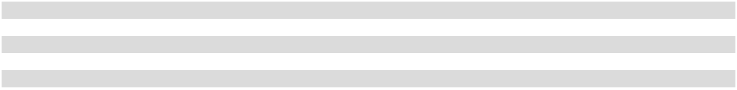

33

Cash Sources and Uses

A summary of cash-based activity is as follows:

 |  |  | Fiscal Year
(in thousands) |  |  | 2025 |  |  | 2024
Cash Sources:
Proceeds from bridge loan |  | $ | 1,200,000 | $ |  | —
Proceeds from term loan facility upon modification |  |  | 950,000 |  |  | —
Net cash provided by operating activities⁽¹⁾ |  |  | 931,904 |  |  | 876,357
Proceeds from the disposal of short-term investments |  |  | 696,415 |  |  | 150,274
Proceeds from the sale of property, plant and equipment |  |  | 6,594 |  |  | 569
Proceeds from bond issuance |  |  | — |  |  | 1,200,000
Total cash sources |  | $ | 3,784,913 |  | $ | 2,227,200
Cash Uses:
Payments related to share repurchases |  | $ | 2,606,031 | $ |  | 625,654
Repayment of bridge loan upon extinguishment |  |  | 800,000 |  |  | —
Purchases of short-term investments |  |  | 390,111 |  |  | 446,309
Repayment of senior bonds |  |  | 350,000 |  |  | —
Additions to property, plant and equipment |  |  | 312,315 |  |  | 371,015
Cash dividends paid |  |  | 86,673 |  |  | 185,635
Payments of acquisition related contingent consideration |  |  | 68,884 |  |  | 64,312
Investment in equity method investees |  |  | 19,600 |  |  | 15,720
Debt issuance fees |  |  | 3,396 |  |  | 15,512
Payments on financing lease obligations |  |  | 1,809 |  |  | 2,488
Total cash uses |  | $ | 4,638,819 |  | $ | 1,726,645
Net (decrease) increase in cash and cash equivalents during period |  | $ | (853,906) |  | $ | 500,555
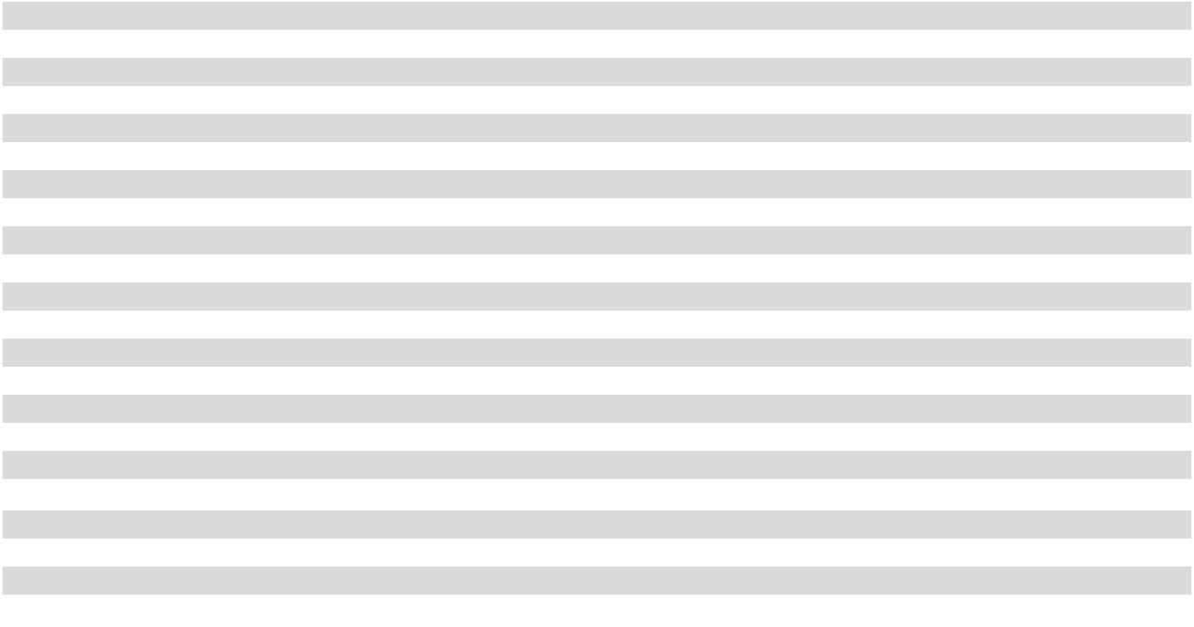

- Net cash provided by operating activities in 2025 included net income tax payments of $196.6 million, net interest payments of $92.8 million and pension plan contributions of $5.0 million. Net cash provided by operating activities in 2024 included net income tax payments of $224.0 million, net interest payments of $56.1 million and pension plan contributions of $2.0 million.

Cash Flows From Operating Activities

During 2025, cash provided by operating activities was $931.9 million, which was an increase of $55.5 million as compared to 2024.

The increase was primarily a result of our strong operating performance during 2025.

Cash Flows From Investing Activities

During 2025, cash used in investing activities was $19.0 million, which was a decrease of $663.2 million as compared to 2024. The Company had net proceeds from short-term investments of $306.3 million during 2025, as compared to net purchases of short-term investments of $296.0 million during 2024, representing a net change of approximately $602 million.

The decrease in cash used in investing activities was also partially a result of fewer additions to property, plant and equipment, which were $312.3 million during 2025 and $371.0 million during 2024. Additions to property, plant and equipment in 2024 included the purchase of the Company’s Nashville, Tennessee production facility for approximately $56 million. There were $33.2 million and $44.9 million of additions to property, plant and equipment accrued in accounts payable, trade as of December 31, 2025 and December 31, 2024, respectively.

The additions to property, plant and equipment reflect the Company’s continued focus on optimizing its supply chain and investing for future growth. The Company expects additions to property, plant and equipment in 2026 to be approximately $300 million.

Cash Flows From Financing Activities

During 2025, cash used in financing activities was $1.77 billion, as compared to cash provided by financing activities of

$306.4 million during 2024, a change of $2.07 billion. The cash used in financing activities during 2025 was primarily related to share repurchases of $2.61 billion and dividend payments of $86.7 million, offset by net debt proceeds of $1.00 billion.

34

The Company had cash payments for acquisition related contingent consideration of $68.9 million during 2025 and $64.3 million during 2024. For the next five years (including in fiscal year 2026), the Company anticipates that the amount it could pay annually under the acquisition related contingent consideration arrangements for the distribution territories subject to acquisition related sub-bottling payments will be in the range of approximately $50 million to $80 million.

Material Contractual Obligations

The Company had a number of contractual obligations and commercial obligations as of December 31, 2025 that are material to an assessment of the Company’s short- and long-term cash requirements.

The Company has outstanding debt of $2.80 billion, $100.0 million of which is contractually due in fiscal year 2026 and classified as current debt on the consolidated balance sheets. The remaining interest payments on the Company’s debt obligations are

$622.2 million determined in reference to the contractual terms of such debt, of which $138.7 million is due in fiscal year 2026. Several of the Company’s debt instruments have variable interest rates and, thus, are impacted by fluctuations in interest rates, which could cause changes in the amount of estimated interest payments reported above.

The Company’s acquisition related contingent consideration liability relates to acquisition related sub-bottling payments required in certain distribution territories under the CBA and totaled $717.9 million as of December 31, 2025. The future expected acquisition related sub-bottling payments extend through the life of the related distribution assets acquired in each distribution territory, which is generally 40 years. The Company’s short-term portion of the acquisition related contingent consideration liability was $74.9 million as of December 31, 2025 and was included within other accrued liabilities in the consolidated balance sheets.

The Company is obligated to purchase 16.0 million cases of finished product from SAC on an annual basis through June 2034. Based on information available as of December 31, 2025, the Company estimates this purchase obligation to be $1.20 billion, of which an estimated $141 million of purchases is expected to occur in fiscal year 2026.

The Company has $137.7 million in total minimum operating lease obligations including interest, of which $28.5 million are due in fiscal year 2026. The Company has $1.9 million in total minimum financing lease obligations including interest, of which $0.6 million are due in fiscal year 2026.

As of December 31, 2025, the Company estimated obligations for its executive benefit plans to be $217.1 million, of which $40.6 million is expected to be paid in fiscal year 2026.

The Company provides postretirement benefits for employees meeting specified qualifying criteria. The Company recognizes the cost of postretirement benefits, which consist principally of medical benefits, during employees’ periods of active service. The Company does not prefund these benefits and has the right to modify or terminate certain of these benefits in the future. As of December 31, 2025, the Company had obligations related to its postretirement benefits plan of $73.7 million, of which $4.4 million is expected to be paid in fiscal year 2026.

The Company is a shareholder of Southeastern Container (“Southeastern”), a plastic bottle manufacturing cooperative from which the Company is obligated to purchase at least 80% of its requirements of plastic bottles for certain designated territories. This obligation has no minimum purchase requirements; however, purchases from Southeastern were $119.3 million during 2025 and are expected to remain material in future foreseeable periods. See Note 21 to the consolidated financial statements for additional information related to Southeastern.

The Company participates in long-term marketing contractual arrangements with certain prestige properties, athletic venues and other locations. As of December 31, 2025, the future payments related to these contractual arrangements, which expire at various dates through 2035, amounted to $151.1 million, of which $37.6 million is expected to be paid in fiscal year 2026.

Hedging Activities

The Company uses commodity derivative instruments to manage its exposure to fluctuations in certain commodity prices where practicable. Fees paid by the Company for commodity derivative instruments are amortized over the corresponding period of the instrument. The Company accounts for its commodity derivative instruments on a mark-to-market basis with any expense or income being reflected as an adjustment to cost of sales or SD&A expenses, consistent with the expense classification of the underlying hedged item.

The Company uses several different financial institutions for commodity derivative instruments to minimize the concentration of credit risk. The Company has master agreements with the counterparties to its commodity derivative instruments that provide for net

35

settlement of derivative transactions. The net impact of the commodity derivative instruments on the consolidated statements of operations was as follows:

 |  |  | Fiscal Year
(in thousands) |  |  | 2025 |  |  | 2024
Decrease in cost of sales |  | $ | (2,002) |  | $ | (590)
Increase in SD&A expenses |  |  | 1,443 |  |  | 2,647
Net impact |  | $ | (559) |  | $ | 2,057

Discussion of Critical Accounting Estimates

In the ordinary course of business, the Company has made a number of estimates and assumptions relating to the reporting of its results of operations and financial position in the preparation of its consolidated financial statements in conformity with GAAP. Actual results could differ significantly from those estimates under different assumptions and conditions. The Company believes the following discussion addresses the Company’s most critical accounting estimates, which are those the Company believes to be the most important to the portrayal of its financial condition and results of operations and that require management’s most difficult, subjective and complex judgments, often as a result of the need to make estimates about the effect of matters that are inherently uncertain.

Any changes in critical accounting estimates are discussed with the Audit Committee of the Company’s Board of Directors during the quarter in which a change is contemplated and prior to making such change.

Revenue Recognition

The Company’s sales are divided into two main categories: (i) bottle/can sales and (ii) other sales. Bottle/can sales include products packaged primarily in plastic bottles and aluminum cans. Bottle/can net pricing is based on the invoice price charged to customers reduced by any promotional allowances. Bottle/can net pricing per unit is impacted by the price charged per package, the sales volume generated for each package and the channels in which those packages are sold. Other sales include sales to other Coca-Cola bottlers, post-mix sales, transportation revenue and equipment maintenance revenue.

The Company’s contracts are derived from customer orders, including customer sales incentives, generated through an order processing and replenishment model. Generally, the Company’s service contracts and contracts related to the delivery of specifically identifiable products have a single performance obligation. Revenues do not include sales or other taxes collected from customers. The Company has defined its performance obligations for its contracts as either at a point in time or over time. Bottle/can sales, sales to other Coca-Cola bottlers and post-mix sales are recognized when control transfers to a customer, which is generally upon delivery and is considered a single point in time (“point in time”).

Other sales, which include revenue for service fees related to the repair of cold drink equipment and delivery fees for freight hauling and brokerage services, are recognized over time (“over time”). Revenues related to cold drink equipment repair are recognized as the respective services are completed using a cost-to-cost input method. Repair services are generally completed in less than one day but can extend up to one month. Revenues related to freight hauling and brokerage services are recognized as the delivery occurs using a miles driven output method. Generally, delivery occurs and freight charges are recognized in the same day. Over time sales orders open at the end of a financial period are not material to the consolidated financial statements.

The Company sells its products and extends credit, generally without requiring collateral, based on an ongoing evaluation of the customer’s business prospects and financial condition. The Company evaluates the collectability of its trade accounts receivable based on a number of factors, including the Company’s historic collections pattern and changes to a specific customer’s ability to meet its financial obligations. The Company typically collects payment from customers within 30 days from the date of sale.

The Company has established an allowance for doubtful accounts to adjust the recorded receivable to the estimated amount the Company believes will ultimately be collected. The Company’s allowance for doubtful accounts in the consolidated balance sheets includes a reserve for customer returns and an allowance for credit losses. The Company experiences customer returns primarily as a result of damaged or out-of-date product. At any given time, the Company estimates less than 1% of bottle/can sales and post-mix sales could be at risk for return by customers. Returned product is recognized as a reduction to net sales.

The Company estimates an allowance for credit losses, based on historic days’ sales outstanding trends, aged customer balances, previously written-off balances and expected recoveries up to balances previously written off, in order to present the net amount expected to be collected. Accounts receivable balances are written off when determined uncollectible and are recognized as a reduction to the allowance for credit losses.

36

Valuation of Long-Lived Assets, Goodwill and Other Intangibles

Management performs recoverability and impairment tests of long-lived assets, goodwill and other intangibles in accordance with GAAP, during which management makes numerous assumptions which involve a significant amount of judgment. When performing impairment tests, management estimates the fair values of the assets using its best assumptions, which management believes would be consistent with what a hypothetical marketplace participant would use. Estimates and assumptions used in these tests are evaluated and updated as appropriate. For certain assets, recoverability and/or impairment tests are required only when conditions exist that indicate the carrying value may not be recoverable. For other assets, impairment tests are required at least annually, or more frequently if events or circumstances indicate that an asset may be impaired.

The Company evaluates the recoverability of the carrying amount of its property, plant and equipment and other intangibles when events or circumstances indicate the carrying amount of an asset or asset group may not be recoverable. These evaluations are performed at a level where independent cash flows may be attributed to either an asset or an asset group. If the Company determines the carrying amount of an asset or asset group is not recoverable based upon the expected undiscounted future cash flows of the asset or asset group, an impairment loss is recorded equal to the excess of the carrying amounts over the estimated fair values of the long-lived assets. During 2025 and 2024, the Company did not identify any impairment triggers related to property, plant and equipment and other intangibles.

All business combinations are accounted for using the acquisition method. All of the Company’s goodwill resides within one reporting unit within the Nonalcoholic Beverages reportable segment and, therefore, the Company has determined it has one reporting unit for the purpose of assessing goodwill for potential impairment. The Company performs its annual goodwill impairment test as of the first day of the fourth quarter each year, and more frequently if facts and circumstances indicate such assets may be impaired, including significant declines in actual or future projected cash flows and significant deterioration of market conditions.

The Company uses its overall market capitalization as part of its estimate of fair value of the reporting unit and in assessing the reasonableness of the Company’s internal estimates of fair value. The Company’s goodwill impairment assessment includes a qualitative assessment to determine whether it is more likely than not that the fair value of the goodwill is below its carrying value, each year, and more often if there are significant changes in business conditions that could result in impairment. When a quantitative analysis is considered necessary for the annual impairment analysis of goodwill, the Company develops an estimated fair value for the reporting unit considering three different approaches: (i) market value, using the Company’s stock price plus outstanding debt;

- discounted cash flow analysis; and (iii) multiple of earnings before interest, taxes, depreciation and amortization based upon relevant industry data.

The estimated fair value of the reporting unit is then compared to its carrying amount, including goodwill. If the estimated fair value exceeds the carrying amount, goodwill is not considered impaired. If the carrying amount, including goodwill, exceeds its estimated fair value, any excess of the carrying value of goodwill of the reporting unit over its fair value is recorded as an impairment. The Company performed its annual impairment test of goodwill as of the first day of the fourth quarter during both 2025 and 2024 and determined there was no impairment of the carrying values of these assets. The Company has determined there has not been an interim impairment trigger since the first day of the fourth quarter of 2025 annual test date.

Acquisition Related Contingent Consideration Liability

The acquisition related contingent consideration liability consists of the estimated amounts due to The Coca-Cola Company under the CBA with The Coca-Cola Company and CCR over the useful life of the related distribution rights. Pursuant to the CBA, the Company is required to make quarterly acquisition related sub-bottling payments to CCR on a continuing basis in exchange for the grant of exclusive rights to distribute, promote, market and sell the authorized brands of The Coca-Cola Company and related products in certain distribution territories the Company acquired from CCR. This acquisition related contingent consideration is valued using a probability weighted discounted cash flow model based on internal forecasts and the WACC derived from market data, which are considered Level 3 inputs.

Each reporting period, the Company adjusts its acquisition related contingent consideration liability related to the distribution territories subject to acquisition related sub-bottling payments to fair value by discounting future expected acquisition related sub-bottling payments required under the CBA using the Company’s estimated WACC. These future expected acquisition related sub-bottling payments extend through the life of the related distribution assets acquired in each distribution territory, which is generally 40 years. As a result, the fair value of the acquisition related contingent consideration liability is impacted by the Company’s WACC, management’s estimate of the acquisition related sub-bottling payments that will be made in the future under the CBA, and current acquisition related sub-bottling payments (all Level 3 inputs). Changes in any of these Level 3 inputs, particularly the underlying risk-free interest rate used to estimate the Company’s WACC, could result in material changes to the fair value of the acquisition related contingent consideration liability and could materially impact the amount of non-cash expense (or income) recorded each reporting

37

period. The Company estimates a 10-basis point change in the underlying risk-free interest rate used to estimate the Company’s WACC would result in a change of approximately $7 million to the Company’s acquisition related contingent consideration liability.

Income Tax Estimates

Income taxes are accounted for under the asset and liability method. Deferred tax assets and liabilities are recognized for the future tax consequences attributable to operating losses and tax credit carryforwards, as well as the differences between the financial statement carrying amounts of existing assets and liabilities and their respective tax bases. The effect on deferred tax assets and liabilities of a change in tax rates is recognized in income in the period that includes the enactment date.

A valuation allowance will be provided against deferred tax assets if the Company determines it is more likely than not such assets will not ultimately be realized.

The Company does not recognize a tax benefit unless it concludes that it is more likely than not that the benefit will be sustained on audit by the taxing authority based solely on the technical merits of the associated tax position. If the recognition threshold is met, the Company recognizes a tax benefit measured at the largest amount of the tax benefit that, in the Company’s judgment, is greater than 50% likely to be realized. The Company records interest and penalties related to uncertain tax positions in income tax expense.

Pension and Postretirement Benefit Obligations

The Company sponsors a pension plan (the “Bargaining Plan”) for certain employees under collective bargaining agreements. Benefits under the Bargaining Plan are determined in accordance with negotiated formulas for the respective participants. Contributions to the Bargaining Plan are based on actuarially determined amounts and are limited to the amounts currently deductible for income tax purposes.

Several statistical and other factors, which attempt to anticipate future events, are used in calculating the expense and liability related to the Bargaining Plan. These factors include assumptions about the discount rate, expected return on plan assets, employee turnover and age at retirement, as determined by the Company, within certain guidelines. In addition, the Company uses subjective factors such as mortality rates to estimate the projected benefit obligation. The actuarial assumptions used by the Company may differ materially from actual results due to changing market and economic conditions, higher or lower withdrawal rates or longer or shorter life spans of participants. These differences may result in a significant impact to the amount of net periodic pension cost recorded by the Company in future periods. See Note 18 to the consolidated financial statements for additional information.

The discount rate used in determining the actuarial present value of the projected benefit obligation for the Bargaining Plan was 5.92% in 2025 and 5.89% in 2024. The discount rate assumption is generally the estimate which can have the most significant impact on the projected benefit obligation and the net periodic pension cost for the Bargaining Plan. The Company determines an appropriate discount rate annually for the Bargaining Plan based on the Aon AA Above Median yield curve as of the measurement date and reviews the discount rate assumption at the end of each year. See Note 18 to the consolidated financial statements for additional information.

Pension costs for the Bargaining Plan were $3.2 million in 2025 and $3.7 million in 2024.

A 0.25% increase or decrease in the discount rate assumption would have impacted the projected benefit obligation and the net periodic pension cost for the Bargaining Plan as follows:

(in thousands) |  |  | 0.25% Increase |  |  | 0.25% Decrease
Increase (decrease) in:
Projected benefit obligation at December 31, 2025 | $ |  | (2,024) | $ |  | 2,156
Net periodic pension cost in 2025 |  |  | (219) |  |  | 178

The weighted average expected long-term rate of return of plan assets used in computing net periodic pension cost for the Bargaining Plan was 7.00% in both 2025 and 2024. These rates reflect an estimate of long-term future returns for the pension plan assets, and the estimate is primarily a function of the asset classes (equities versus fixed income) in which the Bargaining Plan assets are invested.
This analysis includes expected long-term inflation and the risk premiums associated with equity and fixed income investments. See Note 18 to the consolidated financial statements for the details by asset type for the Bargaining Plan. The actual return on pension plan assets for the Bargaining Plan was a gain of 10.4% in 2025 and a gain of 3.7% in 2024.

The Company sponsors a postretirement healthcare plan for employees meeting specified qualifying criteria. Several statistical and other factors, which attempt to anticipate future events, are used in calculating the net periodic postretirement benefit cost and the

38

postretirement benefit obligation for this plan. These factors include assumptions about the discount rate and the expected growth rate for the cost of healthcare benefits. In addition, the Company uses subjective factors such as withdrawal and mortality rates to estimate the projected liability under this plan. The actuarial assumptions used by the Company may differ materially from actual results due to changing market and economic conditions, higher or lower withdrawal rates or longer or shorter life spans of participants. The Company does not prefund its postretirement benefits and has the right to modify or terminate certain of these benefits in the future.

The discount rate assumption, the annual healthcare cost trend and the ultimate trend rate for healthcare costs are key estimates which can have a significant impact on the net periodic postretirement benefit cost and the postretirement benefit obligation in future periods. The Company annually determines the healthcare cost trend based on recent actual medical trend experience and projected experience for subsequent years.

The discount rate assumptions used to determine the postretirement benefit obligation are based on the annual yield on long-term corporate bonds as of the plan’s measurement date. The discount rate used in determining the postretirement benefit obligation was 5.41% in 2025 and 5.68% in 2024. The discount rate was derived using the Aon AA Above Median yield curve. Projected benefit payouts for the plan were matched to the Aon AA Above Median yield curve and an equivalent flat rate was derived.

A 0.25% increase or decrease in the discount rate assumption would have impacted the postretirement benefit obligation and the net periodic postretirement benefit cost for the Company’s postretirement healthcare plan as follows:

(in thousands) |  |  | 0.25% Increase |  |  | 0.25% Decrease
Increase (decrease) in: | $ |  | (1,576) | $ |  | 1,639
Postretirement benefit obligation at December 31, 2025
Net periodic postretirement benefit cost in 2025 |  |  | (133) |  |  | 138

Cautionary Note Regarding Forward-Looking Statements

Certain statements made in this report, or in other public filings, press releases, or other written or oral communications made by the Company, which are not historical facts, are forward-looking statements subject to the safe harbor provisions of the Private Securities Litigation Reform Act of 1995. These forward-looking statements involve risks and uncertainties which we expect will or may occur in the future and may impact our business, financial condition and results of operations. The words “anticipate,” “believe,” “expect,” “intend,” “project,” “may,” “will,” “should,” “could” and similar expressions are intended to identify those forward-looking statements. These forward-looking statements reflect the Company’s best judgment based on current information, and, although we base these statements on circumstances that we believe to be reasonable when made, there can be no assurance that future events will not affect the accuracy of such forward-looking information. As such, the forward-looking statements are not guarantees of future performance, and actual results may vary materially from the projected results and expectations discussed in this report. Factors that might cause the Company’s actual results to differ materially from those anticipated in forward-looking statements include, but are not limited to: increased costs (including due to inflation or uncertainty around tariffs) or disruption, unavailability or shortages of raw materials, fuel and other supplies; the reliance on purchased finished products from external sources; changes in public and consumer perception and preferences, including concerns related to product safety and sustainability, artificial ingredients, brand reputation and obesity; changes in government regulations related to nonalcoholic beverages, including regulations related to obesity, public health, artificial ingredients, recycling, sustainability, product safety and benefit programs, including SNAP; decreases from historic levels of marketing funding support provided to us by The Coca-Cola Company and other beverage companies; material changes in the performance requirements for marketing funding support or our inability to meet such requirements; decreases from historic levels of advertising, marketing and product innovation spending by The Coca-Cola Company and other beverage companies, or advertising campaigns that are negatively perceived by the public; any failure of the several Coca-Cola system governance entities of which we are a participant to function efficiently or in our best interest and any failure or delay of ours to receive anticipated benefits from these governance entities; provisions in our beverage distribution and manufacturing agreements with The Coca-Cola Company that could delay or prevent a change in control of us or a sale of our Coca-Cola distribution or manufacturing businesses; the concentration of our capital stock ownership; our inability to meet requirements under our beverage distribution and manufacturing agreements; changes in the inputs used to calculate our acquisition related contingent consideration liability; technology failures or cyberattacks on our information technology systems or our effective response to technology failures or cyberattacks on our third-party service providers’, business partners’, customers’, suppliers’ or other third parties’ information technology systems; unfavorable changes in the general economy; changes in trade policies, including the imposition of, or increase in, tariffs on imported goods; the concentration risks among our customers and suppliers; lower than expected net pricing of our products resulting from continued and increased customer and competitor consolidations and marketplace competition; the effect of changes in our level of debt, borrowing costs and credit ratings on our access to capital and credit markets, operating flexibility and ability to obtain additional financing to fund future needs; the failure to attract, train and retain qualified employees while controlling labor costs and other labor issues; the failure to maintain productive relationships with our employees covered by collective bargaining agreements, including failing to renegotiate collective bargaining agreements; changes in accounting standards; our use of estimates and assumptions; changes in tax laws, disagreements

39

with tax authorities or additional tax liabilities; changes in legal contingencies; natural disasters, changing weather patterns and unfavorable weather, or the increased frequency of any such events due to climate change, and public expectations around combatting climate change; or legislative or regulatory responses to such change; and the risks discussed in “Item 1A. Risk Factors” of this report and elsewhere herein.

Caution should be taken not to place undue reliance on the forward-looking statements included in this report. The Company assumes no obligation to update any forward-looking statements, except as may be required by law. In evaluating forward-looking statements, these risks and uncertainties should be considered, together with the other risks described from time to time in the Company’s reports and other filings with the SEC.

Item 7A. Quantitative and Qualitative Disclosures About Market Risk.

The Company is subject to interest rate volatility with regard to existing issuances of debt, including its revolving credit facility and the Term Loan Facilities. The Company had outstanding borrowings under the Term Loan Facilities in 2025 totaling $1.35 billion. Based on the Company’s variable rate debt outstanding as of December 31, 2025, we estimate a 1% increase in interest rates would increase annual interest expense by $13.5 million. As of December 31, 2024, the Company did not have any outstanding borrowings on variable rate debt and, as such, estimated a 1% increase in interest rates would have had no impact on interest expense.

The Company’s acquisition related contingent consideration liability, which is adjusted to fair value each reporting period, is also impacted by changes in interest rates. The risk-free interest rate used to estimate the Company’s WACC is a component of the discount rate used to calculate the present value of future expected acquisition related sub-bottling payments due under the CBA. As a result, any changes in the underlying risk-free interest rate could result in material changes to the fair value of the acquisition related contingent consideration liability and could materially impact the amount of non-cash expense (or income) recorded each reporting period. The Company estimates a 10-basis point change in the underlying risk-free interest rate used to estimate the Company’s WACC would result in a change of approximately $7 million to the Company’s acquisition related contingent consideration liability.

The Company is exposed to certain market risks and commodity price risk that arise in the ordinary course of business. The Company may enter into commodity derivative instruments to manage or reduce market risk. The Company does not use commodity derivative instruments for trading or speculative purposes.

The Company is also subject to commodity price risk arising from price movements for certain commodities included as part of its input costs, which predominately relate to our Sparkling products. The Company estimates a 10% increase in the market prices of its key commodities, including aluminum, PET resin and high-fructose corn syrup, and excluding concentrate, over the current market prices would cumulatively increase costs during the next 12 months by approximately $35 million to $40 million assuming no change in volume.

The Company manages its commodity price risk in some cases by entering into contracts with adjustable prices to hedge commodity purchases, including our aluminum input costs and fuel expenses related to our selling and distribution activities. The Company periodically uses commodity derivative instruments in the management of this risk, and estimates a 10% decrease in the underlying commodity prices would have decreased the fair value of our commodity derivative instruments by approximately $4 million as of December 31, 2025.

Fees paid by the Company for agreements to hedge commodity purchases are amortized over the corresponding period of the agreement. The Company accounts for its commodity derivative instruments on a mark-to-market basis with any expense or income being reflected as an adjustment to cost of sales or SD&A expenses, consistent with the expense classification of the underlying hedged item.

The annual rate of inflation in the United States, as measured by year-over-year changes in the Consumer Price Index, was 2.7% in 2025, 2.9% in 2024 and 3.4% in 2023. Inflation in the prices of those commodities important to the Company’s business is reflected in changes in the Consumer Price Index.

The principal effect of inflation in both commodity and consumer prices on the Company’s operating results is to increase both cost of goods sold and SD&A expenses. Although the Company can offset these cost increases by increasing selling prices for its products, consumers may not have the buying power to cover these increased costs and may reduce their volume of purchases of those products. In that event, selling price increases may not be sufficient to offset completely the Company’s cost increases.

40

Item 8. Financial Statements and Supplementary Data.

COCA-COLA CONSOLIDATED, INC.

CONSOLIDATED STATEMENTS OF OPERATIONS

 |  |  |  |  |  | Fiscal Year
(in thousands, except per share data) |  |  | 2025 |  |  | 2024 |  |  | 2023
Net sales |  | $ | 7,228,055 |  | $ | 6,899,716 |  | $ | 6,653,858
Cost of sales |  |  | 4,355,693 |  |  | 4,146,537 |  |  | 4,055,147
Gross profit |  |  | 2,872,362 |  |  | 2,753,179 |  |  | 2,598,711
Selling, delivery and administrative expenses |  |  | 1,921,706 |  |  | 1,832,829 |  |  | 1,764,260
Income from operations |  |  | 950,656 |  |  | 920,350 |  |  | 834,451
Interest expense (income), net |  |  | 42,678 |  |  | 1,848 |  |  | (918)
Mark-to-market on acquisition related contingent consideration |  |  | 131,901 |  |  | 59,166 |  |  | 159,354
Pension plan settlement expense |  |  | — |  |  | — |  |  | 112,796
Other expense, net |  |  | 3,159 |  |  | 2,682 |  |  | 5,738
Income before taxes |  |  | 772,918 |  |  | 856,654 |  |  | 557,481
Income tax expense |  |  | 202,336 |  |  | 223,529 |  |  | 149,106
Net income |  | $ | 570,582 |  | $ | 633,125 |  | $ | 408,375
Basic net income per share:
 |  | $ | 6.82 | $ |  | 7.01 | $ |  | 4.36
Common Stock
Weighted average number of Common Stock shares outstanding
 |  |  | 73,658 |  |  | 80,348 |  |  | 83,690
Class B Common Stock |  | $ | 6.78 | $ |  | 6.95 | $ |  | 4.36
Weighted average number of Class B Common Stock shares outstanding
 |  |  | 10,047 |  |  | 10,047 |  |  | 10,047
Diluted net income per share: |  | $ | 6.81 | $ |  | 6.99 | $ |  | 4.35
Common Stock
Weighted average number of Common Stock shares outstanding – assuming
 |  |  | 83,807 |  |  | 90,524 |  |  | 93,923
dilution |  |  | 83,807 |  |  | 90,524 |  |  | 93,923
Class B Common Stock |  | $ | 6.76 | $ |  | 6.92 | $ |  | 4.34
Weighted average number of Class B Common Stock shares outstanding –
 |  |  | 10,149 |  |  | 10,176 |  |  | 10,233
assuming dilution |  |  | 10,149 |  |  | 10,176 |  |  | 10,233
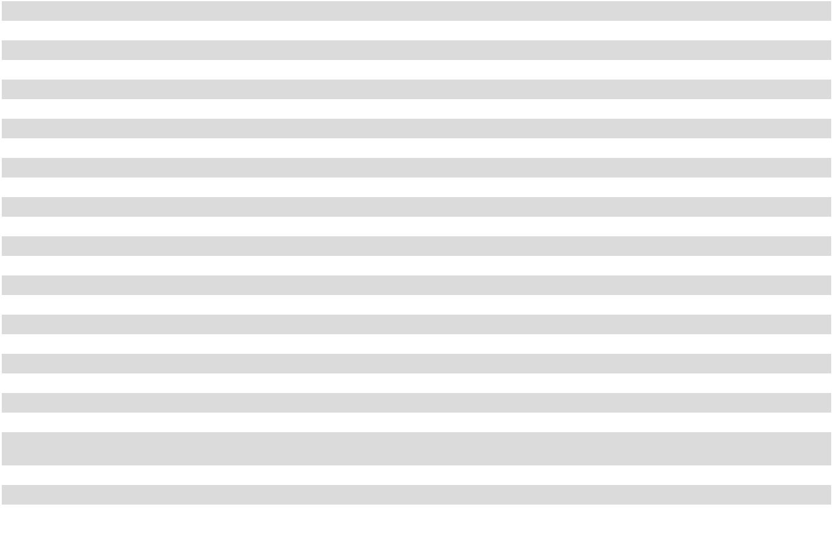

See accompanying notes to consolidated financial statements.

41

COCA-COLA CONSOLIDATED, INC.

CONSOLIDATED STATEMENTS OF COMPREHENSIVE INCOME

 |  |  |  |  |  | Fiscal Year
(in thousands) |  |  | 2025 |  |  | 2024 |  |  | 2023
Net income |  | $ | 570,582 |  | $ | 633,125 |  | $ | 408,375
Other comprehensive (loss) income, net of tax:
Defined benefit plans reclassification including pension costs:
Actuarial gain |  |  | 21 |  |  | 3,885 |  |  | 3,762
Prior service (costs) credits |  |  | (82) |  |  | 12 |  |  | 8
Postretirement benefits reclassification including benefit costs:
Actuarial (loss) gain |  |  | (7,804) |  |  | 2,239 |  |  | (6,031)
Net change in unrealized gain/loss on short-term investments |  |  | (25) |  |  | 25 |  |  | —
Pension plan settlement |  |  | — |  |  | — |  |  | 82,822
Other comprehensive (loss) income, net of tax |  |  | (7,890) |  |  | 6,161 |  |  | 80,561
Comprehensive income |  | $ | 562,692 |  | $ | 639,286 |  | $ | 488,936
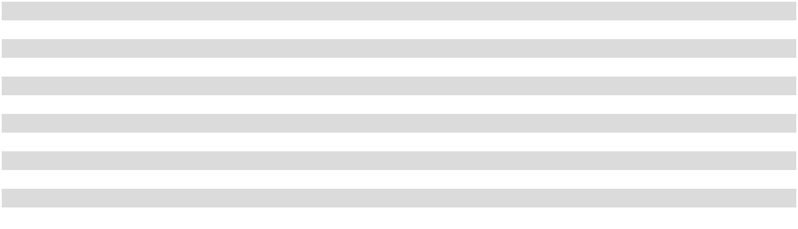

See accompanying notes to consolidated financial statements.

42

COCA-COLA CONSOLIDATED, INC.

CONSOLIDATED BALANCE SHEETS

 | (in thousands, except share data) |  |  |  | December 31, 2025 |  |  | December 31, 2024
 | ASSETS
 | Current Assets:
 | Cash and cash equivalents |  |  | $ |  | 281,918 | $ |  | 1,135,824
 | Short-term investments |  |  |  |  | — |  |  | 301,210
 | Accounts receivable, trade |  |  |  |  | 585,777 |  |  | 567,653
 | Allowance for doubtful accounts |  |  |  |  | (11,176) |  |  | (14,674)
 | Accounts receivable from The Coca-Cola Company |  |  |  |  | 70,197 |  |  | 89,871
 | Accounts receivable, other |  |  |  |  | 54,889 |  |  | 40,692
 | Inventories |  |  |  |  | 336,401 |  |  | 330,395
 | Prepaid expenses and other current assets |  |  |  |  | 108,668 |  |  | 96,331
 | Total current assets |  |  |  |  | 1,426,674 |  |  | 2,547,302
 | Property, plant and equipment, net |  |  |  |  | 1,604,605 |  |  | 1,505,267
 | Right-of-use assets - operating leases |  |  |  |  | 116,611 |  |  | 112,351
 | Leased property under financing leases, net |  |  |  |  | 1,160 |  |  | 3,138
 | Other assets |  |  |  |  | 216,428 |  |  | 181,048
 | Goodwill |  |  |  |  | 165,903 |  |  | 165,903
 | Distribution agreements, net |  |  |  |  | 767,360 |  |  | 792,252
 | Customer lists, net |  |  |  |  | 4,257 |  |  | 5,878
 | Total assets |  |  |  | $ | 4,302,998 |  | $ | 5,313,139
 | LIABILITIES AND (DEFICIT)/EQUITY
 | Current Liabilities:
 | Current portion of obligations under operating leases |  |  | $ |  | 24,412 | $ |  | 23,257
 | Current portion of obligations under financing leases |  |  |  |  | 556 |  |  | 2,685
 | Accounts payable, trade |  |  |  |  | 359,107 |  |  | 334,878
 | Accounts payable to The Coca-Cola Company |  |  |  |  | 182,446 |  |  | 187,271
 | Other accrued liabilities |  |  |  |  | 307,237 |  |  | 246,687
 | Accrued compensation |  |  |  |  | 154,899 |  |  | 168,692
 | Current portion of debt |  |  |  |  | 100,000 |  |  | 349,699
 | Total current liabilities |  |  |  |  | 1,128,657 |  |  | 1,313,169
 | Deferred income taxes |  |  |  |  | 143,738 |  |  | 132,941
 | Pension and postretirement benefit obligations |  |  |  |  | 69,298 |  |  | 58,502
 | Other liabilities |  |  |  |  | 918,755 |  |  | 859,559
 | Noncurrent portion of obligations under operating leases |  |  |  |  | 95,076 |  |  | 92,362
 | Noncurrent portion of obligations under financing leases |  |  |  |  | 1,188 |  |  | 2,346
 | Long-term debt |  |  |  |  | 2,686,009 |  |  | 1,436,649
 | Total liabilities |  |  |  |  | 5,042,721 |  |  | 3,895,528
 | Commitments and Contingencies
 | (Deficit)/Equity:
 | Convertible Preferred Stock, $100.00 par value: authorized - 50,000 shares; issued - none |  |  |  |  | — |  |  | —
 | Nonconvertible Preferred Stock, $100.00 par value: authorized - 50,000 shares; issued - none |  |  |  |  | — |  |  | —
 | Preferred Stock, $0.01 par value: authorized - 20,000,000 shares; issued - none |  |  |  |  | — |  |  | —
 | Common Stock, $1.00 par value: authorized - 300,000,000 shares; issued - 56,517,334 and
 | 108,327,480 shares, respectively |  |  |  |  | 56,517 |  |  | 108,327
 | Class B Common Stock, $1.00 par value: authorized - 100,000,000 shares; issued - 10,046,960 and
 | 16,328,100 shares, respectively |  |  |  |  | 10,047 |  |  | 16,328
 | Class C Common Stock, $1.00 par value: authorized - 20,000,000 shares; issued - none |  |  |  |  | — |  |  | —
 | Additional paid in capital |  |  |  |  | 23,764 |  |  | 23,764
 | Retained (deficit) earnings |  |  |  |  | (824,046) |  |  | 1,395,183
 | Accumulated other comprehensive (loss) income |  |  |  |  | (6,005) |  |  | 1,885
 | Treasury stock, at cost: Common Stock - 0 and 31,196,605 shares, respectively |  |  |  |  | — |  |  | (127,467)
 | Treasury stock, at cost: Class B Common Stock - 0 and 6,281,140 shares, respectively |  |  |  |  | — |  |  | (409)
 | Total (deficit)/equity |  |  |  |  | (739,723) |  |  | 1,417,611
 | Total liabilities and (deficit)/equity |  |  |  | $ | 4,302,998 |  | $ | 5,313,139


See accompanying notes to consolidated financial statements.

43

COCA-COLA CONSOLIDATED, INC.

CONSOLIDATED STATEMENTS OF CASH FLOWS

 |  |  |  |  |  | Fiscal Year
(in thousands) |  |  | 2025 |  |  | 2024 |  |  | 2023
Cash Flows from Operating Activities:
Net income |  | $ | 570,582 | $ |  | 633,125 | $ |  | 408,375
Adjustments to reconcile net income to net cash provided by operating activities:
Depreciation and amortization expense from property, plant and equipment |  |  | 195,081 |  |  | 170,343 |  |  | 153,472
and financing leases |  |  | 195,081 |  |  | 170,343 |  |  | 153,472
Amortization of intangible assets and deferred proceeds, net |  |  | 23,449 |  |  | 23,448 |  |  | 23,494
Fair value adjustment of acquisition related contingent consideration |  |  | 131,901 |  |  | 59,166 |  |  | 159,354
Deferred income taxes |  |  | 13,704 |  |  | 2,529 |  |  | (49,021)
Amortization of debt costs |  |  | 3,346 |  |  | 2,310 |  |  | 991
Loss on sale of property, plant and equipment |  |  | 644 |  |  | 3,168 |  |  | 7,181
Pension plan settlement expense |  |  | — |  |  | — |  |  | 112,796
Change in current assets less current liabilities |  |  | 10,551 |  |  | (3,774) |  |  | 29,138
Change in other noncurrent assets |  |  | 7,054 |  |  | 8,904 |  |  | 12,708
Change in other noncurrent liabilities |  |  | (24,408) |  |  | (22,862) |  |  | (47,798)
Total adjustments |  |  | 361,322 |  |  | 243,232 |  |  | 402,315
Net cash provided by operating activities |  | $ | 931,904 |  | $ | 876,357 |  | $ | 810,690
Cash Flows from Investing Activities:
Proceeds from the disposal of short-term investments |  | $ | 696,415 | $ |  | 150,274 | $ |  | —
Purchases of short-term investments |  |  | (390,111) |  |  | (446,309) |  |  | —
Additions to property, plant and equipment |  |  | (312,315) |  |  | (371,015) |  |  | (282,304)
Investment in equity method investees |  |  | (19,600) |  |  | (15,720) |  |  | (13,741)
Proceeds from the sale of property, plant and equipment |  |  | 6,594 |  |  | 569 |  |  | 695
Net cash used in investing activities |  | $ | (19,017) |  | $ | (682,201) |  | $ | (295,350)
Cash Flows from Financing Activities:
Payments related to share repurchases |  | $ | (2,606,031) | $ |  | (625,654) | $ |  | —
Proceeds from bridge loan |  |  | 1,200,000 |  |  | — |  |  | —
Proceeds from term loan facility upon modification |  |  | 950,000 |  |  | — |  |  | —
Repayment of bridge loan upon extinguishment |  |  | (800,000) |  |  | — |  |  | —
Repayment of senior bonds |  |  | (350,000) |  |  | — |  |  | —
Cash dividends paid |  |  | (86,673) |  |  | (185,635) |  |  | (46,868)
Payments of acquisition related contingent consideration |  |  | (68,884) |  |  | (64,312) |  |  | (28,208)
Debt issuance fees |  |  | (3,396) |  |  | (15,512) |  |  | (340)
Payments on financing lease obligations |  |  | (1,809) |  |  | (2,488) |  |  | (2,303)
Proceeds from bond issuance |  |  | — |  |  | 1,200,000 |  |  | —
Net cash (used in) provided by financing activities |  | $ | (1,766,793) |  | $ | 306,399 |  | $ | (77,719)
Net (decrease) increase in cash and cash equivalents |  | $ | (853,906) | $ |  | 500,555 | $ |  | 437,621
Cash and cash equivalents at beginning of year |  |  | 1,135,824 |  |  | 635,269 |  |  | 197,648
Cash and cash equivalents at end of year |  | $ | 281,918 |  | $ | 1,135,824 |  | $ | 635,269
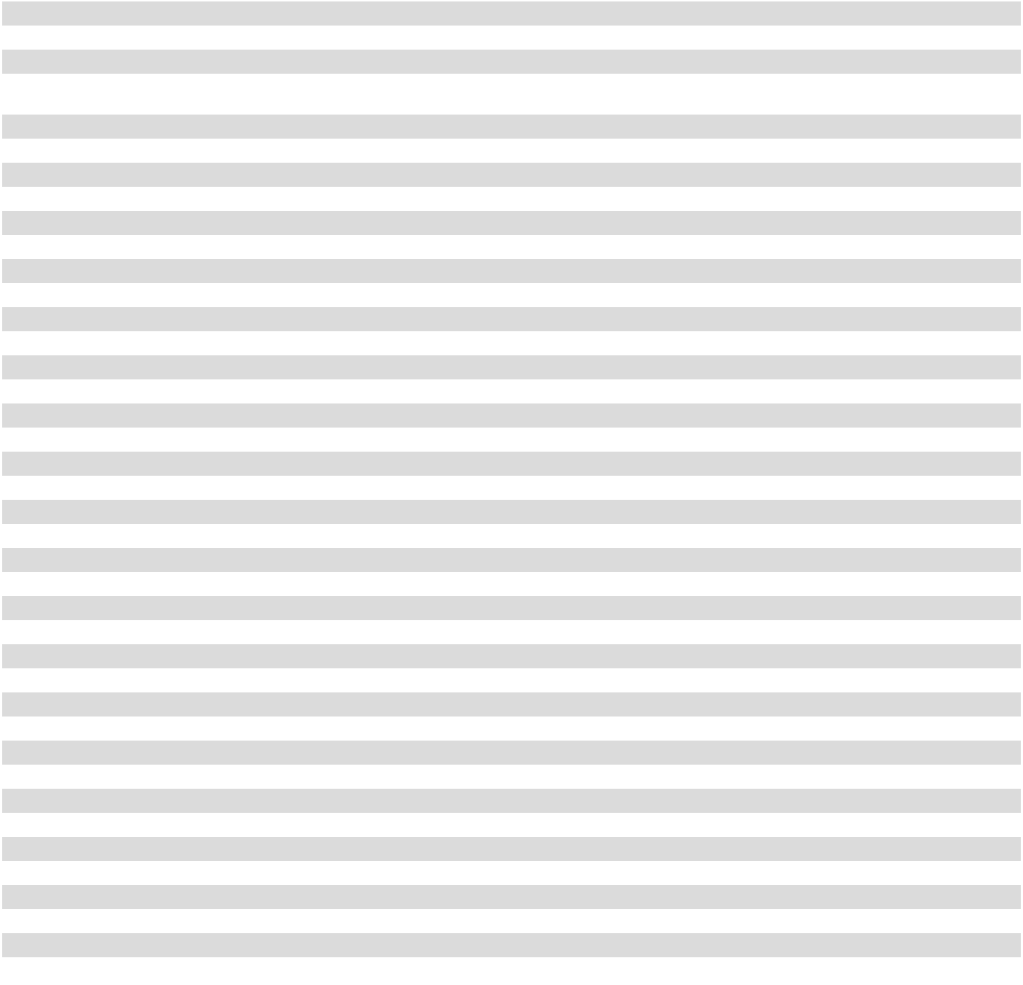

See accompanying notes to consolidated financial statements.

44

COCA-COLA CONSOLIDATED, INC.

CONSOLIDATED STATEMENTS OF CHANGES IN STOCKHOLDERS’ EQUITY (DEFICIT)

 |  |  |  |  |  |  |  |  |  |  |  |  |  | Accumulated |  | Treasury |  |  | Treasury
 |  |  |  |  | Class B |  |  | Additional |  |  | Retained |  |  | Accumulated |  |  |  |  |  | Stock - |  | Total
 |  | Common |  |  |  |  |  |  |  |  |  |  |  | Other |  |  | Stock - |  | Class B |  |  | Total
(in thousands, except per share data) |  |  |  |  | Common |  |  |  | Paid-in |  | Earnings |  | Comprehensive |  |  | Common |  |  | Common |  |  | Equity
(in thousands, except per share data) |  |  | Stock |  |  | Stock |  |  | Capital |  | (Deficit) |  | (Loss) Income |  |  |  | Stock |  |  | Stock |  | (Deficit)
Balance on December 31, 2022 |  | $ | 114,314 |  | $ | 16,328 |  | $ | 18,375 |  | $1,112,462 |  | $ | (84,837) |  | $ | (60,845) |  | $ | (409) |  | $1,115,388
Net income |  |  | — |  |  | — |  |  | — | 408,375 |  |  |  | — |  |  | — |  |  | — | 408,375
Other comprehensive income, net of
tax |  |  | — |  |  | — |  |  | — |  | — |  |  | 80,561 |  |  | — |  |  | — | 80,561
Dividends declared:
Common Stock ($1.80 per share) |  |  | — |  |  | — |  |  | — | (150,642) |  |  |  | — |  |  | — |  |  | — | (150,642)
Class B Common Stock ($1.80 per
share) |  |  | — |  |  | — |  |  | — | (18,084) |  |  |  | — |  |  | — |  |  | — | (18,084)
Balance on December 31, 2023 |  | $ | 114,314 |  | $ | 16,328 |  | $ | 18,375 |  | $1,352,111 |  | $ | (4,276) |  | $ | (60,845) |  | $ | (409) |  | $1,435,598
Net income |  |  | — |  |  | — |  |  | — | 633,125 |  |  |  | — |  |  | — |  |  | — | 633,125
Other comprehensive income, net of
tax |  |  | — |  |  | — |  |  | — |  | — |  |  | 6,161 |  |  | — |  |  | — | 6,161
Dividends declared:
Common Stock ($0.35 per share) |  |  | — |  |  | — |  |  | — | (27,452) |  |  |  | — |  |  | — |  |  | — | (27,452)
Class B Common Stock ($0.35 per
share) |  |  | — |  |  | — |  |  | — | (3,517) |  |  |  | — |  |  | — |  |  | — | (3,517)
Share repurchases⁽¹⁾ |  |  | (5,987) |  |  | — |  |  | 5,389 | (559,084) |  |  |  | — |  |  | (66,622) |  |  | — | (626,304)
Balance on December 31, 2024 |  | $ | 108,327 |  | $ | 16,328 |  | $ | 23,764 |  | $1,395,183 |  | $ | 1,885 |  | $ | (127,467) |  | $ | (409) |  | $1,417,611
Net income |  |  | — |  |  | — |  |  | — | 570,582 |  |  |  | — |  |  | — |  |  | — | 570,582
Other comprehensive loss, net of tax |  |  | — |  |  | — |  |  | — |  | — |  |  | (7,890) |  |  | — |  |  | — | (7,890)
Dividends declared:
Common Stock ($1.00 per share) |  |  | — |  |  | — |  |  | — | (76,625) |  |  |  | — |  |  | — |  |  | — | (76,625)
Class B Common Stock ($1.00 per
share) |  |  | — |  |  | — |  |  | — | (10,048) |  |  |  | — |  |  | — |  |  | — | (10,048)
Share repurchases⁽²⁾ |  |  | (20,322) |  |  | — |  |  | — | (2,578,276) |  |  |  | — |  |  | (34,755) |  |  | — | (2,633,353)
Retirement of Treasury Stock |  |  | (31,488) |  |  | (6,281) |  |  | — | (124,862) |  |  |  | — |  |  | 162,222 |  |  | 409 |  | —
Balance on December 31, 2025 |  | $ | 56,517 |  | $ | 10,047 |  | $ | 23,764 |  | $ (824,046) |  | $ | (6,005) |  | $ | — |  | $ | — |  | $ (739,723)
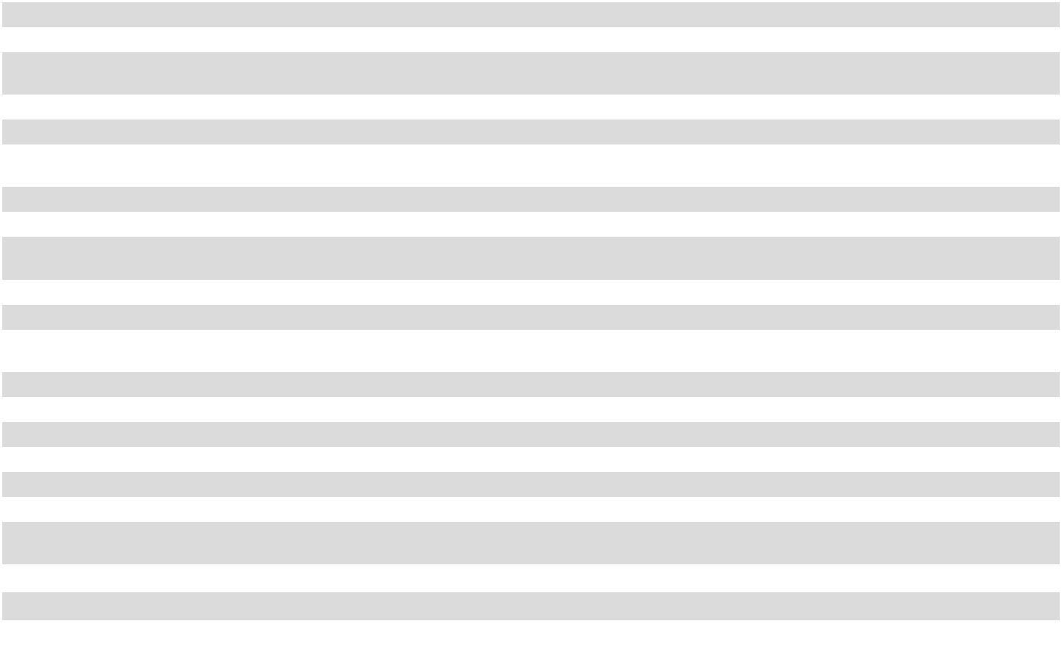

- The share repurchases relate to shares repurchased in a tender offer and a separate share repurchase transaction with a subsidiary of The Coca-Cola Company, as well as shares repurchased under a separate share repurchase program approved by the Board of Directors (as discussed in Note 5).

- The share repurchases relate to the Repurchase (as defined in Note 2), as well as shares repurchased under a separate share repurchase program approved by the Board of Directors (as discussed in Note 5).

See accompanying notes to consolidated financial statements.

45

COCA-COLA CONSOLIDATED, INC.

NOTES TO CONSOLIDATED FINANCIAL STATEMENTS

- Description of Business and Summary of Critical Accounting Policies Description of Business

Coca-Cola Consolidated, Inc. (the “Company”) distributes, markets and manufactures nonalcoholic beverages, primarily products of The Coca-Cola Company, and is the largest Coca-Cola bottler in the United States. Approximately 85% of the Company’s total bottle/ can sales volume to retail customers consists of products of The Coca-Cola Company, which include some of the most recognized and popular beverage brands in the world. The Company also distributes products for several other beverage companies, including Monster Energy Company and Keurig Dr Pepper Inc.

The Company offers a range of nonalcoholic beverage products and flavors, including both sparkling and still beverages, designed to meet the demands of its consumers. Sparkling beverages are carbonated beverages and the Company’s principal sparkling beverage is Coca-Cola. Still beverages include energy products and noncarbonated beverages such as bottled water, ready-to-drink tea, ready-to-drink coffee, enhanced water, juices and sports drinks.

The Company’s products are sold and distributed in the United States through various channels, which include selling directly to customers, including grocery stores, mass merchandise stores, club stores, convenience stores and drug stores, selling to on-premise locations, where products are typically consumed immediately, such as restaurants, schools, amusement parks and recreational facilities, and selling through other channels such as vending machine outlets.

The Company manages its business on the basis of two operating segments. Nonalcoholic Beverages represents the vast majority of the Company’s consolidated net sales and income from operations. The additional operating segment, which includes the Red Classic subsidiaries, does not meet the quantitative threshold for separate reporting, and, therefore, has been reported as “All Other.”

Principles of Consolidation

The consolidated financial statements include the accounts and the consolidated operations of the Company and its majority-owned subsidiaries. All significant intercompany accounts and transactions have been eliminated.

Use of Estimates

The preparation of consolidated financial statements, in conformity with accounting principles generally accepted in the United States (“GAAP”), requires management to make estimates and assumptions that affect the reported amounts of assets and liabilities and the disclosure of contingent assets and liabilities at the date of the financial statements and the reported amounts of revenues and expenses during the reporting period. Actual results could differ from those estimates.

Cash and Cash Equivalents

Cash and cash equivalents include cash on hand, cash in banks and cash equivalents, which are highly liquid money market funds, time deposits, commercial paper and debt instruments with maturities of 90 days or less. The Company maintains cash deposits with major banks, which may exceed federally insured limits. The Company periodically assesses the financial condition of the institutions and believes the risk of any loss is minimal. Investments in debt securities with maturities of 90 days or less that the Company has the positive intent and ability to hold to maturity are carried at amortized cost and classified as held-to-maturity. Investments in debt securities that are not classified as held-to-maturity are carried at fair value and classified as either trading or available-for-sale.

Short-term Investments

Short-term investments include various instruments, such as U.S. Treasury securities, investment-grade corporate bonds and commercial paper instruments, with maturities of greater than three months, but less than one year. Short-term investments that the Company has the positive intent and ability to hold to maturity are carried at amortized cost and classified as held-to-maturity. Short-term investments that are not classified as held-to-maturity are carried at fair value and classified as available-for-sale.

Accounts Receivable, Trade

The Company sells its products and extends credit, generally without requiring collateral, based on an ongoing evaluation of the customer’s business prospects and financial condition. The Company evaluates the collectability of its trade accounts receivable based

46

on a number of factors, including the Company’s historic collections pattern and changes to a specific customer’s ability to meet its financial obligations. The Company typically collects payment from customers within 30 days from the date of sale.

Allowance for Doubtful Accounts

The Company has established an allowance for doubtful accounts to adjust the recorded receivable to the estimated amount the Company believes will ultimately be collected. The Company’s allowance for doubtful accounts in the consolidated balance sheets includes a reserve for customer returns and an allowance for credit losses. The Company experiences customer returns primarily as a result of damaged or out-of-date product. At any given time, the Company estimates less than 1% of bottle/can sales and post-mix sales could be at risk for return by customers. Returned product is recognized as a reduction to net sales.

The Company estimates an allowance for credit losses, based on historic days’ sales outstanding trends, aged customer balances, previously written-off balances and expected recoveries up to balances previously written off, in order to present the net amount expected to be collected. Accounts receivable balances are written off when determined uncollectible and are recognized as a reduction to the allowance for credit losses.

Inventories

Inventories are stated at the lower of cost or net realizable value. Cost is determined on the first-in, first-out method for finished products and manufacturing materials and on the average cost method for plastic shells, plastic pallets and other inventories.

Property, Plant and Equipment

Property, plant and equipment are recorded at cost, less accumulated depreciation. Depreciation is calculated using the straight-line method over the estimated useful lives of the assets. Leasehold improvements on operating leases are depreciated over the shorter of the estimated useful lives or the term of the lease, including renewal options the Company determines are reasonably assured.
Additions and major replacements or betterments are added to the assets at cost. Maintenance and repair costs and minor replacements are charged to expense when incurred. When assets are replaced or otherwise disposed, the cost and accumulated depreciation are removed from the accounts and the gains or losses, if any, are reflected in the consolidated statements of operations. Gains or losses on the disposal of manufacturing equipment and manufacturing plants are included in cost of sales. Gains or losses on the disposal of all other property, plant and equipment are included in selling, delivery and administrative (“SD&A”) expenses.

The Company evaluates the recoverability of the carrying amount of its property, plant and equipment when events or circumstances indicate the carrying amount of an asset or asset group may not be recoverable. These evaluations are performed at a level where independent cash flows may be attributed to either an asset or an asset group. If the Company determines the carrying amount of an asset or asset group is not recoverable based upon the expected undiscounted future cash flows of the asset or asset group, an impairment loss is recorded equal to the excess of the carrying amounts over the estimated fair values of the long-lived assets.

Leases

The Company leases office and warehouse space, machinery and other equipment under noncancelable operating lease agreements and also leases certain warehouse space under financing lease agreements. The Company uses the following policies and assumptions to evaluate its leases:

- Determining a lease: The Company assesses contracts at inception to determine whether an arrangement is or includes a lease, which conveys the Company’s right to control the use of an identified asset for a period of time in exchange for consideration. Operating lease right-of-use assets and associated liabilities are recognized at the commencement date and initially measured based on the present value of lease payments over the defined lease term.

- Allocating lease and non-lease components: The Company has elected the practical expedient to not separate lease and non-lease components for certain classes of underlying assets. The Company has equipment and vehicle lease agreements, which generally have the lease and associated non-lease components accounted for as a single lease component. The Company has real estate lease agreements with lease and non-lease components, which are accounted for separately where applicable.

- Calculating the discount rate: The Company calculates the discount rate based on the discount rate implicit in the lease, or if the implicit rate is not readily determinable from the lease, then the Company calculates an incremental borrowing rate using a portfolio approach. The incremental borrowing rate is calculated using the contractual lease term and the Company’s borrowing rate.

- Recognizing leases: The Company does not recognize leases with a contractual term of less than 12 months on its consolidated balance sheets. Lease expense for these short-term leases is expensed on a straight-line basis over the lease term.

47

- Including rent increases or escalation clauses: Certain leases contain scheduled rent increases or escalation clauses, which can be based on the Consumer Price Index or other rates. The Company assesses each contract individually and applies the appropriate variable payments based on the terms of the agreement.

- Including renewal options and/or purchase options: Certain leases include renewal options to extend the lease term and/or purchase options to purchase the leased asset. The Company assesses these options using a threshold of reasonably certain, which is a high threshold and, therefore, the majority of the Company’s leases do not include renewal periods or purchase options for the measurement of the right-of-use asset and the associated lease liability. For leases the Company is reasonably certain to renew or purchase, those options are included within the lease term and, therefore, included in the measurement of the right-of-use asset and the associated lease liability.

- Including options to terminate: Certain leases include the option to terminate the lease prior to its scheduled expiration. This allows a contractually bound party to terminate its obligation under the lease contract, typically in return for an agreed-upon financial consideration. The terms and conditions of the termination options vary by contract.

- Including residual value guarantees, restrictions or covenants: The Company’s lease agreements do not contain residual value guarantees, restrictions or covenants.

Internal Use Software

The Company capitalizes costs incurred in the development or acquisition of internal use software. The Company expenses costs incurred in the preliminary project planning stage. Costs, such as maintenance and training, are also expensed as incurred. Capitalized costs are amortized over their estimated useful lives using the straight-line method. Amortization expense for internal use software, which is included in depreciation expense, was $1.1 million in 2025, $1.0 million in 2024 and $1.7 million in 2023.

Goodwill

All business combinations are accounted for using the acquisition method. Goodwill is tested for impairment annually, or more frequently if facts and circumstances indicate such assets may be impaired. The Company performs its annual goodwill impairment test, which includes a qualitative assessment to determine whether it is more likely than not that the fair value of the goodwill is below its carrying value, as of the first day of the fourth quarter each year, and more often if there are significant changes in business conditions that could result in impairment.

All of the Company’s goodwill resides within one reporting unit within the Nonalcoholic Beverages reportable segment and, therefore, the Company has determined it has one reporting unit for the purpose of assessing goodwill for potential impairment. The Company uses its overall market capitalization as part of its estimate of fair value of the reporting unit and in assessing the reasonableness of the Company’s internal estimates of fair value.

When a quantitative analysis is considered necessary for the annual impairment analysis of goodwill, the Company develops an estimated fair value for the reporting unit considering three different approaches:

- market value, using the Company’s stock price plus outstanding debt;

- discounted cash flow analysis; and

- multiple of earnings before interest, taxes, depreciation and amortization based upon relevant industry data.

The estimated fair value of the reporting unit is then compared to its carrying amount, including goodwill. If the estimated fair value exceeds the carrying amount, goodwill is not considered impaired. If the carrying amount, including goodwill, exceeds its estimated fair value, any excess of the carrying value of goodwill of the reporting unit over its fair value is recorded as an impairment.

To the extent the actual and projected cash flows decline in the future or if market conditions or market capitalization significantly deteriorate, the Company may be required to perform an interim impairment analysis that could result in an impairment of goodwill.

During 2025, 2024 and 2023, the Company performed its annual impairment test of goodwill and determined there was no impairment of the carrying values of these assets.

Distribution Agreements and Customer Lists

The Company’s definite-lived intangible assets consist of distribution agreements and customer lists, which have estimated useful lives of 20 to 40 years and five to 12 years, respectively. These assets are amortized on a straight-line basis over their estimated useful lives.

48

Acquisition Related Contingent Consideration Liability

The acquisition related contingent consideration liability consists of the estimated amounts due to The Coca-Cola Company under the Company’s comprehensive beverage agreements (as amended, collectively, the “CBA”) with The Coca-Cola Company and Coca-Cola Refreshments USA, LLC (“CCR”), a wholly owned subsidiary of The Coca-Cola Company, over the useful life of the related distribution rights. The CBA relates to a multi-year series of transactions, which were completed in October 2017, through which the Company acquired and exchanged distribution territories and manufacturing plants (the “System Transformation”). Pursuant to the CBA, the Company is required to make quarterly acquisition related sub-bottling payments to CCR on a continuing basis in exchange for the grant of exclusive rights to distribute, promote, market and sell the authorized brands of The Coca-Cola Company and related products in certain distribution territories the Company acquired from CCR. This acquisition related contingent consideration is valued using a probability weighted discounted cash flow model based on internal forecasts and the weighted average cost of capital (“WACC”) derived from market data, which are considered Level 3 inputs.

Each reporting period, the Company adjusts its acquisition related contingent consideration liability related to the distribution territories subject to acquisition related sub-bottling payments to fair value by discounting future expected acquisition related sub-bottling payments required under the CBA using the Company’s estimated WACC. These future expected acquisition related sub-bottling payments extend through the life of the related distribution assets acquired in each distribution territory, which is generally 40 years. As a result, the fair value of the acquisition related contingent consideration liability is impacted by the Company’s WACC, management’s estimate of the acquisition related sub-bottling payments that will be made in the future under the CBA, and current acquisition related sub-bottling payments (all Level 3 inputs). Changes in any of these Level 3 inputs, particularly the underlying risk-free interest rate used to estimate the Company’s WACC, could result in material changes to the fair value of the acquisition related contingent consideration liability and could materially impact the amount of non-cash expense (or income) recorded each reporting period.

Pension and Postretirement Benefit Plans

The Company sponsors a pension plan (the “Bargaining Plan”) for certain employees under collective bargaining agreements. Benefits under the Bargaining Plan are determined in accordance with negotiated formulas for the respective participants. Contributions to the Bargaining Plan are based on actuarially determined amounts and are limited to the amounts currently deductible for income tax purposes. The Company also sponsors a postretirement healthcare plan for employees meeting specified qualifying criteria.

The expense and liability amounts recorded for the benefit plans reflect estimates related to interest rates, investment returns, employee turnover and age at retirement, mortality rates and healthcare costs. The Company determines an appropriate discount rate annually for the Bargaining Plan and the postretirement healthcare plan based on the Aon AA Above Median yield curve as of the measurement date and reviews the discount rate assumption at the end of each year. The service cost components of the net periodic benefit cost of the plans are charged to current operations, and the non-service cost components of the net periodic benefit cost of the plans are classified as other expense, net. In addition, certain other union employees are covered by plans provided by their respective union organizations and the Company expenses amounts as paid in accordance with union agreements.

Income Taxes

Income taxes are accounted for under the asset and liability method. Deferred tax assets and liabilities are recognized for the future tax consequences attributable to operating losses and tax credit carryforwards, as well as the differences between the financial statement carrying amounts of existing assets and liabilities and their respective tax bases. The effect on deferred tax assets and liabilities of a change in tax rates is recognized in income in the period that includes the enactment date.

A valuation allowance will be provided against deferred tax assets if the Company determines it is more likely than not such assets will not ultimately be realized.

The Company does not recognize a tax benefit unless it concludes that it is more likely than not that the benefit will be sustained on audit by the taxing authority based solely on the technical merits of the associated tax position. If the recognition threshold is met, the Company recognizes a tax benefit measured at the largest amount of the tax benefit that, in the Company’s judgment, is greater than 50% likely to be realized. The Company records interest and penalties related to uncertain tax positions in income tax expense.

Revenue Recognition

The Company’s sales are divided into two main categories: (i) bottle/can sales and (ii) other sales. Bottle/can sales include products packaged primarily in plastic bottles and aluminum cans. Bottle/can net pricing is based on the invoice price charged to customers reduced by any promotional allowances. Bottle/can net pricing per unit is impacted by the price charged per package, the sales volume generated for each package and the channels in which those packages are sold. Other sales include sales to other Coca-Cola bottlers,

49

post-mix sales, transportation revenue and equipment maintenance revenue. Post-mix products are dispensed through equipment that mixes fountain syrups with carbonated or still water, enabling fountain retailers to sell finished products to consumers in cups or glasses.

The Company’s contracts are derived from customer orders, including customer sales incentives, generated through an order processing and replenishment model. Generally, the Company’s service contracts and contracts related to the delivery of specifically identifiable products have a single performance obligation. Revenues do not include sales or other taxes collected from customers. The Company has defined its performance obligations for its contracts as either at a point in time or over time. Bottle/can sales, sales to other Coca-Cola bottlers and post-mix sales are recognized when control transfers to a customer, which is generally upon delivery and is considered a single point in time (“point in time”).

Other sales, which include revenue for service fees related to the repair of cold drink equipment and delivery fees for freight hauling and brokerage services, are recognized over time (“over time”). Revenues related to cold drink equipment repair are recognized as the respective services are completed using a cost-to-cost input method. Repair services are generally completed in less than one day but can extend up to one month. Revenues related to freight hauling and brokerage services are recognized as the delivery occurs using a miles driven output method. Generally, delivery occurs and freight charges are recognized in the same day. Over time sales orders open at the end of a financial period are not material to the consolidated financial statements.

Marketing Programs and Sales Incentives

The Company participates in various sales programs with The Coca-Cola Company, other beverage companies and customers to increase the sale of its products. Programs negotiated with customers include arrangements under which allowances can be earned for attaining agreed-upon sales levels. The cost of these various sales incentives is not considered a separate performance obligation and is included as a deduction to net sales.

Allowance payments made to customers can be conditional on the achievement of volume targets and/or marketing commitments. Payments made in advance are recorded as prepayments and amortized in the consolidated statements of operations over the relevant period for which the customer commitment is made. In the event there is no separate identifiable benefit or the fair value of such benefit cannot be established, the amortization of the prepayment is included as a deduction to net sales.

The nature of the Company’s contracts gives rise to several types of variable consideration, including prospective and retrospective rebates. The Company accounts for its prospective and retrospective rebates using the expected value method, which estimates the net price to the customer based on the customer’s expected annual sales volume projections.

Marketing and Other Funding Support

The Company receives marketing funding support payments in cash from The Coca-Cola Company and other beverage companies. The Company’s brand partners also provide funding related to the delivery of post-mix gallons to locally managed customers within the Company’s territories. Payments to the Company for marketing and other funding programs to promote bottle/can sales volume and fountain syrup sales volume are recognized as a reduction to cost of sales, primarily on a per unit basis, as the product is sold. Payments for periodic programs are recognized in the period during which they are earned.

Cash consideration received by a customer from a vendor is presumed to be a reduction of the price of the vendor’s products or services. As such, the cash received is accounted for as a reduction to cost of sales unless it is a specific reimbursement of costs or payments for services. Payments the Company receives from The Coca-Cola Company and other beverage companies for marketing and other funding support are classified as a reduction to cost of sales.

Commodity Derivative Instruments

The Company is subject to the risk of increased costs arising from adverse changes in certain commodity prices. In the normal course of business, the Company manages this risk through a variety of strategies, including the use of commodity derivative instruments. The Company does not use commodity derivative instruments for trading or speculative purposes. These commodity derivative instruments are not designated as hedging instruments under GAAP and are used as “economic hedges” to manage certain commodity price risk. The Company uses several different financial institutions for commodity derivative instruments to minimize the concentration of credit risk. While the Company would be exposed to credit loss in the event of nonperformance by these counterparties, the Company does not anticipate nonperformance by these counterparties.

Commodity derivative instruments held by the Company are marked to market on a quarterly basis and are recognized in earnings consistent with the expense classification of the underlying hedged item. The Company generally pays a fee for these commodity

50

derivative instruments, which is amortized over the corresponding period of each commodity derivative instrument. Settlements of commodity derivative instruments are included in cash flows from operating activities in the consolidated statements of cash flows.

All commodity derivative instruments are recorded at fair value as either assets or liabilities in the consolidated balance sheets. The Company has master agreements with the counterparties to its commodity derivative instruments that provide for net settlement of derivative transactions. Accordingly, the net amounts of derivative assets are recognized in either prepaid expenses and other current assets or other assets in the consolidated balance sheets and the net amounts of derivative liabilities are recognized in either other accrued liabilities or other liabilities in the consolidated balance sheets.

Risk Management Programs

The Company uses various insurance structures to manage costs related to workers’ compensation, auto liability, medical and other insurable risks. These structures consist of retentions, deductibles, limits and a diverse group of insurers that serve to strategically finance, transfer and mitigate the financial impact of losses to the Company. Losses are accrued using assumptions and procedures followed in the insurance industry, then adjusted for company-specific history and expectations.

Cost of Sales

Inputs representing a substantial portion of the Company’s cost of sales include: (i) purchases of finished products, (ii) raw material costs, including aluminum cans, plastic bottles, carbon dioxide and sweetener, (iii) concentrate costs and (iv) manufacturing costs, including labor, overhead and warehouse costs. In addition, cost of sales includes shipping, handling and fuel costs related to the movement of finished products from manufacturing plants to distribution centers, amortization expense of distribution rights, distribution fees of certain products and marketing credits and post-mix funding from brand companies.

Selling, Delivery and Administrative Expenses

SD&A expenses include the following: sales management labor costs, distribution costs resulting from transporting finished products from distribution centers to customer locations, distribution center overhead including depreciation expense, distribution center warehousing costs, delivery vehicles and cold drink equipment, point-of-sale expenses, advertising expenses, cold drink equipment repair costs, amortization of intangible assets and administrative support labor and operating costs.

Shipping and Handling Costs

Shipping and handling costs related to the movement of finished products from manufacturing plants to distribution centers are included in cost of sales. Shipping and handling costs directly related to the movement of finished products from distribution centers to customer locations, including distribution center warehousing costs, are included in SD&A expenses.

Stock Compensation

The Company has a long-term performance equity plan (the “Long-Term Performance Equity Plan”) under which awards are earned and granted to J. Frank Harrison, III, Chairman of the Board of Directors and Chief Executive Officer of the Company, based on the Company’s attainment during a performance period of performance measures specified by the Compensation Committee of the Company’s Board of Directors. Mr. Harrison may elect to have awards earned under the Long-Term Performance Equity Plan settled in cash and/or shares of Class B Common Stock (as defined below). See Note 2 for additional information on the Long-Term Performance Equity Plan.

Common Stock and Class B Common Stock

The Company has two classes of common stock outstanding, Common Stock, par value $1.00 per share (“Common Stock”), and Class B Common Stock, par value $1.00 per share (“Class B Common Stock”). The Common Stock is traded on The Nasdaq Global Select Market under the symbol “COKE.” There is no established public trading market for the Class B Common Stock. Shares of Class B Common Stock are convertible on a share-for-share basis into shares of Common Stock at any time at the option of the holder.

Each share of Common Stock is entitled to one vote per share and each share of Class B Common Stock is entitled to 20 votes per share at all meetings of the Company’s stockholders. Except as otherwise required by law, holders of the Common Stock and the Class B Common Stock vote together as a single class on all matters submitted to the Company’s stockholders, including the election of the Board of Directors. As a result, the holders of the Class B Common Stock control approximately 78% of the total voting power of the stockholders of the Company and control the election of the Board of Directors. In the event of liquidation, there is no preference between the two classes of common stock.

51

Treasury Stock Retirement

In the third quarter of 2025, the Company retired 31,488,535 shares of Common Stock and 6,281,140 shares of Class B Common Stock included in treasury stock. The retired treasury stock had a carrying value of $162.6 million. The retirement of treasury stock was recorded as a reduction to Common Stock and Class B Common Stock at par value, with the excess of carrying value over par value recorded as a deduction from retained (deficit) earnings. Subsequent to the retirement of the above treasury shares in the third quarter of 2025, all additional shares of the Company’s Common Stock that were repurchased during 2025 were immediately retired.

Stock Split

On March 4, 2025, the Company announced that its Board of Directors had approved a 10-for-1 forward stock split (the “Stock Split”) of Common Stock and Class B Common Stock. The Stock Split was effected through an amendment to the Company’s Restated Certificate of Incorporation (the “Amendment”). The Amendment also effected a proportionate increase in the number of authorized shares of Common Stock and Class B Common Stock. The Amendment obtained stockholder approval at the Company’s 2025 Annual Meeting of Stockholders, which took place on May 13, 2025. Each stockholder of record as of the close of business on May 16, 2025 received nine additional shares for each share of Common Stock or Class B Common Stock held as of such date reflected in the stockholder’s account on May 23, 2025. Trading began on a split-adjusted basis on May 27, 2025. The par value per share of Common Stock and Class B Common Stock remains unchanged. Accordingly, an amount equal to the par value of the additional shares issued in the Stock Split was reclassified from additional paid-in capital to Common Stock and Class B Common Stock in the Company’s consolidated financial statements. All references made to share or per share amounts in the accompanying consolidated financial statements and applicable disclosures have been retroactively adjusted to reflect the effects of the Stock Split.

Dividends

No cash dividend or dividend of property or stock other than stock of the Company, as specifically described in the Company’s Restated Certificate of Incorporation, as amended (the “Restated Certificate of Incorporation”), may be declared and paid on the Class B Common Stock unless an equal or greater dividend is declared and paid on the Common Stock. Under the Restated Certificate of Incorporation, the Board of Directors may declare dividends on the Common Stock without declaring equal or any dividends on the Class B Common Stock. Notwithstanding this provision, the Class B Common Stock has voting and conversion rights that allow the Class B Common Stock to participate equally on a per share basis with the Common Stock.

The Company’s Board of Directors has declared, and the Company has paid, dividends on the Common Stock and the Class B Common Stock and each class of common stock has participated equally in all dividends declared by the Board of Directors and paid by the Company since 1994. Dividends paid per share on both the Common Stock and the Class B Common Stock were $1.00 per share in 2025, $2.00 per share in 2024 and $0.50 per share in 2023. Total cash dividends paid were $86.7 million in 2025, $185.6 million in 2024 and $46.9 million in 2023.

Net Income Per Share

The Company applies the two-class method for calculating and presenting net income per share. The two-class method is an earnings allocation formula that determines earnings per share for each class of common stock according to dividends declared or accumulated and participation rights in undistributed earnings. Under this method:

- Income from continuing operations (“net income”) is reduced by the amount of dividends declared in the current period for each class of stock and by the contractual amount of dividends that must be paid for the current period.

- The remaining earnings (“undistributed earnings”) are allocated to the Common Stock and the Class B Common Stock to the extent each security may share in earnings as if all the earnings for the period had been distributed. The total earnings allocated to each security is determined by adding together the amount allocated for dividends and the amount allocated for a participation feature.

- The total earnings allocated to each security is then divided by the number of outstanding shares of the security to which the earnings are allocated to determine the earnings per share for the security.

- Basic and diluted net income per share data are presented for each class of common stock.

In applying the two-class method, the Company determined undistributed earnings should be allocated equally on a per share basis between the Common Stock and the Class B Common Stock due to the aggregate participation rights of the Class B Common Stock (i.e., the voting and conversion rights) and the Company’s history of paying dividends equally on a per share basis on the Common Stock and the Class B Common Stock.

The Class B Common Stock conversion rights allow the Class B Common Stock to participate in dividends equally with the Common Stock. Class B Common Stock is convertible into Common Stock on a one-for-one per share basis at any time at the option of the

52

holder. Accordingly, the holders of the Class B Common Stock can participate equally in any dividends declared on the Common Stock by exercising their conversion rights.

Basic net income per share excludes potential common shares that were dilutive and is computed by dividing net income available for common stockholders by the weighted average number of Common and Class B Common shares outstanding. Diluted net income per share for Common Stock and Class B Common Stock gives effect to all securities representing potential common shares that were dilutive and outstanding during the period. The Company does not have anti-dilutive shares.

Recently Adopted Accounting Pronouncements

In December 2023, the Financial Accounting Standards Board (the “FASB”) issued Accounting Standards Update (“ASU”) 2023-09, “Income Taxes (Topic 740): Improvements to Income Tax Disclosures,” which requires disclosure of specific categories in the rate reconciliation, including additional information for reconciling items that meet a quantitative threshold, and specific disaggregation of income taxes paid and tax expense. The amendment is effective for fiscal years beginning after December 15, 2024. The Company conformed to ASU 2023-09, effective December 31, 2025, using a retrospective approach and included the required disclosures in the income tax notes within the consolidated financial statements. The standard update did not affect the Company’s operating results.

Recently Issued Accounting Pronouncements

In November 2024, the FASB issued ASU 2024-03, “Income Statement - Reporting Comprehensive Income - Expense Disaggregation Disclosures (Subtopic 220-40): Disaggregation of Income Statement Expenses,” which requires disclosure of disaggregated income expenses, including purchases of inventory, employee compensation, depreciation, and intangible asset amortization, among other things. The amendment also requires companies to provide a qualitative description of expense captions not separately disaggregated, as well as the total amount of selling expenses and, annually, the entity’s definition of selling expenses. The amendment is effective for fiscal years beginning after December 15, 2026 and interim periods beginning after December 15, 2027. The Company is in the process of evaluating the impact ASU 2024-03 will have on its consolidated financial statements.

- Related Party Transactions J. Frank Harrison, III

As of December 31, 2025, J. Frank Harrison, III, Chairman of the Board of Directors and Chief Executive Officer of the Company, controlled 10,043,940 shares of Class B Common Stock, which represented approximately 78% of the total voting power of the outstanding Common Stock and Class B Common Stock on a consolidated basis.

The Coca-Cola Company

The Company’s business consists primarily of the distribution, marketing and manufacture of nonalcoholic beverages of

The Coca-Cola Company, which is the sole owner of the formulas under which the primary components of the Company’s soft drink products, either concentrate or syrup, are manufactured.

On November 7, 2025, the Company entered into a purchase agreement (“the Repurchase Agreement”) with Carolina Coca-Cola Bottling Investments, Inc. (the “Seller”), an indirect wholly owned subsidiary of The Coca-Cola Company, The Coca-Cola Company and J. Frank Harrison, III, Chairman of the Board of Directors and Chief Executive Officer of the Company, pursuant to which the Company agreed to purchase and the Seller agreed to sell all of the Seller’s shares of Common Stock for a cash payment in the aggregate amount of approximately $2.4 billion (the “Repurchase”). The closing of the Repurchase also occurred on November 7, 2025. The Company funded the purchase price for the Repurchase with cash on hand and a term loan obtained under a certain bridge loan agreement (the “Bridge Facility”), as further discussed in Note 20.

As a result of the Repurchase, The Coca-Cola Company does not own any shares of Common Stock or Class B Common Stock. The Coca-Cola Company no longer has the right to have a designee proposed by the Company for nomination to the Company’s Board of Directors in the Company’s annual proxy statement.

53

The following table summarizes the significant cash transactions between the Company and The Coca-Cola Company:

 |  |  |  |  |  | Fiscal Year
(in thousands) |  |  | 2025 |  |  | 2024 |  |  | 2023
Payments made by the Company to The Coca-Cola Company⁽¹⁾ |  | $ | 2,263,965 |  | $ | 2,109,748 |  | $ | 2,019,409
Payments made by The Coca-Cola Company to the Company |  |  | 382,017 |  |  | 274,322 |  |  | 253,972

- This excludes acquisition related sub-bottling payments made by the Company to CCR, a wholly owned subsidiary of The Coca-Cola Company, as well as the payment made in connection with the Repurchase (as further discussed above).

More than 80% of the payments made by the Company to The Coca-Cola Company were for concentrate, syrup, sweetener and other finished goods products, which were recorded in cost of sales in the consolidated statements of operations and represent the primary components of the soft drink products the Company manufactures and distributes. Payments made by the Company to

The Coca-Cola Company also included payments for marketing programs associated with large, national customers managed by

The Coca-Cola Company on behalf of the Company, which were recorded as a reduction to net sales in the consolidated statements of operations. Other payments made by the Company to The Coca-Cola Company related to cold drink equipment parts, fees associated with the rights to distribute certain brands and other customary items.

Payments made by The Coca-Cola Company to the Company included annual funding in connection with the Company’s agreement to support certain business initiatives developed by The Coca-Cola Company and funding associated with the delivery of post-mix products to various customers, both of which were recorded as a reduction to cost of sales in the consolidated statements of operations. Payments made by The Coca-Cola Company to the Company also included fountain product delivery and equipment repair services performed by the Company on The Coca-Cola Company’s equipment, all of which were recorded in net sales in the consolidated statements of operations.

Coca-Cola Refreshments USA, LLC

The CBA requires the Company to make quarterly acquisition related sub-bottling payments to CCR on a continuing basis in exchange for the grant of exclusive rights to distribute, promote, market and sell the authorized brands of The Coca-Cola Company and related products in certain distribution territories the Company acquired from CCR. These acquisition related sub-bottling payments are based on gross profit derived from the Company’s sales of certain beverages and beverage products that are sold under the same trademarks that identify a covered beverage, a beverage product or certain cross-licensed brands applicable to the System Transformation.

Acquisition related sub-bottling payments to CCR were $68.9 million in 2025, $64.3 million in 2024 and $28.2 million in 2023. The following table summarizes the liability recorded by the Company to reflect the estimated fair value of contingent consideration related to future expected acquisition related sub-bottling payments to CCR:

(in thousands) |  | December 31, 2025 |  |  | December 31, 2024
Current portion of acquisition related contingent consideration |  | $ | 74,938 |  | $ | 63,982
Noncurrent portion of acquisition related contingent consideration |  |  | 642,970 |  |  | 590,209
Total acquisition related contingent consideration |  | $ | 717,908 |  | $ | 654,191

Southeastern Container (“Southeastern”)

The Company is a shareholder of Southeastern, a plastic bottle manufacturing cooperative. The Company accounts for Southeastern as an equity method investment. The Company’s investment in Southeastern, which was classified as other assets in the consolidated balance sheets, was $21.3 million as of December 31, 2025 and $20.9 million as of December 31, 2024.

South Atlantic Canners, Inc. (“SAC”)

The Company is a shareholder of SAC, a manufacturing cooperative located in Bishopville, South Carolina. All of SAC’s shareholders are Coca-Cola bottlers and each has equal voting rights. The Company accounts for SAC as an equity method investment. The Company’s investment in SAC, which was classified as other assets in the consolidated balance sheets, was

$35.0 million as of December 31, 2025 and $25.3 million as of December 31, 2024. The Company also guarantees a portion of SAC’s debt. As of both December 31, 2025 and December 31, 2024, the Company was not required to guarantee any of SAC’s debt. See Note 21 for additional information.

54

The Company receives a fee for managing the day-to-day operations of SAC pursuant to a management agreement. Proceeds from management fees received from SAC, which were recorded as a reduction to cost of sales in the consolidated statements of operations, were $9.8 million in 2025, $9.5 million in 2024 and $9.3 million in 2023.

Coca-Cola Bottlers’ Sales & Services Company LLC (“CCBSS”)

Along with all other Coca-Cola bottlers in the United States and Canada, the Company is a member of CCBSS, a company formed to provide certain procurement and other services with the intention of enhancing the efficiency and competitiveness of the Coca-Cola bottling system. The Company accounts for CCBSS as an equity method investment and its investment in CCBSS is not material.

CCBSS negotiates the procurement for the majority of the Company’s raw materials, excluding concentrate, and the Company receives a rebate from CCBSS for the purchase of these raw materials. The Company had rebates due from CCBSS of $17.3 million on December 31, 2025 and $14.5 million on December 31, 2024, which were classified as accounts receivable, other in the consolidated balance sheets. Changes in rebates receivable relate to volatility in raw material prices and the timing of cash receipts of rebates.

In addition, the Company pays an administrative fee to CCBSS for its services. The Company incurred administrative fees to CCBSS of $2.9 million in 2025 and $2.8 million in both 2024 and 2023, which were classified as SD&A expenses in the consolidated statements of operations.

CONA Services LLC (“CONA”)

Along with certain other Coca-Cola bottlers, the Company is a member of CONA, an entity formed to provide business process and information technology services to its members. The Company accounts for CONA as an equity method investment. The Company’s investment in CONA, which was classified as other assets in the consolidated balance sheets, was $30.2 million as of December 31, 2025 and $27.5 million as of December 31, 2024.

Pursuant to an amended and restated master services agreement with CONA, the Company is authorized to use the Coke One North America system (the “CONA System”), a uniform information technology system developed to promote operational efficiency and uniformity among North American Coca-Cola bottlers. In exchange for the Company’s rights to use the CONA System and receive CONA-related services, it is charged service fees by CONA. The Company incurred service fees to CONA of $25.7 million in 2025, $26.7 million in 2024 and $27.5 million in 2023, which were classified as SD&A expenses in the consolidated statements of operations.

Related Party Leases

The Company leases its headquarters office facility and an adjacent office facility in Charlotte, North Carolina from Beacon Investment Corporation, of which J. Frank Harrison, III is the majority stockholder and each of Morgan H. Everett, Vice Chair of the Company’s Board of Directors, and the spouse of Ellison C. Glenn, the Company’s Chief Sales and Service Officer, is a minority stockholder. The annual base rent the Company is obligated to pay under this lease is subject to an adjustment for an inflation factor and the lease expires on December 31, 2029. The principal balance outstanding under this lease was $15.9 million on December 31, 2025 and $19.3 million on December 31, 2024. Rental payments for this lease were $4.1 million in 2025, $4.0 million in 2024 and $3.9 million in 2023.

Long-Term Performance Equity Plan

The Long-Term Performance Equity Plan compensates J. Frank Harrison, III based on the Company’s performance. Awards granted to Mr. Harrison under the Long-Term Performance Equity Plan are earned based on the Company’s attainment during a performance period of certain performance measures, each as specified by the Compensation Committee of the Company’s Board of Directors.
These awards may be settled in cash and/or shares of Class B Common Stock, based on the average of the closing prices of shares of Common Stock during the last 20 trading days of the performance period. Compensation expense for the Long-Term Performance Equity Plan, which was included in SD&A expenses in the consolidated statements of operations, was $10.7 million in 2025, $10.5 million in 2024 and $10.3 million in 2023.

- Revenue Recognition

The Company’s sales are divided into two main categories: (i) bottle/can sales and (ii) other sales. Bottle/can sales include products packaged primarily in plastic bottles and aluminum cans. Bottle/can net pricing is based on the invoice price charged to customers reduced by any promotional allowances. Bottle/can net pricing per unit is impacted by the price charged per package, the sales volume

55

generated for each package and the channels in which those packages are sold. Other sales include sales to other Coca-Cola bottlers, post-mix sales, transportation revenue and equipment maintenance revenue.

The Company’s contracts are derived from customer orders, including customer sales incentives, generated through an order processing and replenishment model. Generally, the Company’s service contracts and contracts related to the delivery of specifically identifiable products have a single performance obligation. Revenues do not include sales or other taxes collected from customers. The Company has defined its performance obligations for its contracts as either at a point in time or over time. Bottle/can sales, sales to other Coca-Cola bottlers and post-mix sales are recognized when control transfers to a customer, which is generally upon delivery and is considered a single point in time. Point in time sales accounted for approximately 99% of the Company’s net sales in 2025 and approximately 98% of the Company’s net sales in both 2024 and 2023.

Other sales, which include revenue for service fees related to the repair of cold drink equipment and delivery fees for freight hauling and brokerage services, are recognized over time. Revenues related to cold drink equipment repair are recognized as the respective services are completed using a cost-to-cost input method. Repair services are generally completed in less than one day but can extend up to one month. Revenues related to freight hauling and brokerage services are recognized as the delivery occurs using a miles driven output method. Generally, delivery occurs and freight charges are recognized in the same day. Over time sales orders open at the end of a financial period are not material to the consolidated financial statements.

The following table represents a disaggregation of revenue from contracts with customers:

 |  |  |  |  |  | Fiscal Year
(in thousands) |  |  | 2025 |  |  | 2024 |  |  | 2023
Point in time net sales:
Nonalcoholic Beverages - point in time |  | $ | 7,126,304 | $ |  | 6,781,744 | $ |  | 6,510,155
Total point in time net sales |  | $ | 7,126,304 |  | $ | 6,781,744 |  | $ | 6,510,155
Over time net sales:
Nonalcoholic Beverages - over time⁽¹⁾ |  | $ | 57,478 | $ |  | 57,624 | $ |  | 52,817
All Other - over time⁽¹⁾ |  |  | 44,273 |  |  | 60,348 |  |  | 90,886
Total over time net sales |  | $ | 101,751 |  | $ | 117,972 |  | $ | 143,703
Total net sales
 |  | $ | 7,228,055 |  | $ | 6,899,716 |  | $ | 6,653,858
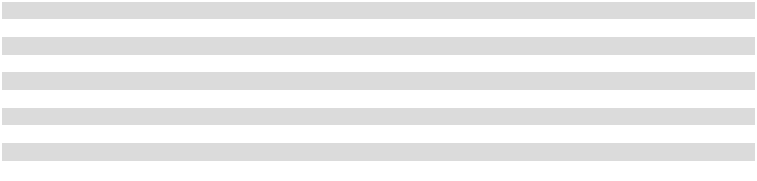

- Due to the liquidation and dissolution of the Data Ventures, Inc. operating segment as of December 31, 2025 (as discussed in Note 4), these figures have been retroactively adjusted for all periods presented to reflect the liquidation and dissolution of the Data Ventures, Inc. operating segment within the “All Other - over time” bucket and the merger of the Data Ventures, Inc. operating segment with the Nonalcoholic Beverages operating segment.

The Company’s allowance for doubtful accounts in the consolidated balance sheets includes a reserve for customer returns and an allowance for credit losses. The Company experiences customer returns primarily as a result of damaged or out-of-date product. At any given time, the Company estimates less than 1% of bottle/can sales and post-mix sales could be at risk for return by customers. Returned product is recognized as a reduction to net sales. The Company’s reserve for customer returns was $6.0 million as of December 31, 2025 and $5.2 million as of December 31, 2024.

The Company estimates an allowance for credit losses, based on historic days’ sales outstanding trends, aged customer balances, previously written-off balances and expected recoveries up to balances previously written off, in order to present the net amount expected to be collected. Accounts receivable balances are written off when determined uncollectible and are recognized as a reduction to the allowance for credit losses. Following is a summary of activity for the allowance for credit losses during 2025, 2024 and 2023:

 |  |  |  |  |  | Fiscal Year
(in thousands) |  |  | 2025 |  |  | 2024 |  |  | 2023
Beginning balance - allowance for credit losses |  | $ | 9,524 |  | $ | 11,560 |  | $ | 13,119
Additions charged to expenses and as a reduction to net sales |  |  | 3,215 |  |  | 3,080 |  |  | 2,639
Deductions |  |  | (7,513) |  |  | (5,116) |  |  | (4,198)
Ending balance - allowance for credit losses |  | $ | 5,226 |  | $ | 9,524 |  | $ | 11,560

56

- Segments

The Company evaluates segment reporting in accordance with FASB Accounting Standards Codification Topic 280, Segment Reporting, each reporting period, including evaluating the reporting package reviewed by the Chief Operating Decision Maker (the “CODM”). The Company has concluded the Chief Executive Officer, the Chief Operating Officer and the Chief Financial Officer, as a group, represent the CODM. Segment asset information is not provided to the CODM.

As of December 31, 2025, the Company has two operating segments, each identified by its unique products and services. Nonalcoholic Beverages represents the vast majority of the Company’s consolidated net sales and income from operations. The accounting policies of the Nonalcoholic Beverages operating segment are the same as those described in the summary of significant accounting policies presented in Note 1. The additional operating segment, which includes the Red Classic subsidiaries, does not meet the quantitative threshold for separate reporting and, therefore, has been reported as “All Other.”

Previously, the Company had three operating segments, Nonalcoholic Beverages and two additional operating segments, which included Data Ventures, Inc. and the Red Classic subsidiaries. Since the two additional operating segments did not meet the quantitative thresholds for separate reporting, either individually or in the aggregate, they were combined into “All Other.” As of December 31, 2025, the Data Ventures, Inc. operating segment was liquidated, dissolved and merged into the Nonalcoholic Beverages operating segment. For reporting purposes, all periods presented have been retroactively adjusted to reflect the dissolution of the Data Ventures, Inc. operating segment within the “All Other” bucket and the merger of the Data Ventures, Inc. operating segment with the Nonalcoholic Beverages operating segment.

The CODM uses net sales, gross profit and income from operations in the annual budgeting and forecasting process. Monthly, the CODM considers budget-to-actual variances and current year to prior year variances for these profit measures when making strategic business decisions and allocating resources to Company operations.

The Company’s segment results are as follows:
 |  |  |  |  |  | Fiscal Year 2025
(in thousands) |  |  | Nonalcoholic |  |  | All Other |  | Eliminations(1) |  |  |  | Total
 |  |  | Beverages |  |  | All Other |  |  |  |  |  | Total
Net sales |  | $ | 7,183,782 |  | $ | 325,969 |  | $ | (281,696) |  | $ | 7,228,055
Cost of goods sold |  |  | 4,380,271 |  |  | 186,810 |  |  | (211,388) |  |  | 4,355,693
Gross profit |  |  | 2,803,511 |  |  | 139,159 |  |  | (70,308) |  |  | 2,872,362
Selling, delivery and administrative expenses:
Payroll costs⁽²⁾ |  | $ | 1,203,097 | $ |  | 50,542 | $ |  | — | $ |  | 1,253,639
Fleet costs⁽³⁾ |  |  | 99,135 |  |  | 31,216 |  |  | — |  |  | 130,351
Depreciation and amortization expense⁽⁴⁾ |  |  | 115,744 |  |  | 2,204 |  |  | — |  |  | 117,948
All other segment items⁽⁵⁾ |  |  | 460,370 |  |  | 29,706 |  |  | (70,308) |  |  | 419,768
Total selling, delivery and administrative expenses |  |  | 1,878,346 |  |  | 113,668 |  |  | (70,308) |  |  | 1,921,706
Income from operations |  | $ | 925,165 |  | $ | 25,491 |  | $ | — |  | $ | 950,656
Total depreciation and amortization expense⁽⁴⁾
 |  | $ | 197,602 |  | $ | 20,928 |  | $ | — |  | $ | 218,530

57

 |  |  |  |  |  | Fiscal Year 2024
(in thousands) |  |  | Nonalcoholic |  |  | All Other |  | Eliminations⁽¹⁾ |  |  |  | Total
 |  |  | Beverages |  |  | All Other |  |  |  |  |  | Total
Net sales |  | $ | 6,839,368 |  | $ | 342,892 |  | $ | (282,544) |  | $ | 6,899,716
Cost of goods sold |  |  | 4,138,869 |  |  | 219,204 |  |  | (211,536) |  |  | 4,146,537
Gross profit |  |  | 2,700,499 |  |  | 123,688 |  |  | (71,008) |  |  | 2,753,179
Selling, delivery and administrative expenses:
Payroll costs⁽²⁾ |  | $ | 1,149,363 | $ |  | 50,668 | $ |  | — | $ |  | 1,200,031
Fleet costs⁽³⁾ |  |  | 103,444 |  |  | 31,475 |  |  | — |  |  | 134,919
Depreciation and amortization expense⁽⁴⁾ |  |  | 103,451 |  |  | 1,993 |  |  | — |  |  | 105,444
All other segment items⁽⁵⁾ |  |  | 437,014 |  |  | 26,429 |  |  | (71,008) |  |  | 392,435
Total selling, delivery and administrative expenses |  |  | 1,793,272 |  |  | 110,565 |  |  | (71,008) |  |  | 1,832,829
Income from operations |  | $ | 907,227 |  | $ | 13,123 |  | $ | — |  | $ | 920,350
Total depreciation and amortization expense⁽⁴⁾
 |  | $ | 177,527 |  | $ | 16,264 |  | $ | — |  | $ | 193,791
 |  |  |  |  |  | Fiscal Year 2023
(in thousands) |  |  | Nonalcoholic |  |  | All Other |  | Eliminations⁽¹⁾ |  |  |  | Total
 |  |  | Beverages |  |  | All Other |  |  |  |  |  | Total
Net sales |  | $ | 6,562,972 |  | $ | 367,422 |  | $ | (276,536) |  | $ | 6,653,858
Cost of goods sold |  |  | 3,999,292 |  |  | 263,307 |  |  | (207,452) |  |  | 4,055,147
Gross profit |  |  | 2,563,680 |  |  | 104,115 |  |  | (69,084) |  |  | 2,598,711
Selling, delivery and administrative expenses:
Payroll costs⁽²⁾ |  | $ | 1,097,684 | $ |  | 53,894 | $ |  | — | $ |  | 1,151,578
Fleet costs⁽³⁾ |  |  | 106,235 |  |  | 32,945 |  |  | — |  |  | 139,180
Depreciation and amortization expense⁽⁴⁾ |  |  | 95,330 |  |  | 2,104 |  |  | — |  |  | 97,434
All other segment items⁽⁵⁾ |  |  | 422,939 |  |  | 22,213 |  |  | (69,084) |  |  | 376,068
Total selling, delivery and administrative expenses |  |  | 1,722,188 |  |  | 111,156 |  |  | (69,084) |  |  | 1,764,260
Income from operations |  | $ | 841,492 |  | $ | (7,041) |  | $ | — |  | $ | 834,451
Total depreciation and amortization expense⁽⁴⁾
 |  | $ | 164,494 |  | $ | 12,472 |  | $ | — |  | $ | 176,966

- The entire net sales elimination represents net sales from the All Other segment to the Nonalcoholic Beverages segment. The entire cost of goods sold and SD&A eliminations represent costs incurred by the All Other segment in the generation of net sales to the Nonalcoholic Beverages segment.
- Payroll costs includes compensation, incentive plans, defined contribution plans, healthcare benefits and tax-advantaged spending accounts.

- Fleet costs includes fleet repairs, maintenance and fuel and oil costs.

- Total depreciation and amortization expense is included within both cost of goods sold and SD&A expenses. For segment reporting, the difference between total depreciation and amortization expense and the portion within SD&A expenses is the amount within cost of goods sold.

- All other segment items includes information technology costs, stewardship, insurance and other costs incurred in the selling and delivery of the Company’s products.

58

- Net Income Per Share

The following table sets forth the computation of basic net income per share and diluted net income per share under the two-class method. See Note 1 for additional information related to net income per share.

 |  |  |  |  |  | Fiscal Year
(in thousands, except per share data) |  |  | 2025 |  |  | 2024 |  |  | 2023
Numerator for basic and diluted net income per Common Stock and
Class B Common Stock share:
Net income |  | $ | 570,582 | $ |  | 633,125 | $ |  | 408,375
Less dividends: |  |  | 76,625 |  |  | 165,541 |  |  | 41,844
Common Stock |  |  | 76,625 |  |  | 165,541 |  |  | 41,844
Class B Common Stock |  |  | 10,048 |  |  | 20,094 |  |  | 5,024
Total undistributed earnings |  | $ | 483,909 |  | $ | 447,490 |  | $ | 361,507
Common Stock undistributed earnings – basic |  | $ | 425,826 | $ |  | 397,753 | $ |  | 322,760
Class B Common Stock undistributed earnings – basic |  |  | 58,083 |  |  | 49,737 |  |  | 38,747
Total undistributed earnings – basic |  | $ | 483,909 |  | $ | 447,490 |  | $ | 361,507
Common Stock undistributed earnings – diluted |  | $ | 425,308 | $ |  | 397,187 | $ |  | 322,120
Class B Common Stock undistributed earnings – diluted |  |  | 58,601 |  |  | 50,303 |  |  | 39,387
Total undistributed earnings – diluted |  | $ | 483,909 |  | $ | 447,490 |  | $ | 361,507
Numerator for basic net income per Common Stock share:
 |  | $ | 76,625 | $ |  | 165,541 | $ |  | 41,844
Dividends on Common Stock
Common Stock undistributed earnings – basic |  |  | 425,826 |  |  | 397,753 |  |  | 322,760
Numerator for basic net income per Common Stock share |  | $ | 502,451 |  | $ | 563,294 |  | $ | 364,604
Numerator for basic net income per Class B Common Stock share:
Dividends on Class B Common Stock |  | $ | 10,048 | $ |  | 20,094 | $ |  | 5,024
Class B Common Stock undistributed earnings – basic |  |  | 58,083 |  |  | 49,737 |  |  | 38,747
Numerator for basic net income per Class B Common Stock share |  | $ | 68,131 |  | $ | 69,831 |  | $ | 43,771
Numerator for diluted net income per Common Stock share:
Dividends on Common Stock |  | $ | 76,625 | $ |  | 165,541 | $ |  | 41,844
Dividends on Class B Common Stock assumed converted to Common Stock |  |  | 10,048 |  |  | 20,094 |  |  | 5,024
Common Stock undistributed earnings – diluted |  |  | 483,909 |  |  | 447,490 |  |  | 361,507
Numerator for diluted net income per Common Stock share |  | $ | 570,582 |  | $ | 633,125 |  | $ | 408,375
Numerator for diluted net income per Class B Common Stock share:
Dividends on Class B Common Stock |  | $ | 10,048 | $ |  | 20,094 | $ |  | 5,024
Class B Common Stock undistributed earnings – diluted |  |  | 58,601 |  |  | 50,303 |  |  | 39,387
Numerator for diluted net income per Class B Common Stock share |  | $ | 68,649 |  | $ | 70,397 |  | $ | 44,411
Denominator for basic net income per Common Stock and Class B
Common Stock share:
Common Stock weighted average shares outstanding – basic |  |  | 73,658 |  |  | 80,348 |  |  | 83,690
Class B Common Stock weighted average shares outstanding – basic |  |  | 10,047 |  |  | 10,047 |  |  | 10,047
Denominator for diluted net income per Common Stock and Class B
Common Stock share:
Common Stock weighted average shares outstanding – diluted (assumes |  |  | 83,807 |  |  | 90,524 |  |  | 93,923
conversion of Class B Common Stock to Common Stock) |  |  | 83,807 |  |  | 90,524 |  |  | 93,923
Class B Common Stock weighted average shares outstanding – diluted |  |  | 10,149 |  |  | 10,176 |  |  | 10,233


59

 |  |  |  |  |  | Fiscal Year
(in thousands, except per share data) |  |  | 2025 |  |  | 2024 |  |  | 2023
Basic net income per share:
Common Stock |  | $ | 6.82 | $ |  | 7.01 | $ |  | 4.36
Class B Common Stock
 |  | $ | 6.78 |  | $ | 6.95 |  | $ | 4.36
Diluted net income per share:
Common Stock |  | $ | 6.81 | $ |  | 6.99 | $ |  | 4.35
Class B Common Stock
 |  | $ | 6.76 |  | $ | 6.92 |  | $ | 4.34
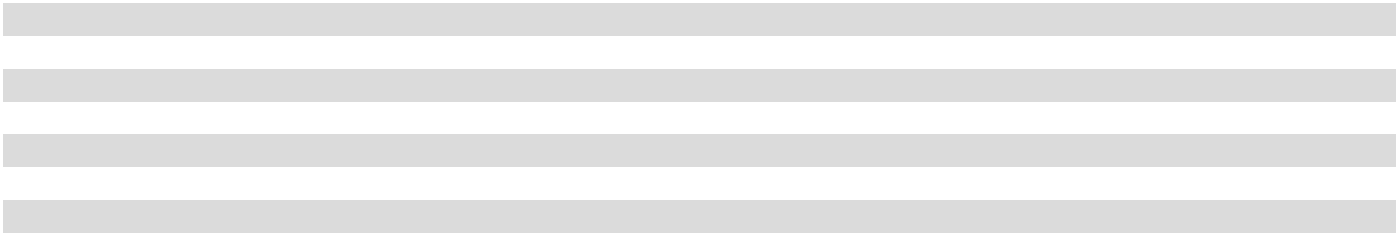

NOTES TO TABLE

- For purposes of the diluted net income per share computation for Common Stock, all shares of Class B Common Stock are assumed to be converted; therefore, 100% of undistributed earnings is allocated to Common Stock.
- For purposes of the diluted net income per share computation for Class B Common Stock, weighted average shares of Class B Common Stock are assumed to be outstanding for the entire period and not converted.

- For periods presented during which the Company has net income, the denominator for diluted net income per share for Common Stock and Class B Common Stock includes the dilutive effect of unvested performance shares relative to the Long-Term Performance Equity Plan. For periods presented during which the Company has net loss, the unvested performance shares granted pursuant to the Long-Term Performance Equity Plan are excluded from the computation of diluted net loss per share, as the effect would have been anti-dilutive. See Note 2 for additional information on the Long-Term Performance Equity Plan.

- The Long-Term Performance Equity Plan awards may be settled in cash and/or shares of Class B Common Stock. Once an election has been made to settle an award in cash, the dilutive effect of unvested performance shares relative to such award is prospectively removed from the denominator in the computation of diluted net income per share.

- The Company did not have anti-dilutive unvested performance shares for any periods presented.

- On November 7, 2025, the Company entered into the Repurchase Agreement with the Seller, The Coca-Cola Company and J. Frank Harrison, III, Chairman of the Board of Directors and Chief Executive Officer of the Company, pursuant to which the Company agreed to purchase and the Seller agreed to sell all 18,835,460 of the Seller’s shares of Common Stock.

- On March 4, 2025, the Company announced that its Board of Directors had approved the Stock Split of Common Stock and Class B Common Stock. The Stock Split was effected through the Amendment. The Amendment also effected a proportionate increase in the number of authorized shares of Common Stock and Class B Common Stock. The Amendment obtained stockholder approval at the Company’s 2025 Annual Meeting of Stockholders, which took place on May 13, 2025. Each stockholder of record as of the close of business on May 16, 2025 received nine additional shares for each share of Common Stock or Class B Common Stock held as of such date reflected in the stockholder’s account on May 23, 2025. Trading began on a split-adjusted basis on May 27, 2025. All share or per share amounts reflected above have been retroactively adjusted to reflect the effects of the Stock Split.

- On August 20, 2024, the Company announced that its Board of Directors had approved a share repurchase program (the “Share Repurchase Program”) under which the Company was initially authorized to repurchase up to $1.00 billion of Common Stock. On November 7, 2025, the Company’s Board of Directors reduced the total authorization under the Share Repurchase Program from $1.00 billion to $400.0 million. The share repurchase authorization is discretionary and has no expiration date. There were 1,778,081 shares of Common Stock repurchased under the Share Repurchase Program during 2025. Refer to “Item 5. Market for Registrant’s Common Equity, Related Stockholder Matters and Issuer Purchases of Equity Securities” for further details related to the Share Repurchase Program.

- Short-Term Investments

Short-term investments that the Company has the positive intent and ability to hold to maturity are carried at amortized cost and classified as held-to-maturity. Short-term investments that are not classified as held-to-maturity are carried at fair value and classified as available-for-sale. Realized gains and losses on available-for-sale investments are included in net income. Unrealized gains and losses, net of tax, on available-for-sale investments are included in the consolidated balance sheet as a component of accumulated other comprehensive (loss) income.

As of December 31, 2025, the Company did not have any short-term investments. As of December 31, 2024, all of the Company’s short-term investments were classified as available-for-sale and had weighted average maturities of less than one year. The Company did not identify any other-than-temporary impairment on its available-for-sale investments during 2025 or 2024.

60

As of December 31, 2024, the Company’s available-for-sale investments consisted of the following cost, unrealized positions and estimated fair value, disaggregated by class of instrument:

(in thousands) |  |  | Cost |  |  | Gross Unrealized |  |  |  |  | Estimated Fair Value
(in thousands) |  |  |  |  |  | Gains |  |  | Losses
U.S. Treasury securities |  | $ | 178,016 |  | $ | 67 |  | $ | (44) |  | $ | 178,039
Corporate bonds |  |  | 103,970 |  |  | 77 |  |  | (78) |  |  | 103,969
Commercial paper instruments |  |  | 17,657 |  |  | 6 |  |  | — |  |  | 17,663
Asset-backed securities |  |  | 1,534 |  |  | 5 |  |  | — |  |  | 1,539
Total short-term investments |  | $ | 301,177 |  | $ | 155 |  | $ | (122) |  | $ | 301,210

The sale and/or maturity of available-for-sale investments resulted in the following realized activity during 2025 and 2024:

(in thousands) |  |  | 2025 |  |  | 2024
Gross realized gains |  | $ | 69 |  | $ | —
Gross realized losses |  |  | (57) |  |  | —
Proceeds |  |  | 696,415 |  |  | 150,274

7. | Inventories
Inventories consisted of the following:
(in thousands) |  |  | December 31, 2025 |  |  | December 31, 2024
Finished products |  |  | $ | 218,380 |  | $ | 203,373
Manufacturing materials |  |  |  | 73,825 |  |  | 84,096
Plastic shells, plastic pallets and other inventories |  |  |  | 44,196 |  |  | 42,926
Total inventories |  |  | $ | 336,401 |  | $ | 330,395
8. | Prepaid Expenses and Other Current Assets
Prepaid expenses and other current assets consisted of the following:
(in thousands) |  |  | December 31, 2025 |  |  | December 31, 2024
Repair parts |  |  | $ | 35,109 |  | $ | 34,465
Prepaid taxes |  |  |  | 19,952 |  |  | 12,119
Prepaid software |  |  |  | 11,940 |  |  | 8,616
Prepaid marketing |  |  |  | 5,545 |  |  | 5,142
Commodity hedges at fair market value |  |  |  | 4,242 |  |  | 2,472
Other prepaid expenses and other current assets |  |  |  | 31,880 |  |  | 33,517
Total prepaid expenses and other current assets |  |  | $ | 108,668 |  | $ | 96,331

61

- Property, Plant and Equipment, Net

The principal categories and estimated useful lives of property, plant and equipment, net were as follows:

(in thousands) |  | December 31, 2025 |  |  | December 31, 2024 Estimated Useful Lives
Land |  | $ | 138,309 |  | $ | 132,543
Buildings |  |  | 534,167 |  |  | 493,810 |  | 8-50 years
Machinery and equipment |  |  | 663,064 |  |  | 563,834 |  | 5-20 years
Transportation equipment |  |  | 743,325 |  |  | 682,263 |  | 3-20 years
Furniture and fixtures |  |  | 110,819 |  |  | 113,156 |  | 3-10 years
Cold drink dispensing equipment |  |  | 466,537 |  |  | 456,984 |  | 3-17 years
Leasehold and land improvements |  |  | 217,833 |  |  | 192,282 |  | 5-20 years
Software for internal use |  |  | 23,567 |  |  | 50,293 |  | 3-10 years
Construction in progress |  |  | 53,307 |  |  | 77,707
Total property, plant and equipment, at cost |  |  | 2,950,928 |  |  | 2,762,872
Less: Accumulated depreciation and amortization |  |  | 1,346,323 |  |  | 1,257,605
Property, plant and equipment, net |  | $ | 1,604,605 |  | $ | 1,505,267

During 2025, 2024 and 2023, the Company performed periodic reviews of property, plant and equipment and determined no material impairment existed.

- Leases

Following is a summary of the weighted average remaining lease term and the weighted average discount rate for the Company’s leases:

 |  | December 31, 2025 |  | December 31, 2024
Weighted average remaining lease term:
Operating leases |  | 6.4 years |  | 6.4 years
Financing leases |  | 4.1 years |  | 2.9 years
Weighted average discount rate:
Operating leases | 4.4 % |  | 4.1 %
Financing leases | 4.8 % |  | 5.2 %
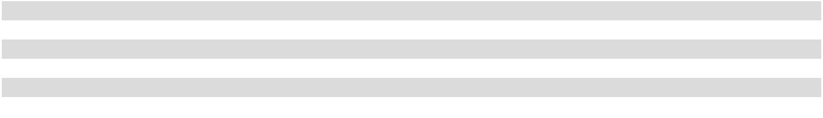

Following is a summary of the Company’s leases within the consolidated statements of operations:

 |  |  |  |  |  | Fiscal Year
(in thousands) |  |  | 2025 |  |  | 2024 |  |  | 2023
Operating lease costs |  | $ | 27,579 |  | $ | 29,616 |  | $ | 32,959
Short-term and variable leases |  |  | 7,952 |  |  | 12,816 |  |  | 15,995
Depreciation expense from financing leases |  |  | 1,051 |  |  | 1,647 |  |  | 1,646
Interest expense on financing lease obligations |  |  | 156 |  |  | 321 |  |  | 447
Total lease cost |  | $ | 36,738 |  | $ | 44,400 |  | $ | 51,047

62

The future minimum lease payments related to the Company’s leases include renewal options the Company has determined to be reasonably certain and exclude payments to landlords for real estate taxes and common area maintenance. Following is a summary of future minimum lease payments for all noncancelable operating leases and financing leases as of December 31, 2025:

(in thousands) |  |  | Operating Leases |  |  | Financing Leases
2026 |  | $ | 28,530 |  | $ | 627
2027 |  |  | 24,969 |  |  | 338
2028 |  |  | 20,403 |  |  | 345
2029 |  |  | 19,095 |  |  | 352
2030 |  |  | 11,447 |  |  | 268
Thereafter |  |  | 33,290 |  |  | —
Total minimum lease payments including interest |  | $ | 137,734 |  | $ | 1,930
Less: Amounts representing interest |  |  | 18,246 |  |  | 186
Present value of minimum lease principal payments |  |  | 119,488 |  |  | 1,744
Less: Current portion of lease liabilities - operating and financing leases |  |  | 24,412 |  |  | 556
Noncurrent portion of lease liabilities - operating and financing leases |  | $ | 95,076 |  | $ | 1,188

Following is a summary of future minimum lease payments for all noncancelable operating leases and financing leases as of

December 31, 2024:

(in thousands) |  |  | Operating Leases |  |  | Financing Leases
2025 |  | $ | 26,799 |  | $ | 2,869
2026 |  |  | 24,578 |  |  | 1,233
2027 |  |  | 21,101 |  |  | 338
2028 |  |  | 16,427 |  |  | 345
2029 |  |  | 15,046 |  |  | 352
Thereafter |  |  | 27,482 |  |  | 268
Total minimum lease payments including interest |  | $ | 131,433 |  | $ | 5,405
Less: Amounts representing interest |  |  | 15,814 |  |  | 374
Present value of minimum lease principal payments |  |  | 115,619 |  |  | 5,031
Less: Current portion of lease liabilities - operating and financing leases |  |  | 23,257 |  |  | 2,685
Noncurrent portion of lease liabilities - operating and financing leases |  | $ | 92,362 |  | $ | 2,346

Following is a summary of the Company’s leases within the consolidated statements of cash flows:

 |  |  |  |  |  |  | Fiscal Year
(in thousands) |  |  |  | 2025 |  |  | 2024 |  |  | 2023
Cash flows from operating activities impact:
 | Operating leases |  | $ | 28,522 | $ |  | 32,102 | $ |  | 33,013
 | Interest payments on financing lease obligations |  |  | 156 |  |  | 321 |  |  | 447
Total cash flows from operating activities impact |  |  | $ | 28,678 |  | $ | 32,423 |  | $ | 33,460
Cash flows from financing activities impact:
 | Principal payments on financing lease obligations |  | $ | 1,809 | $ |  | 2,488 | $ |  | 2,303
Total cash flows from financing activities impact |  |  | $ | 1,809 |  | $ | 2,488 |  | $ | 2,303
11. | Distribution Agreements, Net
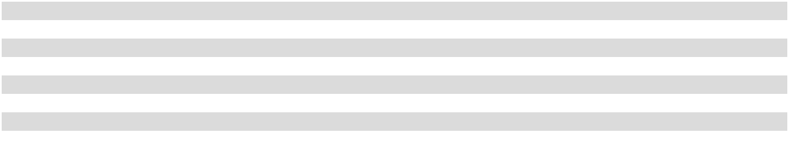

Distribution agreements, net, which are amortized on a straight-line basis and have estimated useful lives of 20 to 40 years, consisted of the following:

(in thousands) |  | December 31, 2025 |  |  | December 31, 2024
Distribution agreements at cost |  | $ | 990,191 |  | $ | 990,191
Less: Accumulated amortization |  |  | 222,831 |  |  | 197,939
Distribution agreements, net |  | $ | 767,360 |  | $ | 792,252

63

Assuming no impairment of distribution agreements, net, amortization expense in future years based upon recorded amounts as of December 31, 2025 will be $24.8 million, on average, for each fiscal year 2026 through 2030.

- Customer Lists, Net

Customer lists, net, which are amortized on a straight-line basis and have estimated useful lives of five to 12 years, consisted of the following:

(in thousands) |  | December 31, 2025 |  |  | December 31, 2024
Customer lists at cost |  | $ | 25,288 |  | $ | 25,288
Less: Accumulated amortization |  |  | 21,031 |  |  | 19,410
Customer lists, net |  | $ | 4,257 |  | $ | 5,878

Assuming no impairment of customer lists, net, amortization expense in future years based upon recorded amounts as of December 31, 2025 will be as follows for each fiscal year 2026 through 2030:

(in thousands) |  |  | Amortization expense
2026 |  | $ | 1,578
2027 |  |  | 1,293
2028 |  |  | 1,002
2029 |  |  | 384
2030 |  |  | —
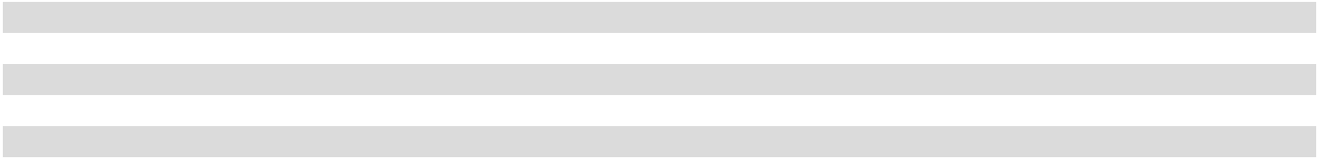

- Supply Chain Finance Program

The Company has an agreement with a third-party financial institution to facilitate a supply chain finance program (the “SCF program”), which allows qualifying suppliers to sell their receivables from the Company to the financial institution. The participating suppliers negotiate their outstanding receivable arrangements and associated fees directly with the financial institution, and the Company is not party to those agreements. Once a qualifying supplier elects to participate in the SCF program and reaches an agreement with the financial institution, the supplier elects which individual Company invoices it sells to the financial institution. Suppliers participating in the SCF program may sell their invoices to the financial institution for payment in full by the financial institution to the supplier by the original maturity date of the invoice, or discounted payment at an earlier date as agreed upon with the supplier. Our current payment terms with most of our suppliers are 90 days. The Company’s obligations to its suppliers, including amounts due and scheduled payment terms, are not impacted by a supplier’s participation in the SCF program.

All outstanding amounts related to suppliers participating in the SCF program are recorded in accounts payable, trade in the consolidated balance sheets, and associated payments are included in operating activities in the consolidated statements of cash flows. The Company’s outstanding confirmed obligations included in accounts payable, trade in the consolidated balance sheets were $66.6 million as of December 31, 2025 and $52.2 million as of December 31, 2024.

The following table is a rollforward of the Company’s outstanding obligations confirmed as valid under the SCF program for 2025 and 2024:

 |  |  | Fiscal Year
(in thousands) |  |  | 2025 |  |  | 2024
Confirmed obligations outstanding at the beginning of the year |  | $ | 52,167 |  | $ | 55,105
Invoices confirmed during the year |  |  | 262,818 |  |  | 230,346
Confirmed invoices paid during the year |  |  | (248,415) |  |  | (233,284)
Confirmed obligations outstanding at the end of the year |  | $ | 66,570 |  | $ | 52,167

64

14. | Other Accrued Liabilities
Other accrued liabilities consisted of the following:
(in thousands) |  |  | December 31, 2025 |  |  | December 31, 2024
Current portion of acquisition related contingent consideration |  |  | $ | 74,938 |  | $ | 63,982
Accrued insurance costs |  |  |  | 68,181 |  |  | 58,040
Accrued marketing costs |  |  |  | 62,467 |  |  | 55,879
Employee and retiree benefit plan accruals |  |  |  | 35,308 |  |  | 33,446
Accrued excise taxes related to share repurchases |  |  |  | 27,972 |  |  | 650
Accrued interest payable |  |  |  | 10,558 |  |  | 7,611
Accrued taxes (other than income taxes) |  |  |  | 6,485 |  |  | 6,821
All other accrued expenses |  |  |  | 21,328 |  |  | 20,258
Total other accrued liabilities |  |  | $ | 307,237 |  | $ | 246,687

- Commodity Derivative Instruments

The Company is subject to the risk of increased costs arising from adverse changes in certain commodity prices. In the normal course of business, the Company manages this risk through a variety of strategies, including the use of commodity derivative instruments. The Company does not use commodity derivative instruments for trading or speculative purposes. These commodity derivative instruments are not designated as hedging instruments under GAAP and are used as “economic hedges” to manage certain commodity price risk. The Company uses several different financial institutions for commodity derivative instruments to minimize the concentration of credit risk. While the Company would be exposed to credit loss in the event of nonperformance by these counterparties, the Company does not anticipate nonperformance by these counterparties.

Commodity derivative instruments held by the Company are marked to market on a quarterly basis and are recognized in earnings consistent with the expense classification of the underlying hedged item. The Company generally pays a fee for these commodity derivative instruments, which is amortized over the corresponding period of each commodity derivative instrument. Settlements of commodity derivative instruments are included in cash flows from operating activities in the consolidated statements of cash flows. The following table summarizes pre-tax changes in the fair values of the Company’s commodity derivative instruments and the classification of such changes in the consolidated statements of operations:

 |  |  |  |  |  | Fiscal Year
(in thousands) |  |  | 2025 |  |  | 2024 |  |  | 2023
Cost of sales |  | $ | 2,183 |  | $ | (728) |  | $ | 1,220
Selling, delivery and administrative expenses |  |  | (455) |  |  | (547) |  |  | (2,281)
Total gain (loss) |  | $ | 1,728 |  | $ | (1,275) |  | $ | (1,061)

All commodity derivative instruments are recorded at fair value as either assets or liabilities in the consolidated balance sheets. The Company has master agreements with the counterparties to its commodity derivative instruments that provide for net settlement of derivative transactions. Accordingly, the net amounts of derivative assets are recognized in either prepaid expenses and other current assets or other assets in the consolidated balance sheets and the net amounts of derivative liabilities are recognized in either other accrued liabilities or other liabilities in the consolidated balance sheets. The following table summarizes the fair values of the Company’s commodity derivative instruments and the classification of such instruments in the consolidated balance sheets:

(in thousands) |  | December 31, 2025 |  |  | December 31, 2024
Assets:
Prepaid expenses and other current assets | $ |  | 4,242 | $ |  | 2,472
Total assets |  | $ | 4,242 |  | $ | 2,472
Liabilities:
Other accrued liabilities | $ |  | 42 | $ |  | —
Total liabilities |  | $ | 42 |  | $ | —

65

The following table summarizes the Company’s gross commodity derivative instrument assets and gross commodity derivative instrument liabilities in the consolidated balance sheets:

(in thousands) |  | December 31, 2025 |  |  | December 31, 2024
Gross commodity derivative instrument assets |  | $ | 4,994 |  | $ | 2,472
Gross commodity derivative instrument liabilities |  |  | 794 |  |  | —

The following table summarizes the Company’s outstanding commodity derivative instruments:

(in thousands) |  |  | December 31, 2025 |  |  | December 31, 2024
Notional amount of outstanding commodity derivative instruments |  |  | $ | 12,714 |  | $ | 50,928
Latest maturity date of outstanding commodity derivative instruments |  |  |  | December 2026 |  |  | December 2025
16. | Fair Values of Financial Instruments

GAAP requires assets and liabilities carried at fair value to be classified and disclosed in one of the following categories:

- Level 1: Quoted market prices in active markets for identical assets or liabilities.

- Level 2: Observable market-based inputs or unobservable inputs that are corroborated by market data.

- Level 3: Unobservable inputs that are not corroborated by market data.

The below methods and assumptions were used by the Company in estimating the fair values of its financial instruments. There were no transfers of assets or liabilities between levels in any period presented.

Financial Instrument |  | Fair Value |  | Methods and Assumptions
Financial Instrument |  | Level |  | Methods and Assumptions
Deferred compensation plan |  | Level 1 |  | The fair value of the Company’s nonqualified deferred compensation plan for certain
assets and liabilities |  |  |  | executives and other highly compensated employees is based on the fair values of
 |  |  |  | associated assets and liabilities, which are held in mutual funds and are based on the
 |  |  |  | quoted market prices of the securities held within the mutual funds.
Pension plan assets |  | Level 1 |  | The fair values of the Company’s Level 1 pension plan assets, which are equity
 |  |  |  | securities and fixed income investment vehicles, are valued using the quoted market
 |  |  |  | prices of those securities which are actively traded on national exchanges.
Short-term investments |  | Level 1 |  | The fair values of the Company’s Level 1 short-term investments, which are U.S.
 |  |  |  | Treasury securities, corporate bonds and asset-backed securities, are based on the quoted
 |  |  |  | market prices of those securities which are actively traded on national exchanges.
Pension plan assets |  | Level 2 |  | The fair values of the Company’s Level 2 pension plan assets, which are investments
 |  |  |  | that are pooled with other investments in a commingled fund, are valued using the net
 |  |  |  | asset value produced by the fund manager. The assets within the commingled funds
 |  |  |  | have a readily determinable fair market value.
Short-term investments |  | Level 2 |  | The fair values of the Company’s Level 2 short-term investments, which are commercial
 |  |  |  | paper instruments, are based on estimated current market prices and have readily
 |  |  |  | determinable fair market values.
Commodity derivative |  | Level 2 |  | The fair values of the Company’s commodity derivative instruments are based on
instruments |  |  |  | current settlement values at each balance sheet date, which represent the estimated
 |  |  |  | amounts the Company would have received or paid upon termination of those
 |  |  |  | instruments. The Company’s credit risk related to the commodity derivative instruments
 |  |  |  | is managed by requiring high standards for its counterparties and periodic settlements.
 |  |  |  | The Company considers nonperformance risk in determining the fair values of
 |  |  |  | commodity derivative instruments.
Debt |  | Level 2 |  | The carrying amounts of the Company’s variable rate debt approximate the fair values
 |  |  |  | due to variable interest rates with short reset periods. The fair values of the Company’s
 |  |  |  | fixed rate debt are based on estimated current market prices.
Acquisition related |  | Level 3 |  | The fair value of the Company’s acquisition related contingent consideration is based on
contingent consideration |  |  |  | internal forecasts and the WACC derived from market data.
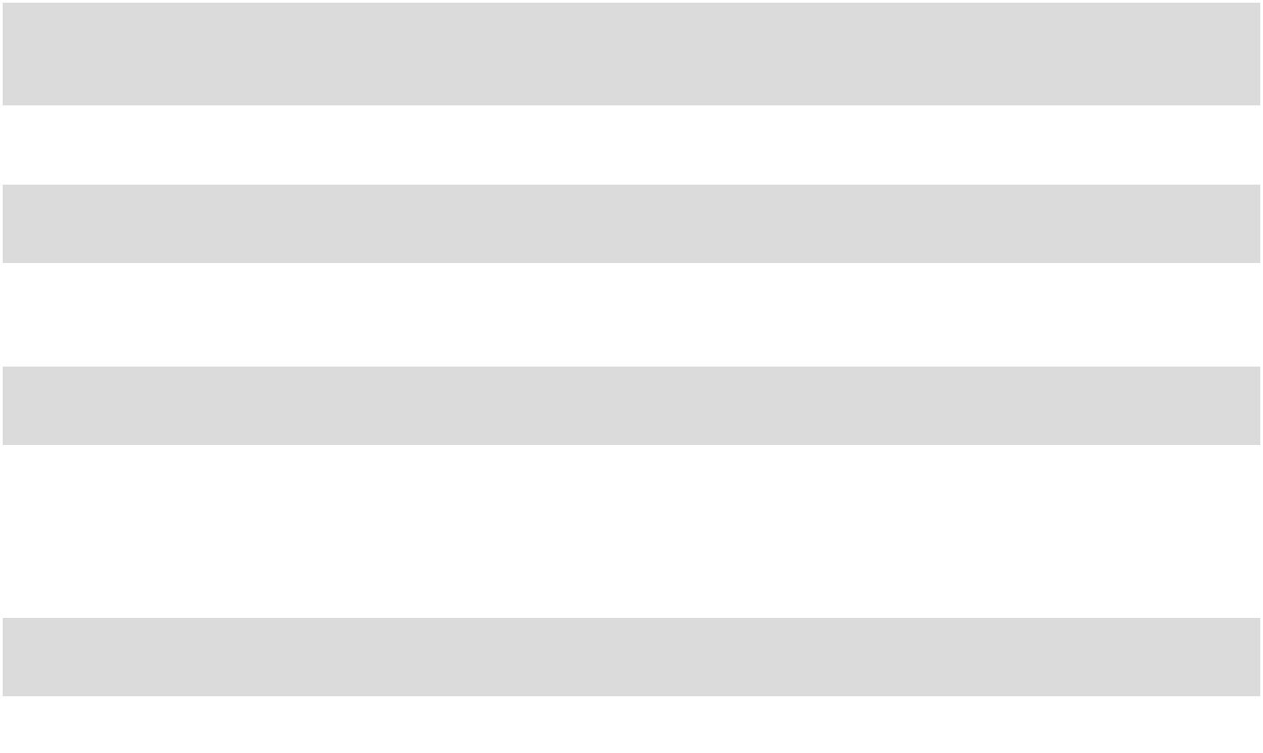

66

The following tables summarize the carrying amounts and the fair values by level of the Company’s deferred compensation plan assets and liabilities, short-term investments, pension plan assets, commodity derivative instruments, debt and acquisition related contingent consideration:

 |  |  |  |  |  |  | December 31, 2025
(in thousands) |  |  | Carrying |  |  | Total |  |  |  | Fair Value |  |  | Fair Value |  |  | Fair Value
 |  |  | Amount |  |  | Fair Value |  |  |  | Level 1 |  |  | Level 2 |  |  | Level 3
Assets:
Deferred compensation plan assets |  | $ | 95,195 | $ |  | 95,195 | $ |  |  | 95,195 | $ |  | — $ |  |  | —
Pension plan assets |  |  | 58,536 |  |  | 58,536 |  |  |  | 41,304 |  |  | 17,232 |  |  | —
Commodity derivative instruments |  |  | 4,242 |  |  | 4,242 |  |  |  | — |  |  | 4,242 |  |  | —
Liabilities:
Deferred compensation plan liabilities |  |  | 95,195 |  |  | 95,195 |  |  |  | 95,195 |  |  | — |  |  | —
Debt |  |  | 2,786,009 |  |  | 2,848,500 |  |  |  | — |  |  | 2,848,500 |  |  | —
Acquisition related contingent consideration |  |  | 717,908 |  |  | 717,908 |  |  |  | — |  |  | — |  |  | 717,908
Commodity derivative instruments |  |  | 42 |  |  | 42 |  |  |  | — |  |  | 42 |  |  | —
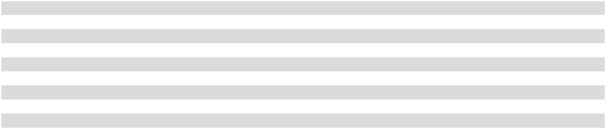

 |  |  |  |  |  |  | December 31, 2024
 |  |  | Carrying |  |  | Total |  |  |  | Fair Value |  |  | Fair Value |  |  | Fair Value
(in thousands) |  |  | Amount |  |  | Fair Value |  |  |  | Level 1 |  |  | Level 2 |  |  | Level 3
Assets:
Deferred compensation plan assets |  | $ | 81,123 | $ |  | 81,123 | $ |  |  | 81,123 | $ |  | — $ |  |  | —
Short-term investments |  |  | 301,210 |  |  | 301,210 |  |  |  | 283,547 |  |  | 17,663
Pension plan assets |  |  | 49,617 |  |  | 49,617 |  |  |  | 34,655 |  |  | 14,962 |  |  | —
Commodity derivative instruments |  |  | 2,472 |  |  | 2,472 |  |  |  | — |  |  | 2,472 |  |  | —
Liabilities:
Deferred compensation plan liabilities |  |  | 81,123 |  |  | 81,123 |  |  |  | 81,123 |  |  | — |  |  | —
Debt |  |  | 1,786,348 |  |  | 1,803,500 |  |  |  | — |  |  | 1,803,500 |  |  | —
Acquisition related contingent consideration |  |  | 654,191 |  |  | 654,191 |  |  |  | — |  |  | — |  |  | 654,191

The acquisition related contingent consideration was valued using a probability weighted discounted cash flow model based on internal forecasts and the WACC derived from market data, which are considered Level 3 inputs. Each reporting period, the Company adjusts its acquisition related contingent consideration liability related to the distribution territories subject to acquisition related sub-bottling payments to fair value by discounting future expected acquisition related sub-bottling payments required under the CBA using the Company’s estimated WACC.

The future expected acquisition related sub-bottling payments extend through the life of the related distribution assets acquired in each distribution territory, which is generally 40 years. As a result, the fair value of the acquisition related contingent consideration liability is impacted by the Company’s WACC, management’s estimate of the acquisition related sub-bottling payments that will be made in the future under the CBA and current acquisition related sub-bottling payments (all Level 3 inputs). Changes in any of these Level 3 inputs, particularly the underlying risk-free interest rate used to estimate the Company’s WACC, could result in material changes to the fair value of the acquisition related contingent consideration liability and could materially impact the amount of non-cash expense (or income) recorded each reporting period.

The acquisition related contingent consideration liability is the Company’s only Level 3 asset or liability. A summary of the Level 3 activity is as follows:

 |  |  | Fiscal Year
(in thousands) |  |  | 2025 |  |  | 2024
Beginning balance - Level 3 liability |  | $ | 654,191 |  | $ | 669,337
Payments of acquisition related contingent consideration |  |  | (68,884) |  |  | (64,312)
Reclassification to current payables |  |  | 700 |  |  | (10,000)
Increase in fair value |  |  | 131,901 |  |  | 59,166
Ending balance - Level 3 liability |  | $ | 717,908 |  | $ | 654,191

As of December 31, 2025 and December 31, 2024, a WACC of 8.5% and 9.3%, respectively, was utilized in the valuation of the Company’s acquisition related contingent consideration liability. The increase in the fair value of the acquisition related contingent

67

consideration liability in 2025 was primarily driven by decreases in the WACC used to calculate the fair value of the liability and higher projections of future cash flows in the distribution territories subject to acquisition related sub-bottling payments. This fair value adjustment was recorded in mark-to-market on acquisition related contingent consideration in the consolidated statement of operations for 2025.

For the next five years (including in fiscal year 2026), the Company anticipates that the amount it could pay annually under the acquisition related contingent consideration arrangements for the distribution territories subject to acquisition related sub-bottling payments will be in the range of approximately $50 million to $80 million.

- Income Taxes

The current income tax provision represents the estimated amount of income taxes paid or payable for the year, as well as changes in estimates from prior years. The deferred income tax provision (benefit) represents the change in deferred tax liabilities and assets. The following table presents the significant components of the provision for income taxes:

 |  |  |  |  |  | Fiscal Year
(in thousands) |  |  | 2025 |  |  | 2024 |  |  | 2023
Current: |  | $ | 149,255 | $ |  | 179,019 | $ |  | 158,475
Federal
State |  |  | 39,377 |  |  | 41,981 |  |  | 39,652
Total current provision |  | $ | 188,632 |  | $ | 221,000 |  | $ | 198,127
Deferred:
 |  | $ | 12,430 | $ |  | 958 | $ |  | (40,658)
Federal
State |  |  | 1,274 |  |  | 1,571 |  |  | (8,363)
Total deferred provision (benefit) |  | $ | 13,704 |  | $ | 2,529 |  | $ | (49,021)
Income tax expense
 |  | $ | 202,336 |  | $ | 223,529 |  | $ | 149,106

The Company’s effective income tax rate was 26.2% for 2025, 26.1% for 2024 and 26.7% for 2023. The following table provides a reconciliation of income tax expense at the statutory federal rate to actual income tax expense:

 |  |  |  |  |  |  |  |  | Fiscal Year
 |  |  | 2025 |  |  |  |  |  | 2024 |  |  |  |  |  | 2023
 |  |  | Income |  | % pre-tax |  |  |  | Income |  | % pre-tax |  |  |  | Income |  | % pre-tax
(in thousands) |  | tax expense |  |  | income |  |  | tax expense |  |  | income |  |  | tax expense |  |  | income
U.S. federal statutory expense |  | $ | 162,312 |  | 21.0 | % |  | $ | 179,898 |  | 21.0 | % |  | $ | 117,071 |  | 21.0 | %
State income taxes, net of federal |  |  | 30,188 | 4.0 |  |  |  |  | 32,638 | 3.8 |  |  |  |  | 21,494 | 3.9
benefit⁽¹⁾ |  |  | 30,188 |  |  |  |  |  | 32,638 |  |  |  |  |  | 21,494
Nontaxable/nondeductible items |  |  | 10,047 | 1.3 |  |  |  |  | 10,494 | 1.2 |  |  |  |  | 11,290 | 2.0
Changes in valuation allowance |  |  | 168 |  | — |  |  |  | 1,414 | 0.2 |  |  |  |  | 701 | 0.1
Adjustment for uncertain tax positions |  |  | 70 |  | — |  |  |  | 55 |  | — |  |  |  | 52 |  | —
Other, net |  |  | 126 |  | — |  |  |  | 215 |  | — |  |  |  | (257) | (0.1)
Tax credits |  |  | (575) | (0.1) |  |  |  |  | (1,185) | (0.1) |  |  |  |  | (1,245) | (0.2)
Income tax expense |  | $ | 202,336 |  | 26.2 % |  |  | $ | 223,529 |  | 26.1 % |  |  | $ | 149,106 |  | 26.7 %
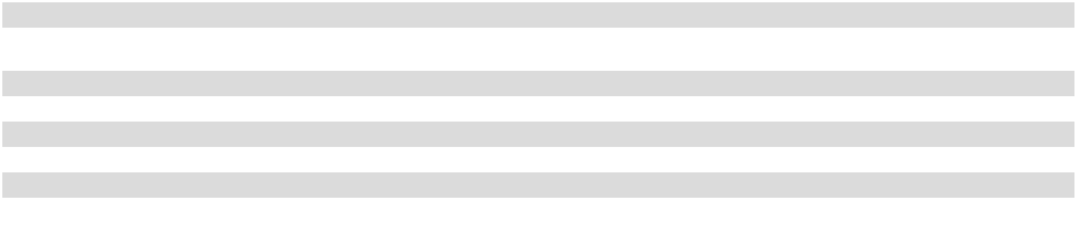

- The states that contribute to the majority (greater than 50%) of the tax effect in this category include Indiana, Maryland, Virginia and Tennessee for fiscal years 2025, 2024 and 2023.

Total cash income taxes paid in 2025 was $196.6 million, of which $155.0 million related to federal tax and $41.6 million related to state and local tax jurisdictions. Total cash income taxes paid in 2024 was $224.0 million, of which $180.0 million related to federal tax and $44.0 related to state and local tax jurisdictions. Total cash income taxes paid in 2023 was $200.8 million, of which $162.0 million related to federal tax and $38.8 million related to state and local tax jurisdictions. For 2025, 2024 and 2023, no cash taxes paid to any individual state or local jurisdiction met or exceeded 5% of total cash income taxes paid.

The Company records liabilities for uncertain tax positions related to income tax positions. These liabilities reflect the Company’s best estimate of the ultimate income tax liability based on known facts and information. Material changes in facts or information, as well as

68

the expiration of statutes of limitations and/or settlements with individual tax jurisdictions, may result in material adjustments to these estimates in the future.

The Company recognizes potential interest and penalties related to uncertain tax positions in income tax expense. During 2025, 2024 and 2023, the interest and penalties related to uncertain tax positions recognized in income tax expense were not material. In addition, the amount of interest and penalties accrued at December 31, 2025 and December 31, 2024 were not material.

The Company had uncertain tax positions, including accrued interest, of $0.5 million on December 31, 2025 and $0.4 million on December 31, 2024, all of which would affect the Company’s effective income tax rate if recognized.

A reconciliation of uncertain tax positions, excluding accrued interest, is as follows:

 |  |  |  |  |  | Fiscal Year
(in thousands) |  |  | 2025 |  |  | 2024 |  |  | 2023
Beginning balance - gross uncertain tax positions |  | $ | 374 |  | $ | 330 |  | $ | 285
Increase as a result of tax positions taken in the current year |  |  | 120 |  |  | 105 |  |  | 105
Reduction as a result of the expiration of the applicable statute of limitations |  |  | (61) |  |  | (61) |  |  | (60)
Ending balance - gross uncertain tax positions |  | $ | 433 |  | $ | 374 |  | $ | 330

Deferred income taxes are recorded based upon temporary differences between the financial statement and tax bases of assets and liabilities and available net operating loss and tax credit carryforwards. Temporary differences and carryforwards that comprised deferred income tax assets and liabilities were as follows:

(in thousands) |  | December 31, 2025 |  |  | December 31, 2024
Acquisition related contingent consideration |  | $ | 176,850 |  | $ | 160,120
Deferred compensation |  |  | 39,364 |  |  | 34,308
Accrued liabilities |  |  | 35,285 |  |  | 35,912
Operating lease liabilities |  |  | 29,435 |  |  | 28,299
Deferred revenue |  |  | 25,195 |  |  | 25,474
Postretirement benefits |  |  | 16,114 |  |  | 13,179
Transactional costs |  |  | 2,253 |  |  | 2,670
Net operating loss carryforwards |  |  | 564 |  |  | 754
Financing lease agreements |  |  | — |  |  | 287
Other |  |  | — |  |  | 956
Deferred income tax assets |  | $ | 325,060 |  | $ | 301,959
Less: Valuation allowance for deferred tax assets |  |  | 5,715 |  |  | 5,535
Net deferred income tax asset |  | $ | 319,345 |  | $ | 296,424
Depreciation | $ |  | (245,739) | $ |  | (212,926)
Intangible assets |  |  | (165,413) |  |  | (167,428)
Right-of-use assets - operating leases |  |  | (28,726) |  |  | (27,499)
Prepaid expenses |  |  | (10,399) |  |  | (9,784)
Inventory |  |  | (7,169) |  |  | (8,547)
Patronage dividend |  |  | (2,728) |  |  | (3,181)
Other |  |  | (2,909) |  |  | —
Deferred income tax liabilities |  | $ | (463,083) |  | $ | (429,365)
Net deferred income tax liability
Net deferred income tax liability |  | $ | (143,738) |  | $ | (132,941)
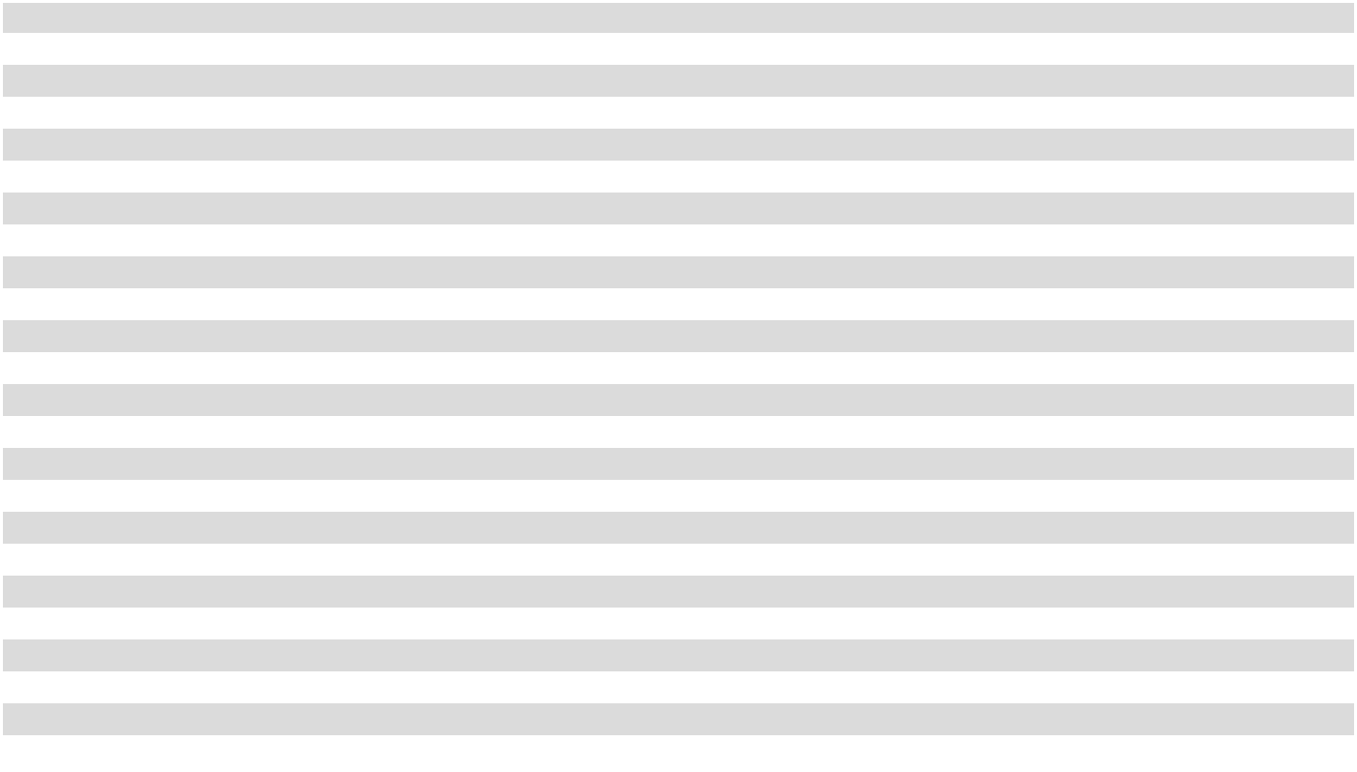

The Company’s deferred income tax assets and liabilities are subject to adjustment in future periods based on the Company’s ongoing evaluations of such deferred assets and liabilities and new information available to the Company.

Valuation allowances are recognized on deferred tax assets if the Company believes it is more likely than not that some or all of the deferred tax assets will not be realized. The Company believes the majority of the deferred tax assets will be realized due to the reversal of certain significant temporary differences and anticipated future taxable income from operations.

69

The valuation allowance of $5.7 million on December 31, 2025 and $5.5 million on December 31, 2024 was established primarily for certain loss carryforwards and deferred compensation.

As of December 31, 2025, the Company had no federal net operating losses and $11.3 million of state net operating losses available to reduce future income taxes, which expire in varying amounts through 2045.

Prior tax years beginning in year 2022 remain open to examination by the Internal Revenue Service, and various tax years beginning in year 2002 remain open to examination by certain state tax jurisdictions due to loss carryforwards.

On July 4, 2025, H.R. 1, commonly known as the “One Big Beautiful Bill Act” (the “OBBBA”), was enacted into law. The OBBBA is a reconciliation bill impacting businesses as it includes a broad range of tax reform provisions. The Company does not expect any material net impact to its consolidated financial statements as a result of the OBBBA.

- Benefit Plans Executive Benefit Plans

In addition to the Company’s Director Deferral Plan, the Company has four executive benefit plans: the Supplemental Savings Incentive Plan, the Long-Term Retention Plan, the Officer Retention Plan and the Long-Term Performance Plan. The Company also has a Long-Term Performance Equity Plan, as discussed in Note 2.

Pursuant to the Supplemental Savings Incentive Plan, as amended and restated effective July 30, 2024, eligible participants may elect to defer a portion of their annual salary and bonus. Participants are immediately vested in all deferred contributions they make and become fully vested in Company contributions upon completion of five years of service with the Company, termination of employment due to death or retirement or a change in control. Participant deferrals and Company contributions made in years prior to 2006 are invested in either a fixed benefit option or certain investment funds determined by the participant. Beginning in 2010, the Company may elect at its discretion to match up to 50% of the first 6% of salary, excluding bonuses, deferred by the participant. During 2025, 2024 and 2023, the Company matched 50% of the first 6% of salary, excluding bonuses, deferred by the participant. The Company may also make discretionary contributions to participants’ accounts.

Under the Director Deferral Plan, as amended and restated effective January 1, 2014, non-employee directors may defer payment of all or a portion of their annual retainer and meeting fees. There is no Company matching contribution under the Director Deferral Plan. The liability under these two deferral plans was as follows:

(in thousands) |  | December 31, 2025 |  |  | December 31, 2024
Current liabilities |  | $ | 10,372 |  | $ | 10,424
Noncurrent liabilities |  |  | 94,102 |  |  | 89,293
Total liability - Supplemental Savings Incentive Plan and Director Deferral Plan |  | $ | 104,474 |  | $ | 99,717

Under the Long-Term Retention Plan, as amended and restated effective July 30, 2024, the Company accrues a defined amount each year for an eligible participant based upon an award schedule. Amounts awarded may earn an investment return based on certain investment funds specified by the Company. Accrued benefits under the Long-Term Retention Plan are 50% vested until age 51. Beginning at age 51, the vesting percentage increases by 5% each year until the accrued benefit is fully vested at age 60. Participants receive payments from the plan upon retirement or, in certain instances, upon termination of employment. Payments are made in the form of monthly installments over a period of 10, 15 or 20 years. The liability under this plan was as follows:

(in thousands) |  | December 31, 2025 |  |  | December 31, 2024
Current liabilities |  | $ | 287 |  | $ | 268
Noncurrent liabilities |  |  | 19,934 |  |  | 14,660
Total liability - Long-Term Retention Plan |  | $ | 20,221 |  | $ | 14,928

Under the Officer Retention Plan, as amended and restated effective July 30, 2024, eligible participants may elect to receive an annuity payable in equal monthly installments over a 10-, 15- or 20-year period commencing at retirement or, in certain instances, upon termination of employment. The benefits under the Officer Retention Plan increase with each year of participation as set forth in an agreement between the participant and the Company. Accrued benefits under the Officer Retention Plan are 50% vested until age

70

- Beginning at age 51, the vesting percentage increases by 5% each year until the accrued benefit is fully vested at age 60. The liability under this plan was as follows:

(in thousands) |  | December 31, 2025 |  |  | December 31, 2024
Current liabilities |  | $ | 2,458 |  | $ | 3,489
Noncurrent liabilities |  |  | 33,780 |  |  | 32,486
Total liability - Officer Retention Plan |  | $ | 36,238 |  | $ | 35,975

Under the Long-Term Performance Plan, as amended and restated effective July 30, 2024, the Compensation Committee of the Company’s Board of Directors establishes dollar amounts to which a participant shall be entitled upon attainment of the applicable performance measures. Bonus awards under the Long-Term Performance Plan are made to executive officers based on the relative achievement of performance measures in terms of the Company-sponsored objectives or objectives related to the performance of the individual participant or of the subsidiary, division, department, region or function in which the participant is employed. The liability under this plan was as follows:

(in thousands) |  | December 31, 2025 |  |  | December 31, 2024
Current liabilities |  | $ | 10,234 |  | $ | 9,588
Noncurrent liabilities |  |  | 10,580 |  |  | 9,541
Total liability - Long-Term Performance Plan |  | $ | 20,814 |  | $ | 19,129

Pension Plan

The Company sponsors a pension plan (the “Bargaining Plan”) for certain employees under collective bargaining agreements. Benefits under the Bargaining Plan are determined in accordance with negotiated formulas for the respective participants. Contributions to the Bargaining Plan are based on actuarially determined amounts and are limited to the amounts currently deductible for income tax purposes. The Company updates its mortality assumptions used in the calculation of its pension liability each year using The Society of Actuaries’ latest mortality tables and mortality projection scales.

The following tables set forth pertinent information for the Bargaining Plan:

 |  |  | Fiscal Year
(in thousands) |  |  | 2025 |  |  | 2024
Beginning balance - Bargaining Plan projected benefit obligation |  | $ | 44,935 |  | $ | 46,123
Service cost |  |  | 3,703 |  |  | 4,330
Interest cost |  |  | 2,722 |  |  | 2,379
Plan amendments |  |  | 124 |  |  | —
Actuarial loss (gain) |  |  | 1,665 |  |  | (7,000)
Benefits paid |  |  | (1,049) |  |  | (897)
Ending balance - Bargaining Plan projected benefit obligation |  | $ | 52,100 |  | $ | 44,935

Changes in Projected Benefit Obligation

The plan assets of the Bargaining Plan were in excess of the projected benefit obligation and the accumulated benefit obligation as of both December 31, 2025 and December 31, 2024. The accumulated benefit obligation associated with the Bargaining Plan was $52.1 million on December 31, 2025 and $44.9 million on December 31, 2024.

Changes to demographic assumptions for the Bargaining Plan, as compared to the previous year, was the primary driver of the actuarial loss in 2025. The increase in the discount rate for the Bargaining Plan, as compared to the previous year, was the primary driver of the actuarial gain in 2024. The actuarial loss (gain), net of tax, was recorded in accumulated other comprehensive (loss) income in the consolidated balance sheets.

71

Change in Plan Assets

 |  |  |  |  |  |  |  |  |  |  |  |  |  |  | Fiscal Year
(in thousands) |  |  |  |  |  |  |  |  | 2025 |  |  |  |  |  |  |  |  |  |  |  |  | 2024
Beginning balance - Bargaining Plan assets at fair value |  |  |  |  |  |  |  |  | $ |  |  |  |  | 49,617 |  |  |  | $ |  |  |  | 47,321
Actual return on plan assets |  |  |  |  |  |  |  |  |  |  |  |  |  | 5,231 |  |  |  |  |  |  |  | 1,424
Employer contributions |  |  |  |  |  |  |  |  |  |  |  |  |  | 5,000 |  |  |  |  |  |  |  | 2,000
Benefits and expenses paid |  |  |  |  |  |  |  |  |  |  |  |  |  | (1,312) |  |  |  |  |  |  |  | (1,128)
Ending balance - Bargaining Plan assets at fair value |  |  |  |  |  |  |  |  | $ |  |  |  |  | 58,536 |  |  |  | $ |  |  |  | 49,617
Funded Status
(in thousands) |  |  |  |  |  |  |  |  | December 31, 2025 |  |  |  |  |  |  |  |  | December 31, 2024
Projected benefit obligation |  |  |  |  |  |  | $ |  |  |  |  |  |  | (52,100) |  |  | $ |  |  |  |  | (44,935)
Plan assets at fair value |  |  |  |  |  |  |  |  |  |  |  |  |  | 58,536 |  |  |  |  |  |  |  | 49,617
Net funded status - Bargaining Plan |  |  |  |  |  |  |  |  | $ |  |  |  |  | 6,436 |  |  |  | $ |  |  |  | 4,682
Amounts Recognized in the Consolidated Balance Sheets
(in thousands) |  |  |  |  |  |  |  |  | December 31, 2025 |  |  |  |  |  |  |  |  | December 31, 2024
Assets: |  |  |  |  |  |  | $ |  |  |  |  |  |  | 6,436 |  |  | $ |  |  |  |  | 4,682
Noncurrent assets
Total asset - Bargaining Plan |  |  |  |  |  |  |  |  | $ |  |  |  |  | 6,436 |  |  |  | $ |  |  |  | 4,682
Net Periodic Pension Cost
 |  |  |  |  |  |  |  |  |  |  |  |  |  | Fiscal Year
(in thousands) |  |  |  |  |  |  | 2025 |  |  |  |  |  |  | 2024 |  |  |  |  |  |  |  | 2023
Service cost |  |  |  |  |  | $ | 3,703 |  |  |  |  |  | $ | 4,330 |  |  |  |  |  |  | $ | 3,996
Interest cost |  |  |  |  |  |  | 2,722 |  |  |  |  |  |  | 2,379 |  |  |  |  |  |  |  | 2,079
Expected return on plan assets |  |  |  |  |  |  | (3,276) |  |  |  |  |  |  | (3,050) |  |  |  |  |  |  |  | (2,438)
Amortization of prior service costs |  |  |  |  |  |  | 16 |  |  |  |  |  |  |  |  |  | 16 |  |  |  |  | 16
Net periodic pension cost - Bargaining Plan |  |  |  |  |  | $ | 3,165 |  |  |  |  |  | $ | 3,675 |  |  |  |  |  |  | $ | 3,653
Significant Assumptions
 |  |  |  |  |  |  |  |  |  |  |  |  |  |  |  | Fiscal Year
 |  |  |  |  |  |  |  |  |  |  | 2025 |  |  | 2024 |  |  |  |  |  |  |  | 2023
Projected benefit obligation at the measurement date:
Discount rate - Bargaining Plan |  |  |  |  |  |  |  |  |  |  |  | 5.92 % |  |  |  |  | 5.89 % |  |  |  |  | 5.16 %
Weighted average rate of compensation increase |  |  |  |  |  |  |  |  |  |  |  |  | N/A |  |  |  |  | N/A |  |  |  |  | N/A
Net periodic pension cost for the fiscal year:
Discount rate - Bargaining Plan |  |  |  |  |  |  |  |  |  |  |  | 5.89 % |  |  |  |  | 5.16 % |  |  |  |  | 5.34 %
Weighted average expected long-term rate of return of plan assets - Bargaining Plan⁽¹⁾ |  |  |  |  |  |  |  |  |  |  |  | 7.00 % |  |  |  |  | 7.00 % |  |  |  |  | 7.00 %
Weighted average rate of compensation increase |  |  |  |  |  |  |  |  |  |  |  |  | N/A |  |  |  |  | N/A |  |  |  |  | N/A
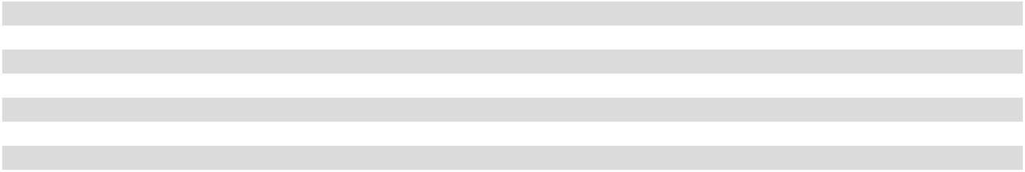

- The weighted average expected long-term rate of return assumption for the Bargaining Plan assets, which was used to compute net periodic pension cost, is based upon target asset allocation and is determined using forward-looking performance and duration assumptions set at the beginning of each fiscal year.

72

Cash Flows
The anticipated future pension benefit payments as of December 31, 2025 were as follows:
 | (in thousands) |  |  | Anticipated Future Payment
 | 2026 |  |  | $ | 1,535
2027 |  |  |  |  | 1,782
2028 |  |  |  |  | 2,043
2029 |  |  |  |  | 2,299
2030 |  |  |  |  | 2,562
2031 - 2035 |  |  |  |  | 17,154

The Company expects to make cash contributions to the Bargaining Plan of approximately $5 million during fiscal year 2026.

Plan Assets

All assets in the Bargaining Plan are invested in institutional investment funds managed by professional investment advisors which hold U.S. and international equity and debt securities. The objective of the Company’s investment philosophy is to earn the Bargaining Plan’s targeted rate of return over longer periods without assuming excess investment risk. The weighted average expected long-term rate of return assumption for the Bargaining Plan assets, which will be used to compute fiscal year 2026 net periodic pension cost, is based upon target asset allocation and is determined using forward-looking performance and duration assumptions in the context of historical returns and volatilities for each asset class. The Company evaluates the rate of return assumption on an annual basis.

The Company’s actual asset allocation at December 31, 2025 and December 31, 2024 and target asset allocation for fiscal year 2026 by asset category for the Bargaining Plan were as follows:

 |  | Percentage of Bargaining Plan |  |  |  |  |  |  |  | Target Asset
 |  | Assets at Fiscal Year-End |  |  |  |  |  |  |  | Allocation
 |  | 2025 |  | 2024 |  |  |  |  |  | 2026
U.S. debt securities |  |  | 54 | % |  |  | 50 | % |  | 50 | %
U.S. equity securities |  |  | 26 | % |  |  | 26 | % | 25 |  | %
International debt securities |  |  | 2 | % |  |  | 3 | % |  | — %
International equity securities |  |  | 11 | % |  |  | 13 | % | 13 |  | %
Cash and cash equivalents |  |  | 1 | % |  |  | 1 | % | 2 |  | %
Other |  |  | 6 | % |  |  | 7 | % | 10 |  | %
Total |  |  | 100 % |  |  |  | 100 % |  |  | 100 %

The expected long-term rate of return on assets for the Bargaining Plan as of December 31, 2025 was 7.00%.

Debt securities in the Bargaining Plan as of December 31, 2025 consisted primarily of investments in government and corporate bonds with a weighted average maturity of approximately 18 years. U.S. equity securities in the Bargaining Plan as of December 31, 2025 included large-capitalization, mid-capitalization and small-capitalization domestic equity funds represented by various indices. International equity securities in the Bargaining Plan as of December 31, 2025 included companies from both developed and emerging markets outside the United States. Other investments in the Bargaining Plan as of December 31, 2025 included alternative investment funds and other strategic opportunities. Cash and cash equivalents have a weighted average duration of less than one year.

The following table summarizes the Bargaining Plan assets, which are classified as Level 1 and Level 2 for fair value measurement.

The Company does not have any Level 3 pension plan assets. See Note 16 for additional information.

(in thousands) |  | December 31, 2025 |  |  | December 31, 2024
Pension plan assets - fixed income |  | $ | 32,491 |  | $ | 26,243
Pension plan assets - equity securities |  |  | 21,819 |  |  | 19,468
Pension plan assets - cash and cash equivalents |  |  | 588 |  |  | 671
Pension plan assets - other |  |  | 3,638 |  |  | 3,235
Total pension plan assets |  | $ | 58,536 |  | $ | 49,617

73

401(k) Savings Plan

The Company provides a 401(k) Savings Plan for substantially all of its employees who are not part of collective bargaining agreements and for certain employees who are part of collective bargaining agreements. The Company’s matching contribution for employees who are not part of collective bargaining agreements is discretionary, with the option to match contributions for eligible participants up to 5% based on the Company’s financial results. For all years presented, the Company matched the maximum 5% of participants’ contributions. The Company’s matching contribution for employees who are part of collective bargaining agreements is determined in accordance with negotiated formulas for the respective employees. The total expense for the Company’s matching contributions to the 401(k) Savings Plan was $35.1 million in 2025, $32.7 million in 2024 and $30.5 million in 2023.

Postretirement Benefits

The Company provides postretirement benefits for employees meeting specified qualifying criteria. The Company recognizes the cost of postretirement benefits, which consist principally of medical benefits, during employees’ periods of active service. The Company does not prefund these benefits and has the right to modify or terminate certain of these benefits in the future.

The following tables set forth pertinent information for the Company’s postretirement benefit plan:

Reconciliation of Activity

 |  |  | Fiscal Year
(in thousands) |  |  | 2025 |  |  | 2024
Benefit obligation at beginning of year |  | $ | 62,100 |  | $ | 63,828
Service cost |  |  | 1,072 |  |  | 1,163
Interest cost |  |  | 3,640 |  |  | 3,102
Plan participants’ contributions |  |  | 702 |  |  | 707
Actuarial loss (gain) |  |  | 10,539 |  |  | (2,920)
Benefits paid |  |  | (4,382) |  |  | (3,780)
Benefit obligation at end of year |  | $ | 73,671 |  | $ | 62,100

Updates to the health care claims assumptions for the postretirement benefit plan, as compared to the previous year, was the primary driver of the actuarial loss in 2025. Updates to demographic assumptions and the increase in the discount rate for the postretirement benefit plan, as compared to the previous year, partially offset by updates to claim trends, were the primary drivers of the actuarial gain in 2024. The actuarial loss (gain), net of tax, was recorded in accumulated other comprehensive (loss) income in the consolidated balance sheets.

Reconciliation of Plan Assets Fair Value

 |  |  |  | Fiscal Year
(in thousands) |  |  |  | 2025 |  |  | 2024
Fair value of plan assets at beginning of year |  |  | $ | — |  | $ | —
Employer contributions |  |  |  | 3,680 |  |  | 3,073
Plan participants’ contributions |  |  |  | 702 |  |  | 707
Benefits paid |  |  |  | (4,382) |  |  | (3,780)
Fair value of plan assets at end of year |  |  | $ | — |  | $ | —
Funded Status
(in thousands) |  |  | December 31, 2025 |  |  | December 31, 2024
Current liabilities |  |  | $ | (4,373) |  | $ | (3,598)
Noncurrent liabilities |  |  |  | (69,298) |  |  | (58,502)
Total liability - postretirement benefits |  |  | $ | (73,671) |  | $ | (62,100)

74

Net Periodic Postretirement Benefit Cost

 |  |  |  |  |  |  | Fiscal Year
(in thousands) |  |  |  | 2025 |  |  | 2024 |  |  | 2023
Service cost |  |  | $ | 1,072 |  | $ | 1,163 |  | $ | 1,085
Interest cost |  |  |  | 3,640 |  |  | 3,102 |  |  | 2,761
Recognized net actuarial loss |  |  |  | 187 |  |  | 44 |  |  | —
Net periodic postretirement benefit cost |  |  | $ | 4,899 |  | $ | 4,309 |  | $ | 3,846
Significant Assumptions
 |  |  |  |  |  |  | Fiscal Year
 |  |  |  | 2025 |  |  | 2024 |  |  | 2023
Benefit obligation at the measurement date:
Weighted average healthcare cost trend rate - Pre-Medicare |  |  |  | 8.07 % |  |  | 8.45 % |  |  | 7.88 %
Weighted average healthcare cost trend rate - Post-Medicare |  |  |  | 9.23 % |  |  | 9.73 % |  |  | 8.65 %
Benefit obligation discount rate |  |  |  | 5.41 % |  |  | 5.68 % |  |  | 5.02 %
Net periodic postretirement benefit cost discount rate for fiscal year |  |  |  | 5.68 % |  |  | 5.02 % |  |  | 5.19 %
Postretirement benefit expense - Pre-Medicare:
Weighted average healthcare cost trend rate |  |  |  | 8.45 % |  |  | 7.88 % |  |  | 6.58 %
Trend rate graded down to ultimate rate |  |  |  | 4.50 % |  |  | 4.50 % |  |  | 4.50 %
Ultimate rate year |  |  |  | 2034 |  |  | 2033 |  |  | 2032
Postretirement benefit expense - Post-Medicare:
Weighted average healthcare cost trend rate |  |  |  | 9.73 % |  |  | 8.65 % |  |  | 6.89 %
Trend rate graded down to ultimate rate |  |  |  | 4.50 % |  |  | 4.50 % |  |  | 4.50 %
Ultimate rate year |  |  |  | 2034 |  |  | 2033 |  |  | 2032
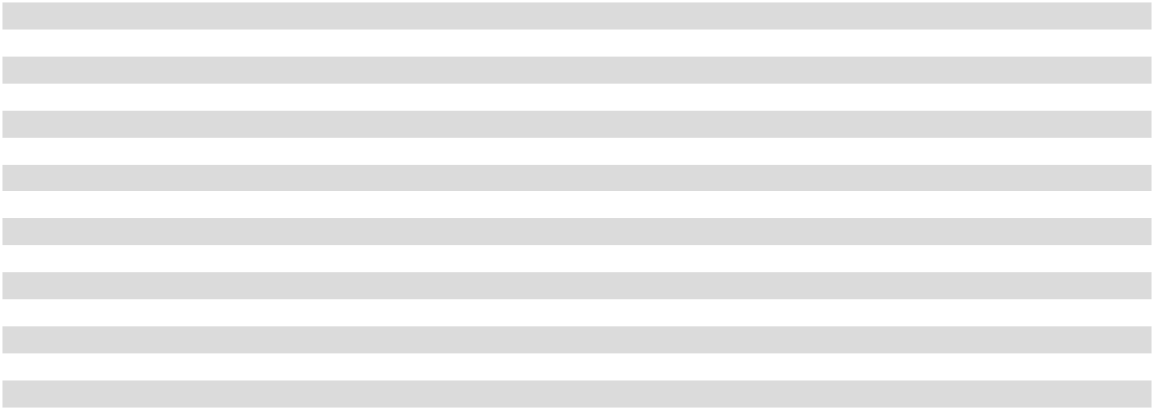

Cash Flows

The anticipated future postretirement benefit payments reflecting expected future service as of December 31, 2025 were as follows:

(in thousands) |  | Anticipated Future Payment
2026 |  | $ | 4,373
2027 |  |  | 5,016
2028 |  |  | 5,612
2029 |  |  | 5,824
2030 |  |  | 6,207
2031 - 2035 |  |  | 31,546

Accumulated Other Comprehensive Income (Loss)

A reconciliation of the gross amounts in accumulated other comprehensive income (loss) not yet recognized as components of net periodic benefit cost associated with the plans discussed above is as follows:

 |  | December 31, |  |  |  | Actuarial |  | Reclassification |  |  | December 31,
(in thousands) |  |  | 2024 |  | Gain (Loss) |  |  |  | Adjustments |  |  | 2025
Bargaining Plan:
Actuarial gain | $ |  | 5,362 | $ |  | 26 | $ |  | — | $ |  | 5,388
Prior service costs |  |  | (131) |  |  | (124) |  |  | 16 |  |  | (239)
Postretirement Medical:
Actuarial loss |  |  | (4,252) |  |  | (10,539) |  |  | 187 |  |  | (14,604)
Total within accumulated other comprehensive income (loss) |  | $ | 979 |  | $ | (10,637) |  | $ | 203 |  | $ | (9,455)
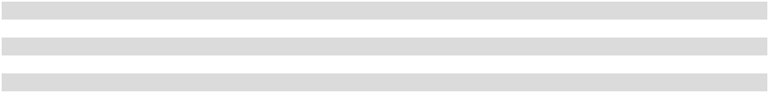

75

Multiemployer Pension Plans

Certain employees of the Company whose employment is covered under collective bargaining agreements participate in a multiemployer pension plan, the Employers-Teamsters Local Union Nos. 175 and 505 Pension Fund (the “Teamsters Plan”). The Company makes monthly contributions to the Teamsters Plan on behalf of such employees. The collective bargaining agreements covering the Teamsters Plan expire at various times through 2027. The Company expects these agreements will be renegotiated.

Participating in the Teamsters Plan involves certain risks in addition to the risks associated with single employer pension plans, as contributed assets are pooled and may be used to provide benefits to employees of other participating employers. If a participating employer stops contributing to the Teamsters Plan, the unfunded obligations of the Teamsters Plan may be borne by the remaining participating employers. If the Company chooses to stop participating in the Teamsters Plan, the Company could be required to pay the Teamsters Plan a withdrawal liability based on the underfunded status of the Teamsters Plan. The Company does not anticipate withdrawing from the Teamsters Plan.

In 2015, the Company increased its contribution rates to the Teamsters Plan, with additional increases occurring annually, as part of a rehabilitation plan, which was incorporated into the renewal of collective bargaining agreements with the unions effective

April 28, 2014 and adopted by the Company as a rehabilitation plan effective January 1, 2015. This is a result of the Teamsters Plan being certified by its actuary as being in “critical” status for the plan year beginning January 1, 2013.

The Company’s participation in the Teamsters Plan is outlined in the table below. A red zone represents less than 80% funding and requires a financial improvement plan (“FIP”) or rehabilitation plan (“RP”).

 |  |  |  |  |  | Fiscal Year
(in thousands) |  |  | 2025 |  |  | 2024 |  |  | 2023
Pension Protection Act Zone Status |  |  | Red |  |  | Red |  |  | Red
FIP or RP pending or implemented |  |  | Yes |  |  | Yes |  |  | Yes
Surcharge imposed |  |  | Yes |  |  | Yes |  |  | Yes
Contribution |  | $ | 1,052 |  | $ | 1,032 |  | $ | 999

According to the Teamsters Plan’s Form 5500 for both the plan years ended December 31, 2024 and December 31, 2023, the Company was not listed as providing more than 5% of the total contributions. At the date these consolidated financial statements were issued, a Form 5500 was not available for the plan year ended December 31, 2025.

The Company has a liability recorded for withdrawing from a multiemployer pension plan in 2008 and is required to make payments of approximately $1 million to this multiemployer pension plan each year through 2028. As of December 31, 2025, the Company had $2.4 million remaining on this liability.

19. | Other Liabilities
Other liabilities consisted of the following:
(in thousands) |  |  | December 31, 2025 |  |  | December 31, 2024
Noncurrent portion of acquisition related contingent consideration |  |  | $ | 642,970 |  | $ | 590,209
Accruals for executive benefit plans |  |  |  | 176,506 |  |  | 163,444
Noncurrent deferred proceeds from related parties |  |  |  | 94,048 |  |  | 97,112
Other |  |  |  | 5,231 |  |  | 8,794
Total other liabilities |  |  | $ | 918,755 |  | $ | 859,559

In 2017, The Coca-Cola Company agreed to provide the Company a fee to compensate the Company for the net economic impact of changes made by The Coca-Cola Company to the authorized pricing on sales of covered beverages produced at certain manufacturing plants owned by the Company (the “Legacy Facilities Credit”), which was recorded as a deferred liability and will be amortized as a reduction to cost of sales over a period of 40 years.

Also in 2017, upon the conversion of the Company’s then-existing bottling agreements pursuant to the CBA, the Company received a fee from CCR (the “Territory Conversion Fee”), which was recorded as a deferred liability and will be amortized as a reduction to cost of sales over a period of 40 years. Together, the Legacy Facilities Credit and the Territory Conversion Fee are “deferred proceeds from related parties.”

76

- Debt

Following is a summary of the Company’s debt:

 |  | Maturity |  | Interest |  | Interest |  | Public / |  | December 31, |  |  | December 31,
(in thousands) |  | Date |  | Rate |  | Paid |  | Nonpublic |  |  | 2025 |  |  | 2024
Senior bonds (the “2025 Senior Bonds”)⁽¹⁾ |  | 11/25/2025 |  | 3.800% |  | Semi-annually |  | Public |  | $ | — |  | $ | 350,000
Senior notes⁽²⁾ | 10/10/2026 |  | 3.930% |  |  | Quarterly |  | Nonpublic |  |  | 100,000 |  |  | 100,000
Term loan facility (the “Three-Year Term
Loan Facility”)⁽³⁾ | 12/8/2028 |  |  | Variable |  | Monthly |  | Nonpublic |  |  | 900,000 |  |  | —
Senior bonds (the “2029 Senior Bonds”)⁽⁴⁾ | 6/1/2029 |  | 5.250% |  |  | Semi-annually |  | Public |  |  | 700,000 |  |  | 700,000
Revolving credit facility⁽⁵⁾ | 6/10/2029 |  |  | Variable |  | Varies |  | Nonpublic |  |  | — |  |  | —
Senior notes | 3/21/2030 |  | 3.960% |  |  | Quarterly |  | Nonpublic |  |  | 150,000 |  |  | 150,000
Term loan facility (the “Five-Year Term
Loan Facility”)⁽³⁾ | 12/6/2030 |  |  | Variable |  | Monthly |  | Nonpublic |  |  | 450,000 |  |  | —
Senior bonds (the “2034 Senior Bonds”)⁽⁶⁾ | 6/1/2034 |  | 5.450% |  |  | Semi-annually |  | Public |  |  | 500,000 |  |  | 500,000
Unamortized discount on senior |  | Various |  |  |  |  |  |  |  |  | (1,201) |  |  | (1,482)
_{bonds}(1)(4)(6) |  | Various |  |  |  |  |  |  |  |  | (1,201) |  |  | (1,482)
Debt issuance costs |  |  |  |  |  |  |  |  |  |  | (12,790) |  |  | (12,170)
Total debt |  |  |  |  |  |  |  |  |  |  | 2,786,009 |  |  | 1,786,348
Less: Current portion of debt⁽¹⁾⁽²⁾ |  |  |  |  |  |  |  |  |  |  | 100,000 |  |  | 349,699
Total long-term debt |  |  |  |  |  |  |  |  |  | $ | 2,686,009 |  | $ | 1,436,649
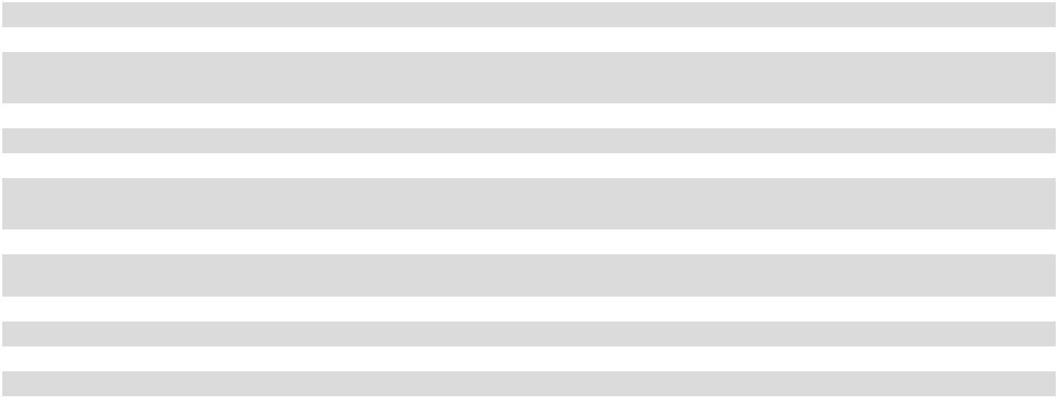

- The 2025 Senior Bonds were issued at 99.975% of par. The 2025 Senior Bonds were fully repaid during the fourth quarter of 2025.
- As of December 31, 2025, the senior notes maturing in 2026 were classified as current portion of debt in the consolidated balance sheets.

- The Term Loan Facilities (as defined below) were issued in connection with the financing of the Repurchase, as further discussed in Note 2.

- The 2029 Senior Bonds were issued at 99.843% of par.

- The Company’s revolving credit facility has an aggregate maximum borrowing capacity of $500 million. The Company currently believes all banks participating in the revolving credit facility have the ability to and will meet any funding requests from the Company.

- The 2034 Senior Bonds were issued at 99.893% of par.

The principal maturities of debt outstanding on December 31, 2025 were as follows:
 | (in thousands) |  |  | Debt Maturities
 | 2026 |  | $ | 100,000
2027 |  |  |  | —
2028 |  |  |  | 900,000
2029 |  |  |  | 700,000
2030 |  |  |  | 600,000
 | Thereafter |  |  | 500,000
 | Total debt |  | $ | 2,800,000

The Company mitigates its financing risk by using multiple financial institutions and only entering into credit arrangements with institutions with investment grade credit ratings. The Company monitors counterparty credit ratings on an ongoing basis.

The Company entered into the Bridge Facility, dated as of November 7, 2025, providing for a 364-day senior unsecured bridge term loan facility in an aggregate principal amount of $1.20 billion to fund the Repurchase. Also on November 7, 2025, the Company borrowed $1.20 billion under the Bridge Facility, the full amount available under the Bridge Facility.

On December 8, 2025, the Company entered into a term loan agreement, providing for (i) the Three-Year Term Loan Facility, a senior unsecured term loan facility in the aggregate principal amount of up to $900 million, maturing on December 8, 2028 and (ii) the Five-Year Term Loan Facility, a senior unsecured term loan facility in the aggregate principal amount of up to $450 million, maturing on December 6, 2030 (collectively, the “Term Loan Facilities”). Also on December 8, 2025, the Company borrowed $1.35 billion under the Term Loan Facilities, the full amount available under the Term Loan Facilities. In conjunction with the borrowings under the Term

77

Loan Facilities, the Company modified and extinguished the Bridge Facility discussed above, fully repaying the $1.20 billion outstanding under the Bridge Facility through a net cash settlement with the lender.

Subsequent to the end of 2025, on February 9, 2026, the Company repaid $150 million of the $450 million aggregate principal balance outstanding under the Five-Year Term Loan Facility using cash on hand.

The indentures under which the 2025 Senior Bonds, the 2029 Senior Bonds and the 2034 Senior Bonds were issued do not include financial covenants, but do limit the incurrence of certain liens and encumbrances as well as indebtedness by the Company’s subsidiaries in excess of certain amounts. The agreements under which the Company’s nonpublic debt, including the Revolving Credit Facility and the Term Loan Facilities, was issued include two financial covenants: a consolidated cash flow/fixed charges ratio and a consolidated funded indebtedness/cash flow ratio, each as defined in the respective agreement. The Company was in compliance with these covenants as of December 31, 2025. These covenants have not restricted, and are not expected to restrict, the Company’s liquidity or capital resources.

All outstanding debt has been issued by the Company and none has been issued by any of its subsidiaries. There are no guarantees of the Company’s debt.

- Commitments and Contingencies Manufacturing Cooperatives

The Company is obligated to purchase at least 80% of its requirements of plastic bottles for certain designated territories from Southeastern. The Company is also obligated to purchase 16.0 million cases of finished product from SAC on an annual basis through June 2034. The Company purchased 27.3 million cases, 26.5 million cases and 25.3 million cases of finished product from SAC in 2025, 2024 and 2023, respectively.

The following table summarizes the Company’s purchases from these manufacturing cooperatives:

 |  |  |  |  |  | Fiscal Year
(in thousands) |  |  | 2025 |  |  | 2024 |  |  | 2023
Purchases from Southeastern |  | $ | 119,344 |  | $ | 142,208 |  | $ | 146,898
Purchases from SAC |  |  | 222,443 |  |  | 213,317 |  |  | 200,239
Total purchases from manufacturing cooperatives |  | $ | 341,787 |  | $ | 355,525 |  | $ | 347,137

The Company guarantees a portion of SAC’s debt, which matures in 2028, based on the ratio of SAC’s total liabilities to SAC’s shareholders’ equity as of December 31 of each year. As of December 31, 2025 and December 31, 2024, the ratio of SAC’s total liabilities to SAC’s shareholders’ equity was such that the Company was not required to guarantee any of SAC’s debt. In the event SAC fails to fulfill its commitments under the related debt, the Company would be responsible for payment to the lenders up to the level of the guarantee. The Company does not anticipate SAC will fail to fulfill its commitments related to the debt. The Company further believes SAC has sufficient assets, including production equipment, facilities and working capital, and the ability to adjust the selling prices of its products to adequately mitigate the risk of material loss relating to the Company’s guarantee.

The Company holds no assets as collateral against the SAC guarantee, the fair value of which is immaterial to the consolidated financial statements. The Company monitors its investment in SAC and would be required to write down its investment if an impairment, other than a temporary impairment, was identified. No impairment of the Company’s investment in SAC was identified as of December 31, 2025, and there was no impairment identified in 2025, 2024 or 2023.

Other Commitments and Contingencies

The Company has standby letters of credit, primarily related to its property and casualty insurance programs. These letters of credit totaled $47.5 million on December 31, 2025 and $39.0 million on December 31, 2024.

The Company participates in long-term marketing contractual arrangements with certain prestige properties, athletic venues and other locations. As of December 31, 2025, the future payments related to these contractual arrangements, which expire at various dates through 2035, amounted to $151.1 million. As of December 31, 2024, the future payments related to these contractual arrangements amounted to $135.5 million.

The Company is involved in various claims and legal proceedings which have arisen in the ordinary course of its business. Although it is difficult to predict the ultimate outcome of these claims and legal proceedings, management believes the ultimate disposition of

78

these matters will not have a material adverse effect on the financial condition, results of operations or cash flows of the Company. No material amount of loss in excess of recorded amounts is believed to be reasonably possible as a result of these claims and legal proceedings.

The Company is subject to audits by tax authorities in jurisdictions where it conducts business. These audits may result in assessments that are subsequently resolved with the authorities or potentially through the courts. Management believes the Company has adequately provided for any assessments likely to result from these audits; however, final assessments, if any, could be different than the amounts recorded in the consolidated financial statements.

- Risks and Uncertainties

Approximately 85% of the Company’s total bottle/can sales volume to retail customers consists of products of

The Coca-Cola Company, which is the sole supplier of these products or of the concentrates or syrups required to manufacture these products. The remaining bottle/can sales volume to retail customers consists of products of other beverage companies. The Company has beverage agreements with The Coca-Cola Company and other beverage companies under which it has various requirements.
Failure to meet the requirements of these beverage agreements could result in the loss of distribution rights for the respective products.

The Company faces concentration risks related to a few customers comprising a large portion of the Company’s annual sales volume and net sales. The table below summarizes the percentage of the Company’s total bottle/can sales volume to its largest customers, as well as the percentage of the Company’s total net sales, which are included in the Nonalcoholic Beverages segment, that such volume represents. No other customer represented greater than 10% of the Company’s total net sales for any of the years presented.

Fiscal Year

 |  | 2025 |  |  |  | 2024 |  |  |  | 2023
Approximate percent of the Company’s total bottle/can sales volume: |  |  | 21 | % |  |  | 21 | % | 21 |  | %
Walmart Inc.⁽¹⁾ |  |  | 21 | %
The Kroger Co.⁽²⁾ |  |  | 15 | % |  |  | 15 | % | 14 |  | %
Total approximate percent of the Company’s total bottle/can sales volume |  |  | 36 % |  |  |  | 36 % |  |  | 35 %
Approximate percent of the Company’s total net sales: |  |  | 17 | % |  |  | 17 | % | 17 |  | %
Walmart Inc.⁽¹⁾ |  |  | 17 | %
The Kroger Co.⁽²⁾ |  |  | 12 | % |  |  | 12 | % | 11 |  | %
Total approximate percent of the Company’s total net sales |  |  | 29 % |  |  |  | 29 % |  |  | 28 %

- Includes bottle/can sales volume related to the Walmart, Sam’s Club and Walmart Neighborhood Market chains.

- Includes bottle/can sales volume related to the Kroger and Harris Teeter chains.

The Company purchases all of the plastic bottles used in its manufacturing plants from Southeastern and Western Container, two manufacturing cooperatives the Company co-owns with several other Coca-Cola bottlers, and all of its aluminum cans from two domestic suppliers. See Note 2 and Note 21 for additional information.

The Company is exposed to price risk on commodities such as aluminum, corn and PET resin (a petroleum- or plant-based product), which affects the cost of raw materials used in the production of its finished products. The Company both produces and procures these finished products. Examples of the raw materials affected are aluminum cans and plastic bottles used for packaging and high-fructose corn syrup used as a product ingredient. Further, the Company is exposed to commodity price risk on crude oil, which impacts the Company’s cost of fuel used in the movement and delivery of the Company’s products. The Company participates in commodity hedging and risk mitigation programs, including programs administered by CCBSS and programs the Company administers.

Certain liabilities of the Company, including retirement benefit obligations and the Company’s pension liability, are subject to risk of changes in both long-term and short-term interest rates.

Several of the Company’s debt instruments have variable interest rates, and thus are impacted by fluctuations in interest rates, which could cause changes in the amount of estimated interest payments.

The Company’s acquisition related contingent consideration liability related to the distribution territories subject to acquisition related sub-bottling payments is subject to risk as a result of changes in the Company’s probability weighted discounted cash flow model, which is based on internal forecasts, and changes in the Company’s WACC, which is derived from market data.

79

Approximately 15% of the Company’s workforce is covered by collective bargaining agreements. The Company’s collective bargaining agreements, which generally have three- to five-year terms, expire at various dates through 2029. Terms and conditions of new labor union agreements could increase the Company’s exposure to work interruptions or stoppages.

- Accumulated Other Comprehensive Income (Loss)

Accumulated other comprehensive income (loss) (“AOCI(L)”) is composed of adjustments to the Company’s pension and postretirement medical benefit plans and unrealized gains/losses on the Company’s available-for-sale short-term investments.

Following is a summary of AOCI(L) for 2025, 2024 and 2023:

 |  |  |  |  | Gains (Losses) During |  |  |  |  |  |  | Reclassification to
 |  | December 31, |  |  |  | the Period |  |  |  |  |  | Income |  |  |  |  | December 31,
(in thousands) |  |  |  |  |  | Pre-tax |  |  | Tax |  |  | Pre-tax |  |  | Tax
(in thousands) |  |  | 2024 |  |  | Activity |  |  | Effect |  |  | Activity |  |  | Effect |  |  | 2025
Net pension activity:
Actuarial gain | $ |  | 4,418 |  | $ | 26 | $ |  | (5) | $ |  | — | $ |  | — | $ |  | 4,439
Prior service costs |  |  | (85) |  |  | (124) |  |  | 31 |  |  | 16 |  |  | (5) |  |  | (167)
Net postretirement benefits activity:
Actuarial gain (loss) |  |  | 2,960 |  |  | (10,539) |  |  | 2,594 |  |  | 187 |  |  | (46) |  |  | (4,844)
Prior service costs |  |  | (624) |  |  | — |  |  | — |  |  | — |  |  | — |  |  | (624)
Unrealized gain on short-term |  |  | 25 |  |  | 20 |  |  | (6) |  |  | (53) |  |  | 14 |  |  | —
investments |  |  | 25 |  |  | 20 |  |  | (6) |  |  | (53) |  |  | 14 |  |  | —
Reclassification of stranded tax effects |  |  | (4,809) |  |  | — |  |  | — |  |  | — |  |  | — |  |  | (4,809)
Total AOCI(L) |  | $ | 1,885 |  | $ | (10,617) |  | $ | 2,614 |  | $ | 150 |  | $ | (37) |  | $ | (6,005)
 |  |  |  |  | Gains (Losses) During |  |  |  |  |  |  | Reclassification to
 |  | December 31, |  |  |  | the Period |  |  |  |  |  | Income |  |  |  |  | December 31,
 |  |  |  |  |  | Pre-tax |  |  | Tax |  |  | Pre-tax |  |  | Tax
(in thousands) |  |  | 2023 |  |  | Activity |  |  | Effect |  |  | Activity |  |  | Effect |  |  | 2024
Net pension activity:
Actuarial gain | $ |  | 533 |  | $ | 5,144 | $ |  | (1,259) | $ |  | — | $ |  | — | $ |  | 4,418
Prior service costs |  |  | (97) |  |  | — |  |  | — |  |  | 16 |  |  | (4) |  |  | (85)
Net postretirement benefits activity:
Actuarial gain |  |  | 721 |  |  | 2,920 |  |  | (715) |  |  | 44 |  |  | (10) |  |  | 2,960
Prior service costs |  |  | (624) |  |  | — |  |  | — |  |  | — |  |  | — |  |  | (624)
Unrealized gain on short-term |  |  | — |  |  | 33 |  |  | (8) |  |  | — |  |  | — |  |  | 25
investments |  |  |  |  |  | 33 |  |  | (8) |  |  | — |  |  | — |  |  | 25
Reclassification of stranded tax effects |  |  | (4,809) |  |  | — |  |  | — |  |  | — |  |  | — |  |  | (4,809)
Total AOCI(L) |  | $ | (4,276) |  | $ | 8,097 |  | $ | (1,982) |  | $ | 60 |  | $ | (14) |  | $ | 1,885
 |  |  |  |  | Gains (Losses) During |  |  |  |  |  |  | Reclassification to
 |  | December 31, |  |  |  | the Period |  |  |  |  |  | Income |  |  |  |  | December 31,
 |  |  |  |  |  | Pre-tax |  |  | Tax |  |  | Pre-tax |  |  | Tax
(in thousands) |  |  | 2022 |  |  | Activity |  |  | Effect |  |  | Activity |  |  | Effect |  |  | 2023
Net pension activity:
Actuarial loss | $ |  | (71,140) |  | $ | 3,036 | $ |  | (744) | $ |  | 1,946 | $ |  | (476) | $ |  | (67,378)
Prior service costs |  |  | (105) |  |  | (5) |  |  | 1 |  |  | 16 |  |  | (4) |  |  | (97)
Pension plan settlement |  |  | — |  |  | — |  |  | — |  |  | 112,796 |  |  | (44,885) |  |  | 67,911
Net postretirement benefits activity:
Actuarial gain |  |  | 6,752 |  |  | (7,986) |  |  | 1,955 |  |  | — |  |  | — |  |  | 721
Prior service costs |  |  | (624) |  |  | — |  |  | — |  |  | — |  |  | — |  |  | (624)
Reclassification of stranded tax effects |  |  | (19,720) |  |  | — |  |  | — |  |  | — |  |  | 14,911 |  |  | (4,809)
Total AOCI(L) |  | $ | (84,837) |  | $ | (4,955) |  | $ | 1,212 |  | $ | 114,758 |  | $ | (30,454) |  | $ | (4,276)
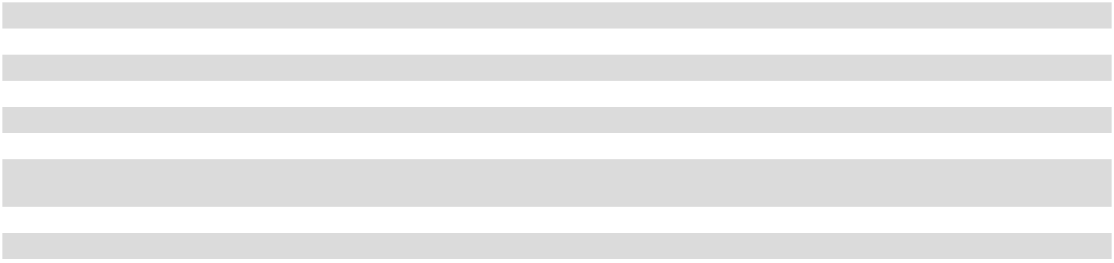

80

24. | Supplemental Disclosures of Cash Flow Information
Changes in current assets and current liabilities affecting cash were as follows:
 |  |  |  |  |  |  | Fiscal Year
(in thousands) |  |  |  | 2025 |  |  | 2024 |  |  | 2023
Short-term investments |  |  | $ | (5,127) |  | $ | (5,142) |  | $ | —
Accounts receivable, trade |  |  |  | (18,124) |  |  | (11,720) |  |  | (23,886)
Allowance for doubtful accounts |  |  |  | (3,498) |  |  | (1,386) |  |  | (59)
Accounts receivable from The Coca-Cola Company |  |  |  | 19,674 |  |  | (37,935) |  |  | (16,150)
Accounts receivable, other |  |  |  | (14,197) |  |  | 26,889 |  |  | (12,902)
Inventories |  |  |  | (6,006) |  |  | (8,463) |  |  | 25,613
Prepaid expenses and other current assets |  |  |  | (12,337) |  |  | (7,746) |  |  | 5,682
Accounts payable, trade |  |  |  | 35,556 |  |  | (36,496) |  |  | 17,096
Accounts payable to The Coca-Cola Company |  |  |  | (4,825) |  |  | 47,772 |  |  | (23,284)
Other accrued liabilities |  |  |  | 33,228 |  |  | 8,693 |  |  | 37,017
Accrued compensation |  |  |  | (13,793) |  |  | 21,760 |  |  | 20,011
Change in current assets less current liabilities |  |  | $ | 10,551 |  | $ | (3,774) |  | $ | 29,138

The Company had the following net cash payments during the period for income taxes and interest:

 |  |  |  |  |  |  |  | Fiscal Year
(in thousands) |  |  | 2025 |  |  | 2024 |  |  |  |  |  |  |  | 2023
Income taxes |  | $ | 196,579 |  |  |  |  | $ | 223,975 |  |  |  | $ | 200,812
Interest |  |  | 92,835 |  |  |  |  |  | 56,094 |  |  |  |  | 23,960
The Company had the following significant non-cash financing and investing activities:
 |  |  |  |  |  |  |  |  |  | Fiscal Year
(in thousands) |  |  |  |  |  | 2025 |  |  | 2024 |  |  |  |  | 2023
Additions to property, plant and equipment accrued and recorded in accounts payable, trade |  |  |  |  | $ | 33,237 |  |  |  | $ 44,946 |  |  |  |  | $ 59,014
Accrued excise taxes related to share repurchases |  |  |  |  |  | 27,972 |  |  |  |  | 650 |  |  |  | —
Right-of-use assets obtained in exchange for operating lease obligations |  |  |  |  |  | 27,001 |  |  | 17,280 |  |  |  |  | 10,215
Dividends declared but not yet paid |  |  |  |  |  |  |  | — |  |  |  | — |  | 154,666

81

Management’s Report on Internal Control over Financial Reporting

Management of Coca-Cola Consolidated, Inc. (the “Company”) is responsible for establishing and maintaining adequate internal control over financial reporting as such term is defined in Rules 13a-15(f) and 15d-15(f) under the Securities Exchange Act of 1934, as amended. The Company’s internal control over financial reporting is a process designed under the supervision of the Company’s chief executive and chief financial officers to provide reasonable assurance regarding the reliability of financial reporting and the preparation of the Company’s consolidated financial statements for external purposes in accordance with accounting principles generally accepted in the United States. The Company’s internal control over financial reporting includes policies and procedures that:

- pertain to the maintenance of records that, in reasonable detail, accurately and fairly reflect transactions and dispositions of assets of the Company;

- provide reasonable assurance that transactions are recorded as necessary to permit preparation of financial statements in accordance with U.S. generally accepted accounting principles, and that receipts and expenditures are being made only in accordance with authorizations of management and the directors of the Company; and

- provide reasonable assurance regarding prevention or timely detection of unauthorized acquisition, use or disposition of the Company’s assets that could have a material effect on the Company’s financial statements.

Because of its inherent limitations, internal control over financial reporting may not prevent or detect all misstatements. Also, projections of any evaluation of effectiveness to future periods are subject to the risk that controls may become inadequate due to changes in conditions, or that the degree of compliance with the policies or procedures may deteriorate.

As of December 31, 2025, management assessed the effectiveness of the Company’s internal control over financial reporting based on the framework established in Internal Control – Integrated Framework (2013) issued by the Committee of Sponsoring Organizations of the Treadway Commission (COSO). Based on this assessment, management determined that the Company’s internal control over financial reporting as of December 31, 2025 was effective.

The effectiveness of the Company’s internal control over financial reporting as of December 31, 2025, has been audited by PricewaterhouseCoopers LLP (PCAOB ID 238), an independent registered public accounting firm, which is included in “Item 8. Financial Statements and Supplementary Data” of this report.

February 18, 2026

82

Report of Independent Registered Public Accounting Firm

To the Board of Directors and Stockholders of Coca-Cola Consolidated, Inc.

Opinions on the Financial Statements and Internal Control over Financial Reporting

We have audited the accompanying consolidated balance sheets of Coca-Cola Consolidated, Inc. and its subsidiaries (the “Company”) as of December 31, 2025 and 2024, and the related consolidated statements of operations, of comprehensive income, of changes in stockholders’ equity (deficit) and of cash flows for each of the three years in the period ended December 31, 2025, including the related notes and schedule of valuation and qualifying accounts and reserves for each of the three years in the period ended December 31, 2025 appearing under Item 15(a)(2) (collectively referred to as the “consolidated financial statements”). We also have audited the Company’s internal control over financial reporting as of December 31, 2025, based on criteria established in Internal Control - Integrated Framework (2013) issued by the Committee of Sponsoring Organizations of the Treadway Commission (COSO).

In our opinion, the consolidated financial statements referred to above present fairly, in all material respects, the financial position of the Company as of December 31, 2025 and 2024, and the results of its operations and its cash flows for each of the three years in the period ended December 31, 2025 in conformity with accounting principles generally accepted in the United States of America. Also in our opinion, the Company maintained, in all material respects, effective internal control over financial reporting as of December 31, 2025, based on criteria established in Internal Control - Integrated Framework (2013) issued by the COSO.

Basis for Opinions

The Company’s management is responsible for these consolidated financial statements, for maintaining effective internal control over financial reporting, and for its assessment of the effectiveness of internal control over financial reporting, included in Management’s Report on Internal Control over Financial Reporting appearing under Item 8. Our responsibility is to express opinions on the Company’s consolidated financial statements and on the Company’s internal control over financial reporting based on our audits. We are a public accounting firm registered with the Public Company Accounting Oversight Board (United States) (PCAOB) and are required to be independent with respect to the Company in accordance with the U.S. federal securities laws and the applicable rules and regulations of the Securities and Exchange Commission and the PCAOB.

We conducted our audits in accordance with the standards of the PCAOB. Those standards require that we plan and perform the audits to obtain reasonable assurance about whether the consolidated financial statements are free of material misstatement, whether due to error or fraud, and whether effective internal control over financial reporting was maintained in all material respects.

Our audits of the consolidated financial statements included performing procedures to assess the risks of material misstatement of the consolidated financial statements, whether due to error or fraud, and performing procedures that respond to those risks. Such procedures included examining, on a test basis, evidence regarding the amounts and disclosures in the consolidated financial statements. Our audits also included evaluating the accounting principles used and significant estimates made by management, as well as evaluating the overall presentation of the consolidated financial statements. Our audit of internal control over financial reporting included obtaining an understanding of internal control over financial reporting, assessing the risk that a material weakness exists, and testing and evaluating the design and operating effectiveness of internal control based on the assessed risk. Our audits also included performing such other procedures as we considered necessary in the circumstances. We believe that our audits provide a reasonable basis for our opinions.

Definition and Limitations of Internal Control over Financial Reporting

A company’s internal control over financial reporting is a process designed to provide reasonable assurance regarding the reliability of financial reporting and the preparation of financial statements for external purposes in accordance with generally accepted accounting principles. A company’s internal control over financial reporting includes those policies and procedures that (i) pertain to the maintenance of records that, in reasonable detail, accurately and fairly reflect the transactions and dispositions of the assets of the company; (ii) provide reasonable assurance that transactions are recorded as necessary to permit preparation of financial statements in accordance with generally accepted accounting principles, and that receipts and expenditures of the company are being made only in accordance with authorizations of management and directors of the company; and (iii) provide reasonable assurance regarding prevention or timely detection of unauthorized acquisition, use, or disposition of the company’s assets that could have a material effect on the financial statements.

Because of its inherent limitations, internal control over financial reporting may not prevent or detect misstatements. Also, projections of any evaluation of effectiveness to future periods are subject to the risk that controls may become inadequate because of changes in conditions, or that the degree of compliance with the policies or procedures may deteriorate.

83

Critical Audit Matters

The critical audit matter communicated below is a matter arising from the current period audit of the consolidated financial statements that was communicated or required to be communicated to the audit committee and that (i) relates to accounts or disclosures that are material to the consolidated financial statements and (ii) involved our especially challenging, subjective, or complex judgments. The communication of critical audit matters does not alter in any way our opinion on the consolidated financial statements, taken as a whole, and we are not, by communicating the critical audit matter below, providing a separate opinion on the critical audit matter or on the accounts or disclosures to which it relates.

Acquisition Related Contingent Consideration Liability

As described in Notes 1, 2, and 16 to the consolidated financial statements, the fair value of the acquisition related contingent consideration liability was $717.9 million as of December 31, 2025, which consists of the estimated amounts due to

The Coca-Cola Company under the Company’s comprehensive beverage agreements (as amended, collectively, the “CBA”) with The Coca-Cola Company and Coca-Cola Refreshments USA, LLC (“CCR”), a wholly owned subsidiary of The Coca-Cola Company, over the useful life of the related distribution rights. The CBA relates to a multi-year series of transactions, which were completed in October 2017, through which the Company acquired and exchanged distribution territories and manufacturing plants. Pursuant to the CBA, the Company is required to make quarterly acquisition related sub-bottling payments to CCR on a continuing basis in exchange for the grant of exclusive rights to distribute, promote, market and sell the authorized brands of The Coca-Cola Company and related products in certain distribution territories the Company acquired from CCR. Each reporting period, the Company adjusts its acquisition related contingent consideration liability related to the distribution territories subject to acquisition related sub-bottling payments to fair value by using a probability weighted discounted cash flow model and discounting future expected acquisition related sub-bottling payments required under the CBA using the Company’s estimated weighted average cost of capital (“WACC”). These future expected acquisition related sub-bottling payments extend through the life of the related distribution assets acquired in each distribution territory, which is generally forty years. As a result, the fair value of the acquisition related contingent consideration liability is impacted by the Company’s WACC, management’s estimate of the acquisition related sub-bottling payments that will be made in the future under the CBA, and current acquisition related sub-bottling payments.

The principal considerations for our determination that performing procedures relating to the acquisition related contingent consideration liability is a critical audit matter are (i) the significant judgment by management when estimating the fair value of the acquisition related contingent consideration liability, which in turn led to (ii) a high degree of auditor judgment, subjectivity, and effort in performing procedures and evaluating management’s significant assumptions related to the WACC and current and future acquisition related sub-bottling payments under the CBA, and (iii) the audit effort involved the use of professionals with specialized skill and knowledge.

Addressing the matter involved performing procedures and evaluating audit evidence in connection with forming our overall opinion on the consolidated financial statements. These procedures included testing the effectiveness of controls relating to the valuation of the acquisition related contingent consideration liability. These procedures also included, among others, testing management’s process for determining the fair value of the acquisition related contingent consideration liability; evaluating the appropriateness of the discounted cash flow model; testing the completeness and accuracy of the underlying data used in the model; and evaluating the reasonableness of the significant assumptions related to the WACC and current and future acquisition related sub-bottling payments under the CBA. Evaluating management’s assumptions related to the WACC and current and future acquisition related sub-bottling payments involved evaluating whether the assumptions used were reasonable considering (i) the current and past performance of the distribution territories acquired from CCR, (ii) relevant industry forecasts and macroeconomic conditions, (iii) management’s historical forecasting accuracy, and (iv) whether these assumptions were consistent with evidence obtained in other areas of the audit. Professionals with specialized skill and knowledge were used to assist in evaluating the appropriateness of the discounted cash flow model and evaluating the reasonableness of the WACC.

/s/ PricewaterhouseCoopers LLP

Charlotte, North Carolina

February 18, 2026

We have served as the Company’s auditor since at least 1972. We have not been able to determine the specific year we began serving as auditor of the Company.

84

The financial statement schedule required by Regulation S-X is set forth in response to Item 15 below.

Item 9. Changes in and Disagreements With Accountants on Accounting and Financial Disclosure.

None.

Item 9A. Controls and Procedures.

As of the end of the period covered by this report, the Company carried out an evaluation, under the supervision and with the participation of the Company’s management, including the Company’s Chief Executive Officer and Chief Financial Officer, of the effectiveness of the design and operation of the Company’s “disclosure controls and procedures” (as defined in Rule 13a-15(e) of the Securities Exchange Act of 1934, as amended (the “Exchange Act”)) pursuant to Rule 13a-15(b) of the Exchange Act. Based upon that evaluation, the Chief Executive Officer and the Chief Financial Officer concluded that the Company’s disclosure controls and procedures were effective as of December 31, 2025.

Management’s report on internal control over financial reporting required by Section 404 of the Sarbanes-Oxley Act of 2002 and the report of PricewaterhouseCoopers LLP, an independent registered public accounting firm, on the consolidated financial statements, and its opinion on the effectiveness of the Company’s internal control over financial reporting as of December 31, 2025 are included in “Item 8. Financial Statements and Supplementary Data” of this report.

There has been no change in the Company’s internal control over financial reporting during the quarter ended December 31, 2025 that has materially affected, or is reasonably likely to materially affect, the Company’s internal control over financial reporting.

Item 9B. Other Information.

Insider Trading Arrangements

During the quarter ended December 31, 2025, none of our directors or officers (as defined in Rule 16a-1(f) of the Exchange Act) adopted, modified or terminated a “Rule 10b5-1 trading arrangement” or a “non-Rule 10b5-1 trading arrangement” (as each term is defined in Item 408 of Regulation S-K).

Item 9C. Disclosure Regarding Foreign Jurisdictions that Prevent Inspections.

Not applicable.

85

PART III

Item 10. Directors, Executive Officers and Corporate Governance.

For information with respect to the executive officers of the Company, see “Information About Our Executive Officers” included as a separate item at the end of Part I of this report, which is incorporated herein by reference. For information with respect to the directors of the Company, see “Proposal 1: Election of Directors” in the definitive proxy statement for the Company’s 2026 Annual Meeting of Stockholders (the “2026 Proxy Statement”), which is incorporated herein by reference. For information with respect to the Company’s insider trading policies and procedures, see the “Corporate Governance – The Board of Directors” section of the 2026 Proxy Statement, which is incorporated herein by reference. For information with respect to the Audit Committee of the Board of Directors, see the “Corporate Governance – Board Committees” section of the 2026 Proxy Statement, which is incorporated herein by reference. For information with respect to compliance with Section 16(a) of the Exchange Act, see the “Delinquent Section 16(a) Reports” section of the 2026 Proxy Statement, which is incorporated herein by reference.

The Company has adopted a Code of Ethics for Senior Financial Officers (the “Code of Ethics”), which is intended to qualify as a “code of ethics” within the meaning of Item 406 of Regulation S-K of the Exchange Act. The Code of Ethics applies to the Company’s principal executive officer, principal financial officer, principal accounting officer and persons performing similar functions. The Code of Ethics is available on the Company’s website, www.cokeconsolidated.com.

The Company will disclose information pertaining to any amendment to, or waiver from, the provisions of the Code of Ethics that apply to the Company’s principal executive officer, principal financial officer, principal accounting officer or persons performing similar functions and that relate to any element of the Code of Ethics enumerated in the SEC rules and regulations by posting this information on the Company’s website, www.cokeconsolidated.com.

The information on the Company’s website or linked to or from the Company’s website is not incorporated by reference into, and does not constitute a part of, this report or any other documents the Company files with, or furnishes to, the SEC.

Item 11. Executive Compensation.

For information with respect to executive and director compensation, see the “Compensation Discussion and Analysis,” “Executive Compensation Tables,” “Consideration of Risk Related to Compensation Programs,” “Compensation Committee Interlocks and Insider Participation,” “Compensation Committee Report” and “Director Compensation” sections of the 2026 Proxy Statement, which are incorporated herein by reference.

Item 12. Security Ownership of Certain Beneficial Owners and Management and Related Stockholder Matters.

For information with respect to security ownership of certain beneficial owners and management, see the “Principal Stockholders” and “Security Ownership of Directors, Director Nominees and Executive Officers” sections of the 2026 Proxy Statement, which are incorporated herein by reference. For information with respect to securities authorized for issuance under the Company’s equity compensation plans, see the “Equity Compensation Plan Information” section of the 2026 Proxy Statement, which is incorporated herein by reference.

Item 13. Certain Relationships and Related Transactions, and Director Independence.

For information with respect to certain relationships and related transactions, see the “Corporate Governance – Policy for Review of Related Person Transactions” and “Corporate Governance – Related Person Transactions” sections of the 2026 Proxy Statement, which are incorporated herein by reference. For information with respect to director independence, see the “Corporate Governance – Director Independence” section of the 2026 Proxy Statement, which is incorporated herein by reference.

Item 14. Principal Accountant Fees and Services.

For information with respect to principal accountant fees and services, see “Proposal 3: Ratification of the Appointment of Independent Registered Public Accounting Firm” in the 2026 Proxy Statement, which is incorporated herein by reference.

86

PART IV

Item 15. Exhibits and Financial Statement Schedules.

- List of documents filed as part of this report.

- Financial Statements

Consolidated Statements of Operations 41

Consolidated Statements of Comprehensive Income 42

Consolidated Balance Sheets 43

Consolidated Statements of Cash Flows 44

Consolidated Statements of Changes in Stockholders’ Equity (Deficit) 45

Notes to Consolidated Financial Statements 46

Management’s Report on Internal Control over Financial Reporting 82

Report of Independent Registered Public Accounting Firm 83

2. Financial Statement Schedule

The Financial Statement Schedule included under Item 15 hereof, as required for the fiscal years ended December 31, 2025,

December 31, 2024 and December 31, 2023, consisted of the following:

Schedule II - Valuation and Qualifying Accounts and Reserves ⁹³

All other financial statements and financial statement schedules not listed have been omitted because the required information is included in the consolidated financial statements or the notes thereto, or is not applicable or required.

- Listing of Exhibits

The agreements included in the following exhibits to this report are included to provide information regarding their terms and are not intended to provide any other factual or disclosure information about the Company or the other parties to the agreements. Some of the agreements contain representations and warranties by each of the parties to the applicable agreements. These representations and warranties have been made solely for the benefit of the other parties to the applicable agreements and:

- should not in all instances be treated as categorical statements of fact, but rather as a way of allocating the risk to one of the parties if those statements prove to be inaccurate;

- may have been qualified by disclosures that were made to the other party in connection with the negotiation of the applicable agreement, which disclosures are not necessarily reflected in the agreement;

- may apply standards of materiality in a way that is different from what may be viewed as material to you or other investors; and

- were made only as of the date of the applicable agreement or such other date or dates as may be specified in the agreement and are subject to more recent developments.

Accordingly, these representations and warranties may not describe the actual state of affairs as of the date they were made or at any other time.

87

 |  | EXHIBIT INDEX
Exhibit |  | Description
No. |  | Description
3.1 |  | Restated Certificate of Incorporation of the Company.
3.2 |  | Certificate of Amendment to Restated Certificate of Incorporation of the
 |  | Company.
3.3 |  | Certificate of Amendment to Restated Certificate of Incorporation of the
 |  | Company.
3.4 |  | Certificate of Amendment to Restated Certificate of Incorporation of the
 |  | Company.
3.5 |  | Amended and Restated By-laws of the Company.
4.1 |  | Description of Securities of the Company.
4.2 |  | Specimen of Common Stock Certificate of the Company.
4.3 |  | Certificate Evidencing Right to Exchange Common Stock for Class B
 |  | Common Stock of the Company.
4.4 |  | Supplemental Indenture, dated as of March 3, 1995, between the
 |  | Company and The Bank of New York Mellon Trust Company, N.A., as
 |  | successor trustee.
4.5 |  | Indenture, dated as of December 15, 2020, between the Company and
 |  | Truist Bank, as successor trustee.
4.6 |  | First Supplemental Indenture, dated as of May 21, 2024, by and among
 |  | the Company, U.S. Bank Trust Company, National Association, as prior
 |  | trustee, and Truist Bank, as successor trustee.
4.7 |  | Second Supplemental Indenture, dated as of May 29, 2024, by and
 |  | between the Company and Truist Bank, as trustee.
4.8 |  | Form of 5.250% Senior Notes due 2029 (included in Exhibit 4.7 above).
4.9 |  | Form of 5.450% Senior Notes due 2034 (included in Exhibit 4.7 above).
10.1 |  | Amended and Restated Credit Agreement, dated as of June 10, 2024, by
 |  | and among the Company, Wells Fargo Bank, National Association, as
 |  | administrative agent, swingline lender and issuing lender, and the other
 |  | lenders party thereto.
10.2 |  | Amendment No. 1 to Amended and Restated Credit Agreement, dated as
 |  | of November 7, 2025, by and among the Company, Wells Fargo Bank,
 |  | National Association, as administrative agent, and the other lenders party
 |  | thereto.
10.3 |  | Bridge Loan Agreement, dated as of November 7, 2025, by and among
 |  | the Company, Wells Fargo Bank, National Association, as
 |  | administrative agent, and the other lenders party thereto.
10.4 |  | Term Loan Agreement, dated as of December 8, 2025, by and among the
 |  | Company, Wells Fargo Bank, National Association, as administrative
 |  | agent, and the other lenders party thereto.
10.5 |  | Note Purchase and Private Shelf Agreement, dated March 6, 2018, by
 |  | and among the Company, NYL Investors LLC and the other parties
 |  | thereto.
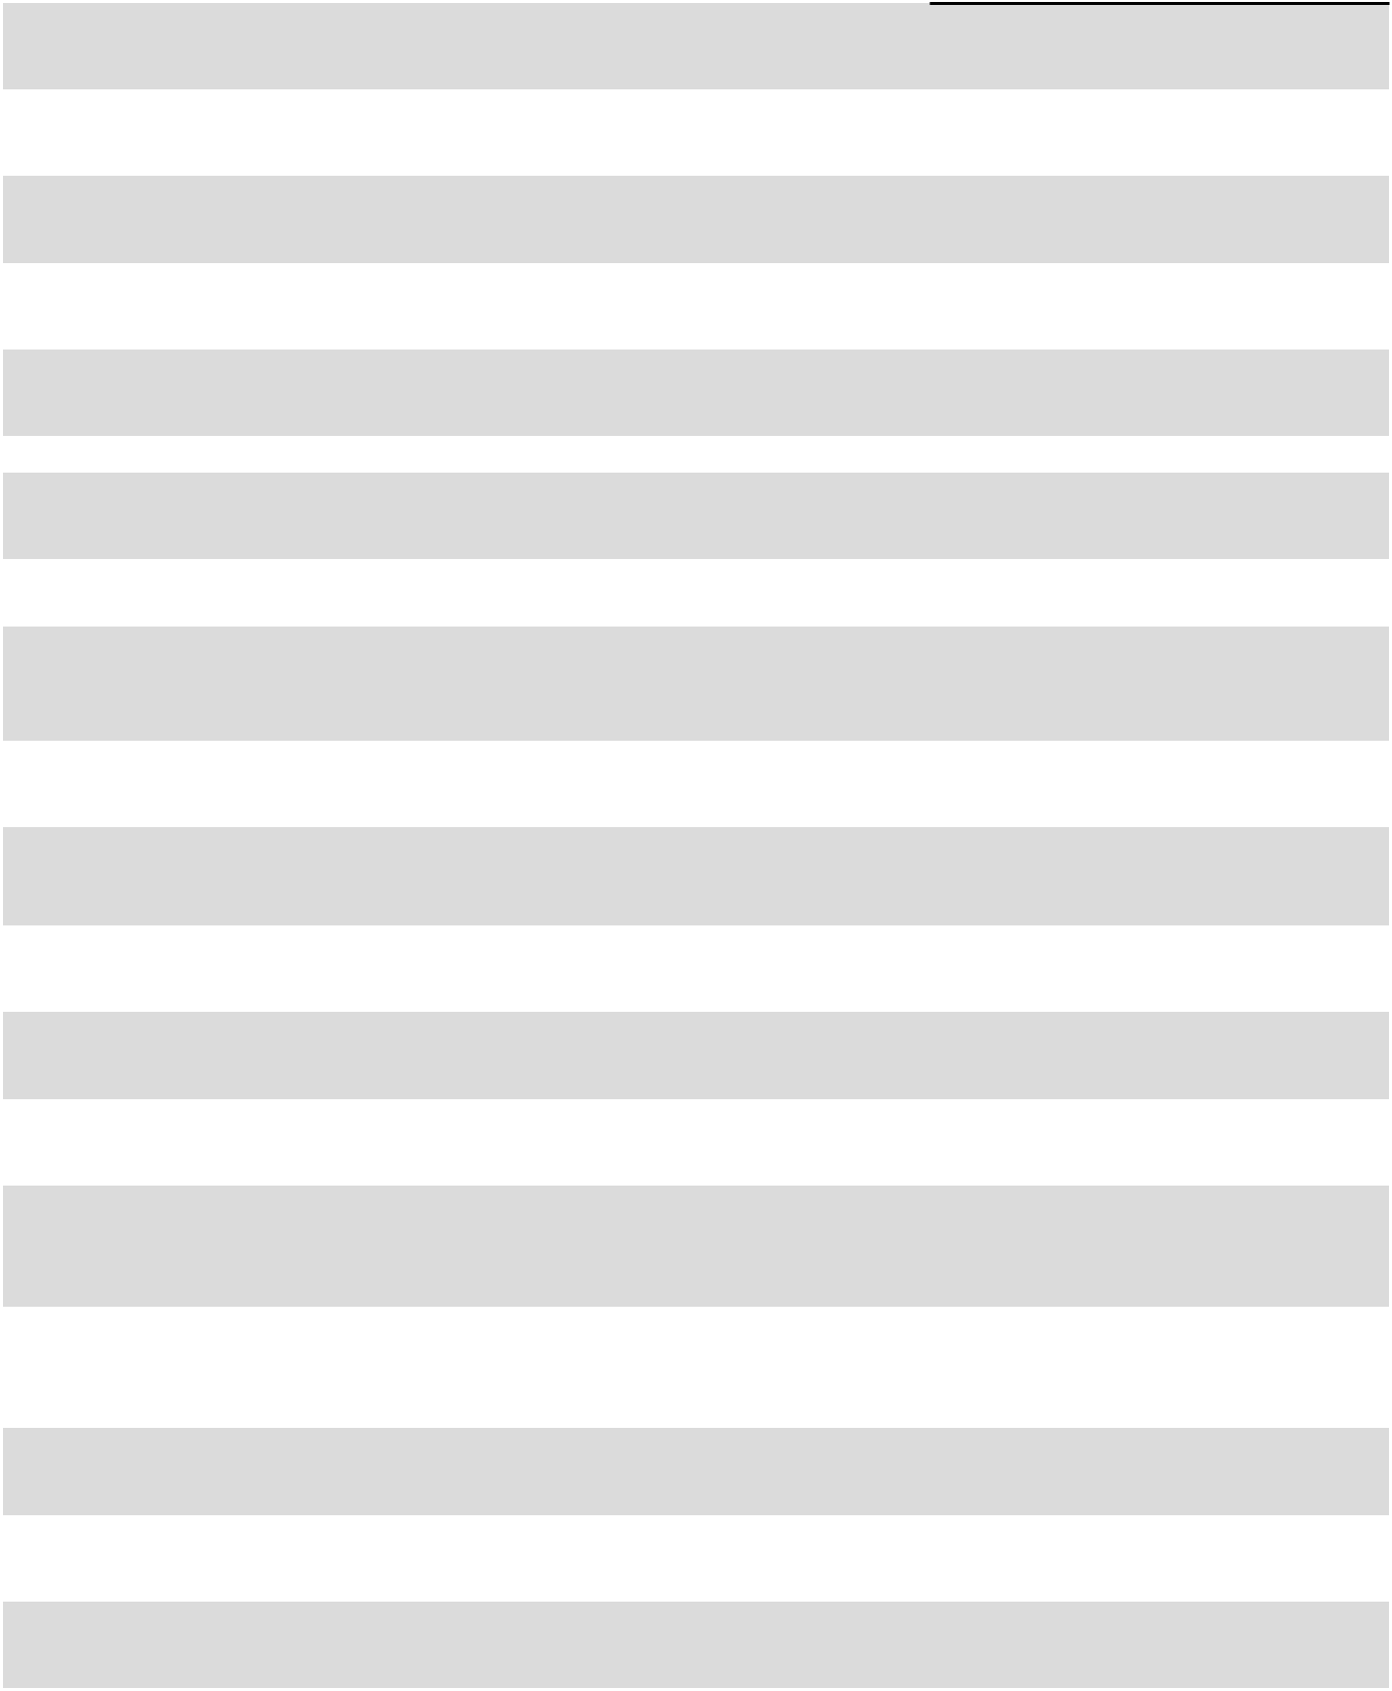

Incorporated by Reference or

Filed/Furnished Herewith

Exhibit 3.1 to the Company’s Quarterly Report on Form 10-Q for the quarter ended July 2, 2017 (File No. 0-9286).

Exhibit 3.1 to the Company’s Current Report on Form 8-K filed on January 2, 2019 (File No. 0-9286).

Exhibit 3.3 to the Company’s Quarterly Report on Form 10-Q for the quarter ended June 30, 2023 (File No. 0-9286).

Exhibit 3.1 to the Company’s Current Report on Form 8-K filed on May 16, 2025 (File No. 0-9286).

Exhibit 3.2 to the Company’s Current Report on Form 8-K filed on January 2, 2019 (File No. 0-9286).

Filed herewith.

Exhibit 4.1 to the Company’s Current Report on Form 8-K filed on February 19, 2019 (File No. 0-9286).

Exhibit 99.3 to the Schedule 13D/A filed on March 19, 2010 (File No. 5-30570).

Exhibit 4.2 to the Company’s Annual Report on Form 10-K for the fiscal year ended December 29, 2002 (File
No. 0-9286).

Exhibit 4.4 to the Company’s Registration
Statement on Form S-3 filed on
December 15, 2020 (File No. 333-251358).

Exhibit 4.1 to the Company’s Current Report on Form 8-K filed on May 24, 2024 (File No. 0-9286).

Exhibit 4.1 to the Company’s Current Report on Form 8-K filed on May 29, 2024 (File No. 0-9286).

Exhibit 4.2 to the Company’s Current Report on Form 8-K filed on May 29, 2024 (File No. 0-9286).

Exhibit 4.3 to the Company’s Current Report on Form 8-K filed on May 29, 2024 (File No. 0-9286).

Exhibit 10.2 to the Company’s Current Report on Form 8-K filed on June 10, 2024 (File No. 0-9286).

Filed herewith.

Filed herewith.

Filed herewith.

Exhibit 10.1 to the Company’s Current Report on Form 8-K filed on March 14, 2018 (File No. 0-9286).

88

Exhibit |  | Description
No. |  | Description
10.6 |  | First Amendment to Note Purchase and Private Shelf Agreement, dated
 |  | July 20, 2018, by and among the Company, NYL Investors LLC and the
 |  | other parties thereto.
10.7 |  | Second Amendment to Note Purchase and Private Shelf Agreement,
 |  | dated November 7, 2025, by and among the Company, NYL Investors
 |  | LLC and the other parties thereto.
10.8 |  | Note Purchase and Private Shelf Agreement, dated January 23, 2019, by
 |  | and among the Company, MetLife Investment Advisors, LLC and the
 |  | other parties thereto.
10.9 |  | First Amendment to Note Purchase and Private Shelf Agreement, dated
 |  | November 7, 2025, by and among the Company, MetLife Investment
 |  | Management, LLC and the other parties thereto.
10.10 |  | Incidence Agreement, dated February 5, 2019, by and between the
 |  | Company and The Coca-Cola Company.
10.11+ |  | National Product Supply Governance Agreement, dated October 30,
 |  | 2015, by and among the Company, The Coca-Cola Company, Coca-Cola
 |  | Bottling Company United, Inc., Coca-Cola Refreshments USA, Inc. and
 |  | Swire Pacific Holdings Inc. d/b/a Swire Coca-Cola USA.
10.12+ |  | First Amendment to National Product Supply Governance Agreement,
 |  | dated October 26, 2018, by and among the Company,
 |  | The Coca-Cola Company, Coca-Cola Bottling Company United, Inc.,
 |  | Swire Pacific Holdings Inc. d/b/a Swire Coca-Cola USA and the other
 |  | parties thereto.
10.13+ |  | Limited Liability Company Agreement of CONA Services LLC, dated
 |  | as of January 27, 2016, by and among the Company,
 |  | The Coca-Cola Company, Coca-Cola Refreshments USA, Inc. and the
 |  | other bottlers named therein.
10.14+ |  | Amendment No. 1 to Limited Liability Company Agreement of CONA
 |  | Services LLC, dated as of April 6, 2016 and effective as of April 2,
 |  | 2016, by and among the Company, The Coca-Cola Company, Coca-Cola
 |  | Refreshments USA, Inc. and the other bottlers named therein.
10.15+ |  | Amendment No. 2 to Limited Liability Company Agreement of CONA
 |  | Services LLC, effective as of February 22, 2017, by and among the
 |  | Company, The Coca-Cola Company, Coca-Cola Refreshments USA,
 |  | Inc. and the other bottlers named therein.
10.16 |  | Amendment No. 3 to Limited Liability Company Agreement of CONA
 |  | Services LLC, dated as of August 5, 2020 and effective as of January 1,
 |  | 2019, by and among the Company, The Coca-Cola Company and the
 |  | other bottlers named therein.
10.17++ |  | Amendment No. 4 to Limited Liability Company Agreement of CONA
 |  | Services LLC, effective as of July 2, 2024, by and among the Company,
 |  | The Coca-Cola Company, North America Operating Unit, CONA
 |  | Services LLC and the other bottlers named therein.
10.18+ |  | Amended and Restated Master Services Agreement, dated as of
 |  | October 2, 2017, by and between the Company and CONA Services
 |  | LLC.
10.19 |  | Omnibus Letter Agreement, dated March 31, 2017, by and between the
 |  | Company and Coca-Cola Refreshments USA, Inc.
10.20 |  | Amended and Restated Ancillary Business Letter, dated March 31, 2017,
 |  | by and between the Company and The Coca-Cola Company.
10.21+ |  | Comprehensive Beverage Agreement, dated March 31, 2017, by and
 |  | among the Company, The Coca-Cola Company and Coca-Cola
 |  | Refreshments USA, Inc.
10.22+ |  | Comprehensive Beverage Agreement, dated March 31, 2017, by and
 |  | between CCBCC Operations, LLC, a wholly owned subsidiary of the

Company (as successor in interest to Piedmont Coca-Cola Bottling Partnership), and The Coca-Cola Company.

Incorporated by Reference or

Filed/Furnished Herewith

Exhibit 10.2 to the Company’s Current Report on Form 8-K filed on July 25, 2018 (File No. 0-9286).

Filed herewith.

Exhibit 10.1 to the Company’s Current Report on Form 8-K filed on February 5, 2019 (File No. 0-9286).

Filed herewith.

Exhibit 10.1 to the Company’s Current Report on Form 8-K filed on February 5, 2019 (File No. 0-9286).

Filed herewith.

Filed herewith.

Filed herewith.

Filed herewith.

Filed herewith.

Exhibit 10.3 to the Company’s Quarterly Report on Form 10-Q for the quarter ended September 27, 2020 (File No. 0-9286).

Exhibit 10.1 to the Company’s Quarterly Report on Form 10-Q for the quarter ended September 27, 2024 (File No. 0-9286).

Filed herewith.

Exhibit 10.1 to the Company’s Current Report on Form 8-K filed on April 4, 2017 (File No. 0-9286).

Exhibit 10.2 to the Company’s Current Report on Form 8-K filed on April 4, 2017 (File No. 0-9286).

Exhibit 10.16 to the Company’s Annual Report on Form 10-K for the fiscal year ended December 31, 2024 (File

No. 0-9286).

Exhibit 10.17 to the Company’s Annual Report on Form 10-K for the fiscal year ended December 31, 2024 (File
No. 0-9286).

89

Exhibit |  | Description
No. |  | Description
10.23+ |  | First Amendment to Comprehensive Beverage Agreement, dated
 |  | April 28, 2017, by and among the Company, The Coca-Cola Company
 |  | and Coca-Cola Refreshments USA, Inc.
10.24+ |  | Amendment to Comprehensive Beverage Agreements, dated October 2,
 |  | 2017, by and among the Company, CCBCC Operations, LLC, a wholly
 |  | owned subsidiary of the Company (as successor in interest to Piedmont
 |  | Coca-Cola Bottling Partnership), The Coca-Cola Company, Coca-Cola
 |  | Refreshments USA, Inc. and CCBC of Wilmington, Inc.
10.25+ |  | Third Amendment to Comprehensive Beverage Agreement, dated
 |  | December 26, 2017, by and among the Company,
 |  | The Coca-Cola Company and Coca-Cola Refreshments USA, Inc.
10.26+ |  | Fourth Amendment to Comprehensive Beverage Agreement, dated
 |  | April 30, 2018, by and among the Company, The Coca-Cola Company
 |  | and Coca-Cola Refreshments USA, Inc.
10.27+ |  | Fifth Amendment to Comprehensive Beverage Agreement, dated
 |  | August 20, 2018, by and among the Company, The Coca-Cola Company
 |  | and Coca-Cola Refreshments USA, Inc.
10.28+ |  | Sixth Amendment to Comprehensive Beverage Agreement, dated
 |  | September 9, 2019, by and among the Company,
 |  | The Coca-Cola Company and Coca-Cola Refreshments USA, LLC
 |  | (formerly known as Coca-Cola Refreshments USA, Inc.)
10.29+ |  | Seventh Amendment to Comprehensive Beverage Agreement, dated
 |  | October 1, 2024, by and among the Company, The Coca-Cola Company
 |  | and Coca-Cola Refreshments USA, LLC
10.30 |  | Second Amendment to Comprehensive Beverage Agreement, dated
 |  | December 31, 2021, by and between CCBCC Operations, LLC, a wholly
 |  | owned subsidiary of the Company, and The Coca-Cola Company.
10.31+ |  | Third Amendment to Comprehensive Beverage Agreement, dated
 |  | October 1, 2024, by and between CCBCC Operations, LLC, a wholly
 |  | owned subsidiary of the Company, and The Coca-Cola Company.
10.32+ |  | Regional Manufacturing Agreement, dated March 31, 2017, by and
 |  | between the Company and The Coca-Cola Company.
10.33 |  | First Amendment to Regional Manufacturing Agreement, dated April 28,
 |  | 2017, by and between the Company and The Coca-Cola Company.
10.34 |  | Second Amendment to Regional Manufacturing Agreement, dated
 |  | October 2, 2017, by and between the Company and
 |  | The Coca-Cola Company.
10.35 |  | Lease Agreement, dated December 30, 2019, by and between the
 |  | Company and Beacon Investment Corporation.
10.36++ |  | Amended and Restated Limited Liability Company Operating
 |  | Agreement of Coca-Cola Bottlers’ Sales & Services Company LLC,
 |  | made as of November 18, 2019, by and between Coca-Cola Bottlers’
 |  | Sales & Services Company LLC and Consolidated Beverage Co., a
 |  | wholly owned subsidiary of the Company.
10.37 |  | Stockholder Conversion Agreement, dated as of March 17, 2022, by and
 |  | among the Company, the JFH Family Limited Partnership—SW1, the
 |  | Anne Lupton Carter Trust f/b/o Sue Anne H. Wells, the JFH Family
 |  | Limited Partnership—DH1 and the Anne Lupton Carter Trust f/b/o
 |  | Deborah S. Harrison.
10.38 |  | Letter Agreement re Stockholder Conversion Agreement, dated as of
 |  | August 8, 2025, by and among the Company, the JFH Family Limited
 |  | Partnership—SW1, the Anne Lupton Carter Trust f/b/o Sue Anne H.
 |  | Wells, the JFH Family Limited Partnership—DH1 and the Anne Lupton
 |  | Carter Trust f/b/o Deborah S. Harrison.
10.39 |  | Purchase Agreement, dated as of November 7, 2025, by and among the
 |  | Company, Carolina Coca-Cola Bottling Investments, Inc., The
 |  | Coca-Cola Company and J. Frank Harrison, III.
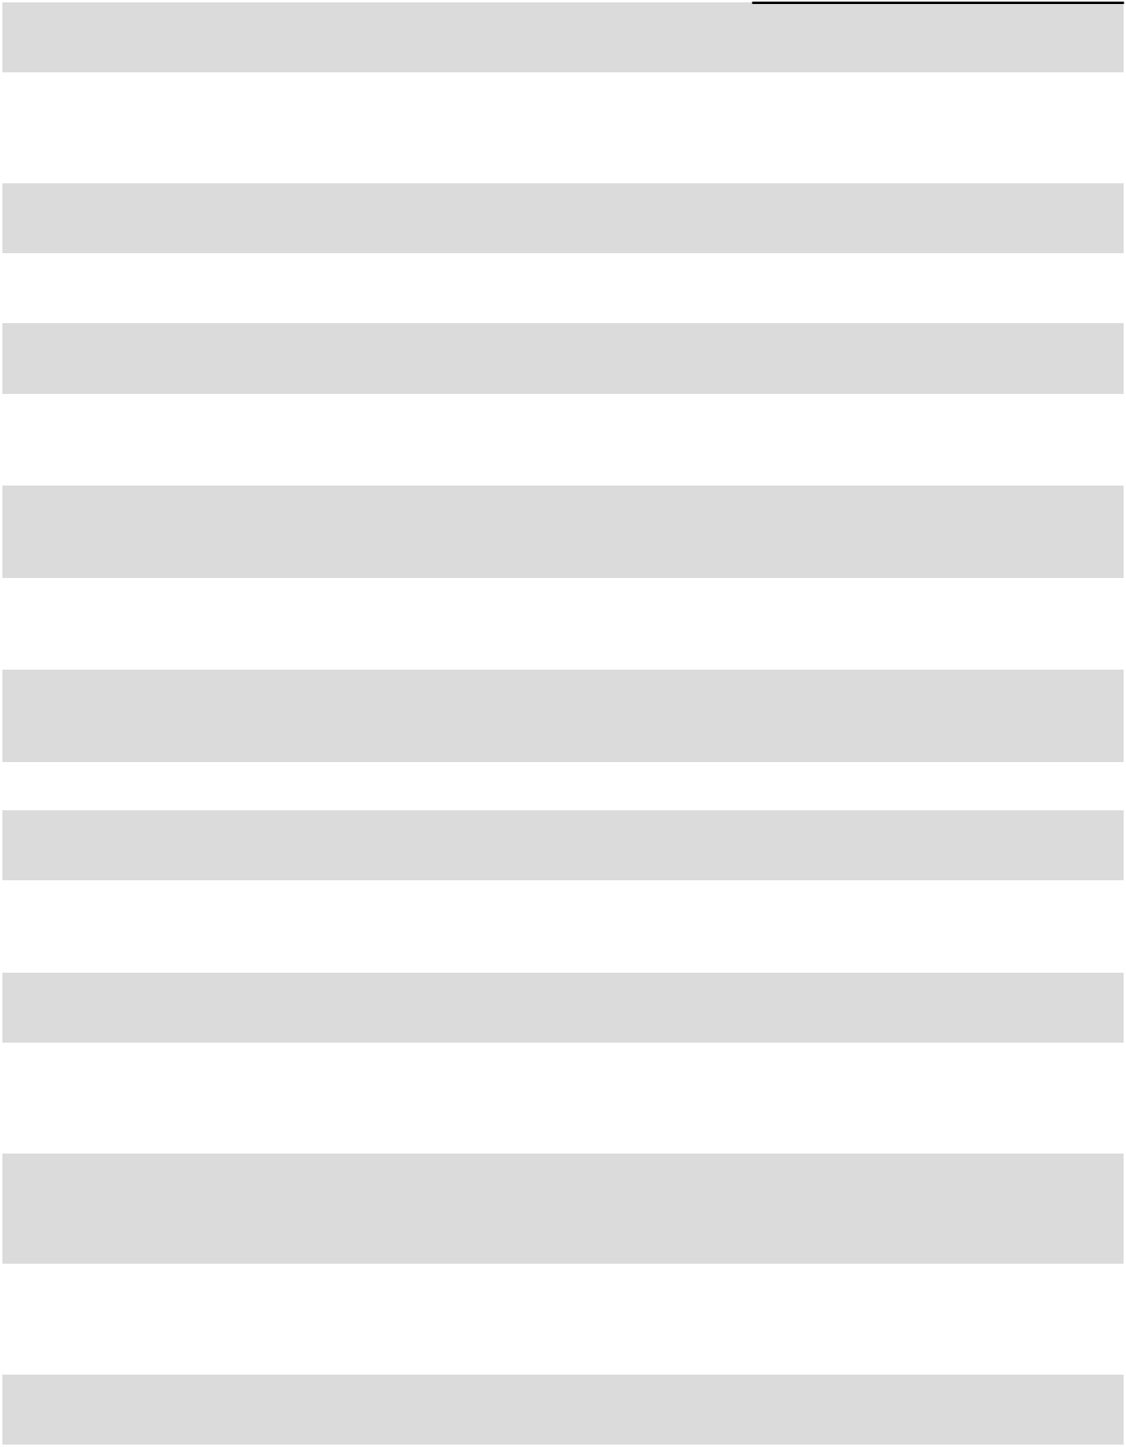

Incorporated by Reference or

Filed/Furnished Herewith

Filed herewith.

Exhibit 10.19 to the Company’s Annual Report on Form 10-K for the fiscal year ended December 31, 2024 (File
No. 0-9286).

Filed herewith.

Filed herewith.

Filed herewith.

Filed herewith.

Exhibit 10.24 to the Company’s Annual Report on Form 10-K for the fiscal year ended December 31, 2024 (File
No. 0-9286).

Exhibit 10.30 to the Company’s Annual Report on Form 10-K for the fiscal year ended December 31, 2021 (File
No. 0-9286).

Exhibit 10.26 to the Company’s Annual Report on Form 10-K for the fiscal year ended December 31, 2024 (File
No. 0-9286).

Filed herewith.

Exhibit 10.2 to the Company’s Quarterly Report on Form 10-Q for the quarter ended July 2, 2017 (File No. 0-9286).

Exhibit 10.73 to the Company’s Annual Report on Form 10-K for the fiscal year ended December 31, 2017

(File No. 0-9286).

Exhibit 10.1 to the Company’s Current Report on Form 8-K filed on January 3, 2020 (File No. 0-9286).

Exhibit 10.40 to the Company’s Annual Report on Form 10-K for the fiscal year ended December 29, 2019 (File

No. 0-9286).

Exhibit 10.2 to the Company’s Current Report on Form 8-K filed on March 23, 2022 (File No. 0-9286).

Exhibit 10 to the Company’s Quarterly Report on Form 10-Q for the quarter ended September 26, 2025 (File No. 0-9286).

Filed herewith.

90

Exhibit |  | Description
No. |  | Description
10.40* |  | Coca-Cola Consolidated, Inc. Annual Bonus Plan, amended and restated
 |  | effective as of July 30, 2024.
10.41* |  | Coca-Cola Consolidated, Inc. Long-Term Performance Plan, amended
 |  | and restated effective as of July 30, 2024.
10.42* |  | Coca-Cola Consolidated, Inc. Supplemental Savings Incentive Plan,
 |  | amended and restated effective as of July 30, 2024.
10.43* |  | Coca-Cola Consolidated, Inc. (formerly Coca-Cola Bottling Co.
 |  | Consolidated) Director Deferral Plan, amended and restated effective as
 |  | of January 1, 2014.
10.44* |  | Amendment No. 1, dated December 10, 2013, to Coca-Cola
 |  | Consolidated, Inc. (formerly Coca-Cola Bottling Co. Consolidated)
 |  | Director Deferral Plan, amended and restated effective as of January 1,
 | 2014.
10.45* |  | Coca-Cola Consolidated, Inc. Officer Retention Plan, amended and
 |  | restated effective as of July 30, 2024.
10.46* |  | Coca-Cola Consolidated, Inc. Long-Term Retention Plan, amended and
 |  | restated effective as of July 30, 2024.
10.47* |  | Coca-Cola Consolidated, Inc. Long-Term Performance Equity Plan,
 |  | amended and restated effective as of July 30, 2024.
10.48* |  | Omnibus Amendment to Coca-Cola Consolidated, Inc. Nonqualified
 |  | Employee Benefit Plans, dated as of September 6, 2019.
10.49* |  | Omnibus Amendment to Coca-Cola Consolidated, Inc. and CCBCC
 |  | Operations, LLC Qualified Employee Benefit Plans, dated as of
 |  | September 6, 2019.
10.50* |  | Form of Amended and Restated Split-Dollar and Deferred Compensation
 |  | Replacement Benefit Agreement, effective as of November 1, 2005, by
 |  | and between the Company and eligible employees of the Company.
10.51* |  | Consulting Agreement, dated as of March 3, 2020, by and between the
 |  | Company and Umesh M. Kasbekar.
10.52* |  | First Amendment to Consulting Agreement, dated as of June 10, 2022,
 |  | by and between the Company and Umesh M. Kasbekar.
10.53 |  | Consulting Agreement, dated as of February 19, 2025, by and between
 |  | the Company and F. Scott Anthony.
19 |  | Coca-Cola Consolidated, Inc. Insider Trading Policy.
21 |  | List of Subsidiaries of the Company.
23 |  | Consent of Independent Registered Public Accounting Firm.
31.1 |  | Certification of Principal Executive Officer pursuant to Rule
 |  | 13a-14(a)/15d-14(a), as adopted pursuant to Section 302 of the Sarbanes-
 |  | Oxley Act of 2002.
31.2 |  | Certification of Principal Financial Officer pursuant to Rule
 |  | 13a-14(a)/15d-14(a), as adopted pursuant to Section 302 of the Sarbanes-
 |  | Oxley Act of 2002.
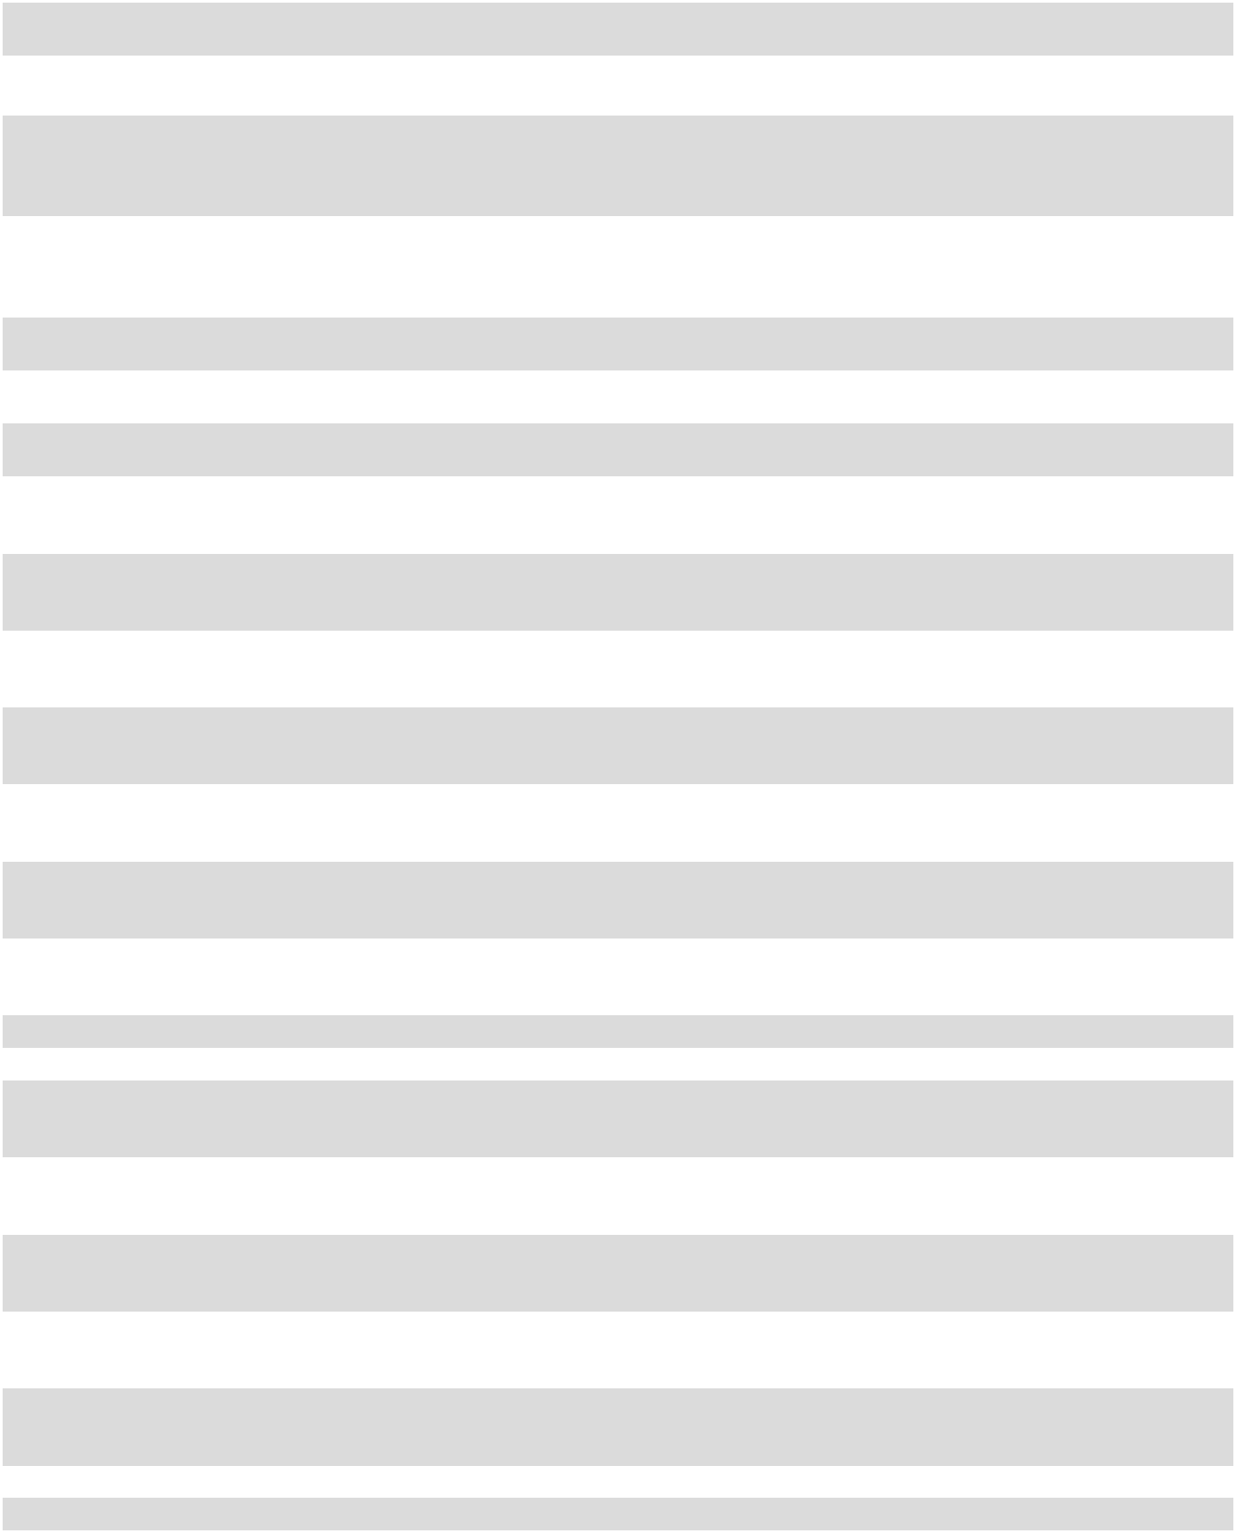
- Certification of Principal Executive Officer and Principal Financial Officer pursuant to 18 U.S.C. Section 1350, as adopted pursuant to Section 906 of the Sarbanes-Oxley Act of 2002.
97* | Coca-Cola Consolidated, Inc. Incentive-Based Compensation Recovery
 | Policy.
101.INS | Inline XBRL Instance Document – the instance document does not
 | appear in the Interactive Data File because its XBRL tags are embedded
 | within the Inline XBRL document.
101.SCH | Inline XBRL Taxonomy Extension Schema Document.
101.CAL | Inline XBRL Taxonomy Extension Calculation Linkbase Document.

Incorporated by Reference or

Filed/Furnished Herewith

Filed herewith.

Filed herewith.

Filed herewith.

Exhibit 10.47 to the Company’s Annual Report on Form 10-K for the fiscal year ended December 31, 2021 (File
No. 0-9286).

Exhibit 10.58 to the Company’s Annual Report on Form 10-K for the fiscal year ended December 30, 2018 (File
No. 0-9286).

Filed herewith.

Filed herewith.

Filed herewith.

Exhibit 10.1 to the Company’s Quarterly Report on Form 10-Q for the quarter ended September 29, 2019 (File No. 0-9286).

Exhibit 10.2 to the Company’s Quarterly Report on Form 10-Q for the quarter ended September 29, 2019 (File No. 0-9286).

Exhibit 10.24 to the Company’s Annual Report on Form 10-K for the fiscal year ended January 1, 2006 (File No. 0-9286).

Exhibit 10.1 to the Company’s Current Report on Form 8-K filed on March 6, 2020 (File No. 0-9286).

Exhibit 10.1 to the Company’s Quarterly Report on Form 10-Q for the quarter ended July 1, 2022 (File No. 0-9286).

Exhibit 10.1 to the Company’s Current Report on Form 8-K/A filed on February 20, 2025 (File No. 0-9286).

Exhibit 99 to the Company’s Quarterly Report on Form 10-Q for the quarter ended September 29, 2023 (File No. 0-9286).

Filed herewith.

Filed herewith.

Filed herewith.

Filed herewith.

Furnished herewith.

Exhibit 10.4 to the Company’s Quarterly Report on Form 10-Q for the quarter ended September 29, 2023 (File No. 0-9286).

Filed herewith.

Filed herewith.

Filed herewith.

91

Exhibit |  | Description |  | Incorporated by Reference or
No. |  | Description |  | Filed/Furnished Herewith
101.DEF |  | Inline XBRL Taxonomy Extension Definition Linkbase Document. |  | Filed herewith.
101.LAB |  | Inline XBRL Taxonomy Extension Label Linkbase Document. |  | Filed herewith.
101.PRE |  | Inline XBRL Taxonomy Extension Presentation Linkbase Document. |  | Filed herewith.
104 |  | Cover Page Interactive Data File – the cover page interactive data file |  | Filed herewith.
 |  | does not appear in the Interactive Data File because its XBRL tags are
 |  | embedded within the Inline XBRL document.
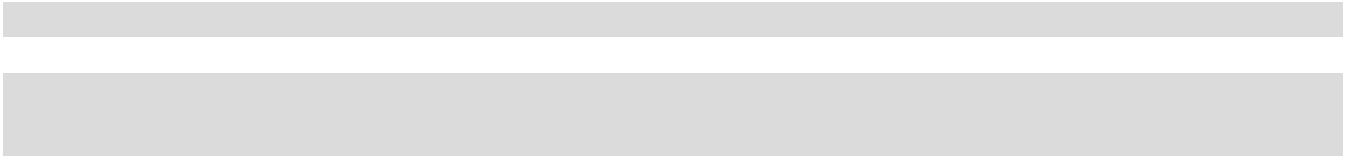

- Certain portions of this exhibit that constitute confidential information have been redacted in accordance with Item 601(b)(10) of Regulation S-K.
- Certain schedules or similar supporting attachments to this exhibit have been omitted in accordance with Item 601(a)(5) of Regulation S-K, and the Company agrees to furnish, on a supplemental basis, a copy of any omitted schedule or similar supporting attachment to the SEC upon request.

- Indicates a management contract or compensatory plan or arrangement.

- Exhibits.

See Item 15(a)(3) above.

- Financial Statement Schedules. See Item 15(a)(2) above.

Item 16. Form 10-K Summary.

None.

92

Schedule II

COCA-COLA CONSOLIDATED, INC.

VALUATION AND QUALIFYING ACCOUNTS AND RESERVES

Allowance for Doubtful Accounts

 |  |  |  |  |  | Fiscal Year
(in thousands) |  |  | 2025 |  |  | 2024 |  |  | 2023
Beginning balance - allowance for doubtful accounts |  | $ | 14,674 |  | $ | 16,060 |  | $ | 16,119
Additions charged to expenses and as a reduction to net sales |  |  | 4,015 |  |  | 3,730 |  |  | 4,139
Deductions |  |  | (7,513) |  |  | (5,116) |  |  | (4,198)
Ending balance - allowance for doubtful accounts |  | $ | 11,176 |  | $ | 14,674 |  | $ | 16,060
Deferred Income Tax Valuation Allowance
 |  |  |  |  |  | Fiscal Year
(in thousands) |  |  | 2025 |  |  | 2024 |  |  | 2023
Beginning balance - valuation allowance for deferred tax assets |  | $ | 5,535 |  | $ | 4,130 |  | $ | 3,428
Additions charged to costs and expenses |  |  | 180 |  |  | 1,405 |  |  | 702
Deductions credited to expense |  |  | — |  |  | — |  |  | —
Ending balance - valuation allowance for deferred tax assets |  | $ | 5,715 |  | $ | 5,535 |  | $ | 4,130

93

SIGNATURES

Pursuant to the requirements of Section 13 or 15(d) of the Securities Exchange Act of 1934, the registrant has duly caused this report to be signed on its behalf by the undersigned, thereunto duly authorized.

 |  | COCA-COLA CONSOLIDATED, INC.
 |  | (REGISTRANT)
Date: February 18, 2026 | By: | /s/ J. Frank Harrison, III
 |  | J. Frank Harrison, III
 |  | Chairman of the Board of Directors
 |  | and Chief Executive Officer

Pursuant to the requirements of the Securities Exchange Act of 1934, this report has been signed below by the following persons on behalf of the registrant and in the capacities and on the dates indicated.

 | Signature |  | Title |  | Date
By: | /s/ J. Frank Harrison, III |  | Chairman of the Board of Directors and |  | February 18, 2026
 | J. Frank Harrison, III |  | Chief Executive Officer
 |  |  | (Principal Executive Officer)
By: | /s/ Matthew J. Blickley |  | Chief Financial Officer and Chief Accounting Officer |  | February 18, 2026
 | Matthew J. Blickley |  | (Principal Financial Officer and Principal Accounting Officer)
By: | /s/ Sharon A. Decker |  | Director |  | February 18, 2026
 | Sharon A. Decker
By: | /s/ Morgan H. Everett |  | Vice Chair of the Board of Directors |  | February 18, 2026
 | Morgan H. Everett
By: | /s/ James R. Helvey, III |  | Director |  | February 18, 2026
 | James R. Helvey, III
By: | /s/ Jason D. Hickey |  | Director |  | February 18, 2026
 | Jason D. Hickey
By: | /s/ William H. Jones |  | Director |  | February 18, 2026
 | William H. Jones
By: | /s/ Umesh M. Kasbekar |  | Non-Executive Vice Chairman of the Board of Directors |  | February 18, 2026
 | Umesh M. Kasbekar
By: | /s/ David M. Katz |  | Director |  | February 18, 2026
 | David M. Katz
By: | /s/ James H. Morgan |  | Director |  | February 18, 2026
 | James H. Morgan
By: | /s/ Dennis A. Wicker |  | Lead Independent Director |  | February 18, 2026
 | Dennis A. Wicker
By: | /s/ Richard T. Williams |  | Director |  | February 18, 2026
 | Richard T. Williams

94

[This page intentionally left blank]

[This page intentionally left blank]


BOARD OF DIRECTORS

J. Frank Harrison, III
CHAIRMAN OF THE BOARD OF DIRECTORS &

CHIEF EXECUTIVE OFFICER,

COCA-COLA CONSOLIDATED, INC.

Dr. Jason D. Hickey | James H. Morgan
PRESIDENT & CHIEF EXECUTIVE OFFICER, | CHAIRMAN, PRESIDENT & CEO,
BLUECROSS BLUESHIELD OF TENNESSEE, INC. | KRISPY KREME DOUGHNUTS, INC.
 | (RETIRED)

Sharon A. Decker
PRESIDENT, TRYON EQUESTRIAN PARTNERS,

CAROLINAS OPERATIONS

Morgan H. Everett
VICE CHAIR OF THE BOARD OF DIRECTORS,

COCA-COLA CONSOLIDATED, INC.

James R. Helvey, III
MANAGING PARTNER,

CASSIA CAPITAL PARTNERS, LLC

Dr. William H. Jones
PRESIDENT,

COLUMBIA INTERNATIONAL UNIVERSITY

Umesh M. Kasbekar
VICE CHAIRMAN

OF THE BOARD OF DIRECTORS,

COCA-COLA CONSOLIDATED, INC.

David M. Katz
PRESIDENT & CHIEF OPERATING OFFICER,

COCA-COLA CONSOLIDATED, INC.

Dennis A. Wicker
OF COUNSEL, WICKER LAW FIRM, PLLC FORMER LIEUTENANT GOVERNOR, STATE OF NORTH CAROLINA

Richard T. Williams
VICE PRESIDENT OF CORPORATE COMMUNITY AFFAIRS, DUKE ENERGY CORPORATION; PRESIDENT, THE DUKE ENERGY FOUNDATION (RETIRED)

 EXECUTIVE OFFICERS

J. Frank Harrison, III | Matthew J. Blickley | Ellison C. Glenn
CHAIRMAN OF THE BOARD OF DIRECTORS & | CHIEF FINANCIAL OFFICER | CHIEF SALES & SERVICE OFFICER
CHIEF EXECUTIVE OFFICER | & CHIEF ACCOUNTING OFFICER
 |  | Christine A. Motherwell
Morgan H. Everett | Joshua L. Dorminy | CHIEF CUSTOMER OFFICER
VICE CHAIR OF THE BOARD OF DIRECTORS | Joshua L. Dorminy | CHIEF CUSTOMER OFFICER
 | EXECUTIVE VICE PRESIDENT,
David M. Katz | ASSISTANT TO CHAIRMAN & CEO | N. Brent Tollison
PRESIDENT & | Donell W. Etheridge | CHIEF PEOPLE & PUBLIC AFFAIRS OFFICER
CHIEF OPERATING OFFICER | Donell W. Etheridge
 | CHIEF SUPPLY CHAIN OFFICER | Clark A. Walker
 | E. Beauregarde Fisher, III | CHIEF COMMERCIAL OFFICER
 | CHIEF LEGAL & ADMINISTRATIVE OFFICER
 | & CORPORATE SECRETARY




